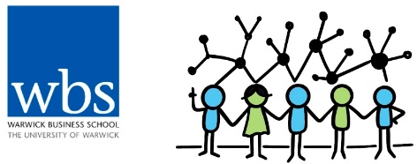

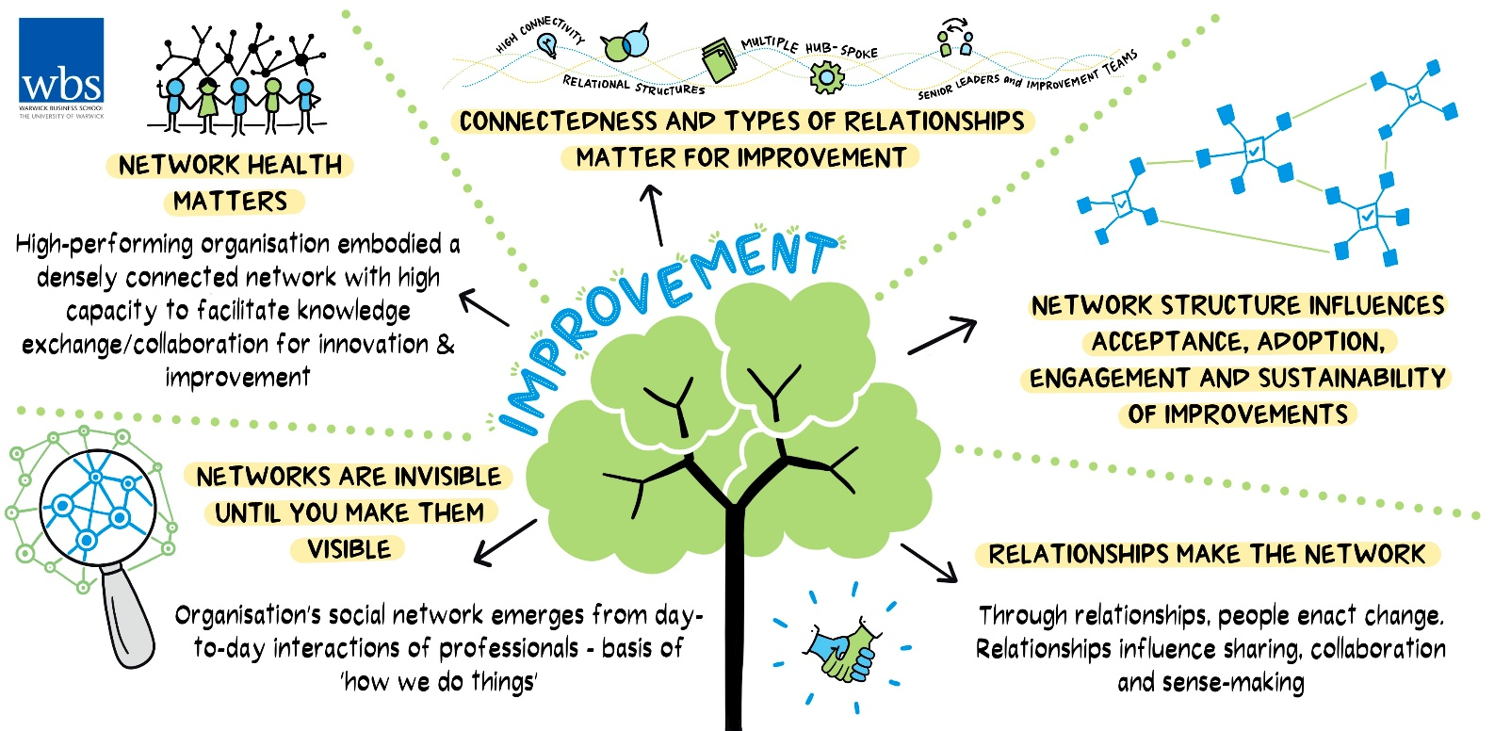
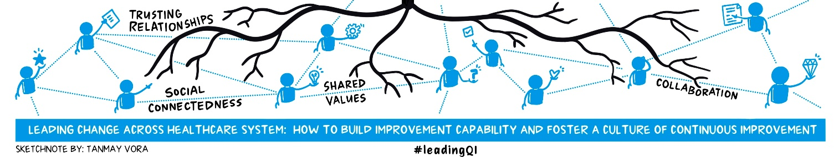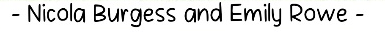
Tweetchat Report

Lesson 4: Why social networks are vital for continuous improvement?
#LeadingQI #QIHour

Tweetchat Date: 25th April 2023
Report Published: 1st June 2023

Contents
What’s our tweetchat series all about? 4
April Tweetchat Report Summary 5
Tweetchat Activity Summary 7
Let's start with a poll! 8
Q1. Our theme this month is about the importance of relational “connectedness” and social networks for improvement. Why does building relationships matter in quality improvement? 10
Key Perspectives on why relationships matter for improvement… 10
Relationships Build Trust which supports and sustains improvements… 11
Relationships create safety to challenge the status quo and support improvement… 12
Relationships support improvement through diversity in views and perspectives… 13
Question 1 Summary 15
Poll. How important is it for senior leaders to (informally) connect with employees? 16
Q2. What practical actions can we take to foster better relationships across teams, departments and levels of the organisation? 16
Summary 16
Gemba, Walkarounds, Being Present & Visible… 16
Ask Questions & Have Conversations… 17
Frame Problems & Move Away from Heroism… 18
Many Examples of Pizza, Coffee, Curry & Cake bringing people together… 19
Other ways to build relationships… 20
Question 2 Summary 21
Q3. How do you use your own networks in your quality improvement work? 22
Summary 22
Formal examples when using professional networks for quality improvement… 22
Informal examples of using professional networks for quality improvement… 24
Question 3 Summary 25
Q4. What advice would you give to senior leaders to foster stronger relationships and networks to support quality improvement? 26
Summary 26
Prioritise and Cultivate Good Relationships… 26
Be Curious, Supportive & Encouraging 28
Question 4 Summary 30
Q5. What insights have you had from this tweetchat and/or what might you do to build your own networks and relationships for quality improvement? 31
Summary 31
Focus on building relationships, connections and networks… 31
Focus on Cultivating Online Networks… 32
Some Participants Shared Advice to help build relationships & networks… 32
Others Shared their Reflections & Showed Appreciation for the tweetchats… 32
Coming Up Next… 34
Core Resources 35
Shared Resources 36

What is our tweetchat series all about?
In October 2022, Warwick Business School held an inaugural ‘tweetchat’ in partnership with #QIhour to accompany a blog entitled ‘Six key lessons from the NHS and Virginia Mason Institute partnership’. Synthesising the key findings from the NHS-VMI evaluation report, the blog incorporated a sketchnote as a vehicle for sharing these lessons far and wide; the result was a global conversation about how to lead continuous improvement within and across health and care settings.
The unprecedented success of our first combined ‘blog, sketchnote and tweetchat’ has led to a partnership with the influential @HelenBevan and @LouWaters_QI in collaboration with #QIHour to foster a global conversation through six additional monthly blogs, sketchnotes and tweetchats between January and June 2023. In each blog, we aim to unpack each of the ‘six lessons’ derived from the evaluation of the NHS-VMI partnership.
It was hosted by Warwick Business School in collaboration with #QIHour alongside a panel of quality improvement leaders from the NHS and the Virginia Mason Institute. The Panel Members are:
Sue Jenkins, Surrey & Sussex Healthcare NHS Trust | @KPOteam_SASH
Lee Sutcliffe, University Hospitals Coventry & Warwickshire | @Sutcliffe1987
James Owen, The Shrewsbury and Telford Hospitals NHS Trust | @SaTHImprovement
Jimmy Parvin, Leeds Teaching Hospital NHS Trust | @jimmy_parvin
Nicola Burgess, Evaluation Lead, Warwick Business School | @DrNicolaBurgess
Bryan Jones, Health Foundation | @BryanJns
Michael Anderson, NHS England | @MichaelNHSE
Helen Bevan, Horizon NHS & Warwick Business School | @HelenBevan
We hope these blogs, sketchnotes and subsequent tweetchats ignite a global conversation and look forward to your feedback, reflections and responses.

April Tweetchat Report Summary
This report was produced to share insights from the fourth in our six-part series, “Why social networks are vital for continuous improvement”, which took place on 25th April 2023.
Poll 1. Let's start with a poll!
- 13 (32.5%) persons responded that it was their first tweetchat suggesting that the series is still garnering interest from QI professionals, and 27 (67.5%) have participated in more than 3 tweetchats suggesting consistent monthly attendance by the majority of respondents.
Q1. Our theme this month is about the importance of relational “connectedness” and social networks for improvement. Why does building relationships matter in quality improvement?
- Building relationships matters for continuous improvement as it builds trust and psychological safety, empowers individuals to challenge the status quo, share ideas and learn together. Building relationships also enables the generation of solutions from diverse perspectives and influences the support and sustainability of improvements.
Poll 2. How important is it for senior leaders to (informally) connect with employees?
- Most of the respondents (92.7% - 164 persons) agreed that it is very important for senior leaders to informally connect with employees, while 13 persons (7.4%) found that it was somewhat important, not important at all, or they did not know if it was important.
Q2. What practical actions can we take to foster better relationships across teams, departments and levels of the organisation?
- Practical examples of how to foster better relationships included going to gemba, being visible and present, asking questions and having conversations, framing problems, facilitating learning in multidisciplinary cohorts, creating safe spaces to share & learn together, and using food to bring people from all levels of the organisation together.
Q3. How do you use your own networks in your quality improvement work?
- Tweetchat participants shared Formal examples which include using networks to offer training and teaching materials, and to facilitate monthly interorganisational and cross-team meetings to share experiences, challenges and learnings; and Informal examples which include using Twitter to share and get QI ideas, and using networks to connect people who may have similar experiences and possible solutions.
Q4. What advice would you give to senior leaders to foster stronger relationships and networks to support quality improvement?
- Key pieces of advice were to prioritise and cultivate good relationships with colleagues, move across organisation levels and boundaries to build connections, share ideas within and outside of your own organisation and to find your own approach to building relationships and networking.
Q5. What insights have you had from this tweetchat and/or what might you do to build your own networks and relationships for quality improvement?
- Tweetchat participants shared that they would encourage their team and colleagues to share successes, learnings and failures with others, in person and online; and also mentioned that the tweetchats are a great place to meet people and build connections by sharing views and experiences.
Figure 1 presents a summary of the themes and keywords that emerged from the tweetchat responses.

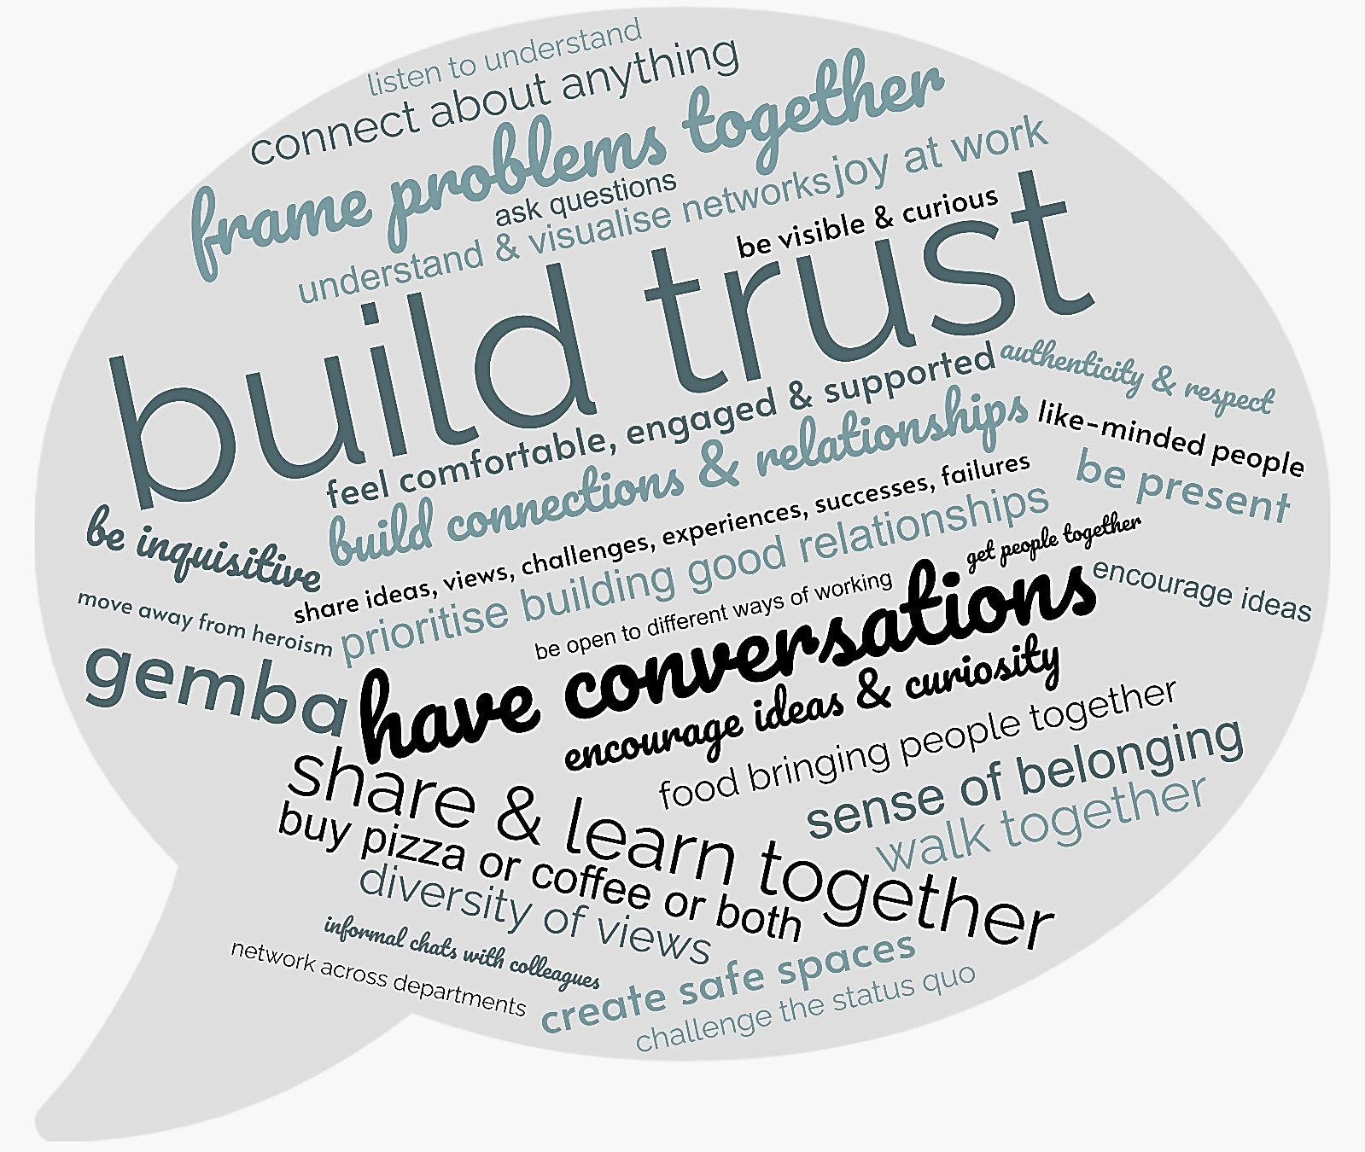

Figure 1: Lesson 4 Tweetchat Themes Summary

Tweetchat Activity Summary
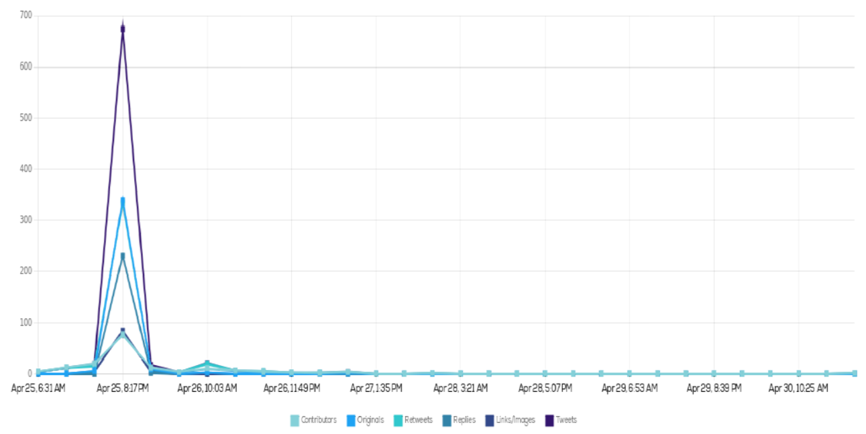 The tweetchat ran from 7-8pm BST on 25th April 2023. The graph above shows tweet activity increasing on that day, peaking during the tweetchat and settling down on 26th March. The tweetchat had 133 participants, who generated 356 original tweets and 417 retweets. Unlike the previous three sessions, #LeadingQI and #QIHour did not trend in the United Kingdom.
Most Popular Tweet of the Session  The most retweeted (151) and liked (452) tweet made by @HelenBevan, has garnered over 71’000 views. It was in response to Q4: What advice would you give to senior leaders looking to foster stronger relationships and networks to support quality improvement? | 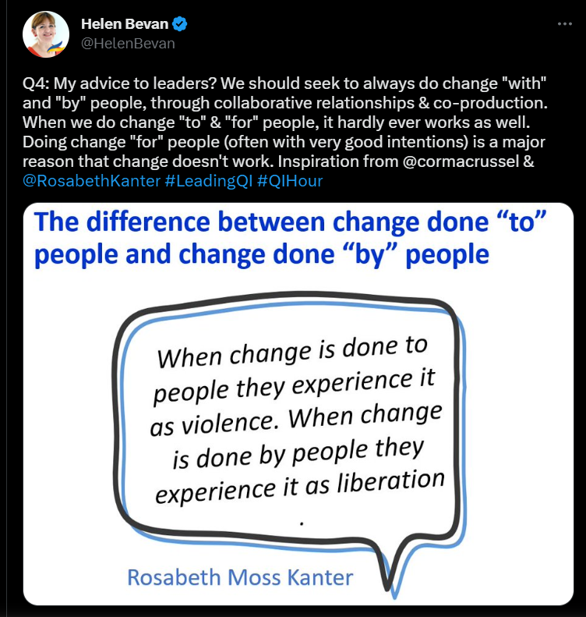

Let's start with a poll!
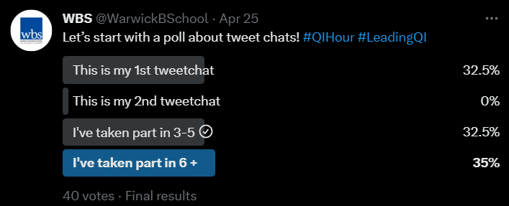 | Question 1 was a poll with 40 votes which sought to understand Tweetchat participation. For 13 (32.5%) persons it was their first tweetchat, and the same amount also have taken part in 3-5 tweetchats, similarly 14 (35%) participants have taken part in 6 or more tweetchats.
Figure 2 summarises the tweetchat attendees and highlights their engagement during the tweetchat, @WarwickBSchool, the tweetchat host, has been removed.
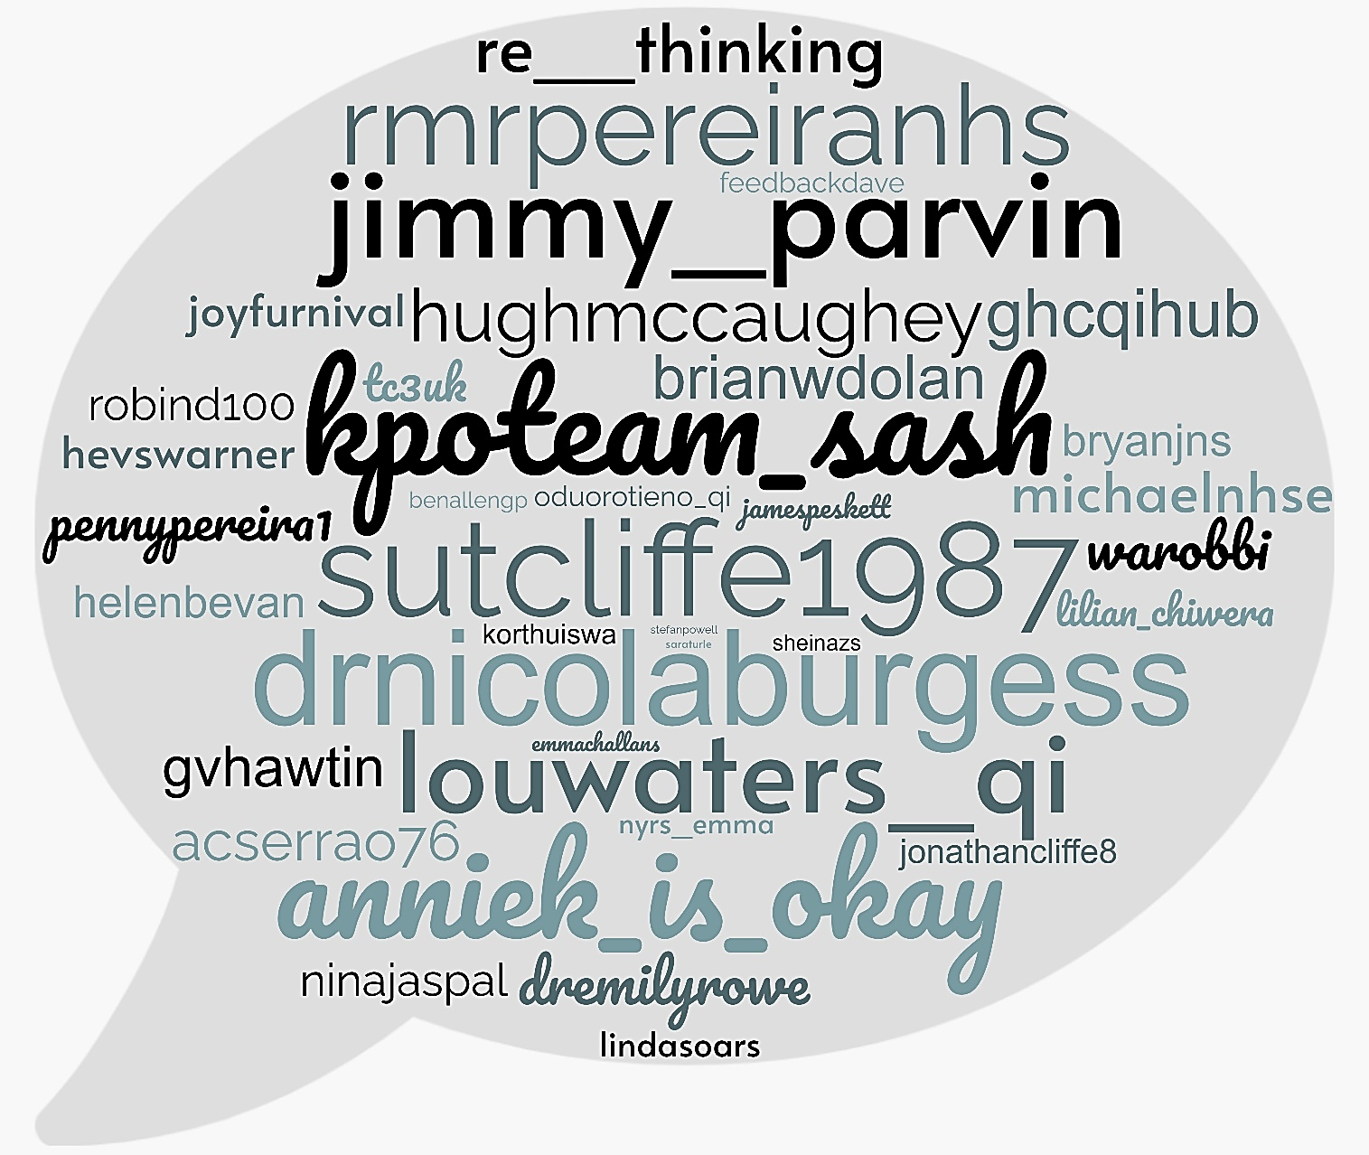
Figure 2: April Tweetchat Participants Summary (without @WarwickBSchool)

The tweetchats have shown steady participation and engagement over the past few months. The tweetchat contributors account for the number of persons tweeting during the tweetchat session, this ranges from 124 to 188, who generated 356 to 520 original tweets and 394 to 586 retweets. This represents a monthly average of 153 tweetchat contributors, 433 original tweets and 451 retweets. It also indicates that for each tweetchat session, between 773 and 1072 tweets are posted and shared using the #LeadingQI handle.

Q1. Our theme this month is about the importance of relational “connectedness” and social networks for improvement. Why does building relationships matter in quality improvement?
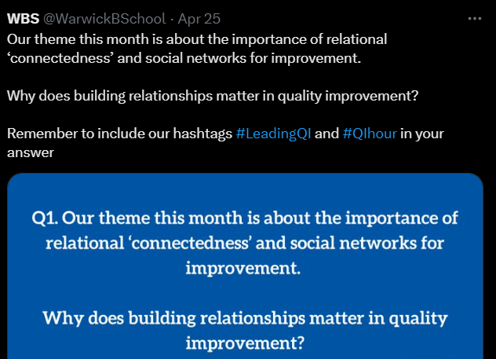 | Building Relationships, Connections, & Connectedness matter for Continuous improvement as it:  - Builds trust and psychological safety,  - Empowers individuals to challenge the status quo, share ideas, learn together,  - Enables the generation of solutions from diverse perspectives,  - Influences the support and sustainability of improvements.

Key Perspectives on why relationships matter for improvement…
@Re__Thinking shared, “The quality of our workplace relationships underpins everything happening in our achievement agenda. Relationships with colleagues & managers affects how we feel arriving at work, how well we are able to do our job, how far we feel valued and part of our team.”
@MichaelNHSE responded that,
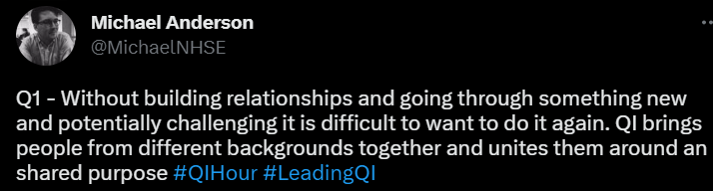
@LouWaters_QI shared that, “Creating improvement is HARD. Working in a challenging org is HARD. Aside from the benefits of relationships & connection to improvement directly, finding your tribe & support system is equally important.”
@KPOteam_SASH replied to @LouWaters_QI saying, “if it was easy we would have all this done and dusted decades ago :-).
@jamespeskett replied,
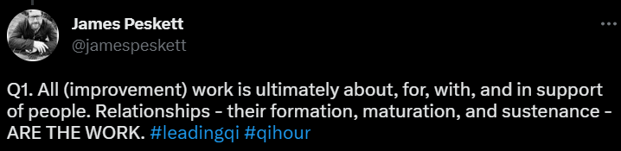
@MariaKordowicz shared a blog they wrote on Relationships, and their improvement, core to QI efforts.
@KPOteam_SASH explained that, “We often talk about CI happening at organisational, system, regional or national levels when actually the real improvements only happen at an individual level when colleagues engage with patients, their peers and others.”
@KPOteam_SASH also added that,
“…WITHOUT RELATIONSHIPS THERE IS NO
SUSTAINABLE, GENUINE IMPROVEMENT.”

@DrNicolaBurgess highlighted,
“We found strong evidence to suggest relational connectedness within healthcare organisations, collaboration for improvement, and performance outcomes.”

Dr Nicola Burgess also added that, “Who is talking to whom, how often and the reciprocity of the relationship matters a great deal. # Relationships that are non-reciprocal, ‘one-way’ or ‘messenger’ type of interactions stymie improvement.
@DrEmilyRowe also shared,
“From the evaluation we found that, relationships distinguished progress, implementation, and sustainability. Through relationships, we share learning and understanding of QI helping it to spread within departments and organisations.”

@HughMcCaughey shared a similar view saying, “Evidence (not least from @WarwickBSchool) tells us, the greater the connectivity, the greater the impact and learning. But it also can be seen in sport, business, industry, art…, they also added that, “Greater connectivity also nurtures greater innovation.”
@KPOteam_SASH replied saying, “your social network analysis that you included in the evaluation was a huge aha moment for us.”
@FeedbackDave shared a view supporting this saying, “…We’ve done various studies using our data. In one culture we found that women and men networked very differently. In another (aged care) we found that visualising the network drove greater inclusion.
@DrEmilyRowe replied to @FeedbackDave, “I agree, visualising networks allows people to actually see their connections with others and they treat their relationships differently as a result.”

Relationships Build Trust which supports and sustains improvements…
@RMRPereiraNHS replied, “Trust plain and simple. Knowing I can turn to colleagues and seek the support to make an improvement happen is the only way it can happen. Key foundation is engagement and having relationships is fundamental to that.”
@lilian_chiwera replied that,
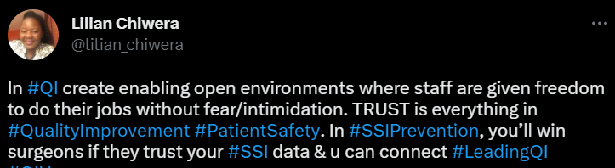
@Sutcliffe1987 shared that, “Building relationships builds trust and building trust starts to get you into the space where people can be inquisitive, ask open questions and feel supported if things fail. Without that network the person leading feels like an island.”
@BrianwDolan shared a very important perspective,
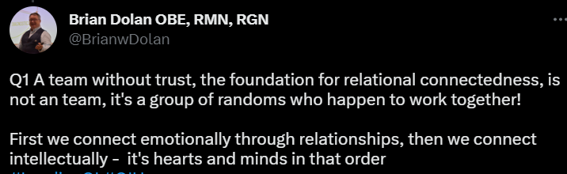
@DrNicolaBurgess replied to @BrianwDolan, “I love this, 'a team without trust is not a team, it's a group of randoms' Connecting hearts and minds matter for sustainable improvement.”
@AnnieK_is_okay replied,

@Sutcliffe1987 replied to @AnnieK_is_okay, “It's definitely about trust, that's our social currency in QI and you need to have people around you to be able to gain and spend that in anything you do.”
@KorthuisWa joined @AnnieK_is_okay & @Sutcliffe1987, replying, “So agree, relationships are needed especially for building the more affective components of trust such as understanding openness, sincerity, and concern.”
@RobinD100’s shared a similar view, “For me Qi all starts with conversations and connection. If you don't work to build good trusting relationships, meaningful Qi or change is not going to happen. Good QI needs Good Conversations.”
@hevswarner explained that,
“Building and sustaining relationships creates trust, respect, bravery. This in turn increases the chances of initiating improvements, sustaining improvements and confidence to challenge current ways of working and culture.”

Relationships create safety to challenge the status quo and support improvement…
@NinaJaspal shared that,
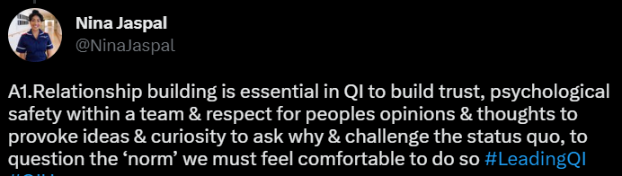
@jimmy_parvin shared a similar view, “Building connections and relationships creates the psychological safety we often need to challenge the status quo, be creative with our thinking, explore opportunities, create and test ideas, and to fail.”
@Sutcliffe1987 replied to @jimmy_parvin, “Love this Jimmy, its easier to challenge the status quo with friends or if not with friends as part of something bigger.”
@HughMcCaughey also replied to @jimmy_parvin, “Agree Jimmy, and also enhances a sense of inclusion and belonging.”
@GHCQIHub shared,
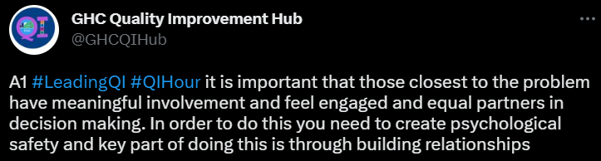
@AnnieK_is_okay replied to @GHCQIHub, “Love this. Have recently been thinking about the #psychologicalcontracts we have in the workplace and how easily it can derail change if we don't honour them.
@DrNicolaBurgess replied to @AnnieK_is_okay and @GHCQIHub saying, “Our next blog and tweetchat due end of May will talk about psychological contracts and the importance of holding each other to account for behaviours not just outcomes.”
@RobinD100 reflected that,
“…we need to remember relationships are two-way things. Sometimes we will hear things we don't want to or get frustrated etc. It’s not just nice chats.”

@Sutcliffe1987 replied to @RobinD100, “This is great, its about maintenance and this is hard, its getting your hand dirty into the detail with people and being honest at looking at why things don't work.

Relationships support improvement through diversity in views and perspectives…
@charlie_psych shared that,
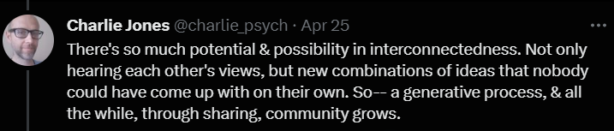
@Sutcliffe1987 replied to @charlie_psych, “Absolutely, its the such an important part I guess the question is how do we all foster interconnectedness, its hard to do when its not in the JD :).”
@BryanJns may have an answer to @Sutcliffe1987’s question,
“…As the Flow Coaching Academy by @HealthFdn found, setting aside dedicated time each week for multi-professional teams to come together is key to sustained improvement.”

@jimmy_parvin may also have an answer,
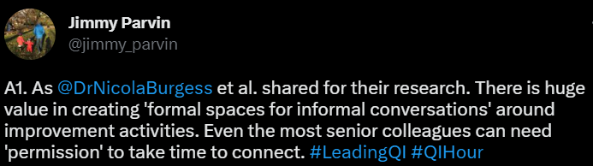
@gvhawtin replied, “being connected it’s how we learn from each other and not re-inventing the wheel! Sharing and connecting with others you can then use and take into your own workplace. It’s the best form of CPD and it’s free plus you meet amazing people.”
@MichaelNHSE replied that,

@HughMcCaughey replied to @MichaelNHSE, “Agree the sense of togetherness and team is important Michael…but it is important it isn’t just a team of like-minded people. Innovations, ldeas and new thinking often comes from diversity of views.”
@LouWaters_QI replied to @HughMcCaughey, “And sharing and spread of said innovation. It widens the testing bed and brings in new diverse voices and ideas.”
@Sutcliffe1987 also replied to @MichaelNHSE, “It’s that feeling of confirming your thoughts are right that acid test and we definitely all need it. “
@MichaelNHSE also replied to @Sutcliffe1987, “I have even grown to like being told I am way off the mark :D - people who work with you and create with you rather than just tell you what is wrong and not how to fix it are the people to surround yourself with.”
@acserrao76 shared,
“…Absolutely think it has opened doors to opportunities and has opened my mind to possibilities too. We are stronger together and a multitude of views and wider collaboration means we can work on improvements that improve quality for many more people.”

@AnnieK_is_okay replied to @acserrao76, “So true. Without a variety of views, we are likely to go down the garden path, so to speak. A good spread of Relationships helps to avoid that.”
@gvhawtin shared, “I’ve learnt so much from others and It’s made me a better person seeing how others make change. I know if I need help my amazing networks are always there.”
@Sutcliffe1987 replied that, “The relationships help set the boundaries too, its only when you start to develop these that you start to get to understand other viewpoints and build the barriers on the work you want improve.”

Question 1 Summary

Figure 3: Why does building relationships matter in quality improvement?
According to the tweetchat responses, building relationships matters because sustained relationships and relational connectedness, builds trust and psychological safety among professionals, which empowers them to challenge the status quo, share ideas, learn together, generate solutions from diverse perspectives and enact change which results in sustained improvement. These points are visually represented in Figure 3. Respondents also shared that connecting emotionally and intellectually, and building trusting relationships with like- and differently- minded individuals is core to QI efforts because a diversity of perspectives is crucial for meaningful and impactful quality improvement. @WaRobbi shared a reply which summarises these points saying, “Healthcare is about People caring for People. QI is people solving problems to help people. The more we can build relationships and empower the ideas of the frontlines the better we can generate solutions that have the biggest impact.”
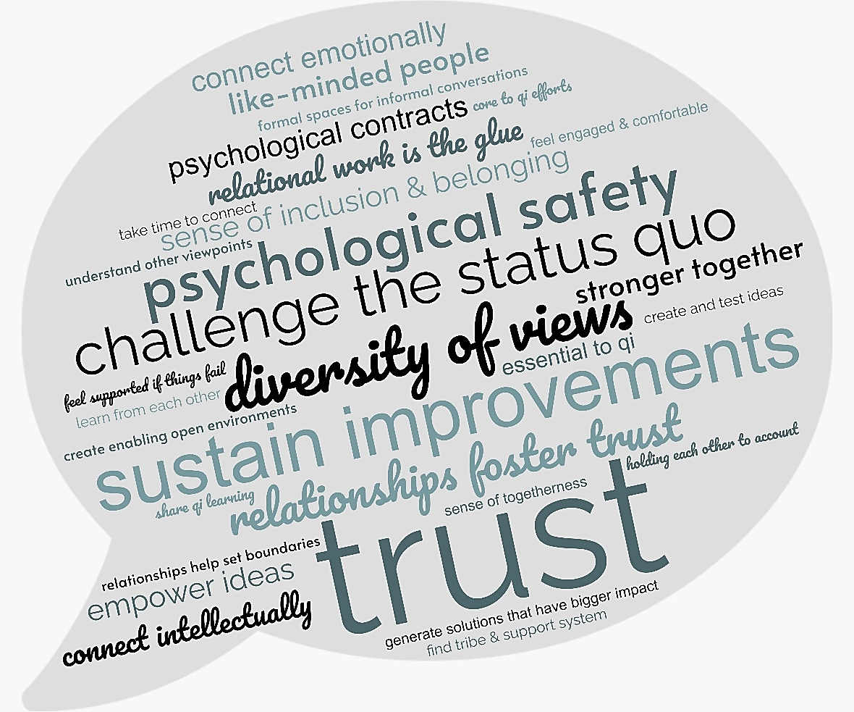
Figure 4: Question 1 Word Cloud

Poll. How important is it for senior leaders to (informally) connect with employees?
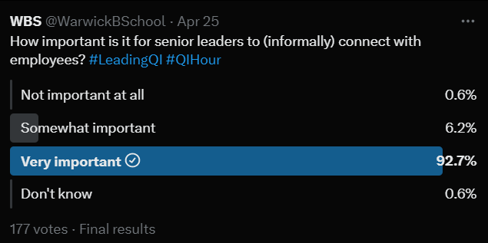 | - 164 persons (92.7%) respondents agreed that it is very important for senior leaders to informally connect with employees,  - 11 persons (6.2%) agreed that it was somewhat important, and  - 2 persons (1.2%) responded that it was not important at all, or they did not know whether it was important.

Q2. What practical actions can we take to foster better relationships across teams, departments and levels of the organisation?
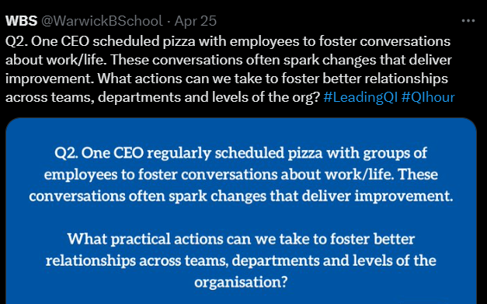 | Practical examples of how to foster better relationships included going to gemba, being visible and present, asking questions and having conversations, framing problems, facilitating learning in multidisciplinary cohorts, creating safe spaces to share & learn together, and using food to bring people from all levels of the organisation together.

Gemba, Walkarounds, Being Present & Visible…
@KPOteam_SASH shared that, “Genbawalks, with a purpose are key. Execs visit different genbas with standard work to support the focus and timing of the visit to support newly graduated lean leaders for their first year.” @KPOteam_SASH also added, “Leaders going to the genba (the place where the work is done) when the going is good as well as tough is really important to do.”
@jimmy_parvin replied to @KPOteam_SASH,
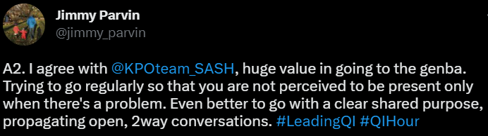
@Sutcliffe1987 replied to @jimmy_parvin & @KPOteam_SASH, “Agree to, going to them is such a well-received gesture, especially in a system that often calls people to offices.”
@LouWaters_QI also replied to @KPOteam_SASH asking, “We have 'Leadership walkarounds'. Would you describe those as Gembawalks or is that something different? If so, how do they differ?”
@KPOteam_SASH replied to @LouWaters_QI saying, “depends if they have purpose or not Lou. Genba walks have purpose "go see ask why show respect" and are supported by standard walk to limit both focus and time.
@DrNicolaBurgess explained,
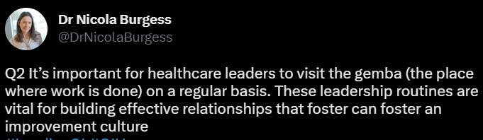
@PennyPereira1 replied to @DrNicolaBurgess, “Gemba is such a powerful principle. How might we help board leaders feel confident to engage and do this well?”
@hevswarner shared,
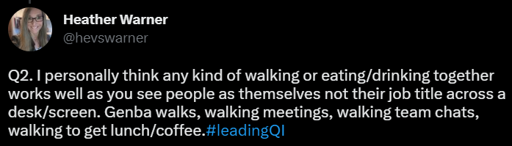
@KorthuisWa replied, “Love the comments about listening and authenticity at the genba, reminds me of "if you believe you already know what the other person is thinking, your not ready to have a conversation.”
@CarenWalshQI also replied,
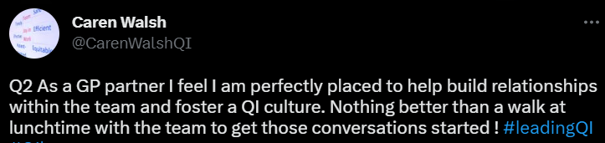
@Nyrs_Emma shared a similar view, “Being present, being visible, being familiar - I think these are all important for fostering relationships and making connections that go beyond the superficial.”
@Sutcliffe1987 replied, “Be inquisitive and be present. We have seen great things when our leaders visit areas (Announced so its not a surprise) and just ask what's going on what are the team working on and what challenges are they facing, Simple appreciative enquiry works.”

Ask Questions & Have Conversations…
@WaRobbi shared,
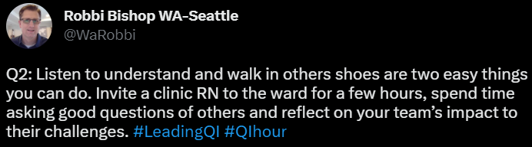
@KPOteam_SASH recommended,
“…Ask staff what making good connections would look like for them - leaders don’t have to have all the ideas in how to best do this ;-)”

@AnnieK_is_okay replied to @KPOteam_SASH, “Yes! Consciously acknowledging that not every decision can or should start with the person who is designated as the leader is so critical in building relationships that lead to improvement of practice.”
@TC3uk replied, “Make it your default to ‘understand first’ – and to check your understanding!”
@Sutcliffe1987 shared, “I guess the other element is modelling the behaviour, do I ask questions, show my own fallibility and really just openly coach and be willing to be coached.”
@jimmy_parvin shared, “The value of connection and informal conversation can be difficult to describe. But I reflect on the different between an online and in-person conference. Often the value between the content is significant.”
@JonathanCliffe8 replied,
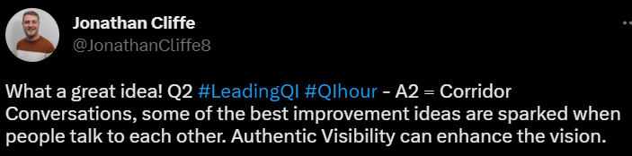
@oduorotieno_QI advised that, “CEOs and the leadership need to take time to listen to the stories in the 'hallways' both from patients and staff. As part of #LeadingQI, these stories should enrich the discussions in the boardroom on what areas that need greater support for better care outcomes.”
@acserrao76 shared, “1/2 hour before team meeting to just connect about anything from pets, the weekend, holidays planned things that bring joy outside work. Helps establish a human connection. A sense of togetherness which helps a team gel and informally connect in the space.”

Frame Problems & Move Away from Heroism…
@NinaJaspal shared that, “Creating space for open dialogue at all levels, leaders giving teams time to reflect on how they can create & sustain new ways of working by adopting a coaching stance, framing the problem for employees rather than fixing the problem!”
@KPOteam_SASH shared, “when our CEO was appointed she said one of the most freeing bits of her role was being a problem framer rather than having to have all the solutions… and that can be so hard for many caped superhero type leaders many of whom will have been promoted because they were great problem solvers rather than framers. We need to walk with these guys too.”
@RMRPereiraNHS replied to @KPOteam_SASH, “Agree totally but maybe the reflection is what development offer do we have to support those heroes to channel it at the appropriate time to enable it to be shared out with others - greater sustainability ultimately.”
@RMRPereiraNHS also added that,
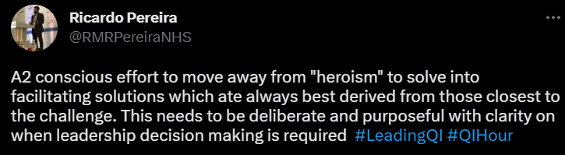
@Sutcliffe1987 replied to @RMRPereiraNHS, “The move away from superhero behaviour is key, but really hard in a system with so many challenges, I guess its often easy to fall back into it.”
@BryanJns shared a similar comment,
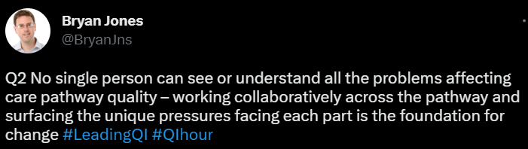
@BryanJns added that, “Tackling hierarchies is key – all improvement team members, whatever their experience or role, has a unique perspective to offer and should feel supported to contribute to the work of identifying and solving problems.”

Many Examples of Pizza, Coffee, Curry & Cake bringing people together…
@BrianwDolan shared,
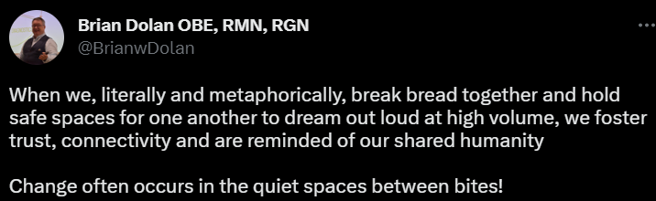
@HughMcCaughey replied, “My former Trust @setrust ran a Curry Club, where those involved in QI came together to share and learn over a curry” and added that “the Pizza or Curry is only to create a safe space to share and learn together. Leaders needs to be visible and listen with interest…show this matters; celebrate and value when staff (and patients) do connect, share and learn.”
@lilian_chiwera replied,
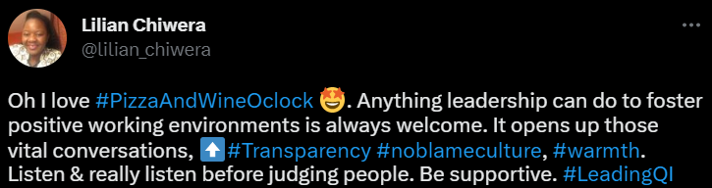
@Nyrs_Emma replied, “I mean, Pizza sounds good...! 😄 I think it's really important to see what works for each team and department. Go to them. ""How can we fit in to their schedule?"" not the other way around."
@RobinD100 also had a similar view, “I think its important for leaders to go to the teams. Pizza, coffee or just scheduled time works. But start with listening and be curious not defensive.”
@jamespeskett shared,
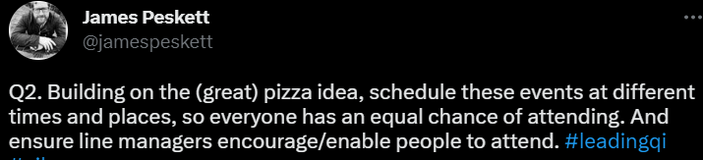
@AnnieK_is_okay said, “This is a tough one because it can easily come across as an insincere action. We have taken turns with each floor in the building take responsibility for a colleague breakfast just for their floor but crossed multiple teams. Then 2 events for all in the yr.”
@DrEmilyRowe replied,
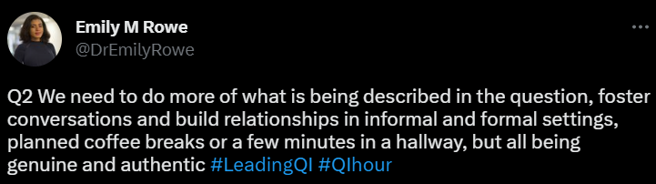

Other ways to build relationships…
@FeedbackDave shared,
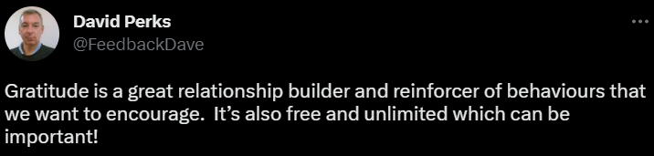
@GHCQIHub replied, “For me u need to make sure u create different opportunities to build relationships acknowledging different personality types and communication preferences. 1st need to understand current situation & then ask colleagues what's working well and even better.”
@KPOteam_SASH shared,
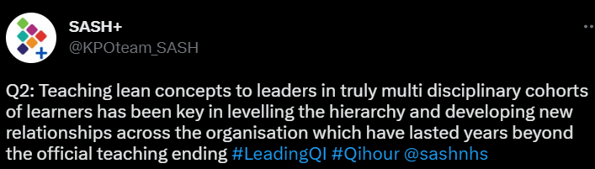
@gvhawtin replied, “Making sure everyone feels they belong it’s easy to do and making sure everyone feels supported no matter what life throws at you, Then the magic can flourish and changes will grow and progress no matter who they are.”
@Sutcliffe1987 replied to @gvhawtin, “Creating belonging is hard, always grateful for tips to help develop that.”
@gvhawtin replied to @Sutcliffe1987 saying, “I think belonging within a team and time and space to develop personally and professionally.”
@TC3uk reflected, “I guess we can all agree that relationships and connectedness are good things and the basis for high performance etc. I’d be interested in hearing thoughts on how to improve/build relationships, especially from a poor start.”
@DrEmilyRowe replied to @TC3uk, “I’d say we have to examine the culture and context. Connectedness comes from a sense of belonging and shared purpose, if there is a sense of togetherness focused on we can and will be better, that sentiment will grow.”
@DrNicolaBurgess also replied to @TC3uk, “Good question! We have seen organisations using crowdsourcing to start an organisation-wide conversation about how it feels to work here for example, and how can we improve.”

Question 2 Summary
Tweetchat participants shared various practical actions that can be used to foster better relationships across teams, departments and levels of the organisation. Some approaches being visible and present, like going to gemba (the place where the work is done), actively showing interest and listening to understand. Some approaches are more casual, such as asking questions and having informal conversations, walking and chatting together. More formal approaches focused on framing problems and facilitating learning in multidisciplinary and multiprofessional cohorts, and a major theme was using food and eating together to create safe spaces for professionals from all levels of the organisation to share & learn together. A summary of the themes captured from the responses is shown in Figure 5.

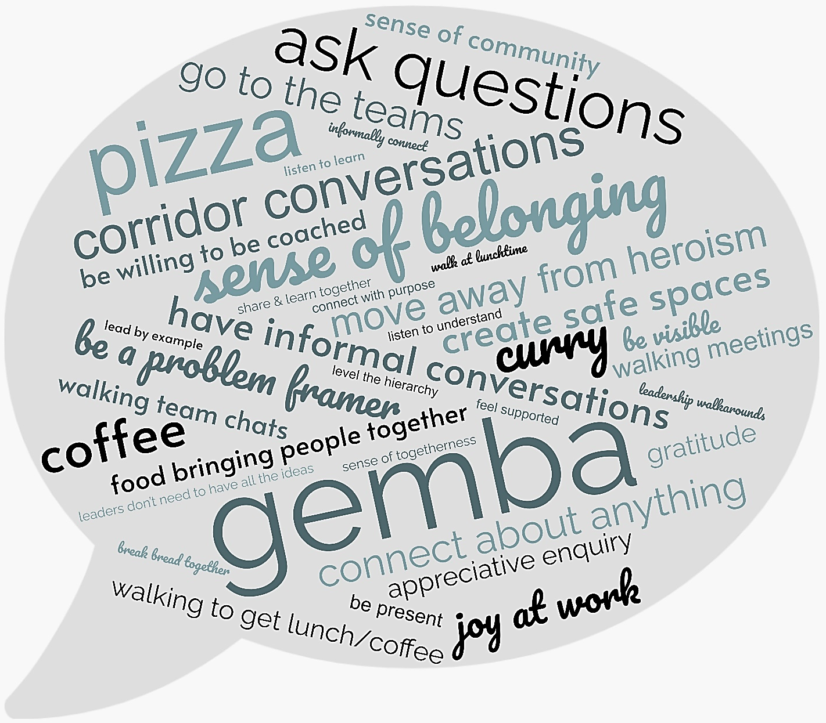
Figure 5: Question 2 Word Cloud

Q3. How do you use your own networks in your quality improvement work?
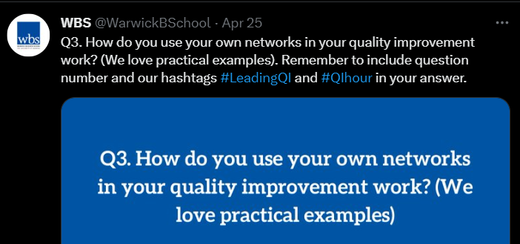 | Examples shared by tweetchat participants were grouped as formal and informal approaches to using networks for quality improvement. This included using networks to facilitate training and share educational materials, as well as, having informal conversations to share QI ideas.

Formal examples when using professional networks for quality improvement…
@KPOteam_SASH shared that,
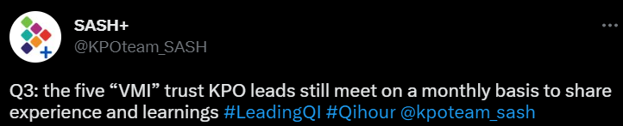
@KPOteam_SASH also added that, “the five “VMI” trusts have shared teaching resources and materials to reduce the waste of processing and over production when there are tiny cohorts planned” and, “we have offered access to all our CI education offers to all staff in our ICS free of charge and have developed bespoke offers to meet the availability needs of primary care colleagues.”
@jimmy_parvin another KPO lead added that, “LTHT has created a 'improvement community' channel on our Teams platform. A shared space for resources and conversations around improvement activities and our training offer.”
@jimmy_parvin also shared that,
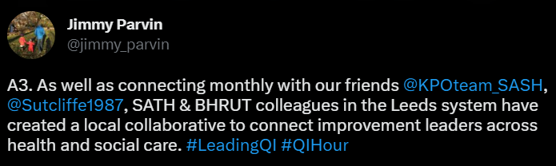
@Sutcliffe1987 replied to @jimmy_parvin saying that, “The meetings between the teams were one of the highlights of the year, it was great to hear the challenges and successes of everyone else, because it just reinforced that even though its hard its worth it.”
@NinaJaspal from the UHCW KPO team said that,
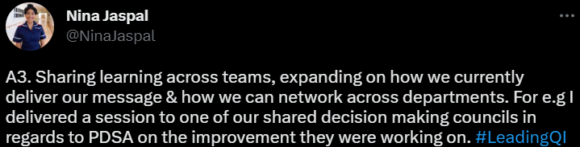
@GHCQIHub responded that,
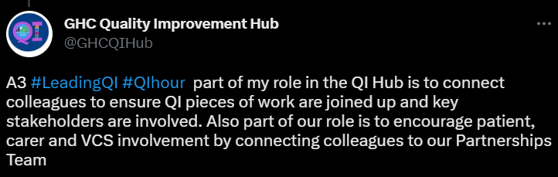
@oduorotieno_QI shared, “As a QI Advisor when #LeadingQI learning sessions, I often carry along coaches from other programs & counties to enable experience sharing when facilitating learning sessions in other programs/counties. A HIV care program coach sharing with TB program coaches.”
@Re__Thinking shared that,
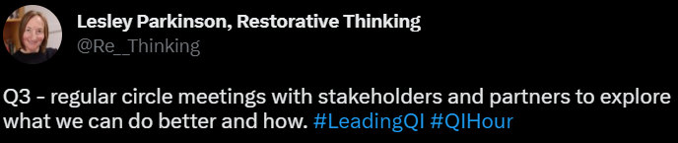
@AnnieK_is_okay said that, “we have recently begun using the network of HPE that's been built over a decade to link the concepts of #LeadingQI in the health sector to #LeadingQI in the Higher Ed space. Finding that marriage very interesting #QIhour @nyonicampion come join this tweetchat” and also shared that, “It's been a labour of love but working with Nurse Educators who are focused on #LeadingQI in their country across sub-Saharan Africa is such an empowering initiative to be involved in.”
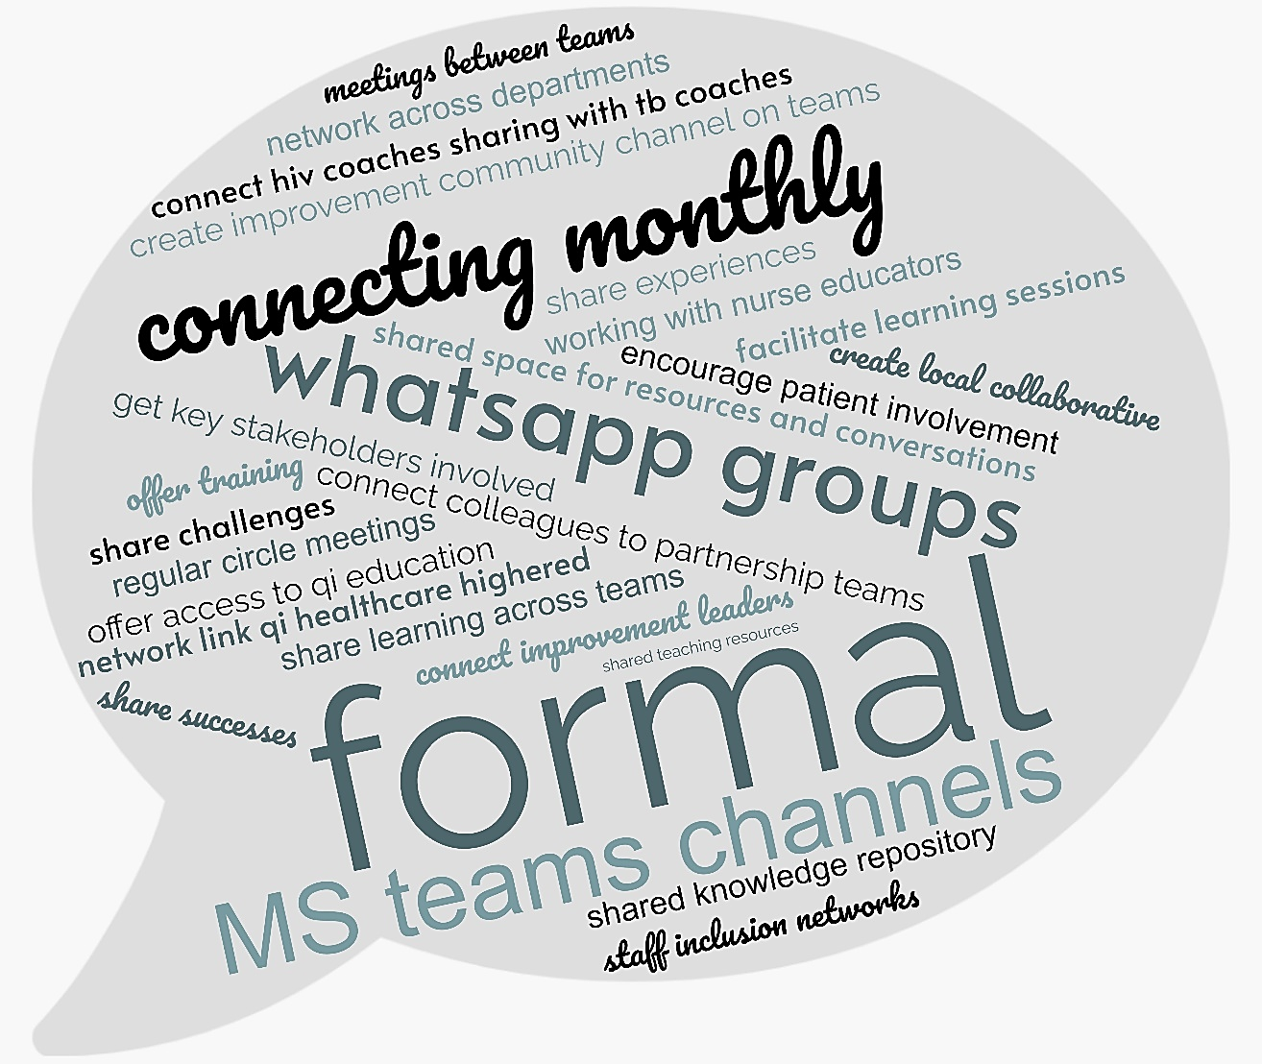
Figure 6: Formal Examples Summary Word Cloud

Informal examples of using professional networks for quality improvement…
@Sutcliffe1987 reflected that, “We often work in complex spaces so as many have reflected already its used as my sounding board, we often have conversations around approaches to work and its about connecting people, so the easiest step is ask the people if your idea connects them.”
@Sutcliffe1987 also added that,
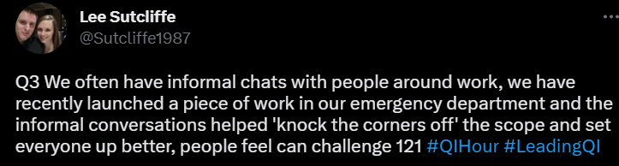
@hevswarner said, “it varies tbh. What springs to mind initially for me is tapping into trusted networks to pave the way for change. Peer to peer conversations work well for QI.”
@MichaelNHSE said that it,
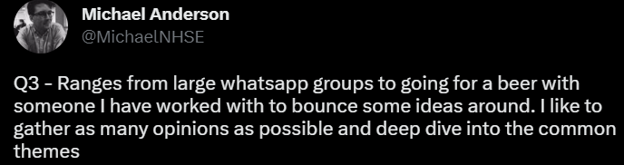
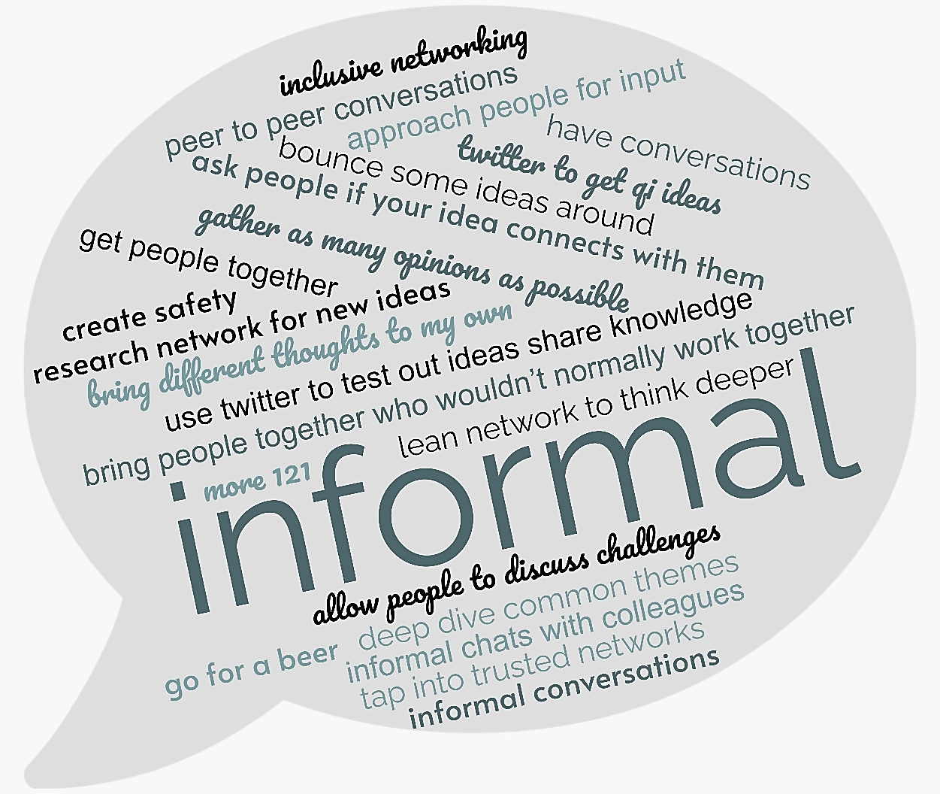
Figure 7: Informal Examples Summary Word Cloud
@BrianwDolan said, “When it comes to using networks, my job is to be like the AA. If I don't know, I'll usually know some who does! Most often it's by connecting great people together where one or both have a QI issue they'd like to solve.”
@joyfurnival shared,
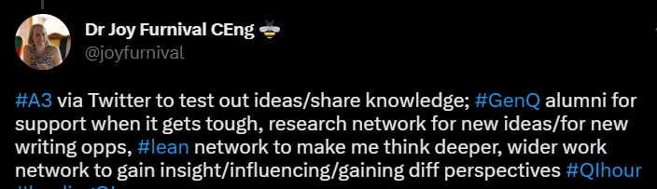
@BenAllenGP also had a similar approach saying, “I use twitter to get QI ideas, ask tricky questions & share examples of solutions we've come up with.”

Question 3 Summary
Tweetchat participants shared formal and informal examples of how they use their networks in quality improvement work.
Formal examples include:
- Monthly interorganisational and cross-team meetings to share experiences, challenges and learnings,
- Using networks to offer training, and share teaching resources and materials,
- Create local collaboratives across trusts to connect QI leaders,
- Create online communities using MS Teams to have a shared space for resources and conversations.
Informal examples include:
- Using Twitter to share and get QI ideas,
- Having peer-to-peer and 1-2-1 conversations with colleagues to bounce ideas around,
- Using networks to connect people who may have similar experiences and possible solutions,
- Using networks to connect people who may not usually work together to generate diverse views and perspectives.

Q4. What advice would you give to senior leaders to foster stronger relationships and networks to support quality improvement?
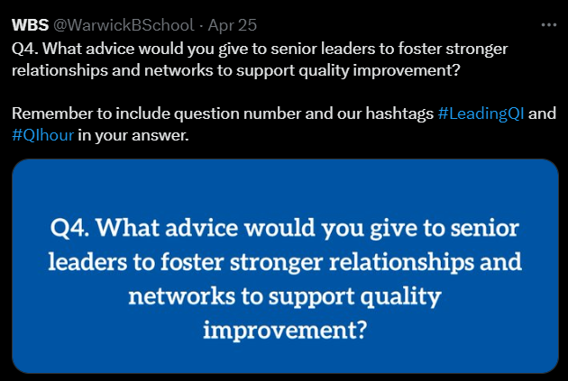 | Some key pieces of advice were to:  - Prioritise cultivating good relationships with colleagues,  - Build connections beyond hierarchical relationships and move across organisation levels and boundaries.  - Make informal spaces to share ideas within and outside of your organisation.

Prioritise and Cultivate Good Relationships…
@Re__Thinking advises to, “Prioritise relationship-building root and branch; invite engagement around how you will do this, explain what's happening, set expectation clarity across the organisation. Then model it.”
@Sutcliffe1987 replied to @Re__Thinking saying, “I always think that it would be interesting if we brought looking at relationship building as a KPI, because we never seem to focus on it.”
@AnnieK_is_okay shared similar advice,
“If you're serious about #LeadingQI then you can't underestimate the impact that the right relationships can have on the success or failure of your outcomes. As a responsible leader, cultivating good relationships should be prioritised from day 1.”
@AnnieK_is_okay also added,
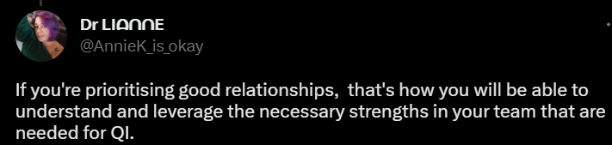
@Sutcliffe1987 shared,
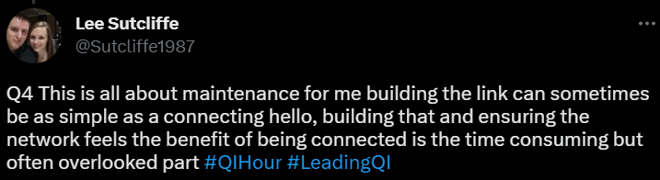
@NinaJaspal shared, “My advice to senior leaders would be to be inquisitive & supportive to areas within their organisation by being visible. No question is a silly question, its important to show empathy and seek out how they can better enable their staff by removing barriers.”
@KPOteam_SASH advised to,

@DrNicolaBurgess replied to @KPOteam_SASH saying, “Advice to senior leaders: Speak to people, always. As you walk down the corridor on your lunch break say hello! As you walk to your car, smile. Learn people's names Engage in small talk whenever possible & appropriate - trust will grow, improvement can happen.”
@jamespeskett joined the conversation with @DrNicolaBurgess & @KPOteam_SASH giving an example, “I once worked for someone who deliberately put their desk as far from the entrance as possible and every time they went in or out, the ‘circulated’. Not about work much, but life in general (often Welsh rugby, as hint!).”
@Sutcliffe1987 also replied, “Saying Hello is the simplest first step, we often talk about how much easier it is to connect when you walk down the corridor not looking at your emails or a phone but its hard to develop that culture.”
@FeedbackDave shared,
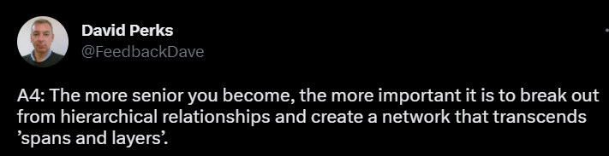
@DrNicolaBurgess replied to @FeedbackDave saying, “That's really good advice - the higher you climb, the more you need to break out from hierarchical relations and 'span' boundaries.”
@BrianwDolan advised,
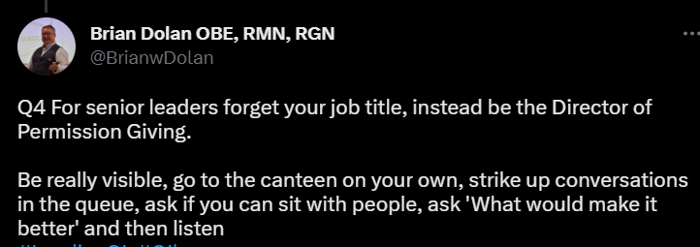
@jimmy_parvin advised senior leaders to, “Look internally for allies as well as externally for inspiration. Create the space to engage with colleagues on what matters to them, and seek to understand the perspectives of all the stakeholders. And buy pizza, or coffee (or both).”
@jamespeskett advised to find what works for you saying,
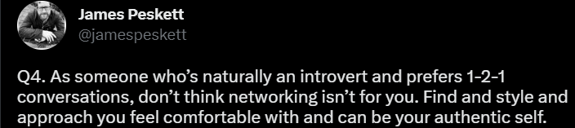
@DrEmilyRowe replied to @jamespeskett, “I can relate to this very much, networking comes in many different styles, simply need to find what approach you are most comfortable with.”
@DrNicolaBurgess also replied to @jamespeskett, “Hear hear! People who are not naturally drawn to 'networking' spaces can benefit from being encouraged to build connections.”

Be Curious, Supportive & Encouraging
@gvhawtin said, “to use your teams strengths to support improvement and nurture it. Learning all the time. Just joined the CSP Associate Network as comms Officer can’t wait to get stuck in!”
@PennyPereira1 shared,
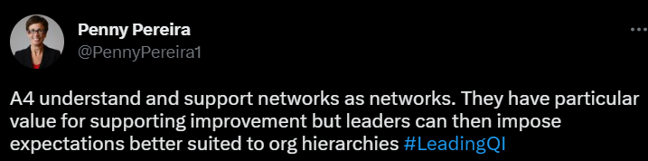
@JonathanCliffe8 shared,
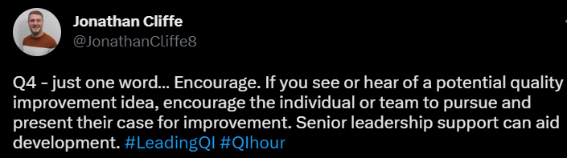
@WaRobbi had three pieces of advice,
#1 be curious and explore both upstream and downstream of your area.
#2 frame problems so others can generate ideas and work together to test/learn.
#3 empower patients and carers.”
@RMRPereiraNHS shared, “5 words - authenticity compassion, inclusivity, advocacy and curiosity. Be you and bring your whole self to your everyday, actively listen and hear to be able to help, constantly ask yourself are the right voices informing this, if people do good things or”…“have great ideas make sure they are shared and attributed and finally keep asking the questions no matter the perceived "silliness" until you feel you understand and are assured to provide your support. Ultimately role modelling runs central - learn & apply.”
@StefanPowell shared similar advice,
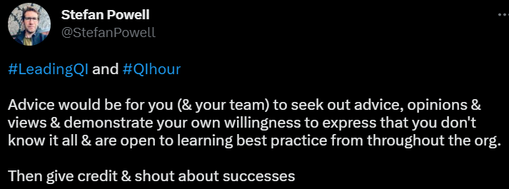
@BryanJns shared that, “Leaders have to encourage the growth of informal spaces to exchange ideas and learning. Not easy when time is so scarce but invaluable in encouraging curiosity and innovative thinking.”

@acserrao76 advised to,
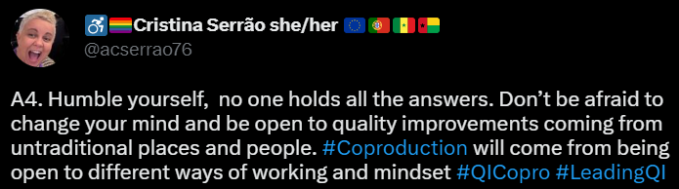
@KPOteam_SASH shared a few pieces of advice as well:
Become a problem framer. This is freeing for you as a leader but more importantly helps generate an industry of problem solvers around you who actually have better ideas than you. Be humble!
Be prepared to find out things that you don’t know and respond appropriately and supportively when you do.
@GHCQIHub advised to, “practice regular gemba walks, be curious and empower colleagues to own their own data and improvement.”
@MichaelNHSE shared,
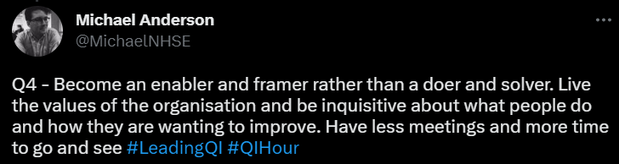
@Sutcliffe1987 replied to @MichaelNHSE saying, “In a complex world with so many problems this always seems like such an easy thing, but people find it so hard. We always seem to feel we have less control over our time and the things we do than we have.”
@joyfurnival shared that,
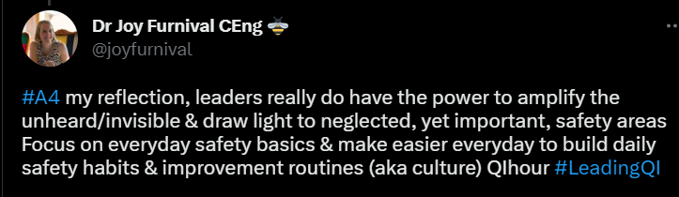
@oduorotieno_QI advised that, “It helps a great deal when senior leadership is able to frame what improvement would look like. When leaders are hazy on what outcomes they would want to see, the teams are left in implementation confusion. #LeadingQI calls shining the light on the 'TrueNorth' #QIHour.”

Question 4 Summary
Many pieces of advice were shared during the tweetchat, some focused on how to build relationships and connections, others focused on different approaches and types of interaction, and some on the qualities and behaviours that senior leaders should exhibit. An important point shared by some of the participants, was to understand the value of relationships and the impact networks can have on improvement outcomes. This was observed in the NHS-VMI Partnership Evaluation. Other advice shared was to:
- Prioritise and cultivate good relationships with colleagues, by building connections beyond hierarchical relationships and moving across organisation levels and boundaries.
- Make informal spaces or have informal chats wherever and whenever possible and appropriate.
- Understand that there are many different approaches to building relationships, and it is best to find what style is best for each person, situation, and environment.
- Be curious and share ideas, within and outside of your organisation.
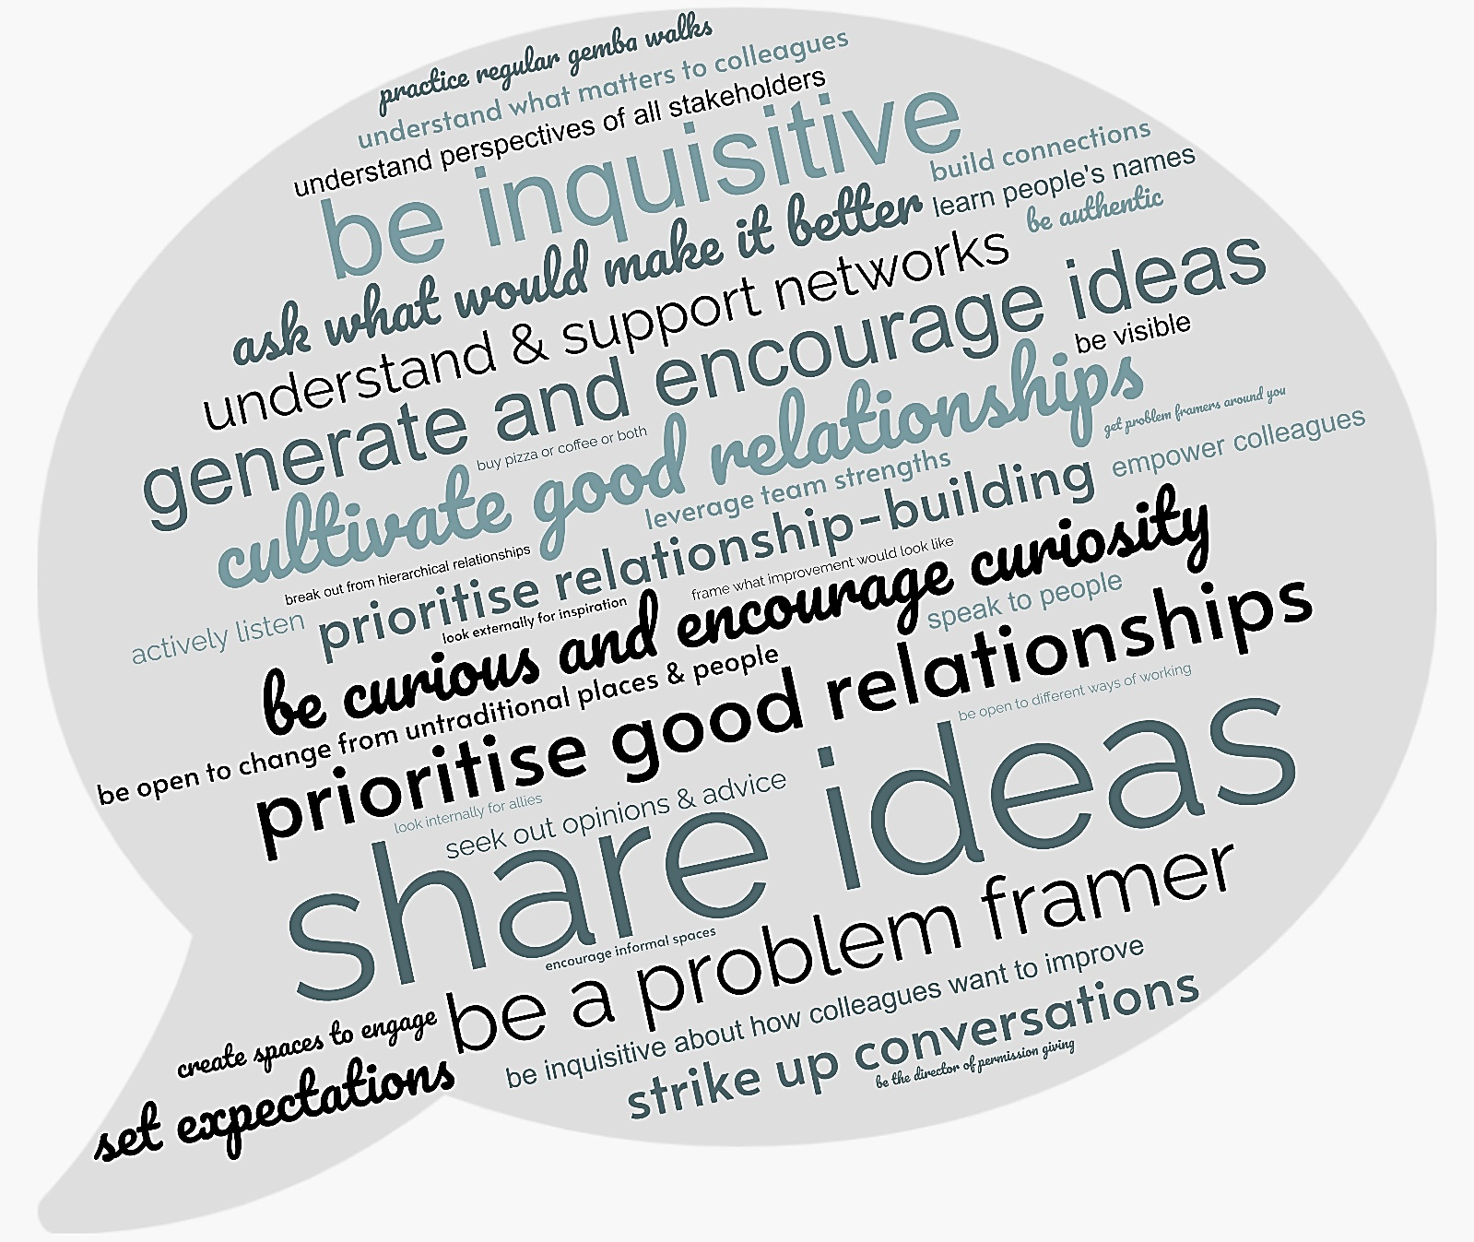
Figure 8: Question 4 Tweet Highlight Word Cloud

Q5. What insights have you had from this tweetchat and/or what might you do to build your own networks and relationships for quality improvement?
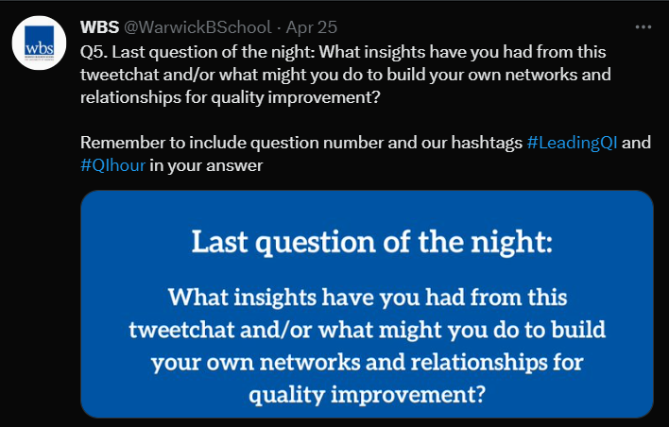 | Tweetchat participants shared that they would find ways to encourage their team and colleagues to invest time in the building relationships and networks, through sharing successes, learnings and failures with others, in person and online. Some also mentioned that these tweetchats are a great place to meet people and build connections by sharing views and experiences.

Focus on building relationships, connections and networks…
@jimmy_parvin shared “Relationships and networks are vital to effective and sustainable improvement. My take-away is to challenge myself to find more opportunities to connect with others, and to encourage my team and colleagues to invest time too.”
@MichaelNHSE said that,
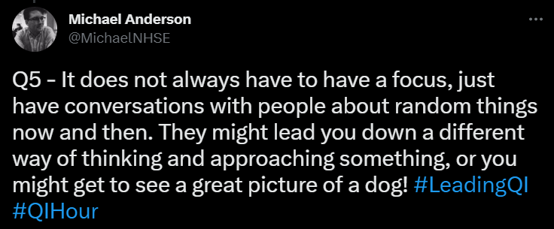
@gvhawtin shared they, “Will continue to improve and build networks they are so important and you never know what amazing people you could meet along the way!”
@jamespeskett reflected that,
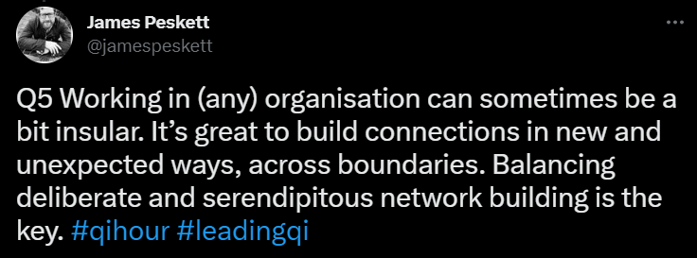
@Sutcliffe1987 replied to @jamespeskett saying that, “Following on from your earlier comment I think organisations can be inherently introverted because its hard to connect and network such large and complex things, but just talking openly is always a great start #theresalwayspoliticsthough.”
@oduorotieno_QI mentioned that “In #LeadingQI, the beauty of the human face in improvement work is driven by social networks and the leadership very much part of it all.”
@AnnieK_is_okay also commented that, “Being a leader means being in a relationship with the people you work with. It requires careful thinking, consideration of what will create a community and can be powerful... but requires humility and skill.”

Focus on Cultivating Online Networks…
@BrianwDolan shared that, “As ever, it's all about people Twitter may sometimes be the devils playground but for healthcare folk it's a magical place of connection - I've followed lots more from here, so thank you for that You are all completely fabulous and this was a great party!”
@NinaJaspal also commented that, “These tweet chats are great for building online networks and always leave me feeling inspired from the discussions, maybe we create a space to connect more often? It’s important we continue sharing our journey internally & externally from our organisation.
@Sutcliffe1987 reflected saying that, “I need to think about how I maintain my virtual network better, I connect with so many interesting people on these tweetchats and then don't give myself the time to explore and maintain them #bebetterwithtwitter.”
@PennyPereira1 commented on, “how the tone and style of the interactions in this chat reflects the ethos of what we’re discussing. You can get this across (even) over Twitter and these brief links open the way for further conversations and action.”

Some Participants Shared Advice to help build relationships & networks…
@RMRPereiraNHS advised,
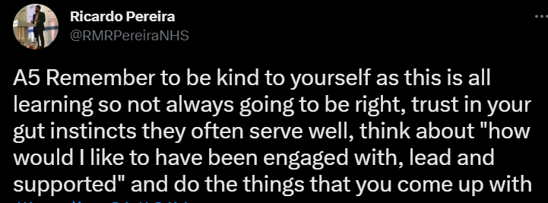
@FeedbackDave reminded that, “Networking is work. Approach it the way that you would approach other urgent and important tasks.”
@KPOteam_SASH said,
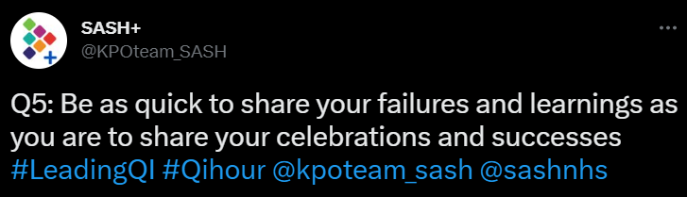
@Sutcliffe1987 shared that, “I think my other learning is that making people see the networks could do wonders for getting people to understand its importance, if its visible we can make it something we keep our focus on.”

Others Shared their Reflections & Showed Appreciation for the tweetchats…
@GHCQIHub shared that,
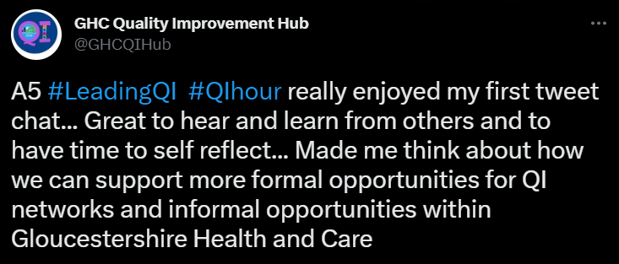
@WaRobbi shared that, “I want to be better about listening and reflecting. I also want to be part of future tweetchats as a way to build relationships, thank you everyone!”
@Sutcliffe1987 responded saying that,

@acserrao76 said, “It’s a reminder of the reason I love tweet chats, its sharing experiences, views, opinions in an open transparent honest way with no fear or care of judgement: here of my own free will, not because it’s work. It’s like having myself refuelled to keep.”
@KorthuisWa showed appreciation saying,
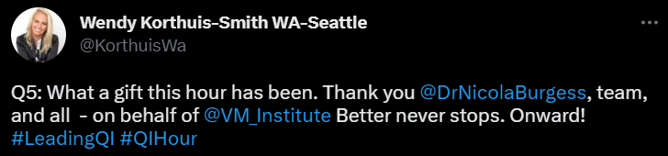
@Re__Thinking responded, “It's been great reading everyone's insights, lots to absorb. Really enjoying this one. Can we have another question please?! 😃
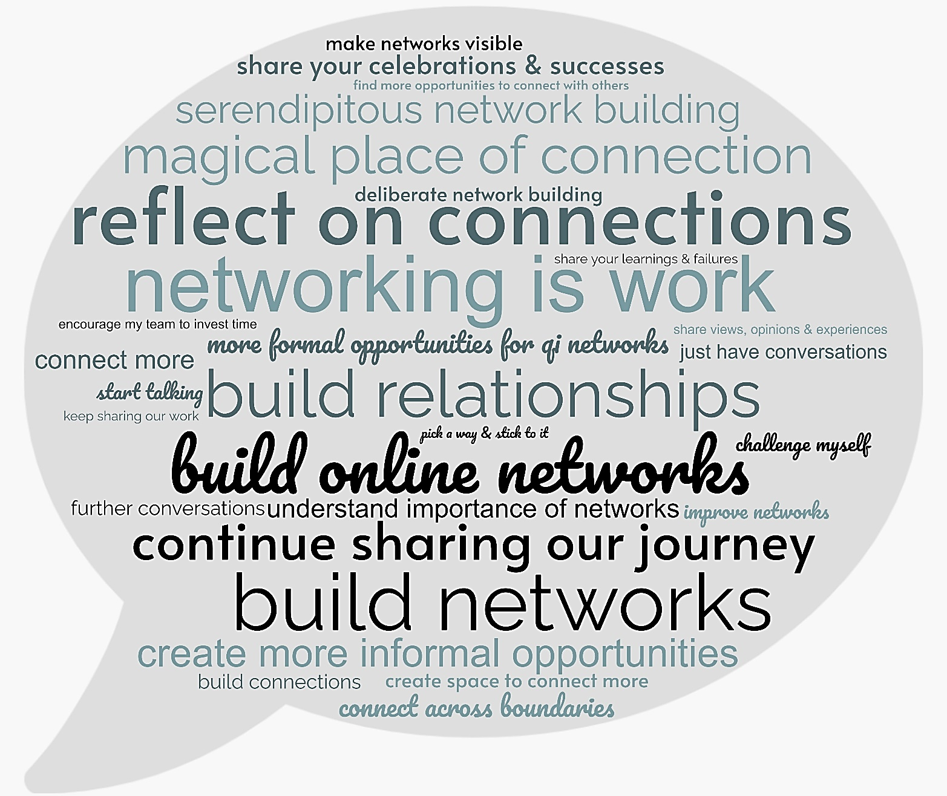
Figure 9: Question 5 Tweet Highlight Word Cloud

Coming Up Next…
Lesson 5:
The fifth tweetchat in this series will be held on Tuesday 6th June 2023 from 7-8pm BST.
A blog, Hold each other to account for behaviours, not just outcomes, written by Dr. Nicola Burgess has been posted to start the conversation.
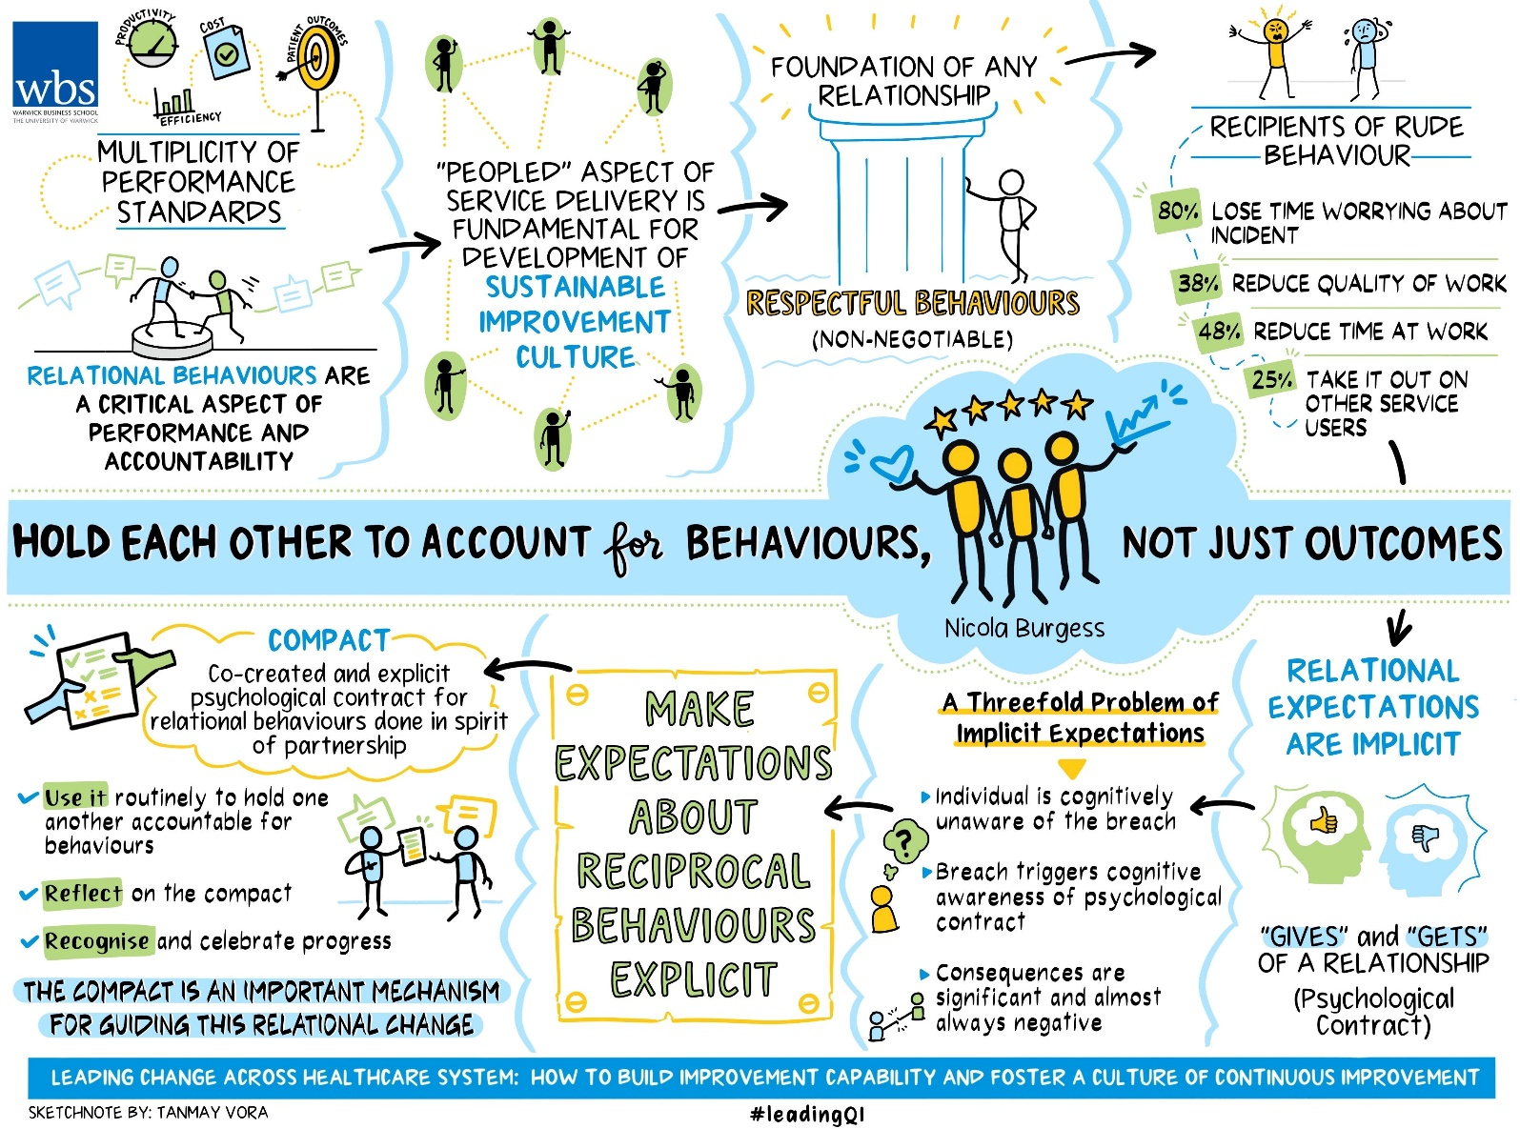
Figure 10: “Hold each other to account for behaviours, not just outcomes” Sketchnote by Tanmay Vora (May 2023)
Interview Invitation
Would you like to share your views on building improvement capability in healthcare teams, organisations and systems?
Please contact Dr. Nicola Burgess at Nicola.Burgess@wbs.ac.uk to arrange an interview.

Core Resources
Reports
- NHS-VMI Evaluation Report, Burgess N (2022), Warwick Business School, “Leading change across a healthcare system: How to build improvement capability and foster a culture of continuous improvement: lessons from an evaluation of the NHS-VMI Partnership”.
- Tweetchat Report, Waters, L (2022), “How to build improvement capability and foster a culture of improvement”.
- January Tweetchat Report, Rowe, E & Burgess, N, Warwick Business School, Lesson 1: Building cultural readiness as foundation for better QI outcomes.
- February Tweetchat Report, Rowe, E, Warwick Medical School, Lesson 2: How to build an effective infrastructure for improvement
- March Tweetchat Report, Rowe, E, Warwick Medical School, Lesson 3: Leaders light the path and show the way for others
Blogs
- Burgess, N (2022), Warwick Business School, “Six key lessons from the NHS and Virginia Mason Institute partnership.”
- Burgess, N (Jan 2023), Warwick Business School, “Build cultural readiness as the foundation for better quality improvement”
- Burgess, N (Feb 2023), Warwick Business School, “How to build an 'improvement infrastructure' in an organisation.”
- Burgess, N (Mar 2023), Warwick Business School, “Leaders show the way and light the path for others.”
- Burgess, N & Rowe, E (April 2023), Warwick Business School, “Why social networks are vital for continuous improvement.”
- Burgess, N (May 2023), Warwick Business School, “Hold each other to account for behaviours, not just outcomes”.

Follow #QITwitter for more from the improvement community.

Shared Resources
Shared by: | Resource:
@lilian_chiwera | 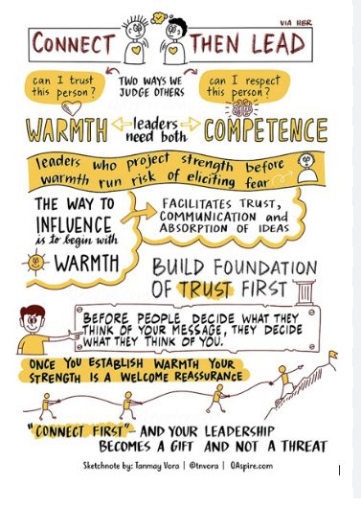
@HelenBevan
@PennyPereira1 | Five principles for implementing the NHS Impact approach to improvement in England
@PennyPereira1 | 10 principles at ‘the human heart’ of improvement: Tell us what you think
@FeedbackDave | Real-time feedback and micro-learning to turn everyday observations into better performance
@MichaelNHSE | NHS Impact is the new, single, shared NHS improvement approach.
@PennyPereira1 | Effective networks for improvement
@PennyPereira1 | Mapping Q: Social network analysis pilots, pitfalls and potential

Written by: This report was produced by Dr Emily Rowe for Warwick Business School.
Tools & Resources Used: The analytics are provided by Tweet Binder for the #LeadingQI and #QIHour hashtags during the period of the 25th-30th April 2023.

