Stacks and ladders:

A common-ground theory of (medical) decision-making

John Fox, Oxford University and OpenClinical

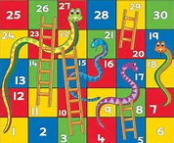
Decision-making is studied in many different fields, from medicine and economics to psychology and the social and management sciences, with key contributions from mathematics, logic and statistics, computer science and artificial intelligence, and increasingly game theory and neuroscience. I have argued that this diversity of thinking (about what decision-making consists of and methods for studying it) has resulted in “silo-isation” of the decision research communities, with the effect of hiding opportunities for understanding the common ground between theories of medical decision-making, and decision making generally.

Scope of the talks

The many silos within and around decision science can be roughly grouped into three broad research programmes: the empirical programme that is concerned with human decision-making in the lab and the field (behavioural theory); work on formal foundations and axioms of rational decision-making (prescriptive theory), and development of techniques and technologies for supporting and improving patient care (decision systems engineering). These perspectives all bring important insights for understanding decision-making, yet they also help to sustain the fragmentation of the field.

In these lectures I will introduce a way of thinking about medical decision-making that seeks to capture some of the common ground of the three research programmes, and discuss some of the practical and clinical benefits this brings.

1: The CREDO stack

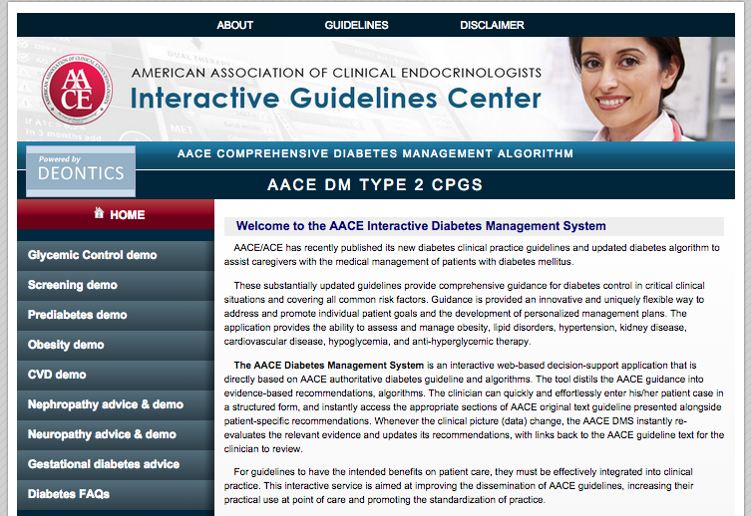
CREDO is a framework for understanding decision-making based on cognitive, formal and computational principles, and a “stack” of software for designing decision-making and AI systems. It has evolved through a long-term programme of empirical studies of clinical practice, attempts to unify theoretical concepts from different branches of decision science, and design of decision technologies based on the unified framework. CREDO has been used to design and deploy a wide range of clinical applications, from detection and diagnosis to treatment and long-term management in many medical specialties and clinical settings. This lecture will give an overview of the main concepts and results that underpin CREDO, and in particular a “common ground” or canonical theory of decision-making under uncertainty, and a technology for developing clinical decision support systems based on the theory. The talk will include demonstrations of decision support systems in oncology and endocrinology (internet access permitting).

2: The knowledge ladder

However well human brains, mathematical theories or computer software can effectively bring about rational decision-making the concepts that these paradigms offer are only a small part of the story. A medical student takes 5-7 years to acquire a body of medical knowledge about anatomy, physiology, biochemistry, genetics (etc etc) and a repertoire of expertise in clinical reasoning, problem-solving, decision-making, planning and strategies for efficient learning. Without a substantial (actually prodigious!) body of knowledge and the expertise to use it appropriately and efficiently theories of reasoning, decision-making, problem-solving and planning are of limited value in understanding medical decision-making.
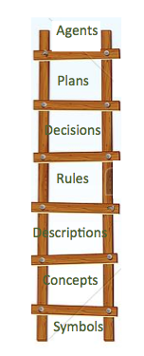
Decision science has tended to ignore knowledge, regarding it as mere content, of little theoretical importance. However, progress in biomedical informatics, AI and computer science is showing that knowledge is far more interesting than just a large collection of facts, numbers or other kinds of content. We now know that medical (all) knowledge has a systematic structure, with many layers of increasing complexity that define the meaning of concepts and determine the power of decision-making heuristics and versatility of expert strategies.

This talk will describe the knowledge ladder, an attempt to capture the structure of medical knowledge from concepts and facts to the kinds of decision-making and care planning strategies that medical students acquire and hone throughout their clinical careers. A repository of 50+ examples of the kind of structured expertise that clinicians may acquire and use in their practice can be found at http://www.openclinical.net. There will be a brief tour of the web site during the workshop but participants can look at the repository themselves and run some demo examples at http://www.openclinical.net/demos.html.

Background papers

- “Probability, Logic and the Cognitive Foundations of Rational Belief” J Applied Logic, 2003 http://www.sciencedirect.com/science/article/pii/S1570868303000132
- “Arguing about the evidence: a logical approach” in P David (ed) Inference, Evidence and Enquiry. https://www.researchgate.net/publication/235864520_Arguing_about_the_evidence_a_logical_approach
- “ A canonical theory of dynamic decision-making” Frontiers in cognitive science, 2013 http://journal.frontiersin.org/article/10.3389/fpsyg.2013.00150/abstract
- “Credo for decision science and engineering” draft at https://www.researchgate.net/publication/267512937_A_credo_for_decision_science_and_engineering
- “OpenClinical.net: A platform for creating and sharing knowledge and promoting best practice in healthcare” Computers in Industry, 2015 https://www.researchgate.net/profile/John_Fox5
- Safe and Sound: Artificial Intelligence in Hazardous Applications, AAAI and MIT Press, 2000.

Bio

I have learned a huge amount from lots of people. I trained as a cognitive psychologist with Donald Broadbent and John Morton in the UK, and then did postdoctoral research in the USA, on cognitive modeling and AI with Allen Newell and Herbert Simon and on visual perception with Ulric Neisser and J J Gibson. After returning to the UK I joined the Medical Research Council and established a programme of experimental and theoretical work on medical decision-making, and subsequently moved to Cancer Research UK to establish a cognitive-systems and AI laboratory. I have spent most of my career trying to understand principles that underpin decision-making and other aspects of cognition, and applied what I learned in the design and implementation of practical medical technologies and applications. These are reviewed in a book on AI safety with Subrata Das. I moved to Oxford University where I set up the OpenClinical.net knowledge-sharing project and this year was invited to become an honorary professor at Warwick University, in the Department of Statistics. I accepted enthusiastically!

