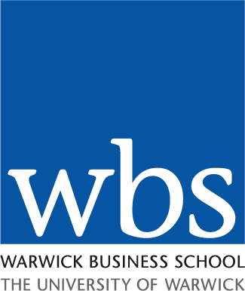 | ISM SEMINAR  Winter Term 2018-19

Speaker: |  | Hans Berends
Title: |  | STRATEGIZING AND THE INITIATION OF INTERORGANIZATIONAL COLLABORATION: A LONGITUDINAL STUDY OF DIGITAL INNOVATION IN AN AUTOMOTIVE COMPANY
Date: |  | 22.11.2018
Venue: |  | 0.009
Time: |  | 14.00 – 16.00
Abstract: |  | We explain how managers establish resource complementarity during their strategizing efforts for interorganizational collaboration. Based on a longitudinal field study of a digital innovation process at an automotive company, we show that resource complementarity is not given but jointly constructed in interactions with multiple potential partners through recursive cycles of what we refer to as “prospective resourcing.” Prospective resourcing mediates the interplay of strategizing and collaboration, thereby reversing the prevailing logic that strategy precedes and determines collaboration. Our findings offer insight into resourcing as a mechanism for developing strategic initiatives and shows how external actors may influence strategizing. The seminar will also reflect on the methodological challenges of longitudinal process research into collaboration for digital innovation.
Biography: |  | Hans Berends is Professor of Innovation and Organization at the Knowledge, Information and Innovation (KIN) Research Group, School of Business and Economics, Vrije Universiteit Amsterdam. He is an organization scientist with a background in philosophy and industrial engineering, and received a PhD from Eindhoven University of Technology for a dissertation on knowledge sharing in industrial research. His work has been published in leading journals including Academy of Management Journal, Organization Science, Organization Studies, Journal of Management Studies, Human Relations, and Journal of Product Innovation Management.  Hans Berends' current research focuses on the organizing of digital innovation. Many of his studies take process research perspectives, explaining the emergence and development of innovation over time. As innovation crosses the boundaries of organization, several studies are concerned with interorganizational collaboration, as well as new forms of collaboration enabled by digital platforms.
Contact: |  | Elaine Smith, ISM Group  elaine.smith@wbs.ac.uk  024 7652 3741  For forthcoming seminars please go to:  http://www2.warwick.ac.uk/fac/soc/wbs/subjects/ism/seminars/
 |  | This seminar has been organised by the ISM Group.

