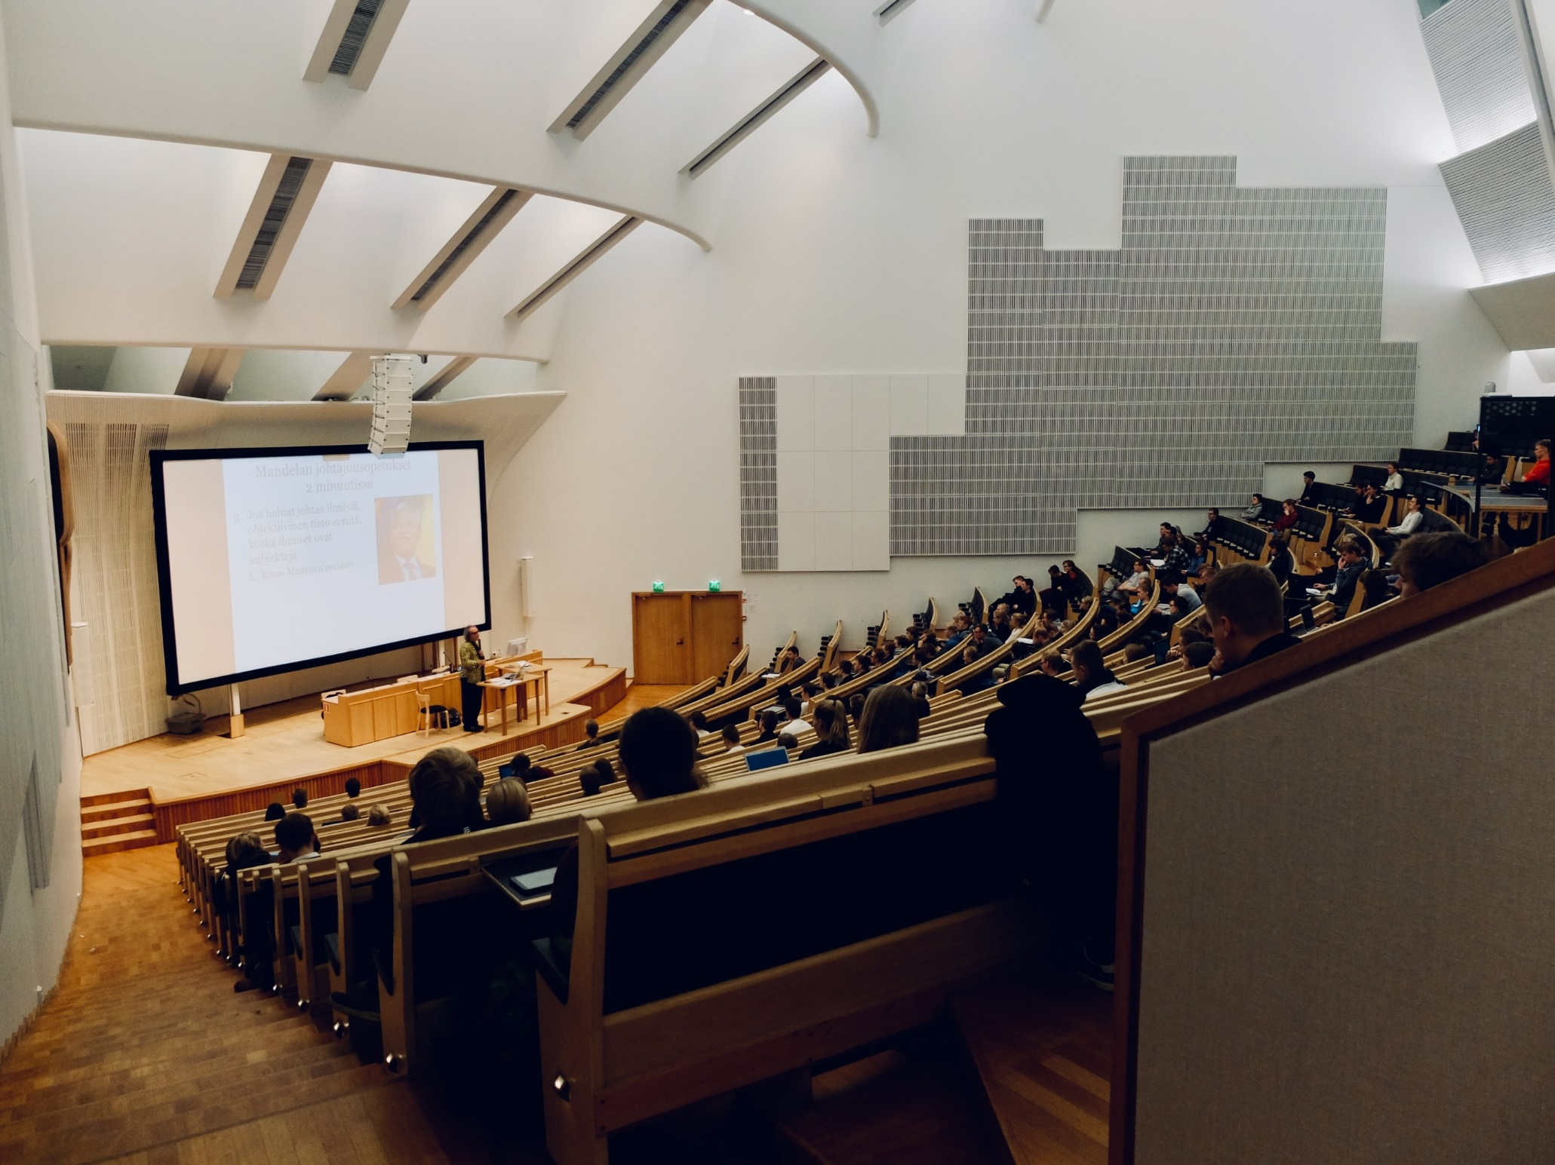

POLICY AND PRACTICE FOR DISABLED STUDENTS
Key takeaways from student and staff focus groups at the University of Warwick
summer 2022

Project team: Dr. Jagjeet Jutley-Neilson, Dr. Elena Riva, Dr Gemma Gray, Prof Felicity Boardman, Sophie Kitching, Robyn Ellison

Contents

Table of contents

Contents 2
Visual Summary 4
Introduction 5
Aims of the project 5
Project Design and Rationale 5
Project Delivery 6
Participants 8
Analysis of stakeholder meetings 8
Key takeaways: Themes 10
The existing structure of formal University support systems is too bureaucratic and reactive, placing an additional burden on disabled students. 10
Support is highly inconsistent within and between departments, and is largely reliant on a few dedicated staff members going above and beyond 13
A severe lack of disability awareness, understanding and training among staff members 14
The need for more information, clarity and transparency for students 15
One size does not fit all 16
Attitudes matter just as much as actions 18
Disability (not) in the curriculum 19
Case studies of good practice 20
Examples from staff workshops 20
Examples from student workshops 22
Appendix: Case study transcripts 24
Staff case studies 24
Student case studies 25

Visual Summary
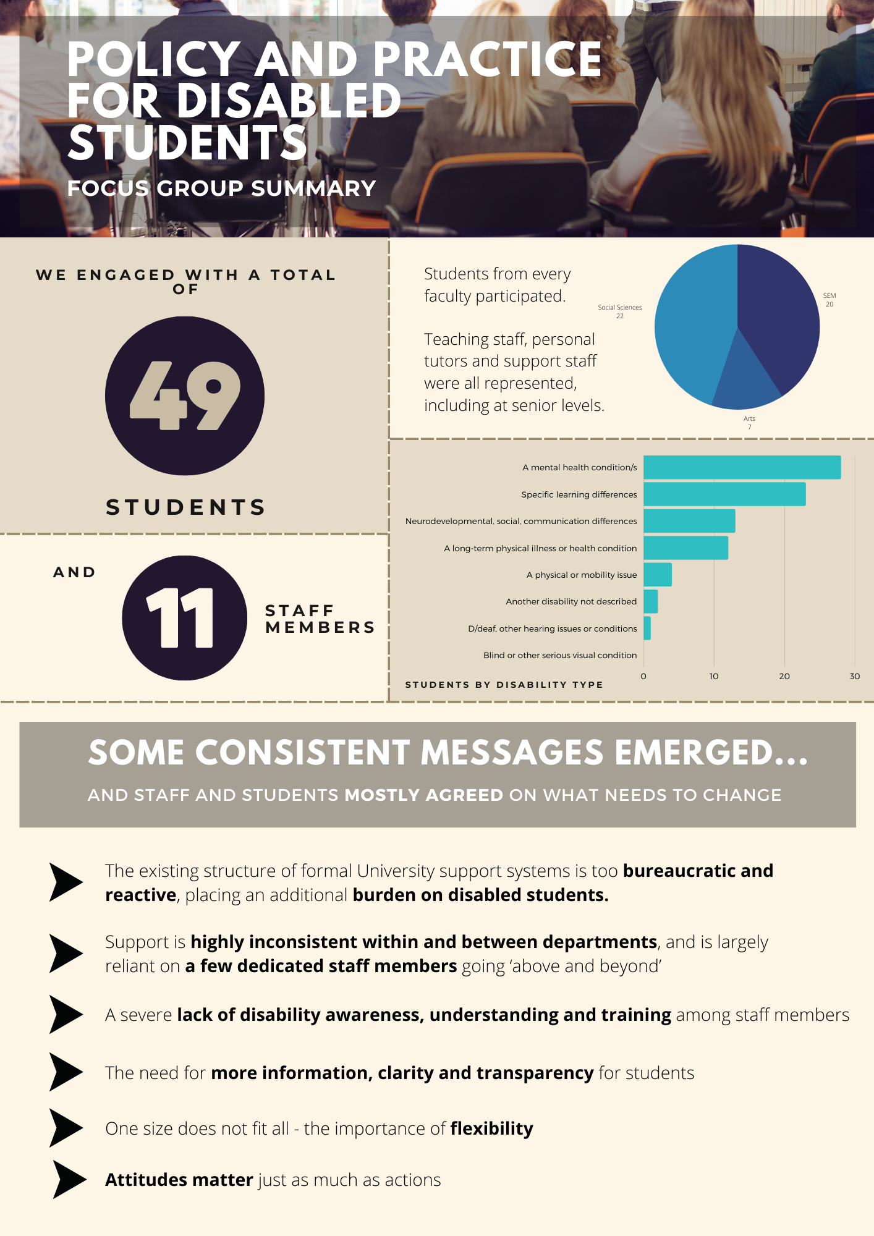

Introduction

Aims of the project
This project aims to provide content for a new code of practice to support disabled students in their academic learning experience and broader student experience across the University of Warwick, through engagement with disabled students and in partnership with other key stakeholders across the university, including academic and professional services staff.

Project Design and Rationale
A co-creative approach was adopted in keeping with the disability rights slogan, “nothing about us without us”. We ensured that disabled students would be centred not only as research subjects or beneficiaries, but through meaningful involvement, participation and collaboration throughout all stages of the project. The centrality of student voice is hence no accident, but rather a recognition of the expertise and varied lived experiences of those at the centre of this project.

Previous studieshave shown that co-creation approaches, including in higher education, allow opportunities for current issues to be explored and holistic, joined-up solutions to be developed. Therefore, for this code of practice, disabled students at the University of Warwick have been consulted and are at the heart of the co-produced project, as both project officers and focus group participants. Staff members, as the intended recipient of the guidance, have also been consulted and we were particularly keen from staff identifying as disabled or disability allies.

The project team had a variety of professional and academic interests in disability, as well as lived experience. This included disabled students and members of staff, as well as those with specific research interests in the area.

Project Delivery
To develop clear standards and suggestions of best practice for developing and delivering inclusive curricula, pedagogies and communities, workshops were held involving key stakeholders. Alongside disabled students at UG, PGT and PGR levels, this also included staff with expertise and/or interest in inclusive practice, including teaching staff, personal tutors, and support staff. Taking this stakeholder approach allowed further engagement with authentic student voice, enabled a better understanding of how current systems of support work in practice, and of the needs and experiences of staff supporting disabled students.

We conducted a review of existing codes of conduct across the higher education sector to identify key topics that would need to be covered. The apparent absence of student voice in these documents reinforced our decision to prioritise stakeholder engagement. Workshops were then designed based on these key topics, through a series of meetings of the project team.

The workshops lasted for two hours and were ran via Microsoft Teams. We ran ten workshops in the space of two weeks, with separate slots for UG&PGT students, PGR students and staff members. The decision was taken to separate participants into three separate categories for a number of reasons. Firstly, PGR students were separated from UG and PGT students to allow a better discussion of the unique aspects of their student experience; UG&PGT workshops tended to focus on topics including experiences of teaching and assessment, which would have been less relevant to students with a research focus. Staff also took part in specific workshops separate from any students, giving them a safe space for reflection to encourage honesty and transparency. For similar reasons, student workshops were run by student members of the project team, without a staff presence, while staff workshops were facilitated by other members of staff.

For the students, the workshops consisted of three sections coined past, present, and future. For the first section, past, the students were asked to map their student journey on Padlet individually, responding to prompts relating to key moments in their time as a student at Warwick, from the applications process through to graduation and beyond. Then for the ‘present’ section, the group was supported to discuss key topics they felt either had shown good practice while they were being supported at university, or where they felt they had been let down. Broad discussion prompts related to topics including assessments, reasonable adjustments, and staff support, and more detailed follow-up questions were asked as appropriate to explore issues raised in more depth. Finally, to finish the workshop, the students were split into smaller groups in breakout rooms to discuss their ideas for change and produce as a group their vision of an ideal future for disabled students at Warwick, again recording their discussions on a Padlet board.

The workshop structure was identical for both the UG/PGT workshops and those for PGR students, although there were minor changes to prompts to better reflect differences in student journey and experience.

The staff workshops were slightly different, but still held the three-part structure. Staff were asked to reflect on their role and how they may currently support disabled students, followed by a group discussion of some of the issues raised and responses to prompts relating to different aspects of student support. Finally, the staff completed the same ‘designing change’ activity as in the student workshops.

Participants who could not attend a live workshop were able to participate asynchronously by completing a questionnaire via Microsoft Forms. This also improved accessibility for students who may find group situations challenging, or prefer written communication over verbal expression in the workshops. The form had the same structure as the live workshops, with broad prompts that allowed students to write as much or as little as they felt necessary in response to the prompts. It was notable that there was far better engagement among PGR students with the asynchronous form than in workshop attendance, perhaps due to scheduling constraints.

Notes were taken from both the live workshops and the form submissions using Padlet to capture participants’ contributions. Some student workshops were recorded with participants’ consent, to aid memory and notetaking. Staff workshops were not recorded, to encourage greater honesty in a safe environment with a reduced risk of repercussions for any more critical feedback.

Participants
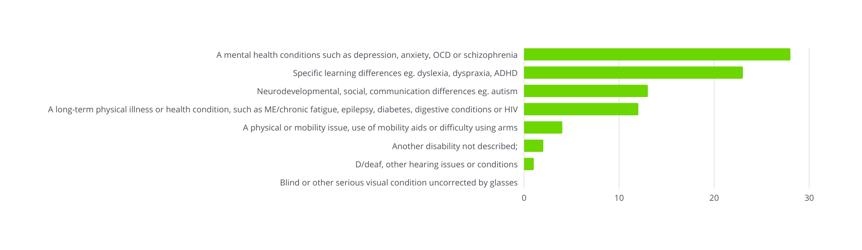
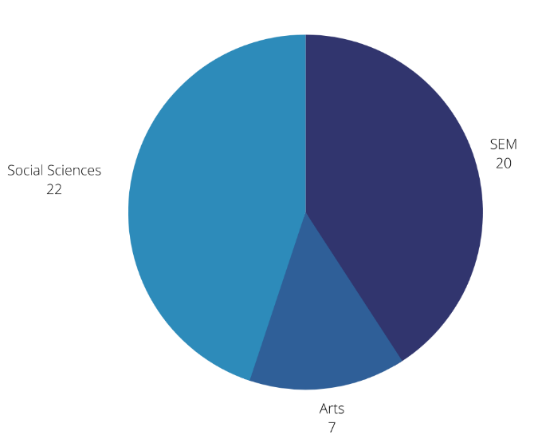
Overall, we engaged with 49 students and 11 members of staff, from faculties and departments across the University (see figure 1). A variety of disability types were represented, across all categories used by the University other than ‘Blind or other serious visual condition uncorrected by glasses’. The most common disability types were mental health conditions and specific learning differences. It was also notable that most students identified with two or more different disability types. Figure 2 displays participant numbers by disability type.
Figure 2 - students by disability category
Figure 1 - students by faculty

Analysis of stakeholder meetings
Similar ideas and concerns were raised by all participants groups, and a number of consistent themes and ideas emerged from the workshop discussions and form submissions. We also extracted case studies of good practice from the Warwick community to include in the finalised code of practice to support and inspire staff in practically implementing change.

Project team and contributions to work

Dr Jagjeet Jutley-Neilson was the principal investigator for this project; they prepared and submitted funding applications to IATL. Dr Elena Riva, Dr Gemma Gray, and Professor Felicity Boardman contributed to the design of the project, edited the funding bid application and contributed to the regular project update meetings.

Sophie Ellison and Robyn Ellison designed the stakeholder meeting questions and processes, which were then further co-produced by the whole project team. Sophie Kitchen and Robyn Ellison ran the student stakeholder meetings and Dr Jagjeet Jutley-Neilson ran staff stakeholder meetings. The conversations from the stakeholder meetings were analysed by Sophie Kitching and were reviewed by Dr Jagjeet Jutley-Neilson and Robyn Ellison.

Robyn Ellison created the animations for the case studies. Sophie Kitching and Robyn Ellison prepared the infographics. Sophie Kitchen prepared the draft and final project report, which was then reviewed by Dr Jagjeet Jutley-Neilson. The whole project team then reviewed the final project report before it was submitted to the IATL web pages.
We are grateful for the funding received from IATL for this project.

Key takeaways: Themes

The existing structure of formal University support systems is too bureaucratic and reactive, placing an undue burden on disabled students.

Many students described the administrative burden of organising and accessing support and adjustments for their disability, with one participant explaining that it felt like “completing a second degree”. Students felt that they had to take on significant responsibility for navigating bureaucratic and complex systems, with, paradoxically, the most effort required when they needed the most support and had the least capacity for the additional workload. This was considered to be an unfair responsibility above that of non-disabled peers, and a barrier to accessing support. The negative impacts of this administrative burden on disabled students are well-understood, and this therefore presents itself as a critical focus for reform.

The process of disclosing their disability and accessing reasonable adjustments was found to be a particularly common challenge. This issue of continuous disclosure is unfortunately far from unique to Warwick, having been identified by students at institutions across the UK. Here, students described having to disclose ‘over and over again’ to different people, and it appeared that communication links between support services and departments were sometimes ineffective, particularly for students on joint degrees. Both staff and students agreed that information about reasonable adjustments was rarely effectively disseminated to other staff members such as lecturers and personal tutors. Staff were therefore often unaware of a student’s disability unless directly informed by the individual student, which was considered frustrating for both parties. This failure in communication meant that there were a considerable number of examples where students’ reasonable adjustments had not been implemented by their department, leading them to feel forgotten and ignored, and in some cases to wonder whether this may have been a deliberate omission. Students described having to email every single tutor at the start of each term, and needing to regularly remind staff when they required particular adjustments, often in response to problems that could have been avoided had adjustments been implemented from the start. Both staff and students agreed that, where the student has consented, it would be useful to have more disability-related information accessible in Tabula, and clearer guidelines for staff on how this kind of information can be shared in compliance with GDPR.

The ‘multiple disabilities’ label on Tabula was heavily criticised as offering no useful information to staff on students’ needs. It was suggested that information on reasonable adjustments could be made accessible to relevant staff members on a student’s Tabula profile to enable them to provide better and more consistent support.

Several students suggested that the Disability Team seemed to lack real power, and were frustrated by their apparent inability to enforce recommendations. Students felt that departments seemed to be able to ignore reasonable adjustments with no consequences. Similarly, students frequently reported encountering disability-related study issues and approaching the Disability Team for assistance, only to be told that the issue could only be resolved by their department, who also appeared unwilling or unable to change. This experience of being passed around with no successful resolution seems to suggest that reform to the relationship between, and relative powers of, academic departments and support services could make a significant difference to students’ experiences.

Staff members also highlighted concerns around the separation of central support teams and academic services, creating a divided system where departments are rendered powerless to meaningfully support disabled students beyond recommending that they get in touch with the Disability Team. We suggest that there should be movement towards a more unified and collaborative system where academic departments and pastoral services communicate closely and work together for students rather than in accidental opposition, but where the Disability Team also have increased powers to compel departmental change and compliance.

The lack of pre-university support for disabled applicants emerged as a concern in all the workshops. Students reported having no support or adjustments made to the application process or admissions interviews, despite having declared their disability to the university. It was also felt by both staff and students that more effort could be made to consider disability when planning open days. Several students felt that the crowded and noisy environment was inaccessible, and some had left with a perception that, beyond the presence of the Disability Team, very little effort had been made to welcome disabled prospective students. More specific events for disabled students, quiet hours for information fairs, chances to speak to current disabled students and better consideration of those with mobility needs with regard to campus and accommodation tours all emerged as potential improvements.

A considerable number of student participants had not identified as disabled prior to joining university. This was particularly common among autistic students, those with SPLDS and those with mental health conditions, all of which were often only identified/diagnosed later into their time at university. Often, these students had struggled significantly prior to their diagnosis, and would likely have benefited from earlier disability support. Several participants were also still awaiting a diagnosis, and noted that it was very difficult to access any support while in this situation, feeling that they had “fallen through the gaps” despite their needs being identical to students with diagnoses. Given the significant barriers to diagnosis for many disabilities – with long waiting lists or costly private alternatives – needs-based support for disabled students without a formal diagnosis seems to be a clear area for improvement.

There was a general feeling that support services were underfunded and understaffed. Students felt that waiting times to get appointments could be too long, and described situations where they had been left waiting for responses to urgent messages to the Disability Team. Mental health support through CAPIT was also raised as an issue by some students, with long waiting lists and some students who felt that they were being “pushed out the door” to make space for others, despite needing more support. CAPIT was also criticised by some for lacking familiarity with disability beyond mental health, and being unable or unwilling to adapt their approach for neurodivergent students or those with energy-limiting conditions.

Finally, while it was felt that support had been improving over time in many ways, including support for international students ineligible for DSA, there were significant concerns among both staff and students over elements of support that were being reduced or withdrawn. In particular, the removal of the Residential Life Team was discussed as a significant step backwards for disabled students, and a concern for several participants.

Support is highly inconsistent within and between departments, and is largely reliant on a few dedicated staff members going above and beyond

While there were certainly some workshop participants who had had great experiences as disabled students at Warwick, there was a notable tendency for these students to identify themselves with vocabulary relating to ‘luck’ and ‘fortune’. Even these students who had themselves been well-supported usually knew friends in other departments who had faced very different experiences, and usually considered their own experiences as an anomaly within a wider picture of inadequate support.

Over the course of the workshops, it became clear that support for disabled students is extremely inconsistent, with some departments performing better than others. This was also noted by staff working in support services, who felt that there were often dramatic differences in the implementation of the same reasonable adjustments across departments, and similar differences in student experience.

Inconsistency between experiences within the same department was also noted, usually due to a particular member of staff going ‘above and beyond’ their role to support disabled students. Often, students cited their personal tutor as this exceptional figure, consistent with previous research indicating the centrality of the personal tutor relationship in support and liaison with other university bodies. Indeed, personal tutors featured heavily in discussions of staff support, both positively and negatively. The personal tutor relationship seemed to be very important to students, and a supportive personal tutor was able to make a significant difference to a student’s overall experience. Better disability training for personal tutors, and more consistent expectations for the personal tutor relationship across departments could therefore be suggested to establish a stronger baseline level of departmental support for disabled students.

Designated departmental disability reps were suggested by both staff and students as a potential reform to improve support and increase consistency. Some departments have already introduced this, and it has been well-regarded from both staff and student perspectives. Similar recommendations have also emerged from previous research exploring the needs of disabled students.

Having such a named representative would give students a clear point of contact for any issues, who would presumably be guaranteed to be supportive, better trained, and much more aware of disability-related concerns than other staff members. This person would also be well-placed to champion disability and advocate for disabled students more widely within the department. Due to workloads and time constraints, some staff suggested that EDI efforts have a tendency to become a “zero-sum game” where issues are worked on in silos and a focus on one EDI area leads other areas to be forgotten – a strong voice for disability in every department would ensure that consideration of disabled students is at the heart of every policy decision. With growing diversity in the student body, greater consideration of intersectionality is crucial to improving student experience.

A severe lack of disability awareness, understanding and training among staff members

Student participants felt that many staff members lacked understanding and awareness of disability, and this was raised as the underlying issue behind several more specific complaints. Several students described having felt humiliated by staff members for their access needs, usually in situations where a lecturer or seminar tutor publicly challenged a behaviour they determined to be ‘odd’. Students felt that some staff members were reluctant to discuss disability at all, and wondered whether this could be linked to a fear of ‘saying the wrong thing’. Others used vocabulary that was outdated, or that the student considered to be offensive. Some students also highlighted situations where staff members had been reluctant to provide reasonable adjustments, based on flawed understandings of equality and equity as synonymous.

Many students felt that marking labels attached to coursework were not always considered by markers, still receiving negative feedback on disability-connected issues that should be ignored. For example, one dyslexic student described consistently receiving negative feedback criticising their grammar and the structuring of their work, despite attaching marking labels intended to make assessors aware of their disability. Staff members discussed how it can be difficult to know what to do with work that has a marking label attached, as they are not familiar with the impacts of every disability on different types of work. The marking guidelines provided by the Disability Team were generally considered to be insufficient to enable them to fairly mark work by disabled students.

Students also felt that staff lacked understanding of exam arrangements and were usually unable to answer questions on this topic. This was considered to be particularly problematic when invigilators seemed to lack training on the implementation of adjustments such as rest breaks, leading to cases where students’ exams were not correctly administered. Staff had noted similar issues, particularly among graduate students working as invigilators, and among GTAs more generally, who appear to have very minimal training.

Students mostly agreed that staff usually had good intentions, but were not always equipped to be able to offer effective support. This was reflected in comments from staff themselves, many of whom expressed a desire for greater access to training and materials to enable them to better support their students. It was commented that, despite wanting to make their teaching more accessible, it was not easy to find materials to assist them in doing this. There was a general consensus that the information provided by the University (such as on the Disability Team’s website) was not particularly helpful, with the website described as confusing and difficult to navigate, with lots of broken links and duplicate/ out of date information making it challenging for staff to find helpful resources. This extended to concerns over a lack of knowledge about the support available for students; many staff wanted to be better informed to be able to more effectively signpost students to the best source of support. Alongside better and more easily accessible information, most staff were also supportive of introducing compulsory awareness and training sessions. Chances to talk to and learn from current disabled students were also highlighted as having been of particular help and interest, and something that staff would like to see more of.

The need for more information, clarity and transparency for students

Unclear, confusing and difficult-to-find information also presented problems for students. Participants discussed difficulties in finding out about the support that was available, and in determining what might be most suitable for them, as well as receiving conflicting information from different sources that made the process more time-consuming and left them unsure on next steps.

Students reported particular difficulty in finding out about reasonable adjustments, both with regard to what might be available to them and then later in relation to how they work in practice. It seems that aiming for a flexible approach that works on a case-by-case basis might actually be confusing and deter some students from reaching out for support. Although there was recognition that it would be impossible to provide a ‘standard list’ of adjustments, students felt that it would be helpful to have clearer guidance on what they might be eligible for. For those with adjustments already in place, several students wanted to see clearer information on their use. For example, there appeared to be some confusion and inconsistency around how ‘flexibility with deadlines’ worked in practice.

A similar lack of clarity was reported in relation to several other university processes frequently used by disabled students, particularly the mitigating circumstances system, and the arrangements for temporary withdrawal and subsequent return.

Students also felt that there was a need for better information on disability support prior to starting university, and even prior to applying. Many students eligible for support may not necessarily identify with the term ‘disability’, may not have received support prior to university, or may be undiagnosed at the time of application – for example, research at one Australian university found that 1/3 of students who received disability support during their course had not identified as disabled at enrollment. Our participants in all of these groups felt that they had not received any information about the support that might be available, and many did not even realise that it existed at all. It seems that wider discussion around university disability support in sixth forms and colleges, and at open days, could be productive in informing many eligible students about the support they could access, rather than students needing to discover it themselves at a crisis point. Students also suggested that there could be changes to messaging around university that focusses on poorly-defined rhetoric of ‘independence’ and ‘self-reliance’, to avoid unintentionally dissuading disabled potential applications.

One size does not fit all

Several students felt that reasonable adjustments were too often thought of as both the starting point and ending point of support for disabled students, when in reality a much broader consideration of the nature and structure of higher education is needed.

There was a general feeling that the structure of many courses fails to account for the needs of disabled students. The intensity of study and assessment was widely critiqued; several students with mental health conditions and chronic illnesses felt that exam season was often a direct contributor to a decline in their health, and there were concerns over the fairness of judging someone’s academic ability based only on their performance in a very short timeframe in which a student may be unwell or experiencing a flare-up or relapse. Among students from the SEM faculty, the lack of a Reading Week was highlighted as a particular concern, meaning that students had little opportunity to rest (as well as to reflect and assimilate knowledge), and contributing to burn out and worsened health for many.

Other particular issues were raised in relation to courses that involve study abroad or work placements. These often failed to appropriately accommodate disabled students, and students felt there was little recognition of the need for support and flexibility. Several students expressed that they had chosen not to take part due to accessibility concerns, or had encountered difficulties if it had been a compulsory part of their course. For example, worries about taking a year abroad related to potential differences in countries’ awareness of and support for disability and mental health conditions, the challenges of moving away from support networks, differences in access to/ continuity of healthcare, and the particular impact of a language barrier in accessing support, even if the course itself was taught in English. For students considering a work placement, there appeared to be an absence of support in finding and securing a placement that would be accessible and welcoming. Students also reported a lack of adjustments to aspects including the number of hours required to complete compulsory placements.

Finally, it is worth noting that students raised a variety of different and opposing concerns and preferences regarding study and assessment. Some students found online lectures to be very difficult to access, whereas others found them to be much more accessible than their in-person equivalents. Some students found heavily weighted exams to be a particularly difficult form of assessment and preferred the flexibility and different formats of coursework, whereas others found coursework challenging and preferred exams as a more accessible option. Some students can’t access verbal assessment methods like presentations and vivas, while others find them much more accessible than written assessments. These differences indicate the importance of overall flexibility and choice; it is impossible to design a universally accessible course, but the more choice students have over how to engage and how to be assessed, the more likely it is that there is an accessible option. In particular, students would like to see more choice of assessment methods, and Universal Lecture Capture across all modules and departments. It is worth noting that the latter recommendation is also a long-standing policy for Warwick Students’ Union.

Attitudes matter just as much as actions

Students expressed concern that underfunded and overly bureaucratic systems for accessing support have further consequences beyond just presenting practical obstacles. One student explained that they feel that “empathy often gets lost in bureaucracy”, and staff become over-focussed on directing students through complex formal support processes and forget about the importance of their own non-practical support. Another student described how they often just want a listening ear, but are instead confronted with escalation through formal processes, with accompanying forms to complete and a list of people to contact. Some students feel that they can end up classified as a condition to be dealt with rather than a person to be supported; disclosing person details or challenges results in a single-sentence response that may resolve the practical query but fails to show care or humanity.

Similarly, there appears to be a general perception among many students that the university does not want to genuinely listen or change, but rather to do as little as possible to resolve the ‘problem’. Several students shared experiences of being made to feel like a ‘nuisance’ for raising accessibility issues, or feeling ‘blamed’ for their disability or needs. Some staff shared similar views of university leadership, feeling that money and reputation are valued above real support for students. Staff and university leadership should think carefully about how their actions, or lack thereof, may be perceived and, if such interpretations are untrue, take action to demonstrate their genuine support to win back trust from the disabled community and its allies.

Disability (not) in the curriculum

There appeared to be general concerns over how disability is, or is not, taught as part of course content. This arose across multiple departments and faculties.

Disability is often not discussed even when issues of race, gender, class and sexuality are considered as integral parts of the course. When students are taught about disability, it is often within the framing of the medical model and outdated concepts and terminologies – and with a tendency to forget or ignore the fact that disabled people will themselves be in the room and studying the content.

Some departments, courses and lecturers do appear to teach disability well, but these are noted as exceptions. Students would like to see equal weight given to disability justice alongside other issues of inequality, and modernised teaching content that is developed and delivered in partnership with paid disabled educators.

Case studies of good practice

Examples from staff workshops

For a visual representation of some of the case studies, click here. A transcript is available in the appendix.
“I make sure to encourage a dialogue with my students. For example, I look up each tutee and check if they have disclosed a disability. I then reach out to suggest a one-to-one to chat. I also encourage all students to come and have a chat about how they’re getting on or if there’s any advice they need – I bring this up quite regularly in group meetings (especially at the start of term or in the run-up to reasonable adjustment deadlines). I try to make sure I have one-to-one chats with every tutee.”
Please note, all the case studies are paraphrased for clarity and are not direct quotes.

Case study 1

This example of inclusive practice to support disabled students came from a personal tutor.

This is a great example of good practice because:

- The staff member is taking the initiative to check student profiles and make sure they are aware of any disclosed disabilities.
- They are aware that not all students will have disclosed their disability (or necessarily even be aware of it), and make sure to extend support to all students rather than just those registered with the Disability Team.
“As a department, we have a specific member of staff whose role includes responsibility for inclusive pedagogy. This ensures that inclusion isn’t dependent on a member of staff taking on the work in their spare time, and allows teaching staff to have the information and resources to be able to make their teaching more accessible.”
- By engaging with students regularly and on a one-to-one basis, they are building rapport and encouraging students to be comfortable discussing their needs.

Case study 2

“We’ve started to run specific events for disabled students in the department, on topics like employability. We work with student societies like Enable to promote them to students.”
This is good practice because:

- It ensures that inclusive pedagogy is always considered
- It reduces the reliance on staff going ‘above and beyond’
- It increases the likelihood that intersectionality will be considered, as one person is working across the broad area, rather than individual staff members working within silos of knowledge.

Case study 3

This is an example of good practice because:
- There is a specific offering for disabled students, acknowledging they make have specific concerns and that one size does not fit all
- There is collaboration with disabled student groups, seeing them as partners rather than opposition and valuing their contributions

Examples from student workshops

It is notable that all three case studies identified from student workshops focus on staff members that were willing to listen to students, and be flexible to take appropriate action to resolve student concerns.
“My lecturer kept sending out material that was really difficult for me to access because of my dyslexia. I sent them an email to explain the issue. They then changed the format to make it more dyslexia-friendly – this made a big difference to my learning.”

For a visual representation of the case studies, click here. A video transcript is available in the appendix. Please note, case studies have been paraphrased for clarity, and names have been changed.

Case study 1

Case study 2

“My personal tutor sends me regular informal check-in emails – things like ‘Hi, how’s everything going?’. This makes me feel like they really care about me, and made me feel a lot more comfortable disclosing when I was struggling. They know to reach out more when I’m quieter because that’s when it makes the most difference. It really helps me.”
Case study 3
“There was a significant assessed presentation coming up in my course. I was worried, because I struggle with presentations, and it would have had a big impact on my grade. I contacted my department about my concerns. Their response was to give me – and all other students – the choice between doing a live presentation or pre-recording a video. They’ve even decided to keep this for future years of students!”

Appendix: Case study transcripts

Staff case studies

Transcript:

Slide 1: Introduction slide titled, “Case Study of Good Practice: Staff Department” with three animated characters discussing and on their laptops underneath.

Slide 2: Animated character to represent the staff member with title above reading, “Meet this staff member at the University of Warwick”. Change of text to, “They shared their example of good practice”

Slide 3: “I hope to encourage a dialogue between myself and the students” – quoted from the staff member, showing them as the same previous animated character.

Slide 4: “For example, I look up each personal tutee and see if they have a disclosed disability and then reach out to suggest a one-to-one chat with them” – continued quote from staff member, depicting them as an animated character as previously seen sat at a desk with emails popping up around the computer.

Slide 5: Depiction of tutor meeting with four tutees and the staff member as animated characters with the text: “but I also say every so often in group meetings (especially at start of term, or in run up to reasonable adjustment deadlines)” “and encourage all students to come and chat about how they are getting on, if there is any advice they need”

Slide 6: “This is a great example of good practice because:

- The responsibility for discourse is taken by the staff member rather than the student

- Support is also emphasised in a group setting to those students who may not have disclosed their disability

- Offering support around key times eg. start of term, around the reasonable adjustment’s deadline.”

Student case studies

Transcript:

Slide 1: Introduction slide titled, “Caste Study of Good Practice: Students” with three students depicted with animated characters.

Slide 2: “Meet; Sara, Eva and Zack” with each animated character popping up with each name. Then text writing, “they shared their experience of good practice at the University of Warwick” appears.

Slide 3: Introduces Eva on her laptop with an animated character of her teacher. The slide reads, “She received informal check-in emails from her tutor” “This allowed Eva to feel cared for and more comfortable to ask for help”

Slide 4: Introduces Zack with an animated character of his tutor. The slide reads, “Zack explained to their lecturer that the current material was not dyslexic friendly”

Slide 5: Continued from last slide with the animated character of the tutor, aside of the text, “Therefore, the lecturer changed the format to make it more accessible, not just for Zack, but for all the students”.

Slide 6: Introduces Sara, with her animated character at a desk with a laptop. The slide reads, “She contacted the department because she was struggling with the upcoming assessed presentation”

Slide 7: Continued from Sara’s case study reading, “The department responded by giving ALL the students a choice between a live presentation or a pre-recorded video” and “They also decided to keep this accessibility in the future.”

Slide 8: Summary slide titled, “Key Take Aways:”

Each example listened to their students:

- Listen

- Act

Not all students may disclose their disability or have an official diagnosis, therefore, extending accessibility for all is creating a better environment for all disabled students.

Mollie Dollinger, Jason Lodge, and Hamish Coates. "Co-creation in higher education: Towards a conceptual model." Journal of Marketing for Higher Education 28, no. 2 (2018): 210-231.
Universities UK. 11 March 2018. “Minding Our Future: Starting a Conversation about the Support of Student Mental Health” Universities UK. Accessed 14th August 2022. https://www.universitiesuk.ac.uk/minding-our-future
Pennie Frow, Suvi Nenonen, Adrian Payne, and Kaj Storbacka. "Managing co‐creation design: A strategic approach to innovation." British journal of management 26, no. 3 (2015): 463-483.
Tim Coughlan and Kate Lister. "The accessibility of administrative processes: Assessing the impacts on students in higher education." In Proceedings of the 15th International Web for All Conference, pp. 1-10. 2018.
Lynne Kendall. "Higher education and disability: Exploring student experiences." Cogent Education 3, no. 1 (2016): 1256142.
Angela Jacklin and Carol Robinson. "What is meant by ‘support’ in higher education? Towards a model of academic and welfare support." Journal of Research in Special Educational Needs 7, no. 2 (2007): 114-123.
Elyse Wakelin "Personal Tutoring in Higher Education: an action research project on how improve personal tutoring for both staff and students." Educational Action Research (2022): 1-16.
Sarah Holloway. "The experience of higher education from the perspective of disabled students." Disability & Society 16, no. 4 (2001): 597-615.
Donna Couzens, Shiralee Poed, Mika Kataoka, Alicia Brandon, Judy Hartley, and Deb Keen. "Support for students with hidden disabilities in universities: A case study." International Journal of Disability, Development and Education 62, no. 1 (2015): 24-41.

