Global Research priorities (GRP) in International Development,
Postgraduate conference 2016/2017
CHALLENGING LANDSCAPES OF GENDER IN/EQUALITY
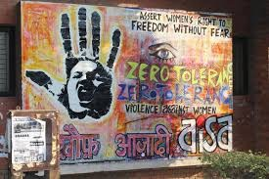
15 June 2017

- CONFERENCE PROGRAMME
- Conference Programme
- GRP International Development Annual Lecture
- GRP International Development Photography Competition winners 2016 - 2017
- CONFERENCE PAPERS
- USEFUL INFORMATION
- About GRP International Development
- About the Venue
- How to get to the University?
- Contact

- CONFERENCE PROGRAMME
Oculus, Room R.001
9.00am-9.30am: Registration and coffee/tea
9.30am-11.00am: Panel I - Gender, markets and women's economic empowerment
11.00am-11.15am: Tea/Coffee
11.15am-12.45pm: Panel II - Gender, rights and identity
12.45pm-1.30pm: Lunch
1.30pm - 1.45pm : Relaunch of LGD Journal
The Journal of Law, Social Justice and Global Development (LGD) is an innovative online journal dedicated to critical analysis on topics related to the impact of globalisation on social justice with a focus on interdisciplinary approach. The Journal carries double blind peer-reviewed articles and is supported by an International Advisory Board.

1.45pm-3.15pm: Panel III - Gender and policy from local to global perspectives
3.15pm-3.30pm: Tea/Coffee + Practical Academic Advice Quick Session
3.30pm-5.00pm: Panel IV - Gender, security and GBV

Oculus, Room R.004
5.30pm-6.30pm:
GRP International Development Annual Lecture 2016 -2017
Dr Uma Chakravarti - Oppositional Imaginations: Resisting the Violence of Normal Times
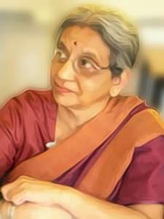
Chaired by Prof Shirin Rai

Drawing upon personal engagements, fractures based on caste, and queer critiques of the women’s movement, Prof Chakravarti will speak on the women’s movement in India since the 1980s: its early interventions in resisting violence against women in ever expanding circles from the home outwards to the streets to the fields to the borders where violence was perpetrated. This will be framed within the larger backdrop of the international women’s movement but also the South Asian women’s movements from the 1980s to the present.

6.30pm-6.45pm:
GRP International Development Annual Photography Competition: Gender and Development winners 2016-2107
The GRP International Development photography competition is open to any University of Warwick student or staff member. We are looking for photographic images that address the annual research theme: ‘Challenging Inequalities, Transforming Gender Relations in the 21st Century’. We received over 40 entries this year. They included visual studies and imagery about representations of gender, interactions and inequalities between men and women, the graduations, fluidity or changes in gender and our understanding of gender, the places and spaces where gender is foregrounded or made problematic, the legality or politics of gender, development organisations that focus on women’s empowerment, or gender respect and understanding, … We will present the winning photographies after the annual lecture.

6.45pm - 8.00pm: Drinks and buffet dinner reception with networking

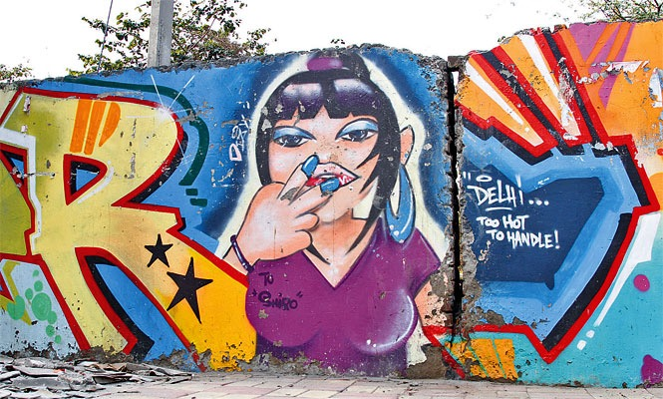

2. CONFERENCE PAPERS

Panel I - Gender, markets and women's economic empowerment, (9.30am-11.00am)
Chair : Prof. Ann Stewart

1. Shepherd Mutswiri (SOAS, University of London)
Gender inequality in the post land reform era in Zimbabwe

NGOs currently working in Zimbabwe are facing a huge stumbling block in their attempt to improve the livelihoods of rural women. This is because the main challenge that needs to be addressed is the deadlock between the U.K. government and the Zimbabwean government after the land reform in 2000. The sanctions imposed on Zimbabwe have had a negative impact on Zimbabwe and on the lives of rural women.

My research and experience inspired me to implement practical ways that can make a positive contribution to gender inequality for rural Zimbabwean women. Four SOAS students and I started an NGO called Funda. We have also partnered with Royal African Society to hold an event in May 2017 to discuss how investing in women and small holder agriculture can be a way out of poverty for Zimbabwean women. I would like to present on the work Funda intends to in Zimbabwe to improve rural women’s lives through agricultural development.

2. Chulani Kodikara (University of Edinburgh)

Diversification as a Survival Strategy amongst Women Headed Households in Mullaitivu

In post war Sri Lanka, small, medium and micro (SME) enterprise development has emerged as the dominant approach to livelihood development for war affected women, and particularly for women heads of households (WHH). Based on seven in-depth interviews with seven women heads of households in Mullaitivu District, one of the districts worst affected by the war, I argue that not every woman who is a recipient of SME programmes becomes an ‘entrepreneur’ running an ‘enterprise’ or even a micro enterprise. Rather they assist women to commence and engage in self-employment activities, as part of a diverse repertoire of extremely precarious livelihood activities and income sources in which their own labour is the most important ingredient.

In this paper I explore the limits of these diverse survival strategies of women headed households in Mullaitivu and the ways in which women’s productive labour is deeply entangled with multiple other labours – the extraordinary labour of remaking their lives after war, the reproductive labour required to take care of family and home and the labour of coping with traumatic memory.

3. Shiping Yu (University of Leeds)

Rural transformation and gender in the political economy of rural development in China

There is increased academic and political concern about the process of rural transformation, livelihoods and the political economy of rural development in China, but concerns around the gendered nature of these processes continue to be under-researched. This paper interrogates these transformation processes using a gendered lens to better understand livelihood shifts and gender relationships in the context of rural development processes in China.

This research focuses on two cohorts of rural women cohorts, the first consisting of women above 50 and the second of women between the ages of 30 and 50, examining the dynamics of gendered livelihoods diversification and societal change based on 40 rural women’s life stories. The first aim of the research is to understand the ways in which the shifts in livelihoods, as well as changes in socio-economic and political structures, have affected the gendered division of labour, women’s lives and gender relationships. The second aim is to highlight the agency of rural women as social actors in their daily livelihood struggles and negotiations with social constraints and institutions.

4. Alexa Russo (Gender Institute at the London School of Economics)

Can markets mobilise? Capitalist means for collective ends and traveling discourses within a neoliberal market

In this paper author will conduct a discursive analysis from a feminist transnational perspective on representations of women’s embroidery work in Gujarat, India, specifically focusing on the collective producer group, Qasab. Her research will focus on the following questions: How are images of the ‘authentic’ third world women deployed in the embroidery market and by whom? Within neoliberal markets, what discourses and logics are utilised and negotiated to produce the ‘authentic’ third world woman as well as the ‘ethical consumer’, and to what political effects? Do these subjectivities allow space for a re-negotiation of socio-economic gendered power relations or is this simply a re-orientation (or re-orientalisation) within a neoliberal system?

The paper utilises Foucault’s governmentally as the theoretical framework, specifically as it applies to a neoliberal and transnational context. Author will also explore the Marxist feminist literature on neoliberal forms of women’s empowerment.

5. Fatima Jivani (SOAS, University of London)

Does Economic Empowerment Lead to a Change in Gender Dynamics? A Case Study of Microfinance and Women’s Empowerment in Karimabad, Hunza, Pakistan

Since the 1990s, terms such as Women in Development and Gender and Development have emerged in the discourse of international development. With the NGOisation of many low-income regions women started being represented as essential and productive members of the society, seen as the missing link in development. Hence, women’s empowerment became a crucial component of development projects, with microfinance emerging as a popular framework to this end.

While there is ample scholarship on the challenges women face in the translation of micro-loans into income-generating activities (not having control over the loans, not having the business skills required, and so on), there is scant research carried out on the link between economic empowerment and social empowerment. It is this gap that this research attempts to address. Located in the valley of Hunza, amidst the snow-clad peaks of Rakaposhi, Karimabad is an exceptional city, for numerous reasons, amongst which is the high literacy rate, and the visibility of women engaged in commercial activities. This research explores whether, and to what extent, generating income changes gender dynamics at the household as well as community level.

Panel II - Gender, rights and identity (11.15am-12.45pm)
Chair: Nina Slokar Boc

1. Riad Azam (University of Bath)

Making differences visible: An Intersectional Feminist analysis of Dalit women

This paper will deal with intersectionality as an important theoretical tool of feminist analysis. This will be followed by an application of the same to analyse the lived realities of Dalit women in which two major issues will be considered. The manifestation of caste in pre-economic liberalisation era in India and the period following it, and the difference of impact it has generated on the question of caste and Dalit women, and finally, the ambivalence in Dalit women’s lives within their homes, where although sexism and patriarchy are perpetuated, it nevertheless remains a site of solidarity in resisting casteist oppression outside.

Taking the scope of that analysis further, this paper will examine the issues pertaining to Dalit women in India; placed at the intersection of caste, class and gender. Unlike race, caste is manifested through more intangible and abstract ways. The problem gets further compounded when in a rapidly growing and increasingly liberalised economy like India, caste ceases to operate through its traditional ways and gains a certain form of anonymity owing to the free-market and liberalising economic policies, rendering the traditional tools of analysis of caste irrelevant.

2. Farhana Abdul Fatah (University of Warwick)

Taking Back My Religion: Power, Hijab, and the Religious Identity Construction of Non-Veiled Muslim Women

Muslim women who have chosen not to veil are often regarded by other Muslims as committing an act against God and thus they are seen as being in conflict with their religious beliefs in Islam and God . One of the most common criticisms of non-veiled women is illustrated in the popular analogy of the ‘unwrapped vs. wrapped candy.’ In this reproach, both veiled and non-veiled women are dehumanised and objectified: the veiled are likened to confectionary that will not ‘become dirty when thrown to the ground,’ while non-veiled women would surely become so, as they are ‘unwrapped’.

Against the backdrop of such pejorative rhetoric and perception, this research aims to explore how non-veiled Muslim women view themselves and how they construct and negotiate their religious identity as Muslims. Guided by Bucholtz & Hall’s (2005) principles on the study of identity, and drawing on 20 interviews with Malaysian Muslim women who do not veil, I examine how these women construct and negotiate their identities in and through discourse. Furthermore, this study will also examine the issue of power – with a particular emphasis on the power struggle between these non-veiled Muslim women and others who are critical of them for not wearing the hijab.

3. Sabera Kara (University of Warwick)

Muslim Women and Legal Reform: Polygamy and ‘Gendered’ Rights under Personal Laws in Twentieth Century South Asia

Polygamy is regularly referred to in debates on Muslim personal law. What appears far more complex is how the social and cultural historian of modern South Asia might go about writing a history of polygamy. The practice of

polygamy among Muslim men has been an issue of considerable debate since the early twentieth century, not only among reformers and politicians, but among Muslim women themselves. High profile Muslim females in women’s organisations in the early twentieth century campaigned for rights they claimed they were entitled to under Islamic law, and spoke out against what they perceived of as patriarchal practices, such as unilateral divorce, unequal succession rights, and the practice of polygamy.

While Muslim women’s succession rights were ‘symbolically’ secured through the legislative enactment of Muslim personal laws in 1937, and Muslim women were legally granted the right to initiate divorce in 1939, polygamy was

not addressed as an issue for reform and was legally accepted as a ‘Muslim’ practice. While polygamy remains legal for Indian Muslims, and calls for its reform are still being made, why has the practice not been dealt with through the legislature in a similar way to the issues of divorce and succession, as they affected women, through Muslim personal laws?

4. Asieh Yousefnejad Shomali (Manchester University)

The role and contribution of feminist press in promoting women empowerment and gender equality in Iran: the case of “Rejaal” and the eligibility of women to stand for the presidential election

This paper reports on research which examines the role of feminist press- as part of an emergent feminist civil society (FCS) - in championing gender inequality in Iran. Using discourse analysis, the project considers how the documents produced by feminist journalists support women's empowerment in Iran, how they communicate particular ideologies, and how these ideologies are positioned in relation to the ideologies of the state (Iranian government).

This paper proposes an analytical framework which is used to identify the ideological work undertaken by FCS authors. This framework draws on a Gramscian perspective on civil society as a potential emancipating terrain in which subordinated social groups- including women- can change the relations of power through raising critical consciousness, confronting the hegemonic discourse of the dominant group, and articulating counter hegemonic discourse. It also utilises Bakhtinian “Dialogism” to explore how FCS documents communicate their ideological positions in order to promote empowerment and create counter hegemony in accordance with Gramscian perspective on civils society/state. We demonstrate the usefulness of this framework through an analysis of one key publication which discusses the use of the term Rejaal in political decision making around “if women can stand for presidential election”.

5. Yulia Dwi Andriyanti (Unversity of Leeds)

UK homonationalism and queer asylum seekers: the case of Adreonke Apapta

Aderonke Apata, a 48 years old Nigerian lesbian activist, was rejected for her asylum claim. The High Court rejected her appeal for to asylum application in 2004 and 2012 due to threat and persecution in Nigeria and the recent criminalisation of homosexual in Nigeria in 2014. The basis of its rejection from the Home Office, as Bird addressed, is that she is not a ‘true lesbian’ because she was engaged and in a sexual relationship with a man and had a biological baby with him. This was also echoed by Judge Bowers in the London High Court who argued that her same-sex relationship and adoption of lesbian customs and a dress was purely a forge to get refugee status. Apata is now continually seeking for justice to the Court of Appeal.

Apata's struggle is one from many cases on how the UK asylum claim on sexual orientation has fiercely enforced the western narrative of homosexual identity into the asylum system that as a result make queer people of colour who don’t fit in the prevailing gay identity misrecognized. Apata’s case is one of evidences on how gender equality concept is unable to cover the intersectionality of women experience – as a woman, lesbian and also person who seeks for asylum claim. I will argue that UK homonationalism has contributed to differentiate queer asylum seeker from gay neo-liberal nationalism as the sexually exceptional subject.

Panel III - Gender and policy from local to global perspectives (1.45pm-3.15pm)
Chair: Martina Mallet

1. Dutt Ayurshi (University of Edinburgh)
Gender: It is more than a footnote to development

This paper argues that the proliferation of ‘Women in Development’ approach has acted as a fleece which looks at women in isolation. The superficial inclusivity characterized by this approach has marred, and thus, nullified the fundamentals of the much needed “Gender and Development” approach. Abound discriminatory social structures, and policies for women to ‘fit into’ these is a scary implication of the WID approach. The claim that femaleness does not equate to gender-ness has been ratified by a case study of ladies’ coach in the Delhi metro. It reflects that while segregation of women in the public sphere may ensure women’s safety, such gender blind interventions can reinstate the patriarchal narrative.

Gender mainstreaming is another underlying theme of the paper which is being scrutinized. The argument rising from this theme is to not perform gender mainstreaming in a way where men are being used as a standard unit of measurement. By opening new pathways for some women to have better-quality jobs is not how gender ought to be navigated into development. Instead, reconfiguring the existing corrosive social structures and creating channels for both men and women to bargain with patriarchy should be the primary goal of gender in development. Lastly, this paper explores the scope of anthropology in development which could lead to broader and deeper action to implement gender-aware policies. Therefore, theoretical interventions combined with ethnographic interventions may be able to devise gender effective strategies in development.

2. Bonnie Groves (SOAS, University of London)

Why the role of gender is important in the global political economy, demonstrated through the short comings of the United Nation’s System of National Accounts

Gender acts as a ‘governing code’ shaping the behaviours and norms which are privileged and legitimated within our political, social and economic interactions. Gender is thus defined, not as a dichotomy between men and women, but as the construction and socialization of norms. The global political economy (GPE) within which we act today rests
on the socially and historically contingent production and reproduction of these norms. My presentation would put the importance of gender within the GPE given that no political or economic interaction is gender-neutral or

ahistorical and therefore, only through a recognition of the importance of the role of gender within the GPE can the current norms be unpacked and that which is deemed feminine be re-valorized.

In twenty minutes I would first contextualize the emergence of gender as a discourse. I would then discuss the traits valorized in the GPE: those of rational, individualistic and efficient neoliberal policies, discussing Ian Bannon and Maria Correia’s concept of ‘hegemonic masculinity’ (2006). Finally, I would draw on Diane Elson’s work on the gendered macro-economy to exemplify the importance of incorporating the devalued and marginalized actors that have been socialized into being seen as the ‘feminized other’ in GPE. The example of the ignorance of the United Nation’s (UN) calculations of the Systems of National Accounts (SNA) demonstrates the current shortsightedness of thinking within the GPE and how recognizing the gender dynamics within informal work, particularly the care economy and ‘social reproduction’, would be crucially beneficial to the analysis of the GPE as whole, in particular to the currently marginalized members of the GPE community (2005).

3. Madiha A. Shekhani (University of Warwick)

Intersectional Inequality, Gender, and Development - The Challenge for Policy

Research and policy on inequality continues to evolve, and has helped place the problem on the forefront of development agendas. Ranging from the Women in Development (WID) framework to Gender and Development (GAD), strides have been made to incorporate gender within the discourse on inequality. Scholars have worked vigorously and continue to do so, to ensure that gender is seen more than just a niche issue in the debate. Although research has become more nuanced, policies to combat the issue largely remain static and one-dimensional. Attention has been fixated upon vertical inequalities, or those amongst people. Intersectional theorists, especially feminist scholars, have spoken of the importance of the persistent and durable nature of horizontal/group or intersecting inequalities.

A burgeoning topic, intersectionality brings to fore the essentially differentiated and complex nature, and experience of inequality. Often development policies pertaining to gender are based on misconceptions regarding the homogeneity of the causes and experiences of inequality; leading to a one-size-fits-all approach to counter multiple and deep rooted manifestations of essentially intersectional inequalities. Building on the work of previous scholars, it shall be argued that the complex product of the intersection of identities such as race, ethnicity, class, etc. with gender, is quite important for development discourses and policy, and rather harmful if disregarded.

4. Natalie Rothwell (University of Warwick)
A critical assessment of the gendered impacts of new managerialism on non-governmental organisations (NGOs)
Abstract: New Managerialism or New Public Management (NPM) are terms that are synonymous with the use of measurement-focused management frameworks within the private, public and non-profit sectors, including within NGOs. NPM tools and approaches have become the overriding methods for demonstrating NGOs viability and effectiveness as development actors. This stems from the need for NGOs to continually demonstrate how they are meeting their goals, within set frameworks and set timeframes. Pressure from donors and the general public for accountability and performance measures add to this agenda.

Despite the prevalence of NPM within development, the topic remains under-investigated, particularly from a gender perspective. This paper rectifies this by assessing the ways in which NPM inhibits or enables gender within NGOs. Reall provides a pertinent example of the ways in which NPM, as well as the need to consider other issues like gender equality, can pull NGOs in many different directions leading to time and resource pressures as well as distorting work that is occurring in the field.

5. Lili Harris (Plan, UK)

“Real Choices, Real Lives”

Plan International’s “Real Choices, Real Lives” qualitative, longitudinal cohort study has been tracking the development of 142 girls and their families in nine countries since 2007. This in-depth study explores a set of intersectional themes: the lived reality of poverty, inter-generational dynamics, and gender analysis, grounded in Sen’s capability approach. The purpose of the study is to gain an in-depth understanding of attitudes and behaviour towards gender within families, and how this impacts on girls, through a longitudinal analysis of their everyday lives. Evidence from the study illustrates how gender roles become embedded in family life and internalised by girls, and boys, from a young age.

The girls in this study turned ten years old in 2016, entering early adolescence. During this life stage in particular, expectations about their roles and responsibilities can change dramatically. The study’s recent focus has therefore been on exploring the discriminatory social norms which drive expectations about girls in the different country contexts. These are considered in relation to the division of labour within households, girls’ play and social capital, and girls’ aspirations for their futures. The analysis exposes how girls (and their mothers) respond to gendered social norms in three ways, as Acceptors, Consenters or Resistors - they tend to either accept or challenge the status quo.

Panel IV - Gender, security and GBV (3.30pm-5.00pm)
Chair: Arzu Naghiyeva

1. Hanna West (University of Bath)
Female engagement’: an embodiment of the securitization of development

As contemporary responses to conflict increasingly involve the integration of development and military actors, differences in their organizational cultures give rise to tensions in operationalizing gendered perspectives. Representative of this securitization of development, and characteristic of the idea of ‘population-centric’ (or ‘hearts and minds’) counterinsurgency, is the British Army policy of ‘female engagement’, introduced in Afghanistan in 2010, following NATO direction. This paper explores different understandings of ‘female engagement’, from the employment of female soldiers in searching, intelligence gathering and winning consent, to the broader efforts of development actors in the Provincial Reconstruction Teams.

As a former practitioner and policy-maker, the author reflects on how her own experience has influenced her analysis of military and development discourses about women in conflict, and on how critical distance has challenged her understanding of gender norms in the military. The paper argues that the masculine culture of the Army is reinforcing attitudes towards, and practices of, counterinsurgency and proposes that this should be challenged by a greater understanding and inclusion of women in the way we understand the battlefield.

2. Katharine Howell (University of Lancaster)

Feminisms, friction and food security: narratives and practices of gender equality within agricultural development interventions in northern Mozambique

‘But women in Mozambique are already equal with men,’ a government agricultural extension worker tells me as we drive back from a visit to the neighbourhood where I eventually spent 12 months carrying out ethnographic fieldwork.

This paper explores interlocking strata of discursive and material constructions of gender through Mozambique’s recent history, from ‘traditional’ matrilineal and uxorilocal social structures and colonialism’s strict binaries to socialist feminism within and after the Mozambican independence struggle, to post-war neoliberalism. It considers how these play out in a rural neighbourhood in the Nacala Development Corridor. In particular, it explores the changes, challenges and frictions which arise from encounters with NGO and government development interventions and contrasting understandings of what gender equality means in relation to food security and how it should be achieved, and the agency of local people in resisting and negotiating constructions they perceive as problematic.

I draw on postcolonial and intersectional feminist theory to question how we can better understand and address conflicting constructions of gender. What do we mean by gender equality, and what are the assumptions and politics which underpin these meanings? As researchers and development workers, what happens when our ideals of empowerment are rejected by ‘disempowered’ women themselves? What kinds of critical, radical gender and development politics can we create around these sites of friction and contestation?

3. Rachel Chimbwete-Phiri (University of Warwick)

Negotiating women’s identities in HIV/AIDS consultations in Malawi

The paper investigates how health professionals negotiate women’s identities in HIV/AIDS prevention from mother to child transmission (PMTCT) counselling sessions in antenatal care at a rural community hospital in Malawi. Although the health care system in Malawi is challenged by inadequate human and medical resources it is guided by the global health standards outlined by World Health Organisation (WHO) and United Nations Programme on HIV and AIDS (UNAIDS).

This ethnographically informed study employs a discourse analytical approach to explore the HIV/AIDS discourses that exist in this context. The paper analyses audio data of interactions between health professionals and pregnant women in HIV/AIDS consultations at an antenatal clinic in a rural hospital in Malawi. It also includes complementary data from observations and interviews with the participants.

Analysis of the interactional data reveals that the health professionals utilise different discursive strategies that recognise the women as informed, collaborators, and fellow information distributors in the reproduction of knowledge about HIV/AIDS. While upholding solidarity with the pregnant women, the health professionals struggle with the dichotomy of their own power and need for client-centeredness, which potentially complicates the women’s participation in the discourse.

4. Martine Heijthuyzen (SOAS, University of London)

From docile to resisting bodies : A Foucauldian analysis of gender-based violence and its resistance in post-revolutionary Egypt

This paper examines the use of gender as a tool of repression as well as resistance in a Foucauldian framework in post-revolutionary Egypt. Gender issues were not initially a part of the formulation of the revolution in Egypt, but became prioritized after the regime sought to undermine the revolution by gender based violence. As in the words of Foucault, it was repression that produced its own resistance. Despite Foucault’s work being criticized by different

feminist approaches, this paper argues that a Foucauldian analysis is useful to understand gender based violence and its resistance in post-revolutionary Egypt. Countering the argument that Foucault’s understanding of disciplinary power is ‘gender blind’ the findings of this paper suggest that one should take Foucault’s notion of power as ubiquitous diffuse and circulating as a starting point that can imply the manifestation of multiple intersecting powers. For the reason being that gender constructions are not the only constructions that are imprinted on the body and can translate into different disciplinary experiences. Secondly, Foucault’s thinking underlines how resistance follows the contours of power, evident in post-revolutionary Egypt in the sense that women not only used their body explicitly as a site of contestation but simultaneously used gender discourses as a tool to address, reveal and subvert the power of the Egyptian post-revolutionary regime.

5. Elisabeth Rodel (University of Warwick)

Facing a World of Inequalities: Transgender People and their Fight in our Society

While an enormous portion of the literature is concerned about gender (in)equality, research on the transgender community is underdeveloped. With the purpose of bringing the discussion about transgender inequalities on the surface, the article synthesises the existing literature on the transgender community towards an overview of different aspects of transgender inequality.

In order to change the landscape for transgender inequality it is necessary to start questioning discursive approaches in contemporary societies and break down socially constructed power relations. From a theoretical point of view it is also crucial to break down the transgender umbrella and increase the visibility of subgroups. The article emphasizes that future research should start tackling the issue of transgender individuals with the overall goal of increasing the knowledge about transgender people in order to understand the transgender community in a better way, to reduce stereotypes and discrimination, and to eliminate inequalities in our contemporary world. This will create the path to an equal and just society that takes the necessities of every individual into account.

3. USEFUL INFORMATION

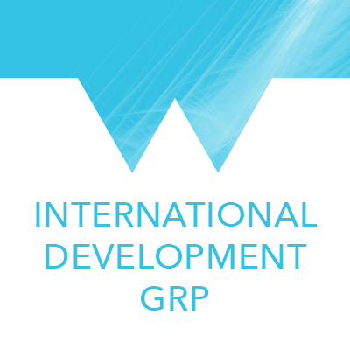

About GRP International Development, Warwick University

GRP International Development International development is one of the University of Warwick’s research priorities. The University is addressing global challenges through our world-class multi-disciplinary research. The GRP International Development seeks answers to urgent problems of poverty, inequality and social and economic change through multidisciplinary and interdisciplinary approach. Scholars ranging from engineering to social science focus on themes such as gender, health, human rights and the role of the private sector, technological innovation and grassroots empowerment. It is through critical analysis that the GRP ID extends the theoretical and empirical boundaries that shape our understanding of international development.

The Global Research Priorities programme on International Development, University of Warwick, will be hosting its first Postgraduate Conference on the theme of Gender and Development. Over the past decade, the international development community has been increasingly focusing on the effectiveness and sustainability of change management efforts of fostering international development and bridging the gender gap. Through addressing gender inequalities in terms of in-country projects, the use of data analysis, and different approaches and methodologies that achieve change, we will examine how change to bring about gender equality is both necessary and urgent.This one-day conference is designed to give postgraduate students from different research areas an opportunity to present and discuss their research and form new connections with their colleagues across different disciplines. We hope to organise a postgraduate conference around our annual theme every year and give students from different areas an opportunity to present their work and develop further ideas about their research.

About the venue

GRP International Development Postgraduate conference 2016 - 2017 will take place in Oculus Building at Warwick University, Room R.001. Oculus Building is our flagship teaching and learning building, constructed in a key position on central campus. There are two large, state-of-the-art, tiered lecture theatres, 12 other top quality, flexible teaching spaces, study areas and a café. Room R.001 is located on the ground floor and contains the following supported equipment: Data Projector, Writing Surfaces, Visualiser, IR Induction Loop, Lapel Radio Microphones, Fixed PC, Blu-ray Player, DVD Player, Laptop Connectivity VGA & HDMI, Touch Screen Display, Wireless Presentation System, Lecture Capture System.

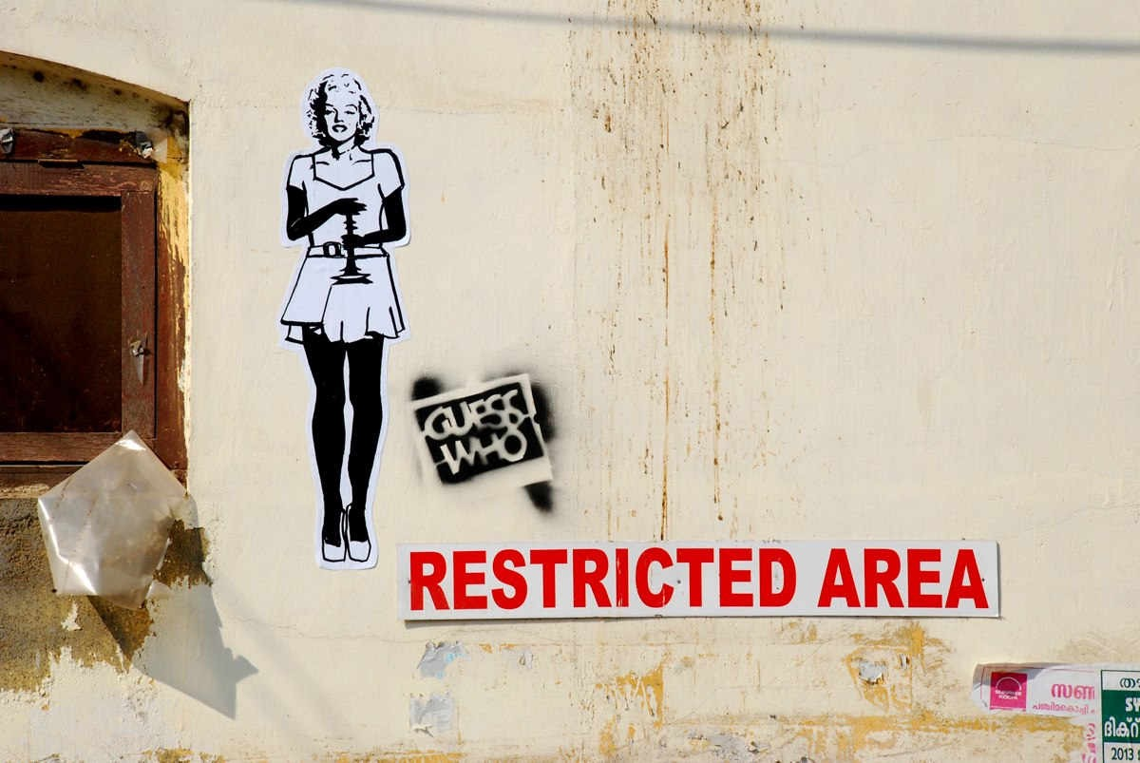
How to get to the University?

1. How to get to the University by Bus

Local buses offer a frequent and convenient way of travelling to and from campus. There are regular bus services to the University campus from Coventry city centre and Coventry rail station, with the journey taking about 30 minutes.

From Leamington Spa

These services all connect the University to Leamington Spa:
▪ Stagecoach U1, U2
▪ Stagecoach U12
▪ National Express 11 - this service collects from the Parade in Leamington Spa.

From Coventry City Centre & Coventry rail station
These services all connect the University to Coventry City Centre and Coventry rail station:
▪ National Express 12X - this express service goes directly from the City Centre to campus, via Coventry Rail station.
▪ National Express 11 & 11U - these services come from Coventry City Centre and Coventry rail station to campus via Earlsdon

From Kenilworth
These services all connect the University to Kenilworth:
▪ Stagecoach U2 - this service comes from Leamington Spa, through Kenilworth, and on to campus.
▪ National Express 11 - this service comes from Leamington Spa, through Kenilworth, and on to campus.

From other areas of Coventry
This service connects the University to other areas of Coventry:
▪ Travel de Courcey 60 - this service goes from the University to University Hospital in Walsgrave, Coventry and to the Ricoh Arena.
▪ Travel de Courcey 43 - this service goes from the University to Eastern Green in Coventry via Tile Hill.

Bus travel tips
▪ National Express buses don't usually give change so make sure you have the correct money available before making your journey. You can find information about fares on the National Express Coventry website but it is best to check with the driver when you board the bus.
▪ Stagecoach buses do give change on the majority of their services.
▪ If you are unsure about which service you need and would like assistance, call Traveline on 0871 2002233 where staff will be able to assist with planning your journey.
▪ If you're a wheelchair user, Stagecoach recommend you contact them before travel to make sure the service you'd like to use is fully wheelchair accessible. Contact Stagecoach Warwickshire.

2. How to get to the University by Rail
There are various rail stations that are easily accessed from the campus and they offer excellent links to Birmingham, London and many other major UK cities.

Coventry Rail Station
Coventry Rail Station, approximately four miles from the campus, is the nearest main-line train station to the University. If you're travelling locally, you may find the nearer, but less frequently served, Canley Rail Station or Tile Hill Rail Station more convenient. You can easily reach Coventry Rail Station from London (Euston) and Birmingham, which run regular and frequent services direct to Coventry. From Coventry Station, there are frequent local bus services to the University.

Follow the signs from the station to Warwick Road (a 2 minute walk) and from there catch the National Express 12X, which travels onto main campus. More information on bus travel to the University can be found here.
Taxis are also available from outside of the station.

Birmingham New Street Rail Station
During weekdays trains from Birmingham New Street depart for Coventry on average every 10 minutes. The journey takes between 20-30 minutes depending on which service is used.

London Midland offer a regular rail service that stops at local rail stations including Canley Rail Station which is a 25 minute walk, or a shorter bike ride or taxi journey than from the main Coventry Rail Station to campus.

Birmingham International Rail Station
The station that serves Birmingham Airport is Birmingham International. During weekdays trains depart from Birmingham International to Coventry on average every 10 minutes. The journey takes between 10-15 minutes depending on which service you use.

London Midland offer a regular rail service that stops at local rail stations including Canley Rail Station which is a 25 minute walk, or a shorter bike ride or taxi journey than from the main Coventry Rail Station to campus.

Canley Rail Station
Canley has a small local rail station that is roughly 1.3 miles away from the University - it's a 25 minute walk, a short bike ride or taxi journey to main campus. There isn't a taxi rank at Canley so please ring a taxi in advance if you need one. London Midland offer a regular rail service that passes through Canley Rail Station going to London, Milton Keynes, Birmingham New Street, Birmingham International, Coventry, Rugby and Northampton.

There is now a new free shuttle bus service between the University of Warwick campus and Canley Railway Station. This consists of three trips to the University from Canley Station each morning, timed to coincide with train arrivals from Birmingham, London and Oxford and also two return trips back to the station each evening to connect with key train departures. The service runs from Monday to Friday. You can find details of the timetable on the Shuttle Bus webpages.

Leamington Spa Rail Station
Leamington Spa Rail Station is roughly 9.5 miles from the University. The station offers rail services to Warwick, Solihull, Coventry, Oxford and Reading as well as a service to London Marylebone.
Stagecoach provides a dedicated frequent bus service from Leamington Spa to tour campus: the Unibus (U1). There is a second version of this route that passes through Kenilworth, named the U2. For information on this service, please visit the Stagecoach website. This service also covers Coventry City Centre and Coventry Rail Station on Sundays and Public Bank Holidays. View the Unibus timetable.

Warwick Rail Station
Warwick Rail Station is in Warwick Town - approximately 8.4 miles from the University campus. The University of Warwick is not in Warwick Town. If you are travelling by rail, we advise you to travel to Coventry Station (not Warwick Station) which is closer to the University and has better public transport links.

3. How to get to the University by coach

Coach to Coventry followed by local bus service
If you're travelling by coach, the most convenient major centre is Coventry, which is well served by national links. Once you have arrived in Coventry, there are frequent local bus services to the University.
Details of coach travel can be obtained from National Express. Megabus also offer a coach service to Coventry from a selection of locations around the United Kingdom, including London. There's a Megabus coach stop Cannon Park Shopping Centre, which is a 5-10 minute walk from central campus.

Coach from Birmingham Airport or Oxford to campus
The Oxford Bus Company runs a coach service from Birmingham Airport to Oxford (and Oxford to Birmingham Airport), which stops on central campus. Find out more about this service, including fares and timetables, here.
Regretfully, this service will be withdrawn after the last service on 25 March 2017. Please click here for more information.

4. Finding the University by car
The postcode for our central campus is CV4 7AL.
You can use that with route planning services like Google Maps, or with your sat nav to find your way to the University. As you get closer to the area, joining the A45 or A46, there will be signs marked "University of Warwick" to help you find us.

Car Parking for visitors
Pay and Display parking facilities are available to all staff, students and visitors to campus. These car parks are clearly marked on the campus maps.
The following charges will apply;
▪ Up-to 4 hours - £2.00
▪ Full Day - £4.00
▪ Up to 2 hours - £1.00 (only available in Arts Centre, Sports Centre, Sports Centre multi-storey and IMC car parks)

Pay stations only accept the correct change.

Map of the University : https://campus.warwick.ac.uk

Contact

Miss Nina Slokar Boc, GRP International Development, Programme Coordinator, Tel: 024 76 5 23119,
email: n.slokar-boc@warwick.ac.uk

