Report 2025-2026
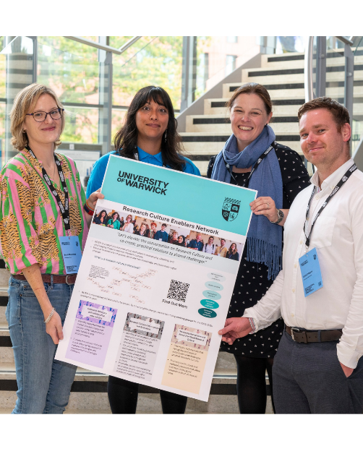
RCEN Chair Dr Rika Nair alongside Dr Sarah Masefield, Dr Amy Mayfield and Dr Cathal Rogers, Co-Leads of the Data Collection and Evaluation Working Group.
Foreword
The Research Culture Enablers Network (RCEN) exists to strengthen and professionalise research culture work across the UK.
Since its launch in December 2023, RCEN has grown in both scale and ambition, reflecting a wider shift across the sector towards strengthening the conditions that enable excellent research. This includes increased attention to the effectiveness and inclusivity of research environments, and the support provided to all those who deliver research. At its core, the network is grounded in a shared commitment to ensuring that research culture work is recognised and embedded within institutional strategies, rather than treated as a ‘nice to have’. This commitment responds to the risks of short-term or isolated approaches to research culture, including duplication of effort and the loss of learning over time.
Situated within the wider work of the National Centre for Research Culture, RCEN contributes to a growing body of shared understanding about what supports effective research culture, while maintaining a practical focus on connecting those undertaking this work. Over the past year, RCEN has become increasingly action-focused, including through the development of new working groups and emerging partnerships that support change at scale.
In addition to reflecting on RCEN’s activities to date and current areas of focus, this report presents findings from the 2025 RCEN survey, completed by 47 research culture enablers working across a diverse range of institutional contexts. Building on our 2024 analysis, the findings offer an updated picture of who undertakes research culture work in the UK, where these roles sit within organisations, and how they are evolving in response to changing sector expectations, including those linked to Strategy, People and Research Environment (SPRE).
The findings reinforce the role of research culture enablers as connectors within and between institutions. They interpret external policy and funding drivers while working closely with their research communities to translate these into local practice. Survey responses also highlight continuing challenges related to role definition and funding sustainability. Respondents also consistently emphasise the value of connection with other research culture professionals, to share practice and develop collective leadership.
As RCEN continues to evolve as a practitioner-led network shaped by those working directly on research culture, the insights in this report will inform future priorities and activities, and we invite all those involved in enhancing research environments to join us in shaping the network’s ongoing work.
Research Culture Enablers Network Committee
Research Culture Enablers Network (RCEN): Activity and Reach
Over the past year, RCEN has engaged colleagues from around 150 distinct UK and international institutions, including approximately 110 UK universities and 20 international universities, alongside research institutes and centres, funders and charities, consultancies, independent organisations, and national and regional networks and consortia (e.g. GW4, Midlands Innovation, White Rose, N8). This breadth reflects RCEN’s role as a convening space that brings together diverse perspectives from across the research system.
A core feature of RCEN is its bi-monthly online meetings, which offer structured opportunities for members to connect and upskill. Each session typically includes structured networking and ‘roadmapping’ activities around a specific research culture challenge, sector updates, presentations from RCEN members, contributions from external guest speakers, and space for informal discussion. Approximately 90 colleagues attend each session, and all meetings are recorded and shared (RCEN Past Recordings) with the network to maximise accessibility.
RCEN sessions this year covered a wide range of themes, combining external expertise with opportunities for members to develop and showcase their own thought leadership. Topics included lived experiences across the research ecosystem, such as findings from the REC HURDLE Wellcome project on research precarity, the Prosper Research England project on unlocking the potential of postdocs, lessons from the Researcher Developer community, and a panel discussion on improving research culture for Mid-Career Researchers. The programme also examined institutional practice, with sessions on establishing research culture communities of practice, embedding culture within research evaluation processes, and CoARA myth-busting. In addition, the network supported ongoing learning and professional development through bitesize training in change management and updates from the Good Practice Exchange team.
Alongside the formal meetings, RCEN maintains an active Teams group, providing a space for informal discussion and peer support from a community of colleagues working on research culture across the sector. The group helps avoid duplication of effort and encourages open exchange: No question is considered too basic.



Survey Findings
This section presents findings from the 2025 RCEN survey, which aimed to develop a clearer understanding of research culture work and to gather feedback on current RCEN activities Building on the survey framework developed in 2024 by Harry Moriarty, this year’s questions were adapted to reflect evolving practices across the sector.
Overall, respondents reported strong perceived value from RCEN membership, particularly in relation to collaboration and sharing practice, raising the visibility and recognition of research culture work, and providing a safe, values-driven community (Fig. 1). These areas appear to be where the network most consistently supports collective sense-making around research culture work. Perceptions of value were more variable for cross-institutional connections, networking and peer support, embedding research culture into practice, and reflecting and challenging institutional assumptions. This variation offers useful pointers for further exploration.

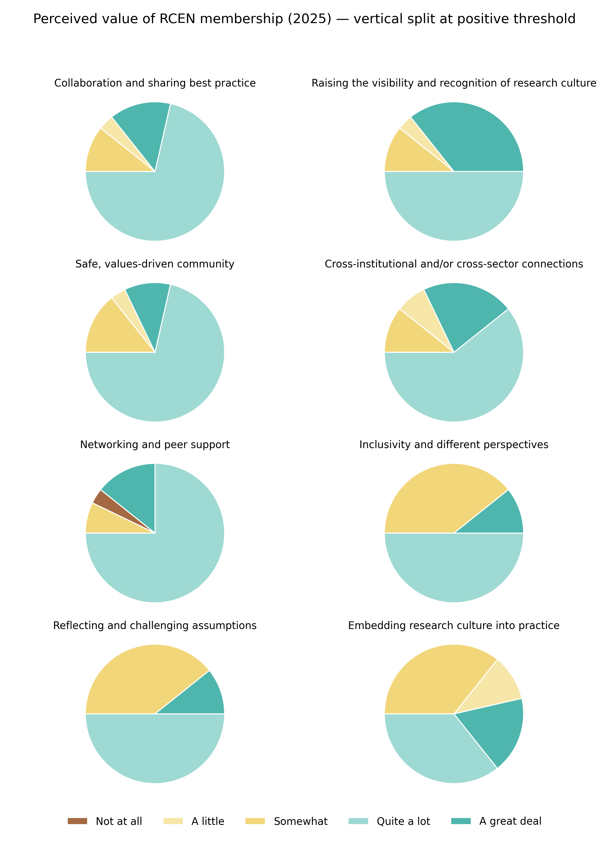
Fig 1. Perceived value of RCEN membership across key areas,

The Work of a Research Culture Enabler
Rather than focusing on a single theme, research culture enablers described roles that cut across several dimensions of the research environment (Fig 2.).
“Working across multiple disciplines, and across both strategic and operational priorities.”
“Bringing people together from across groups to contribute to research culture‑related projects.”
“Contributing to a better research environment and supporting positive change.”
“Seeing people develop confidence and achieve new things.”
“Being part of a wider sector movement, and connecting with others through networks and shared activity.”
Fig 2. What research culture enablers enjoy about their roles
Many respondents indicated that engaging across multiple areas is typical, with work on one issue often connecting to others. Respondents reported a wide range of core activities, including consultation and engagement with research communities, designing and delivering events or programmes, contributing to REF and concordat work, drafting policies and reports, analysing surveys, and engaging with internal and external networks (Fig 3.).
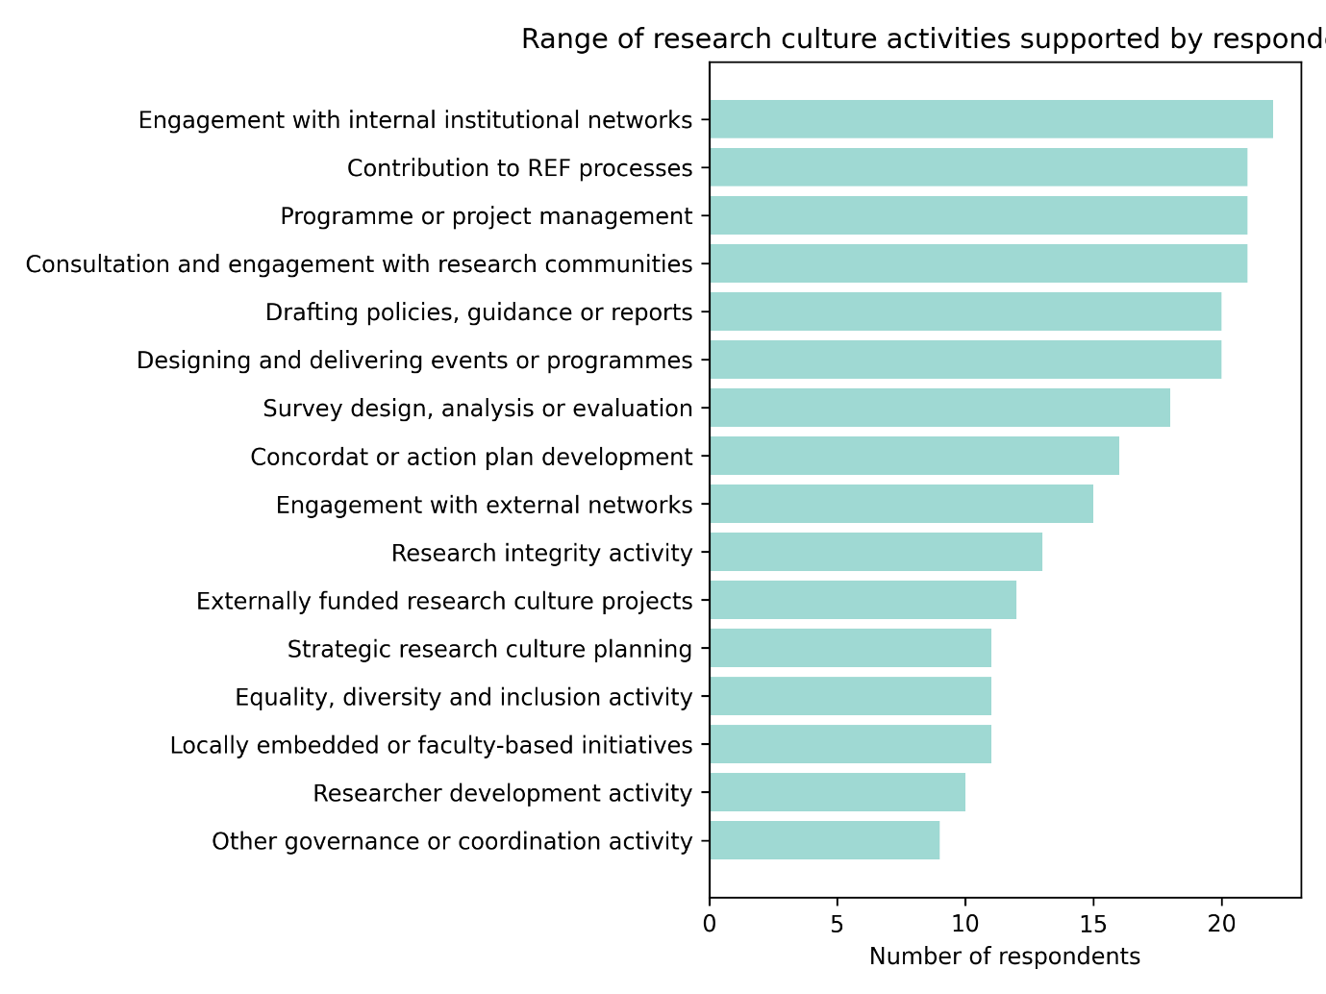
Fig 3. Variety of activities undertaken by research culture enablers

The findings highlight the hybrid nature of research culture roles. They require strategic awareness, analytical capability, relational skills and practical delivery. This combination can be rewarding, but also demanding where roles lack clear boundaries or where expectations expand without corresponding increases in capacity.

Where Research Culture Work Takes Place
To better understand how research culture activity is distributed across institutions, the 2025 RCEN survey asked respondents about the types of research culture activity supported and where this work is located structurally.
Respondents reported a wide range of research culture activities operating at institutional level, including research culture committees, working groups focused on specific priorities, and engagement with research communities through consultations, presentations and workshops. Centrally coordinated programmes linked to equality, research integrity, researcher development and REF expectations also feature prominently.
Alongside these activities, respondents highlighted action plans linked to concordats, externally funded research culture projects, themed programmes of activity, and locally delivered initiatives embedded within faculties or departments.
Overall, research culture work appears increasingly embedded and recognisable. However, it remains unevenly distributed and often dependent on local leadership, individual roles and the availability of dedicated resource. While strategic oversight structures are more common, delivery frequently relies on a small number of individuals working across multiple priorities.
Research culture work is most commonly located within central research or research and innovation offices, as well as researcher development, research strategy, equality and inclusion teams, doctoral colleges and libraries. Many respondents selected multiple locations, reflecting the cross-cutting nature of this work.
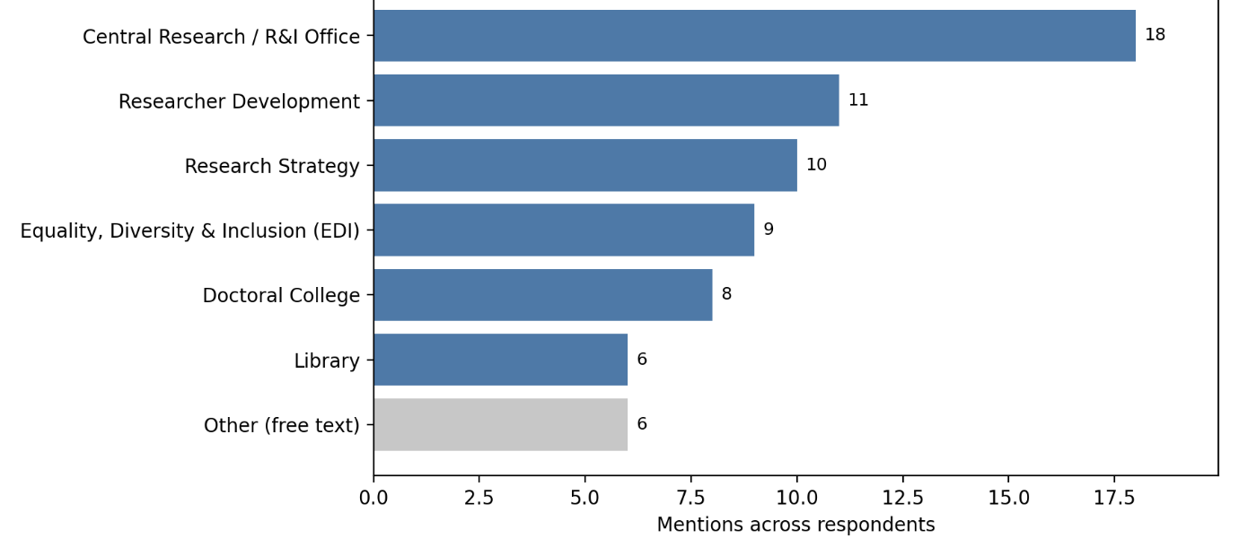
Fig 4. Where research culture work takes place
This distribution allows culture considerations to be embedded across institutional systems, but also contributes to ambiguity around ownership and accountability. Research culture work is rarely confined to a single organisational home and is often carried across boundaries without consistent resourcing.
‘Other’ responses indicate that research culture responsibilities can be embedded within broader roles or teams rather than being held in dedicated posts. These include senior leadership roles where research culture sits alongside wider research portfolios (e.g. A‑PVC Research), Wellcome‑funded project roles supplemented by staff “wearing several hats”, fractional research culture posts (e.g. 0.4 FTE), and project‑based teams comprising a mix of professional roles. Some institutions also reported the emergence of broader organisational “culture” teams, within which research culture intersects with, but is not distinct from, wider organisational culture activity.

Funding Challenges and Opportunities
Uncertainty in the funding landscape presents a challenge for sustaining research culture activity. Concerns included the future of quality-related funding, the absence of further rounds of Wellcome Institutional Research Culture funding, and uncertainty around UKRI-commissioned initiatives such as a potential Good Practice Exchange.
Emerging opportunities include growth in metascience, flexible funding schemes (eg. EDI+ HUB), and increased funder interest in improving research environments (eg. NERC Opening Up the Environment; AHRC Mission Pilot).
RCEN will continue to monitor these developments and aims to support members by sharing intelligence, and enabling collaboration so its members are mobilised to respond to upcoming funding opportunities.
RCEN Working Groups

RCEN Working Groups: Driving Positive Change in Research Culture
RCEN Working Groups were established to move beyond discussion and start driving tangible change in research culture. This initiative grew directly from the voices of our members, with over 350 priorities submitted via the sign-up form, insights shared on Padlets, and ongoing conversations throughout the network.
All feedback was carefully reviewed to create a longlist of potential groups focused on what matters most. The network then contributed to selecting the final working groups.
From these contributions, three key working groups were created:
- Research Culture Data Capture and Evaluation
- Developing Recognition and Reward for Good Research Culture
- Collective Advocacy and Collaboration with Funders



Research Culture Data Capture and Evaluation Working Group
Purpose: To understand what matters most in research culture by co-producing meaningful, evidence-based approaches to data collection and evaluation. The group supports consistent reporting and enables meaningful measurement of progress across the sector.

Objectives:
- Co-produce approaches to data collection that can be embedded in research culture practices
- Map and evaluate existing research culture indicators and frameworks
- Contribute to national conversations on evidence standards, accountability, and benchmarking



Developing Recognition and Reward for Good Research Culture Working Group
Purpose: To champion ways to recognise and reward those contributing to positive research culture within institutions. The group addresses the invisible yet essential contributions that sustain healthy research environments, ensuring these are valued and embedded into institutional policies.

Objectives:
- Map and share case studies and resources supporting recognition and reward
- Influence narratives of excellence to value research culture contributions
- Develop best practices around allyship
- Identify stakeholders and change agents to embed best practice
Recent developments, such as the evolution from PCE to SPRE in the REF, highlight increasing recognition of diverse contributions, including the wider range of outputs and contributors now acknowledged. The group is exploring best practice through initiatives such as OR4’s maturity framework, co-production and integrity tools, and institutional assessment models, alongside contributions from RCEN members via Padlet and collaborative discussions.



Collective Advocacy and Collaboration with Funders Working Group
Purpose: To identify opportunities for collective advocacy and collaboration with funders and policymakers, ensuring that the voices of those most affected by research culture challenges are heard in strategic conversations.

Objectives:
- Develop shared messages and approaches for constructive engagement with funders
- Identify policy touchpoints where RCEN can advocate for improvements
- Promote mutual understanding between research culture enablers and funding bodies

Initiatives in partnership with RCEN:

Making visible research’s hidden advantage: Research Professionals


https://rpfutures.co.uk/
Across RCEN discussions, a consistent insight has emerged: research excellence depends on a wider range of expertise than is typically made visible. Alongside academic and technical contributions, Research Professionals bring essential expertise that enables better research. Making this expertise visible is central to understanding one our research system’s hidden advantages.
Yet many colleagues describe institutional cultures that continue to undervalue Research Professional contributions. These narrow assumptions limit collaboration and weaken the collective capacity of research teams.
“The RPF project challenges outdated perceptions and opens space for dialogue and empathy, recognising Research Professionals as experts whose diverse specialisations are essential to delivering excellent research outcomes. It advocates for parity of esteem and clearer progression pathways across these roles.
“By reframing Research Professional roles not as bureaucratic or compliance-driven, but as integral to the research ecosystem, the project empowers skilled individuals whose deep understanding of research has the potential to enhance collaboration and free up academic time.”
Dr Rika Nair, RCEN Chair and RPF Co-Lead
It is in this context that RCEN welcomes the launch of Research Professional Futures, a £4.5 million Research England–funded initiative running from 2026 to 2029. The programme responds directly to challenges identified across the network by reframing Research Professionals not as ancillary roles, but as a critical, and often hidden, advantage within the research ecosystem.
Research Professional Futures is co-led by Stirling University, Durham University, Warwick and King’s College London, in partnership with the PRISM network, ARMA and the National Centre for Research Culture at the University of Warwick. Research-on-research elements are led by Professor Alis Oancea and colleagues at the University of Oxford, alongside Research Consulting Limited.
At its core, the initiative focuses on recognising Research Professionals as specialists, strengthening clarity around careers and progression, and reshaping how contributions are understood across research systems. By doing so, it aims to support research environments that are more inclusive and future-ready.
This emphasis aligns closely with RCEN priorities around reward and recognition, including the work of the Developing Reward and Recognition for Good Research Culture (RRGC) working group. RCEN will continue to engage with the programme to support co-creation of the Research Professional Blueprint and the translation of evidence into practice across institutions.

Addressing Precarity in Research Careers
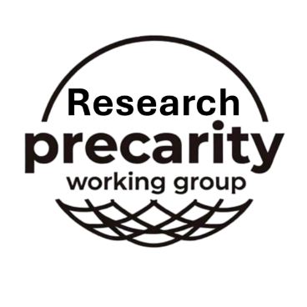
Research Precarity Working Group
Employment precarity in research has emerged as a persistent concern affecting careers across higher education. This includes researchers, professional services colleagues and technical staff, many of whom experience fixed-term contracts, fragmented funding or limited job security.
An emerging national working group focused on precarity is being led by Ash Collins at the University of Nottingham. The group aims to take collective action to reduce the level and impact of employment precarity in research-related careers.

Vision: purpose and desired impact
Take collective action to reduce the level and impact of employment precarity in research-related careers at higher education institutions, including research, professional services and technical staff.
“The mission of the precarity working group is to form a strong national case for change to current employment practices and improve support for those facing employment precarity currently. The working group will achieve this by engaging with funders, HEIs and other relevant national structures, to ask on mass for change, and have open and frank discussions about how this can be achieved by working together.”
Ash Collins, Research Precarity Working Group Chair

RCEN is actively collaborating with this initiative, including promoting its launch. RCEN leads Yasmine Rhoseyn and Rika Nair, are Co-Leads of Workstream 2 (Outreach and Organisation), which focuses on mapping existing support structures, liaising with relevant organisations, and improving signposting for colleagues experiencing precarity. The group is also developing an online presence to raise awareness, expand its membership and provide a focal point for collective action.
Addressing precarity is a key research culture issue, and RCEN will continue to support this work and ensure emerging insights are shared across the community.

