Title Arial pt 16 and justified
[this is a blank 12 pt space – please remove]
First Author,¹ Middle Authors,² Final Author.³ Format for authors: the presenting author should be underlined, names should full name known by (often first name and surname) and initials for other names (e.g. Arthur C. Clarke).
[this is a blank 12 pt space – please remove]
¹ Address of first author including country;
² Address of middle authors (if different);
³ Address of final author (if different).
[this is a blank 12 pt space – please remove]
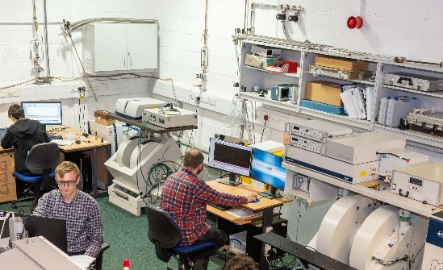
The whole abstract is in single column format with justified text.
Figure 1: Figures are encouraged. They should be labelled using "caption" in MS Word with the caption below the figure. They should be referred to from the abstract text. They should be good enough resolution. The print copy of the abstract book may be black and white, so please check your figure is clear in black and white. Figures can be placed anywhere within the body of the abstract and multiple figures are accepted. The text of the caption should be Arial pt 9, black font, not bold and not italic. Unlike this example, keep the text short.
Notice the 12 pt space between paragraphs in the main text of the abstract. All text is in Arial and, apart from the title, it is all 12 point. Avoid unnecessary italics. Please leave the margins as they are.
You’ll see in Fig. 1 that we’re hard at work taking data at Warwick and are really looking forward to meeting you at RSCESR 2024. That was me referring to Fig. 1.
You may also want to have references, in which case please use square brackets to refer to them.[1]
You may need another reference.[2]
The whole abstract should only be 1 page long and must look clear in black and white.
Please use the abstract template, since it will make assembling a good looking abstract book much more easy for the organisers. You may be asked to reformat if you don’t use the template, or yours may look like the odd one out in the booklet.

[1] Reference, format to be decided by you but must provide enough information for the retrieval of the published article as well as allowing the abstract to fit on one page. Use 12 pt Arial, and no need to have paragraph spaces between references.
[2] Another reference.

