EPR Tuning
Written by: | Dr B G Breeze | 28/04/20
Amended by:

IMPORTANT
Best practice procedure developed in the spectroscopy lab over many years. The spectrometer is tuned such that it no microwaves are reflected when on the resonant frequency of the resonator. This guides assumes that the sample is already loaded and in the correct position.

Spectrometer tuning
Operation mode
buttons
AFC indicator
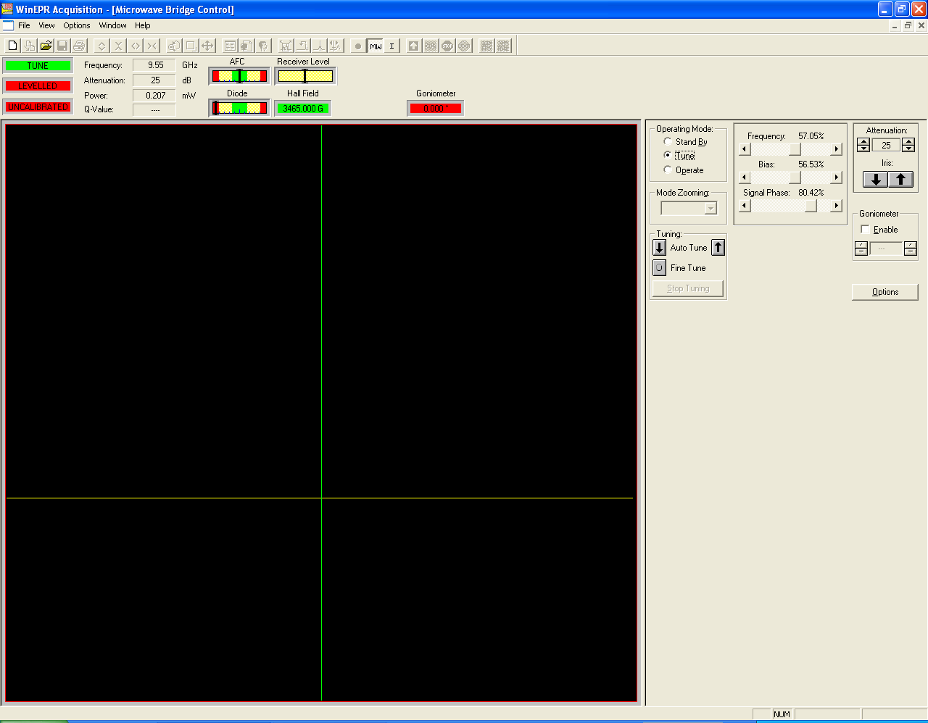
Control
Sliders
Iris Control
Microwave Power (dB)
Diode current
indicator
Note current image not showing microwave dip.

- Open the microwave bridge control window by selecting the “MW” button on the top tool bar
- Set spectrometer in to tune mode and attenuation to 30 dB, turn the bias current slider to zero (far left)
- Adjust the microwave frequency so that the dip is in line with the green line on the tune display. This can be done by using the slider marked Frequency. The arrows perform small steps and clicking on the bar will produce a bigger step. Be aware that the spectrometer has a response lag so it is best to click and then wait for the spectrometer to settle before clicking again.
- Using the square arrows labelled iris adjust the iris until the dip is as deep and narrow as is possible
- Switch the spectrometer to operate using the operation mode button
- Check that the microwaves are at the correct frequency in the AFC bar on the top tool bar. (the indicator should be at the centre of the green section). If the AFC is not centred adjust the frequency using the arrows (and only the arrows) on the frequency slider until it is.
- Adjust the iris so that the diode current bar reads zero.
- Increase the power in 1 dB if the diode current increases use the iris controls to return it to zero
- Repeat step 8 until 3 dB is reached then return 30 dB attenuation.
- Return to tune mode
- Increase the bias until it is at 50%
- Observe the shape of the dip if it has changed and become asymmetric adjust the signal phase using the slider titled phase until it looks symmetric again.
- Return to operate mode
- At 30 dB attenuation use the bias slider to move the diode current into the middle of the green bar by clicking on the slider bar for big steps.
- Use the phase slider to maximise the bias current, do this by clicking on the slider bar for big steps.
- If required use the bias slider to move the diode current into the middle of the green bar.
- Increase the power in 1 dB if the diode current moves off the green bar use the iris to return it to the centre of the green bar
- Repeat step 17 until 3 dB is reached then return 30 dB attenuation.
- Repeat steps 16-18 until the bias current does not alter with power. Adjusting the frequency if the AFC drift
- Once the tuning is complete it should be possible to set the microwaves to any power without the AFC or the Diode gauges moving. The resonator is now critically coupled.
Trouble shooting.
Can’t see the dip: check you are at the correct frequency. This is nominally around 9.78 GHz, but can vary, for example when the VT quartz insert is in place it will be as low as 9.4 GHz.
If you are having trouble tuning with your samples in place, put the spectrometer into stand by, remove the samples and return the tune mode.

