Basic Operation of Horiba LabRam Spectrometer
Written by: | Dr B G Breeze | 01/04/22
Amended by: | Dr B G Breeze | 05/08/22

IMPORTANT
Spectrometers must only be operated by authorized personal, who have had a full induction into working in the Spectroscopy labs and completed local training. A list of trained personal can be found in the webgroup pf-HoribaLabRam-users.

Before beginning any experiment do a quick visual inspection of the spectrometer to confirm it looks in good working order and no previous experiment is left in place. If you have any issues, please contact a member of RTP staff.

Software layout
Main screen
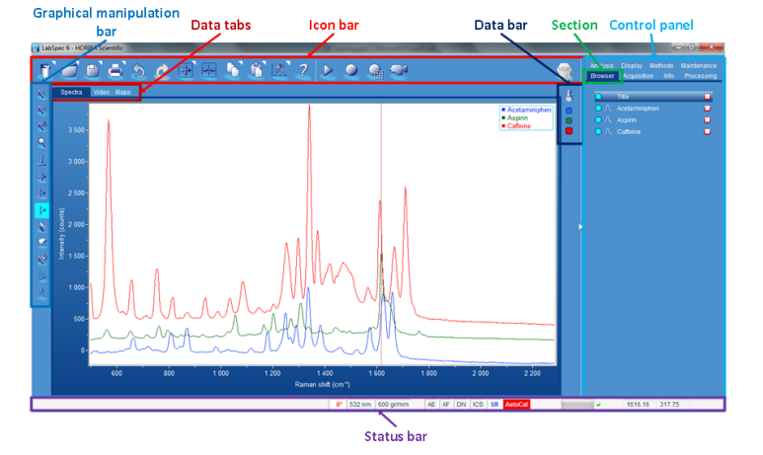

Top bar icons
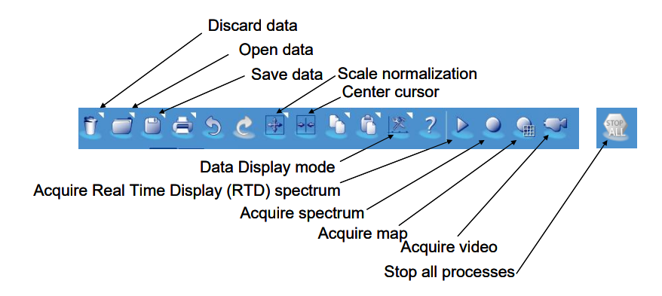
Data Tabs (lower top)

These will change throughout the session depending on the data loaded but the key ones are

Spectra: Display individual spectra
Video: real time display from the microscope or stored images and mosaics
Maps: Collected map data
Shop: ignore
Reports: also ignore unless you want reports (not covered in this SOW)

Control Panel (right hand side)

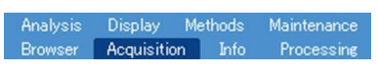
Clicking on each tab changes the options available. These include.

Acquisition: set up all acquisition parameters including hardware settings. I
Analysis: data analysis functions to obtain information from the data (including peak fitting, map characterization and multivariate methods).
Browser: view a list of all data opened in LabSpec 6.
Processing: data processing functions to modify raw data (including smoothing, baseline correction and math functions)
Display: configure the display of spectra / video / mapping window
info: view the information shell for each data file
Methods: create customized multi-step one-click sequences (not often used)
Maintenance: Auto Calibration

Start up:

- The spectrometer should be turned on when you arrive. If not contact RTP staff.
- The Software LabSpec 6 should be loaded. If not open it using the short cut on the desktop
- Turn on the lasers buy turning the key 90 degrees clockwise. Unless you are certain which laser you will be using, please turn on both the 660 nm Cobalt laser and the 488 nm Coherent laser.
- Turn on the Whit light source labelled Video on the right side of the spectrometer housing and turn the dial to 3.
- In the LabSpec 6 software go to the browser tab and close any open data using the red cross.
- Proceed to calibration.

Calibration
In the bottom right-hand side of the LabSpec software you will see the autocalibration indicator. It will either read AC in green when calibrated or AC in red when uncalibrated. If the system is uncalibrated, it must be calibrated before use. If the system is calibrated at the start of your session, it is strongly recommended you perform a calibration anyway.
- Ensure that all required lasers are on and warmed up. This takes roughly 15 minutes from switch on.
- To Start the Auto calibration, click on the autocalibration indicator and a window will appear with three options. “Calibrate all lasers/Grating”, “Calibrate current Laser/Grating” & “cancel”. Unless you intend to only use one setup in your session select “Calibrate all lasers”
- The software will prompt you to ensure laser are turn on and reference sample is in place. Now you can rotate the SP-RCO reference sample into position on the microscope. It is the large Blue Object and should be rotated so it is on the right-hand side of the turret.
- Close the cabinet doors fully. (Left side first)
- Click ok on the screen prompt about laser and references
- You may get a second prompt asking you to “ensure the SP-RCO” reference is in place, click ok
- The automatic reference will run through. This can take a few minutes.
- Towards the end of the reference cycle, you will be prompted to change back to the previous objective. Open the cabinet doors and rotate the asked for objective back into place. And reclose the doors.
- Click OK on the prompt.
- You will get a prompt once the calibration is complete and the autocalibration indicator should now be green. There will also be several spectra displayed in the spectra tab which should say pass in the legend
- go to the browser tab and close all open reference data using the red cross.
- Proceed to Sampel Loading

Sample Loading

- Raise the microscope objective turret using the Z‐position adjustment knob on the left side of the microscope at the top. Place your sample slide onto the stage and secure using the clips. Care should be taken to ensure a sufficient clearance to allow the required objective to be selected without colliding with the sample.
- On the microscope move the 5x objective into position on the far let of the objective turret.
- Turn on the white light and using the ??? box to the right of the sample compartment labelled” video”. And set the power to roughly 4.
- In the software start the video by using the camera icon
- The software should automatically begin to show the live feed from the camera if not select the video tab.
- Focus on the surface of the sample using the position adjustment knob on the left side of the microscope.
- You can use the coarse focus on the inside of the cabinet to bring your sample close to focus then switch to using the joystick for the fine tune. To do this you rotate the joystick clockwise to move the objective towards your sample and counter clockwise to move the objective away from your sample. The best method is to rotate the joystick 1/8th of a turn and hold it there whilst it moves. Do not flick the joystick.
- You can also use the joystick to perform planar XY movement of the stage to find the correct location on your sample.
- Once the sample is in focus, move the objective to the X10 and repeat steps 6-8 then change either the X50LWD or the X100 into position and carefully adjust the focus again. Be careful not to crash the objective onto the sample X100 has <100 µm clearance.
- Whenever the sample objective on the microscope is changed, then the objective setting needs to be changed in LabSpec Tool located at bottom of screen or unt eh acquisition tab under spectrometer configuration
- If you wish you can save the image by clicking on the save data tab. This will save a jpeg/tiff of your image. (This image will not have scale bars, see the notes on copying an image.)
- Once focused and in the correct position you can move onto measurement setup.

Measurement Setup and collection

- Open the Acquisition tab in the control panel
- Setting up auto saving
  - Select the “Tags and Auto save” menu
  - Under “file” select the base folder to save your data in (E:\Data\you\your folder)
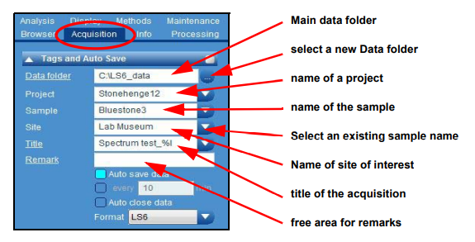
  - You can use the project, sample, and position boxes to create subfolders if required
  - Use name to set the file name for your measurements
  - LabSpec will auto number you file so there is no need to rename each measurement unless you wish too
  - We recommend leaving the file type at the default LS6 file and converting to a .txt later.
- Measurement parameters:
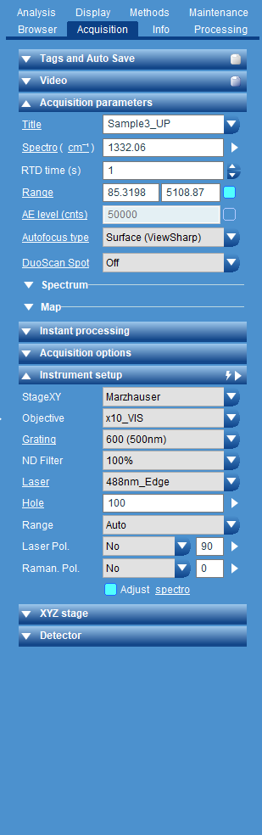
  - Before you can make a measurement
  - Select the Instrument Setup menu
  - Use the options to set the desired instrument parameter for the measurement
  - StageXY: Marhauser
  - Objective: sets the objective
  - Grating: Set grating see appendix one for assistance
  - ND filter: sets the laser power. As a guide 100% ~ 50mW at the sample for both lasers if this is critical, please contact RTP staff.
  - Laser: 488 nm or 660 nm
  - Hole: this is pinhole you value would normally be between 200 – 50. The smaller the number the high confocally the system is operating in, see appendix B
  - Select the Acquisition parameters menu
  - Use the options to input the desired an acquisition parameter.
  - Title: this is the name of your file as set in Tags and Auto Save
  - Spectro (units): Spectro defines the central position of the grating for a static scan. You can click on (units) to change between desired X units (cm-1, nm, eV etc.)
  - RTD time (s): the time spent acquiring in seconds for the real time display mode.
  - AE level: not used please leave unticked
  - Range: If the blue box is highlighted the spectrometer will scan multiple windows between the spectral range specified, (in units defines in Spectro)
  - Autofocus type: Autofocus options default to off. See application notes for details
  - DuoScan Spot: default to off. See application notes for details
  - For a point measurement select the Spectrum sub Menu
  - Acq time (s): the time spent acquiring in seconds
  - Accumulations: number of acquired accumulations (note LabSpec normalizes counts for number of accumulations)
  - AutoFocus mode: Autofocus off as default and set the frequency of auto focusing see See application notes for details
- For a mapping measurement select the Map sub Menu
  - Scanning mode: Normal (point to point) or SWIFT scanning
  - Acq time (s): the time spent acquiring in seconds
  - Accumulations: number of acquired accumulations (note LabSpec normalizes counts for number of accumulations)
  - AutoFocus mode: Autofocus off as default and set the frequency of auto focusing see application notes for details
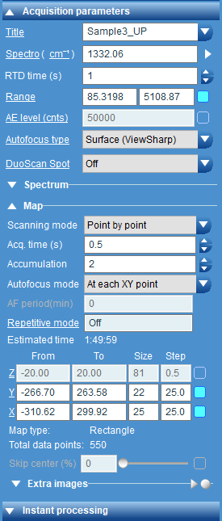
  - Repetitive mode: Off by Default
- There is a table which can be used to define you mapping paramters:
  - The first column indicated the dimension (X, Y Z, Power, Holesize, etc.) ones with the blue boxed ticked are active in your map
  - From: start point of each dimension
  - To: End point of each dimension
  - Size: the number of points to be collected in that dimension
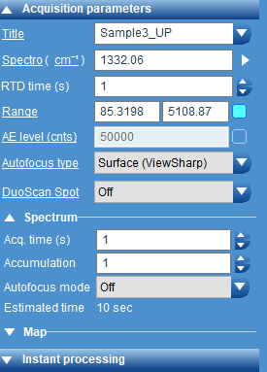
  - Step: the size of the step

- You may wish to confirm you have created by using the Real time display. The Real Time Display (RTD) acquisition constantly reads out a spectrum with the selected acquisition time.
Note: There is no accumulation (averaging) of the spectra, and only a single window detector read out is possible (no extended spectral range).
- To start the RTP use the triangle Start RTD icon.
- Whilst the spectra is refreshing you can alter parameters such as range, laser power and hole to optimize the signal.
- Once you are happy stop the RTD with the Stop Icon. The final scan will still be displayed but not saved
- To start a measurement, use the Start measurement icon.
Note: There is now accumulations (averaging) of the spectra, and both a single window detector read out or extended spectral range are possible.
- The stored data will can now be seen as a file in the browser tab

Displaying and analysing Data

All data that is open in lab spec will appear in the browser tab in the control panel. If the blue box is highlighted that data will be displayed in the spectra, video or map tab as appropriate.
- Select that data you wish to display in the browser tab. Each “open” spectra will have a coloured square icon on the right side of the spectra window indicating which is the active spectrum.
- You data can be displayed in three basic ways. To select which click the data display icon and choose:
  - Individual to display a single set of data at a time
  - Overlay to have all open data overlaid
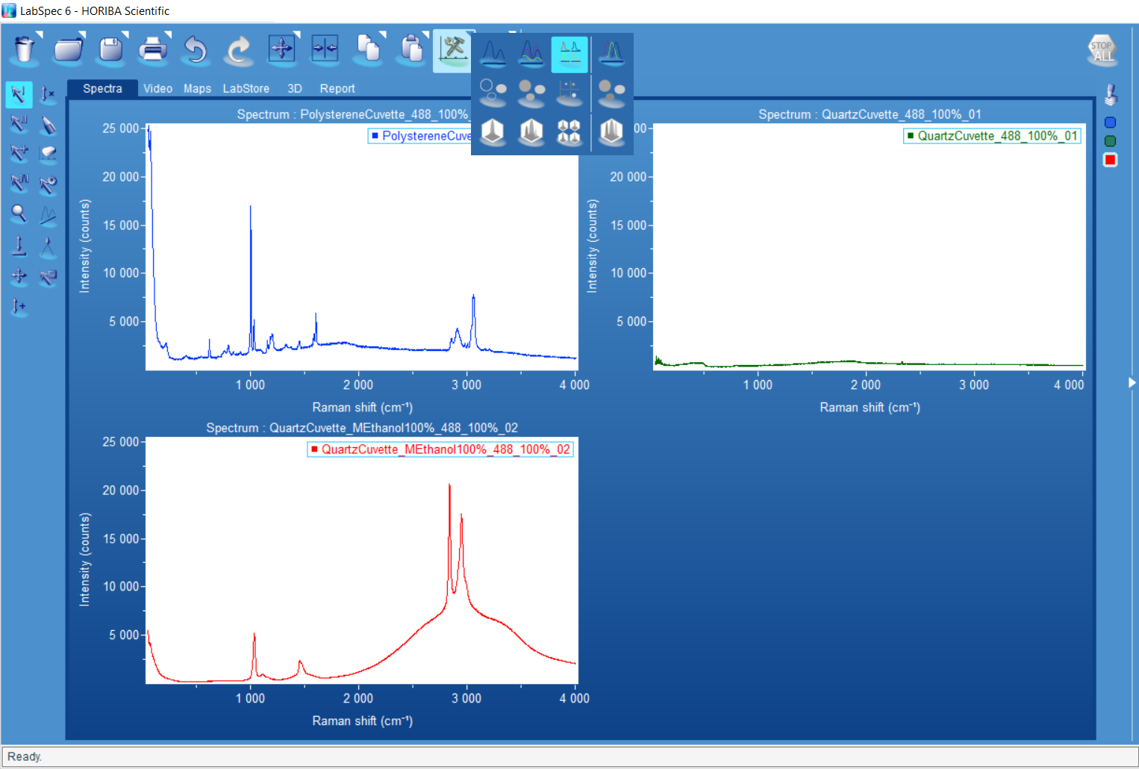
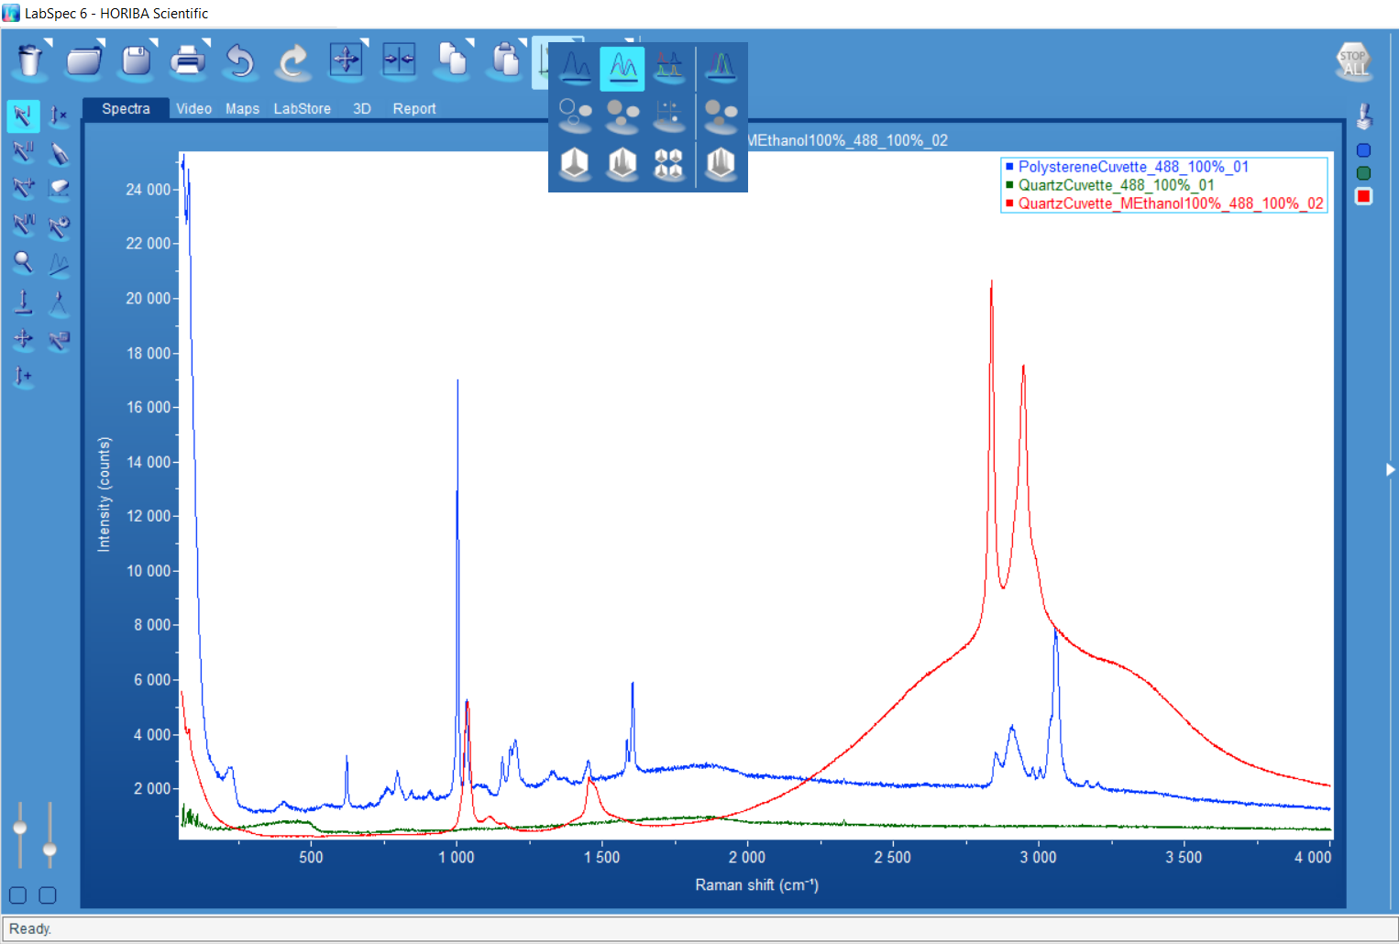
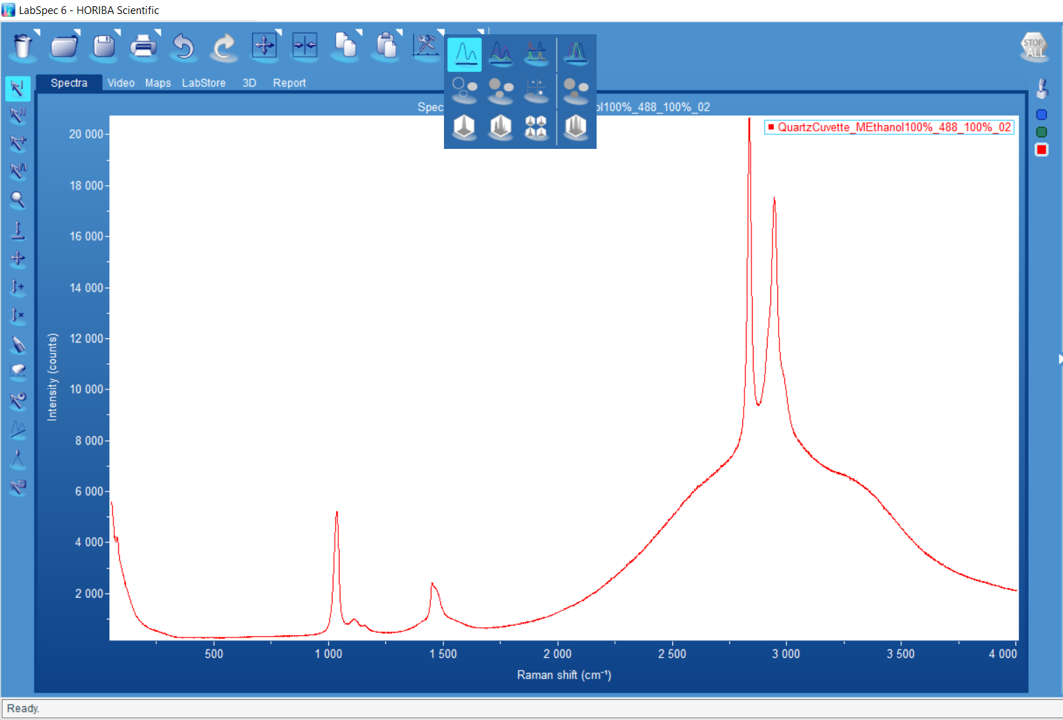
  - Tile to display the data in different windows

- You and also highlight the end column in the data display options to normalize all data.
- Available Cursors in single spectrum,
  - Single line cursor, Intensity and X value and displayed in the Status bar.
  - Double Line Cursor, the position of each cursor and distance between them is displayed in the status bar.
  - Cross hair, Position of the Cursor is displayed in the status bar.
  - Peak Characterization, Peak Area/position are shown on spectrum, Treat these numbers with caution
  - 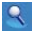Zoom Tool
  - Move region of display
  - Scale intensity (using scroll wheel on mouse)
  - Pen editior
  - Manual Spike remover
  - 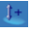Offset data (will alter data)

  - Scale data (will alter data)

- Peak Fitting.
- You may first want to baseline you data prior to fitting
  - Open the processing tab and open the Baselining Window
  - Click Fit and labspec will attempt to fit a basline which will be displayed attached to you data. Leave Attach to curev and Correct Noise Highlighted.
  - If you are not happy with the baseline adjust the degree of freedom (order of polynomial used), Max points (number of baseline points) and Noise points (size of noise), and press fit again.
  - If you are unhappy with the fit or believe labspec is ignoring a region you can use the add baseline tool  to add points to a region by left cliking in that region (the baseline will auto update).
  - Once you are happy press Sud to remove the basline
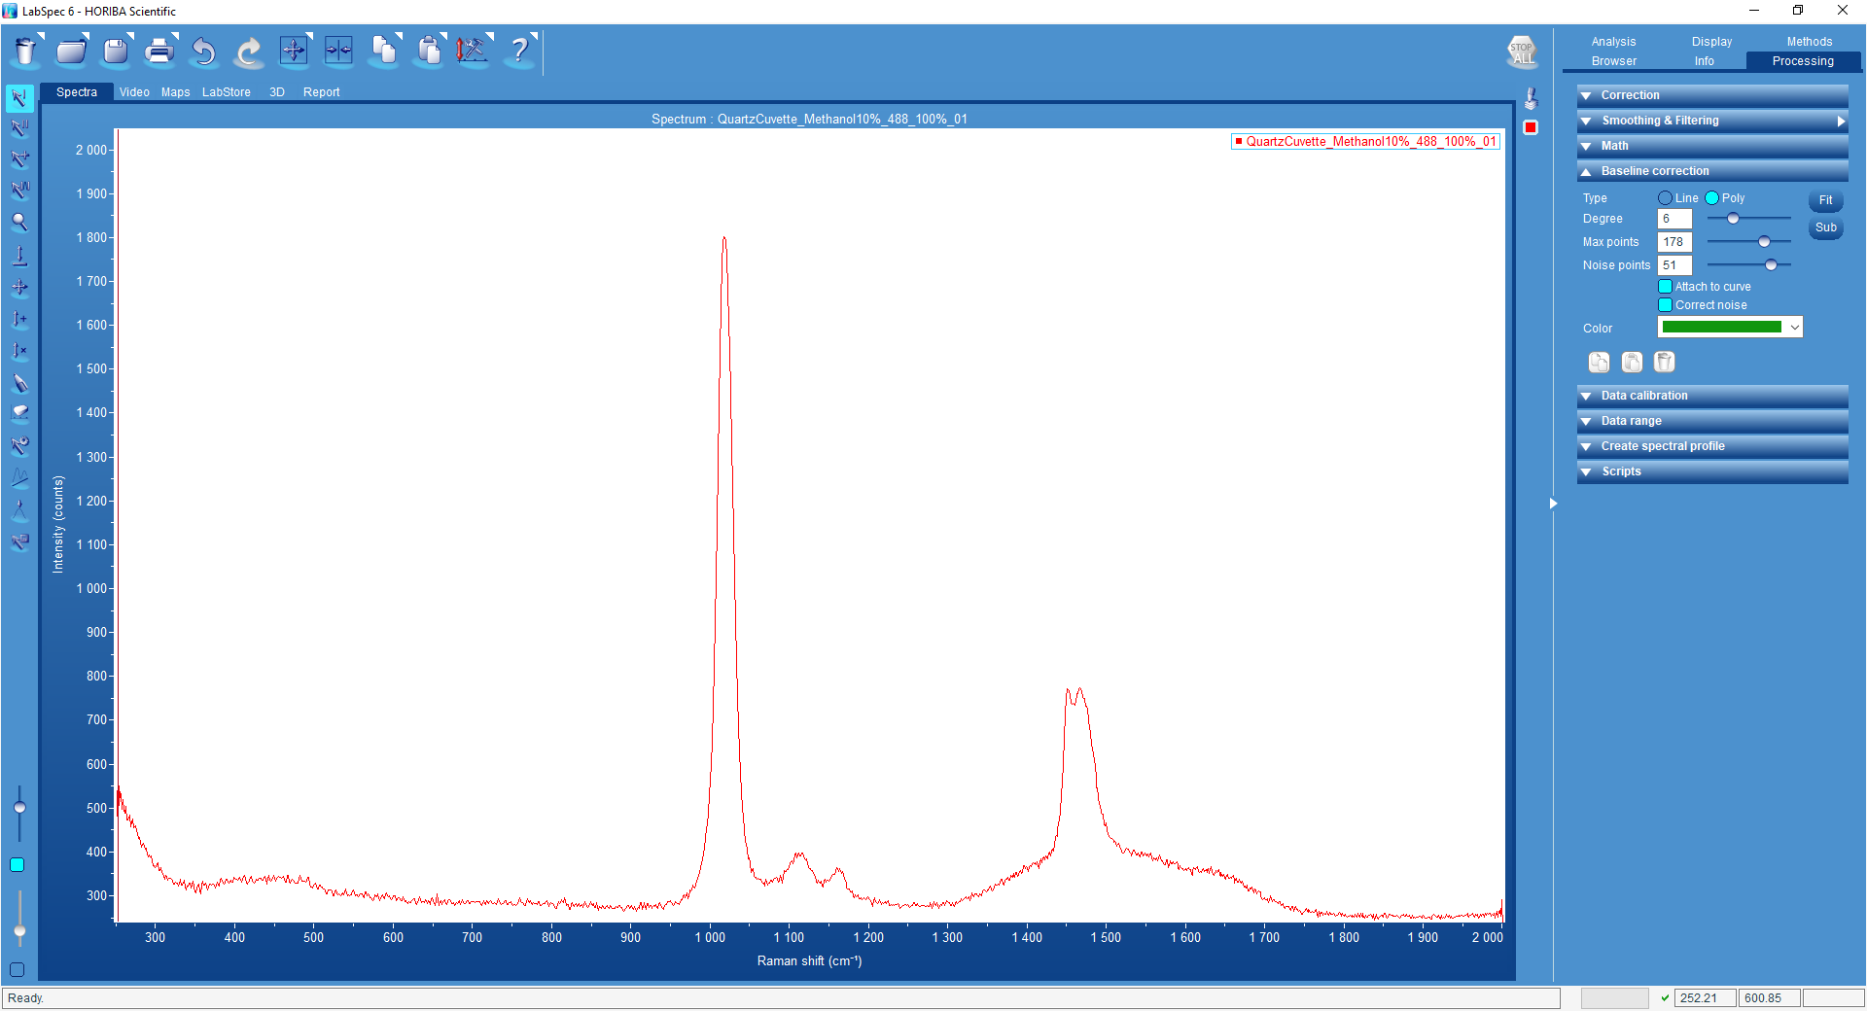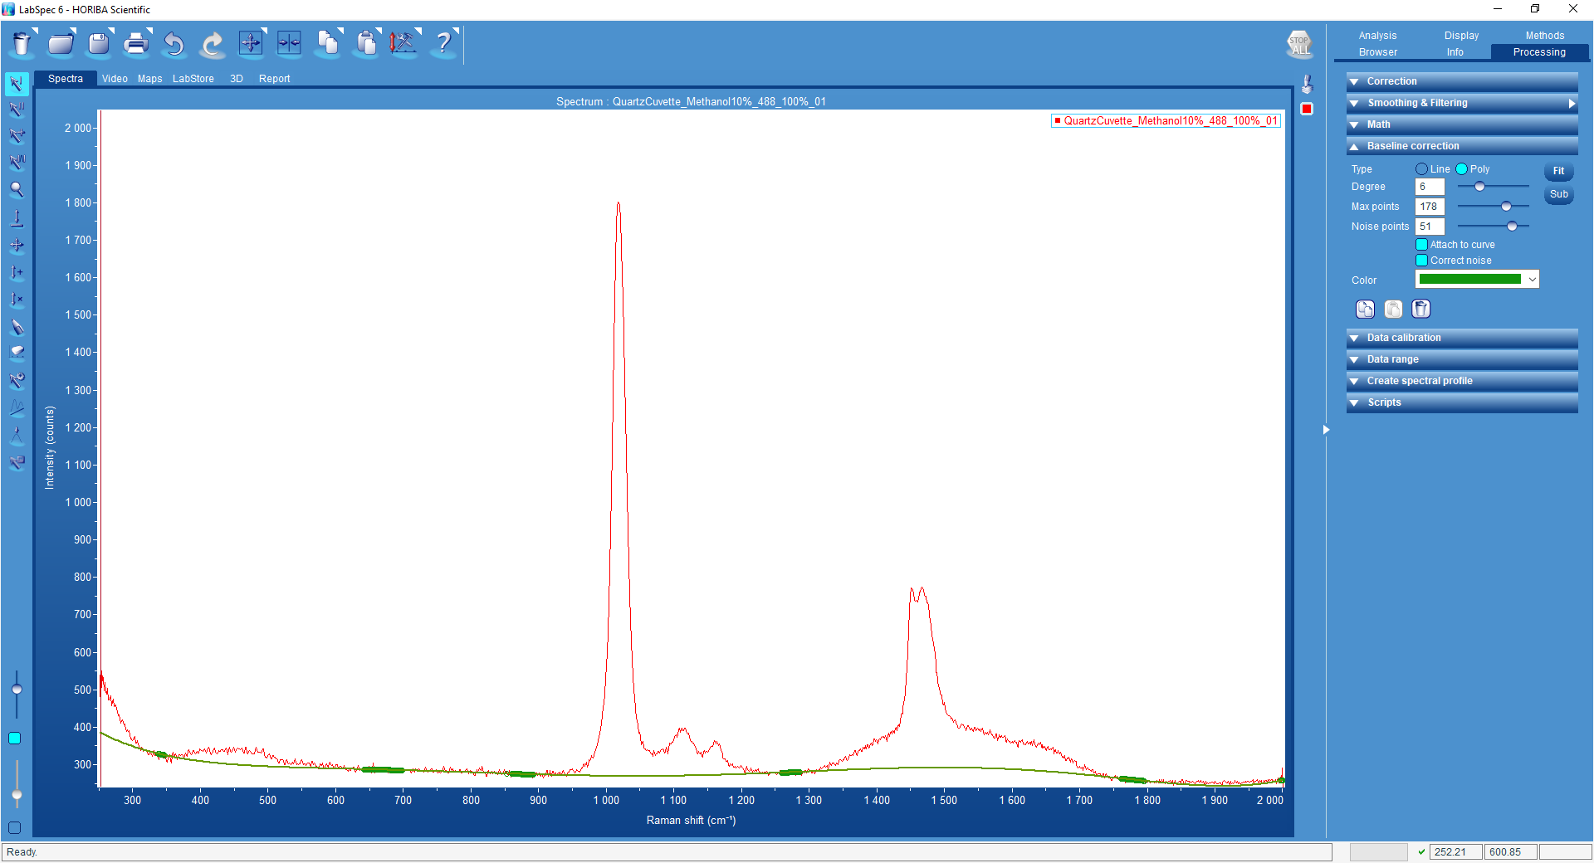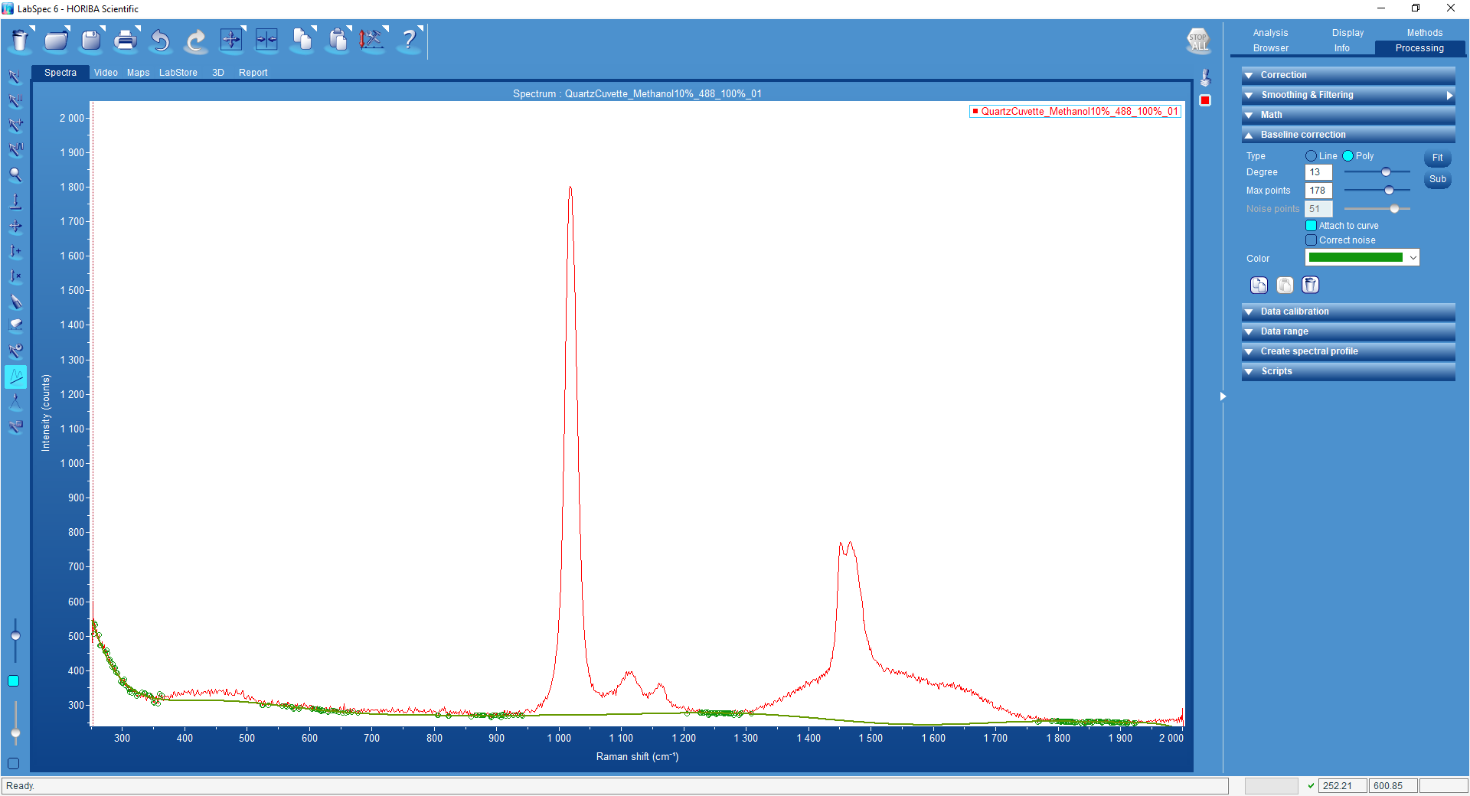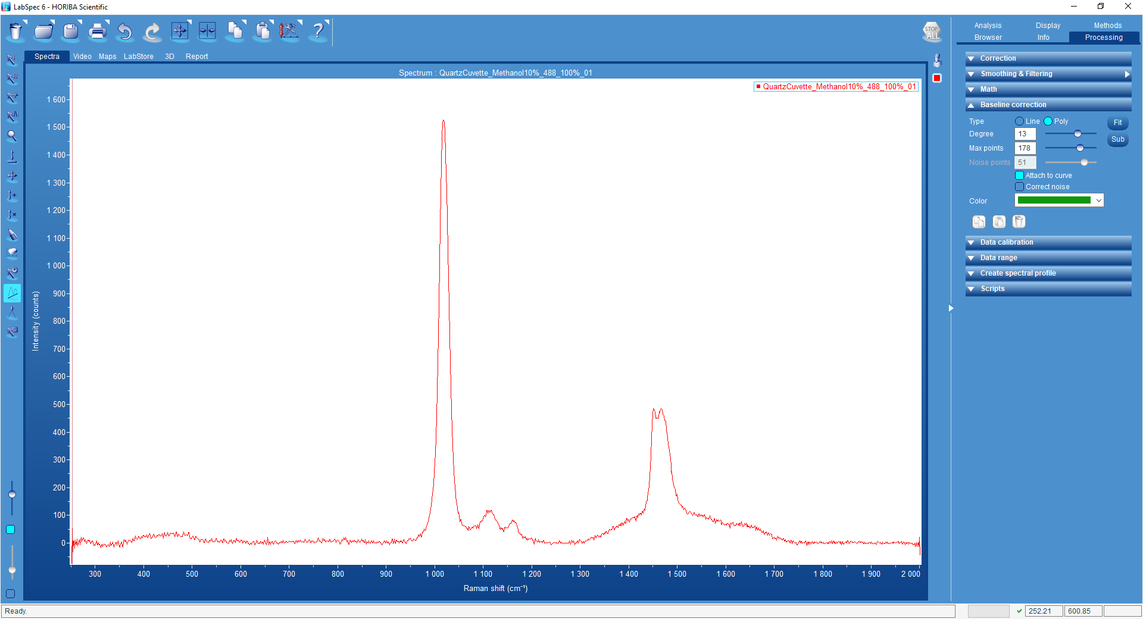
- When ready to fit Select the Analysis tab and the Peaks Widow
- You can select a peak in two ways. (you may use both at the same time)
  - Use the Add Peaks tool by left clicking on the location fo the peak
  - Use the find function
    - To use the find function first set the search parameters
    - Ampl% this is high the peaks are compared to the total height of the spectrum (100% will only find the tallest Peak/ 1% will fit everything including the noise)
    - Size(pix) the expected width of spectral feature in pixels
- Once you have selected you peaks use the drop down to select you line shape
- Under the options tabs you can add some Starting values and constraints.
- When happy Press Fit
- The results are shown on screen you can use the display option to show each peak, the total fit and the residual and all the values are shown in the peak table
- You may want to alter some of the constraints and fit again. To improve the fit if you do this you must re initialize the peaks with the button
- The Copy function in the Peak window can be used to copy the peak table to another program

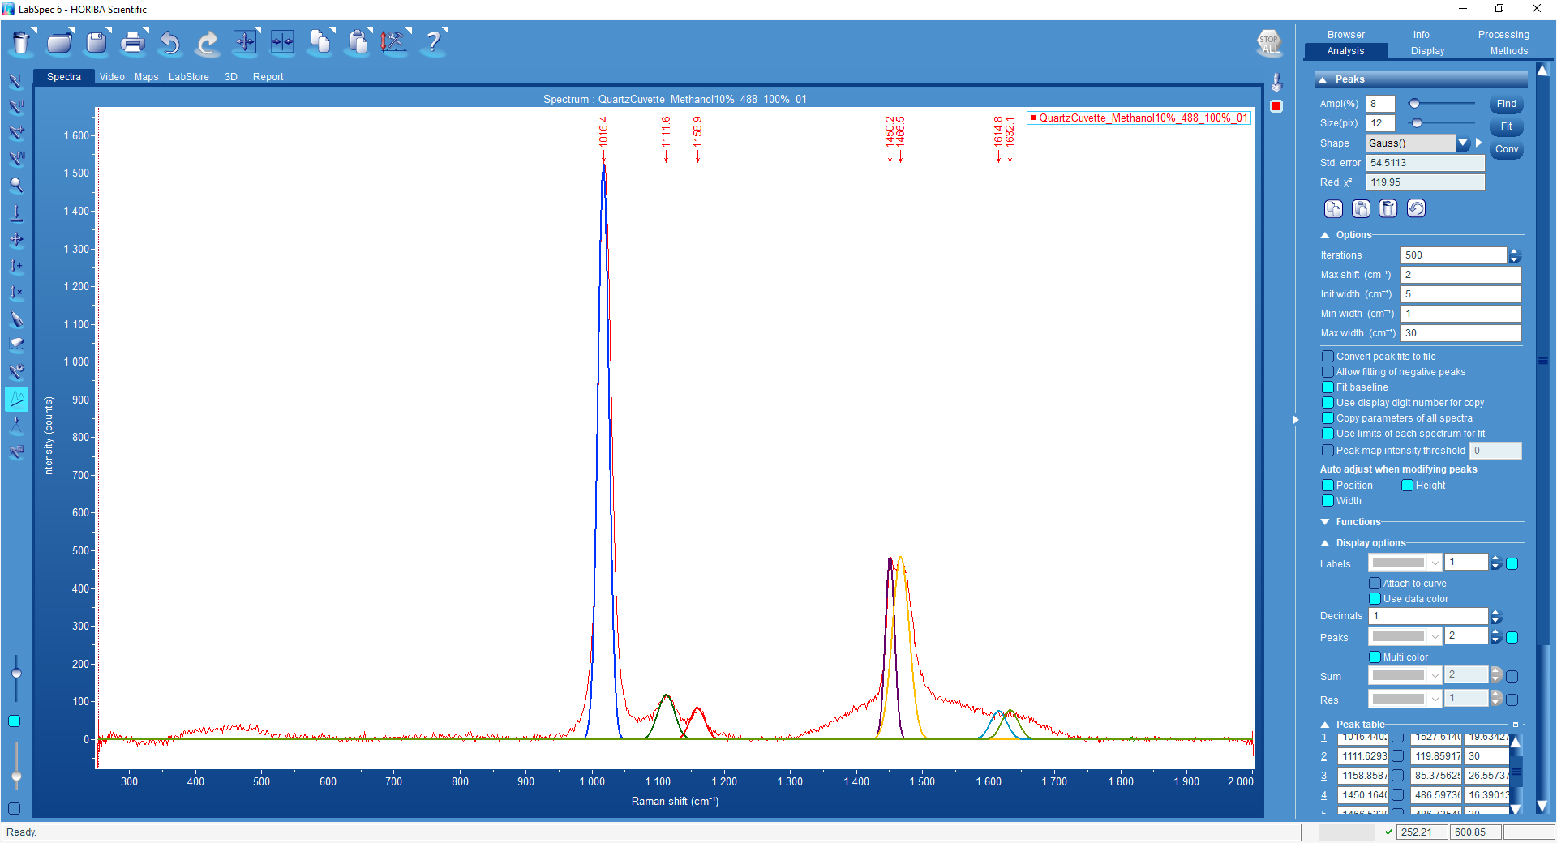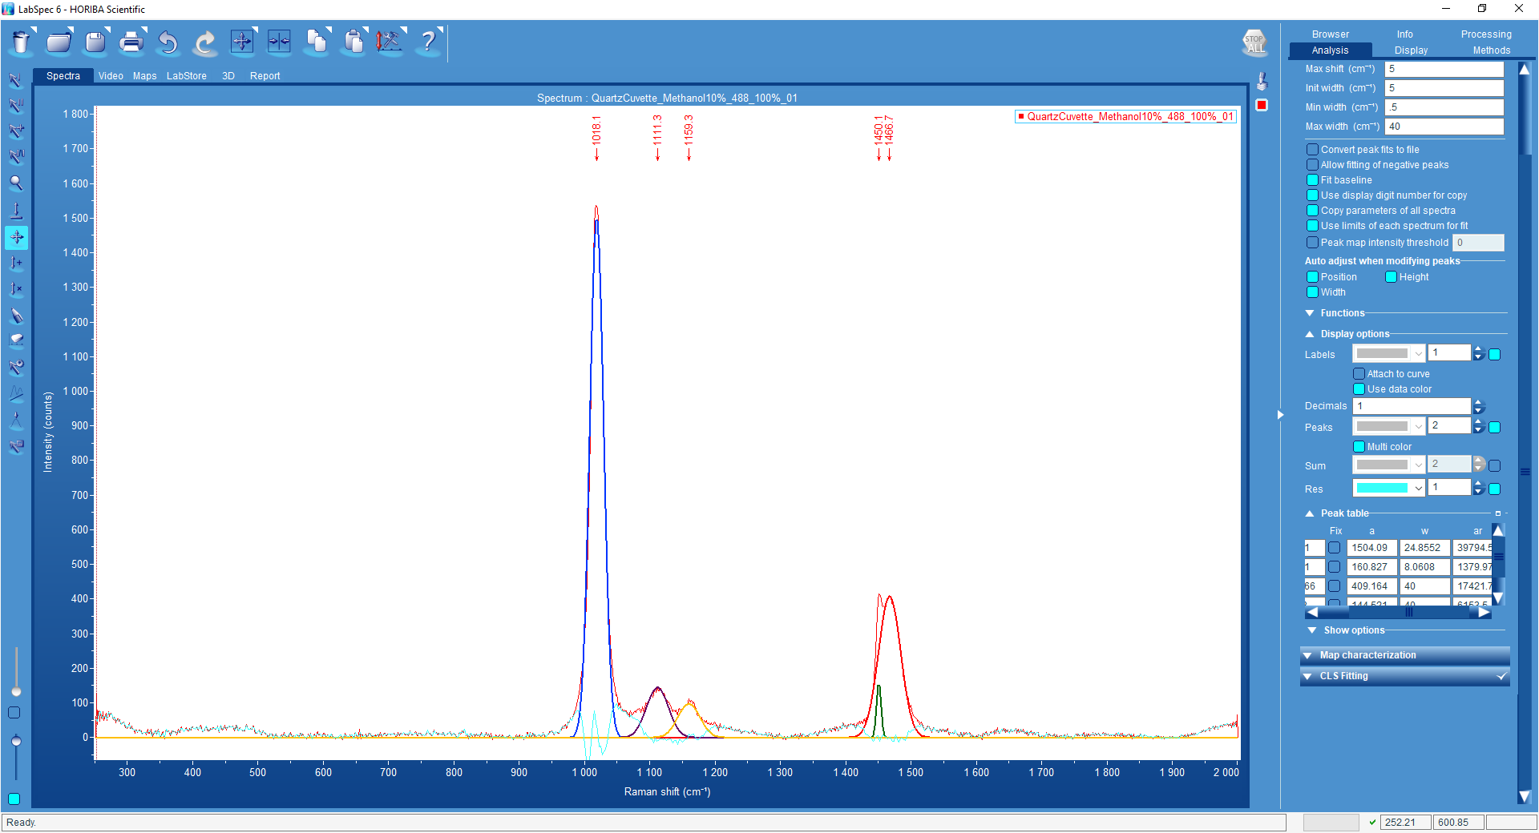

Saving Data

All data should be autosaved as per the instruction I measurement setup and collection but if you may want to save data After processing or export it as a .txt file.
- Make sure that the data you wish to save is selected using the coloured icons on the right of the data.
- Click the Save icon
- Follow the prompts to save the data as a Ls6 or .txt file.
To save an image with scale bars it is best to copy to file.
- Select the Video Pain
- Make sure that the image you wish to save is selected using the coloured icons on the right of the image.
- Confirm the correct objective is selected.
- Highlight the Arrow on the right corner of the copy icon
- Select picture
- Then press save to file
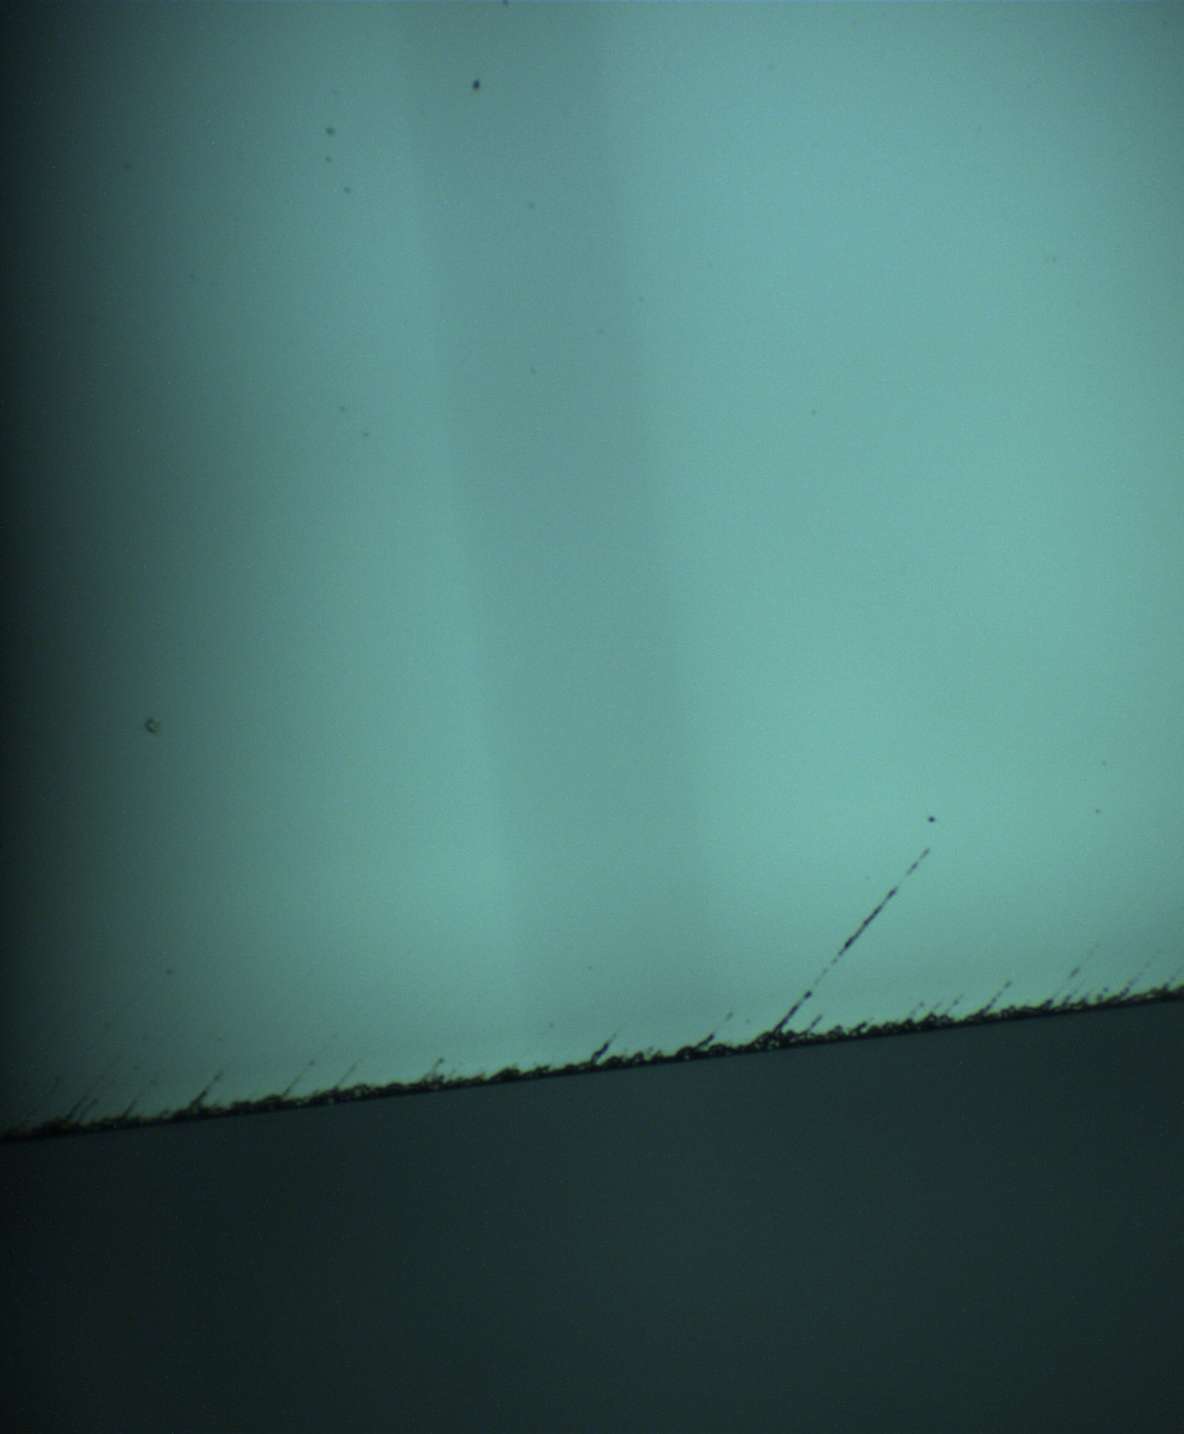
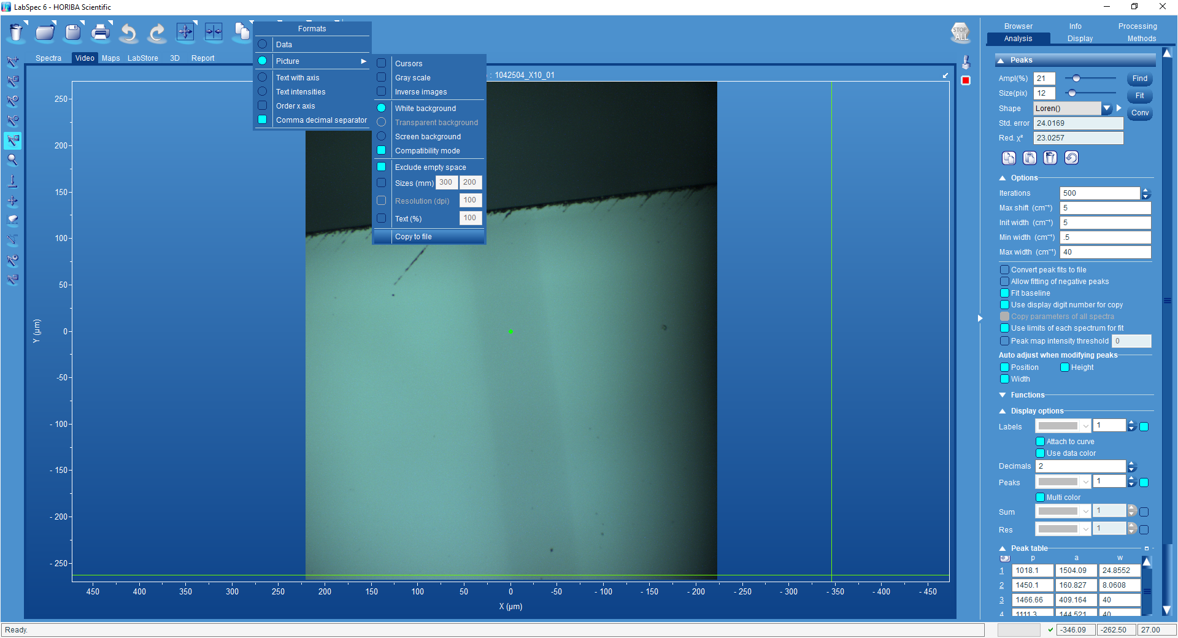
- Follow the prompts to save the data as a jpeg or bitmap.
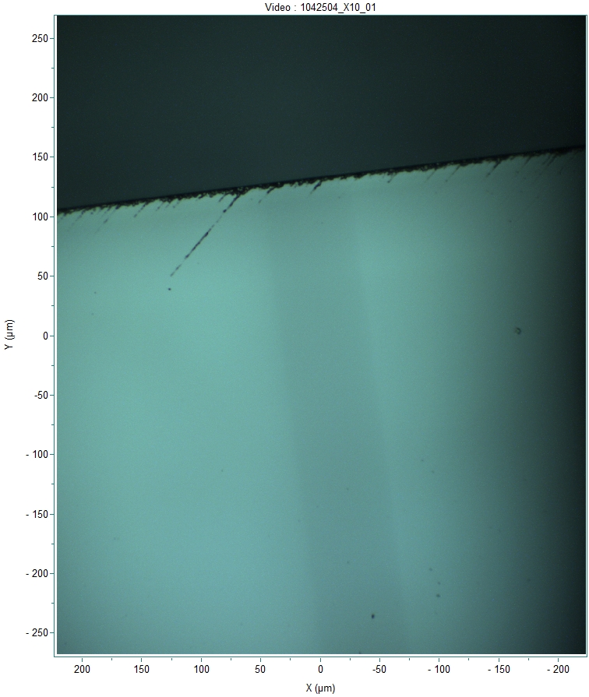

Shut Down

- Remove all samples from the spectrometer
- Close all data in the Browser tab
- Turn off white light
- Leave Spectrometer on and LabSpec 6 open on the PC
- Turn off monitor
- Leave Spectrometer on.
- Report any faults to Spectroscopy@warwick.ac.uk

Appendix A:

Gratings guide

Laser | Default Grating | comments
488 nm | 1800 l/mm | Default
488 nm | 600 l/mm | Lower resolution but better for polarization studies
488 nm | 3000 l/mm | Very high resolution only available upon request
660 nm | 600 l/mm | default

Appendix B

Confocal pinhole Hole

The confocal pinhole affects the sample analysis volume, and the confocal performance of the system. Running a system in confocal mode provides the very best spatial resolution in XY and Z dimensions. Generally, the confocality should be adjusted to match the analysis required; it is strongly dependent on the chosen objective too (see below).

Large value >100: low spatial resolution and non-confocal analysis; higher signal due to large sample analysis volume. Useful for macro measurements and bulk analysis.

Small value <75: high spatial resolution and confocal analysis; lower signal due to small confocal sample analysis volume. Useful for high spatial resolution of microscopic particles and features.

Objectives
Standard objectives for the visible range are x10, x50, x100 objectives.

With high magnification objectives (such as x50, x100) the achievable spatial resolution is high, and laser power density on the sample is also high. These objectives are particularly well suited for working with opaque samples and microscopic features.

With low magnification objectives (such as x10, x20) the achievable spatial resolution is low, and laser power density on the sample is also low. These objectives are particularly well suited for working with transparent samples, liquid samples, and macroscopic features.

