iN10 – Basic operation
Written by: | Dr B G Breeze | 20/10/20
Amended by:

IMPORTANT
Spectrometers must only be operated by authorized personal, who have had a full induction into working in the Spectroscopy labs and completed local training. A list of trained personal can be found in the webgroup px-OpticalAbsortion-users.

Before beginning any experiment do a quick visual inspection of the spectrometer to confirm it looks in good working order and no previous experiment is left in place. If you have any issues, please contact a member of RTP staff.

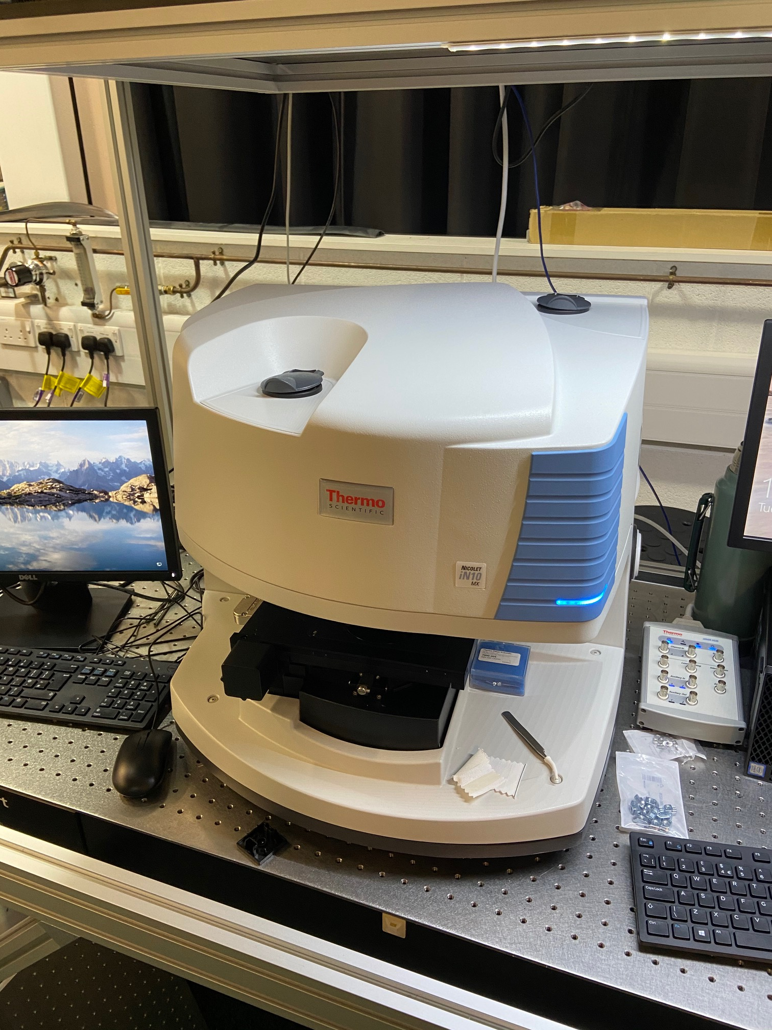
Start of session
- The spectrometer should be on when you arrive. If it is not please turn it on with the power switch on the back left of the spectrometer. (if in doubt contact RTP staff)
- If you have turned the spectrometer on please wait a few minutes whilst it goes through its start up, it is normal for it to make some grinding noises during setup
- Launch the OmnicPicta software with the icon on the desktop.
- Once this is complete the Software will run some health checks on the spectrometer if these fail contact RTP staff. If they pass you will seen a reassuring green tick!
Cooling the Detectors

- The iN10 is equipped with three detectors, a room temperature detector, a LN₂ cooled MCT detector and a LN₂ cooled MCT Array detector for fast mapping. You only need to cool detector you intend to use. And the Process of cooling the two cooled MCT is the same.
- Filling the detectors must be performed slowly or you will cause damage to the spectrometer.
- Insert one of the filling funnels into the detector. (they have a long metal tube attached and are kept on the shelf above the spectrometer)
- Take one of the thermos flasks and fill ¾ with LN₂. You will need to use one of the large funnels from the cryogen area. each detector takes roughly 700 ml of Ln₂ to cool from room temp roughly ½ the flask.
- First put approximately 2 funnels full of LN₂ into he detector and wait a few minutes for the detectors to initially cool. There may be a lot of boil off an spitting during this first fill so take you time.
- Once the boil off has stopped continue to slowly fill the detector. DO NOT allow access LN₂ to over flow as this can cause damage
- Once the detector is full wait for 10 minutes for the detector to stabilise before starting measurements.

Loading Samples

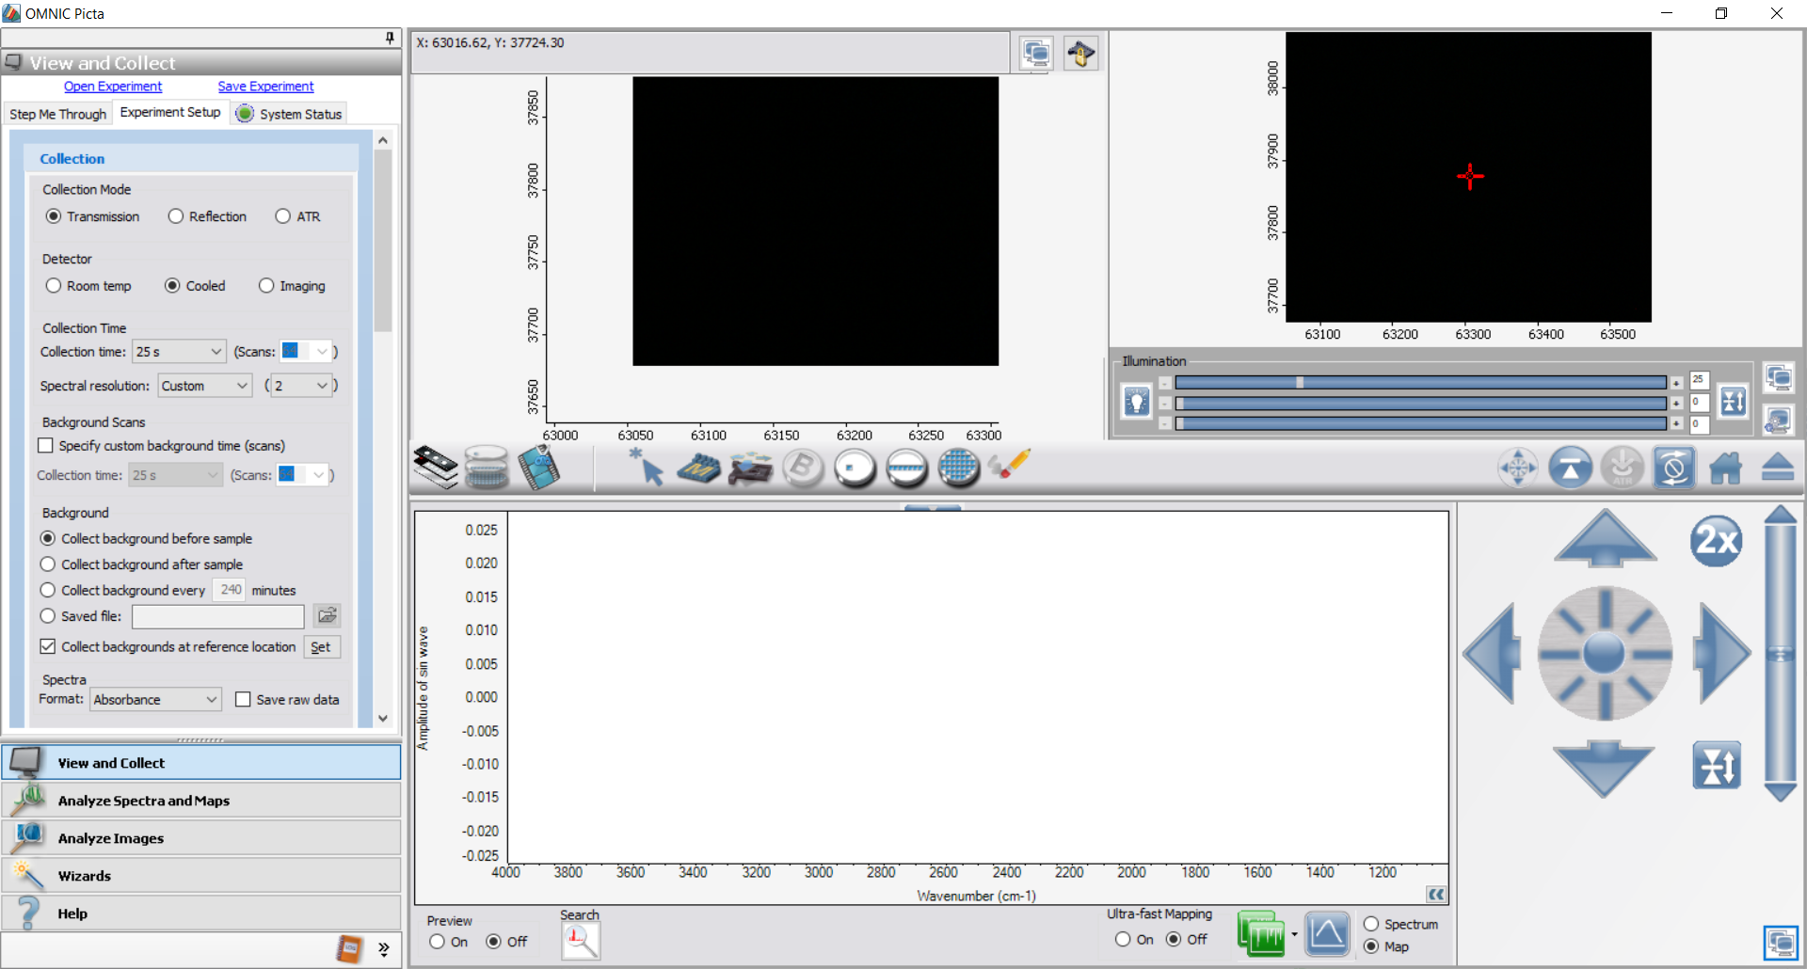
- When you arrive at the spectrometer the motorised stage should be in the ejected position. If not please eject it prior to loading sample using the load/eject Stage button in the picta software.
- First remove the round slide holder from the motorised stage.
- Place the desired slide in the slide holder (see appendix for options)
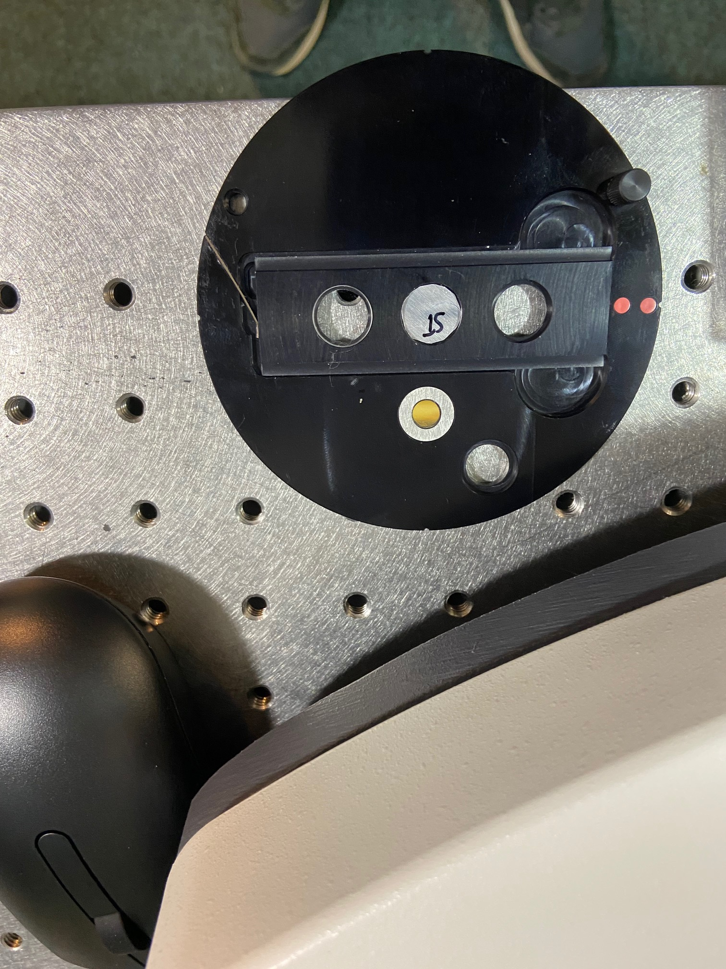
- Replace the round slide holder in the motorised stage ensuring that the red dots align. 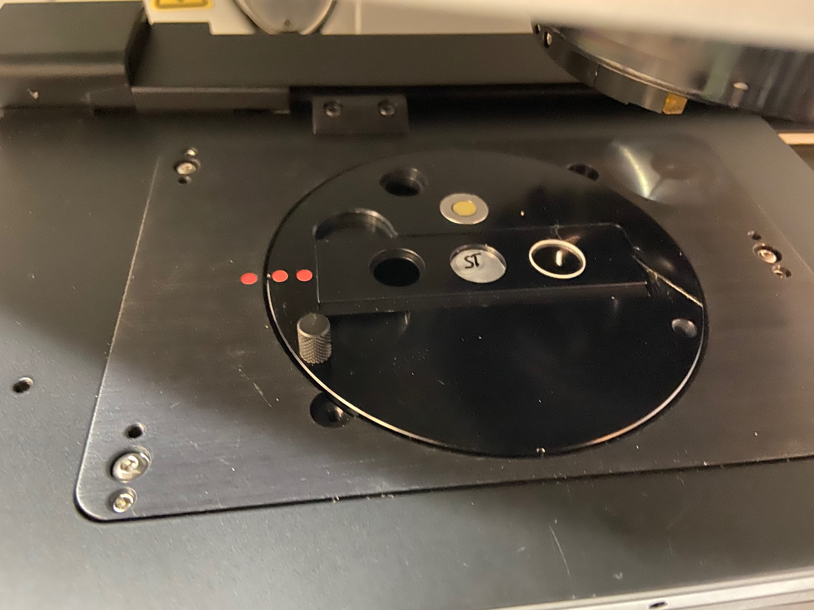
- Load the sample using the load stage button in the software
Setting Map Area

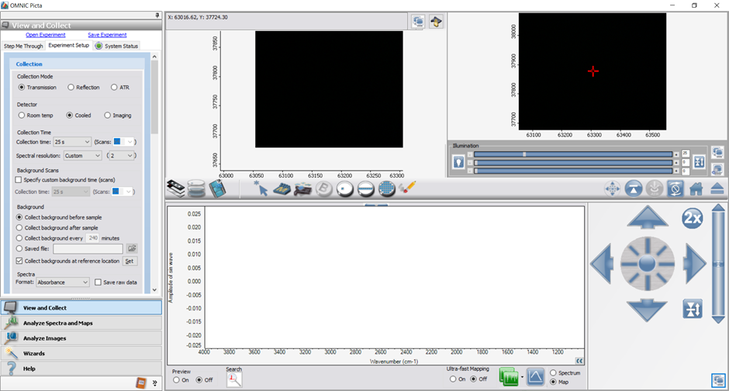

- First use the slide menu in the middle bar to portion the stage roughly over your sample
  - Select slide menu
  - Select the used slide from the options
  - Click on the sample position on the
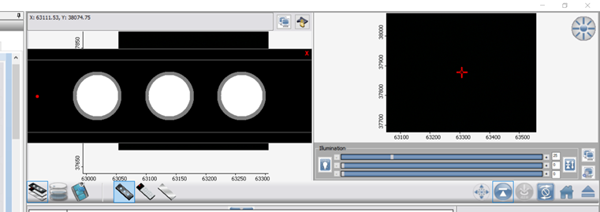
- once the stage has moved to the rough sample position open the joy stick using the positioning icon . This will maximise the joystick in the bottom left
- Focusing on the sample
  - First turn the reflection light on to around 25% using the top of the light slider.
  - The live feed of the sample will appear in the top right hand window
  - To position the sample in and XY plane use either the arrow to take discrete steps or the central circular icon to continuously move. The further across you move the dot the faster the stage will move. You can change the responsiveness of the stage by clicking on the response button that will toggle between 1x/2x/3x.
  - To focus the sample in Z use the bar on the left hand side as with the XY you can use either the arrow to take discrete steps or the central circular icon to continuously move. The further across you move the dot the faster the stage will move. You can change the responsiveness of the stage by clicking on the response button that will toggle between 1x/2x/3x.
  - Once you are focused you may need to adjust the light level using the slider.
- If you are performing transmission measurement once you have focused on the sample you will need to run the beam condesor optimistaion
  - Select the beam condenser menu using
  - Then select optimise condenser
  - The bar on the left of the menu should go green if not contact RTP staff.
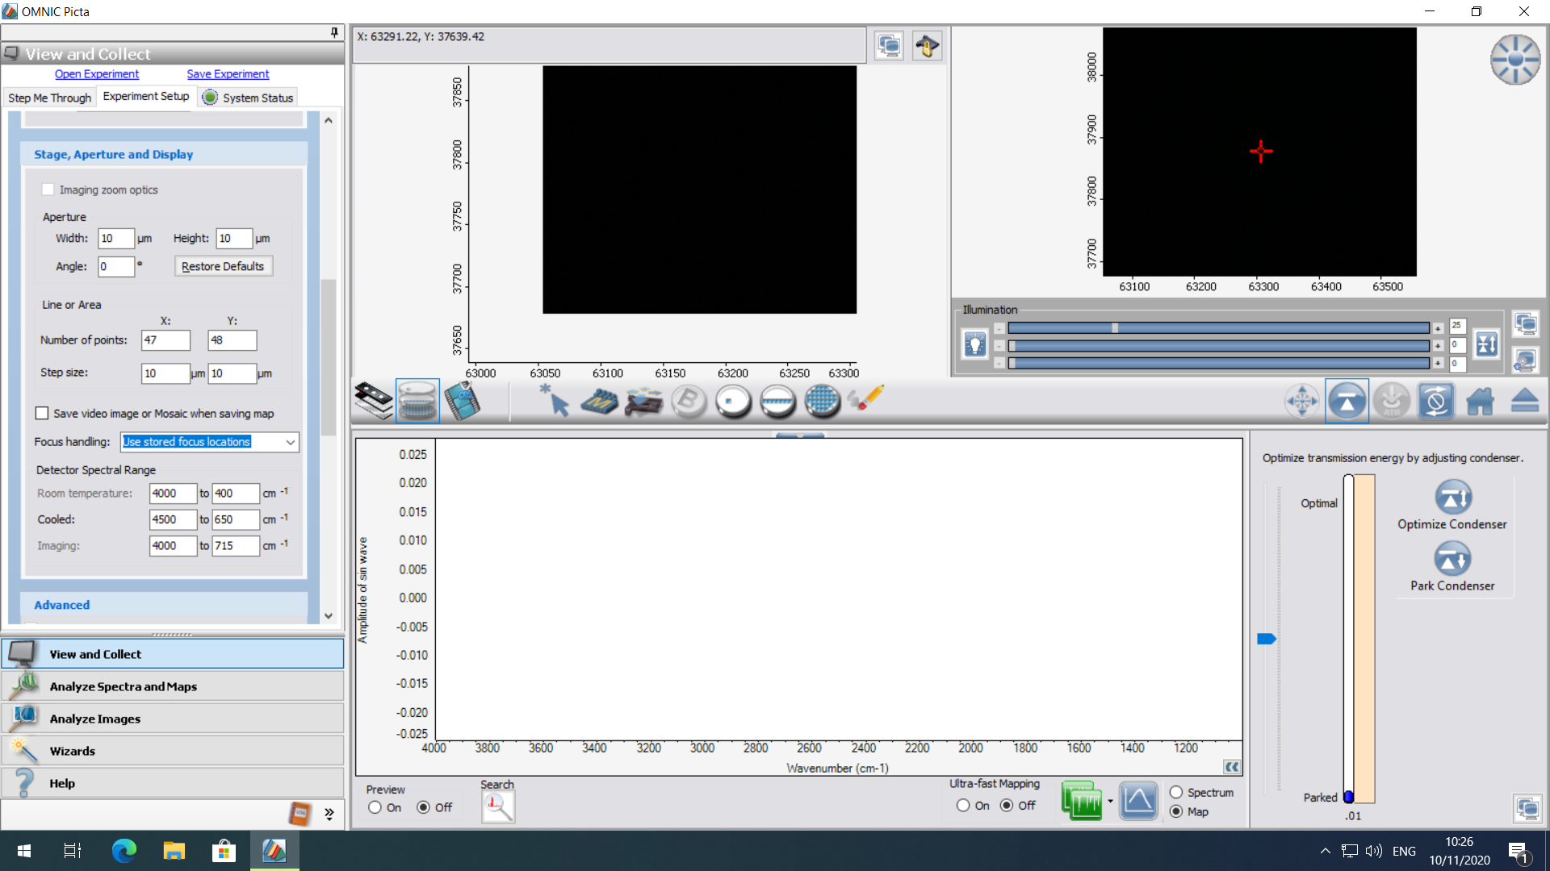
- The image on the top right is the live feed of you sample the image in the centre is a stored image or mosaic of the sample
- If there is anything displayed in the mosaic area from previous users right click on the image and select “delete mosaic” and “delete Map Area” and “Delete Backgroud”
- It my be necessary to initialise the zoom on the mosaic area to do the scroll the middle mouse button until the mosaic image matches the live feed.
- On the middle bar select the Map view option using the 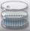 button
- Use the scroll button to zoom out to the approximate area you wish to map
- Select the Area tool, , and draw a box on the mosaic window.
- Use the capture mosaic, , button to collect the mosaic
- Once you have collected the image you can redraw the Map you wish to collect. You can either select a point map, a line map, ,or an area. then draw the map on the image.

Setting parameter,
- The parameter for measurement can be selected on the left hand column when you have the View and Collect tab initiated.
- Under the Collection Box you need to set the following
- Select the appropriate collection mode
  - Transmission – For transparent samples on a microscope slide or on aperture
  - Reflection – for solid and opaque sample where surface analysis is required
  - ATR – For samples where contact based measurements are possible (see separate SoP
- Select Detector
  - Room Temp– for general set up and point anaylisi of strong signals
  - Cooled – For mapping measurements
  - Imaging – for rapid collection of maps over large areas
- Select you resolution. The defaults are High (4 cm⁻¹), medium (8 cm⁻¹), low (16 cm⁻¹) you may also select custom to select other options. The higher the resolution will allow detection of sharp features but will result in a noiser spectrum (or longer acquisition times)
- Select the collection time.
- Under background scans you can select to collect the background for a different number of scans. As default the background will be collected for the same time as the measurements.
- Under Background select when you want you back ground to be taken from the options. You can also select to have the back ground taken from the reference location on the slide. If this box is ticked the sample slide will move the to gold dis or window to make a measurement. If not you will need to use the to select a background location on the mosaic image.
- Uning the drop down box under Spectral format, you can chose the Y axis for you experiment. You can usually transform the data after collection.
- In the stage aperture and display you can adjust the following
- Enter the X and Y size of your aperture (this is the size of spot that will be measured). The default is a 100 um x 100 um but both x and y can be set between 10 – 200 um. The smaller the window the noiser the spectrum will be.
- Enter the number of points or step size for you map.
- At the bottom of this box you can also adjust the spectral range it is recommended you stick to the defaults as out side this range the efficiency is much less and will result in a noisy spectrum:
Detector | Default (recommended) | Maximum Range
Room Temp | 4000 cm⁻¹ - 400 cm⁻¹ | 7000 cm⁻¹ - 400 cm⁻¹
Cooled | 4000 cm⁻¹ - 650 cm⁻¹ | 7000 cm⁻¹ - 650 cm⁻¹
Imaging | 4000 cm⁻¹ -715 cm⁻¹ | 7000 cm⁻¹ -715 cm⁻¹

Data Collection and Saving
- To start the scan press the collect spectra icon, , on the bottom of the window
- You will be asked to enter a file name and location. It is recommended you store the file in the default location and move it once it have finished. There is a short cut to the default data location on the desktop.
- The microscope will move to the background location and take the background
- The microscope will begin taking the data
- Data will have auto Saved as a .map file there is a matlab script available to open the data on you PC. If you do not have access to matlab please talk to RTP staff.

End of session

- Eject the Stage using the eject button and remove you samples
- Leave PC and Spectrometer turned on
- Make sure to leave the bench in a tidy state.

