IS50R – Basic operation
Written by: | Dr B G Breeze | 20/09/20
Amended by:

IMPORTANT
Spectrometers must only be operated by authorized personal, who have had a full induction into working in the Spectroscopy labs and completed local training. A list of trained personal can be found in the webgroup px-OpticalAbsortion-users.

Before beginning any experiment do a quick visual inspection of the spectrometer to confirm it looks in good working order and no previous experiment is left in place. If you have any issues, please contact a member of RTP staff.

Not ATR not installed. 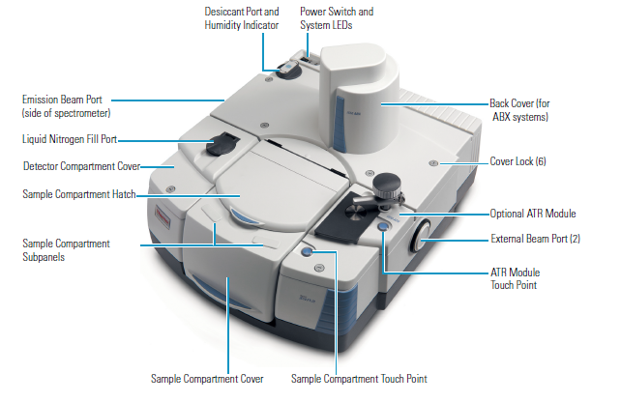
Note ATR not installed as standard on RTP system

Start of session
- The spectromter should be on when you arrive. If it is not please turn it on with the power switch on the back left of the spectrometer. (if in doubt contact RTP staff)
- If you have turned the spectrometer on please wait a few minutes whilst it goes through its start up, it is normal for it to make some grinding noises during setup
- Launch the Omnic software with the icon on the desktop.
- Once you boot the software select the desired experiment from the drop down menu (Transmission E.S.P is the default)
- Once this is complete the Software will run some health checks on the spectrometer if these fail contact RTP staff. If they pass you will seen a reassuring green tick!
Spectrometer setup
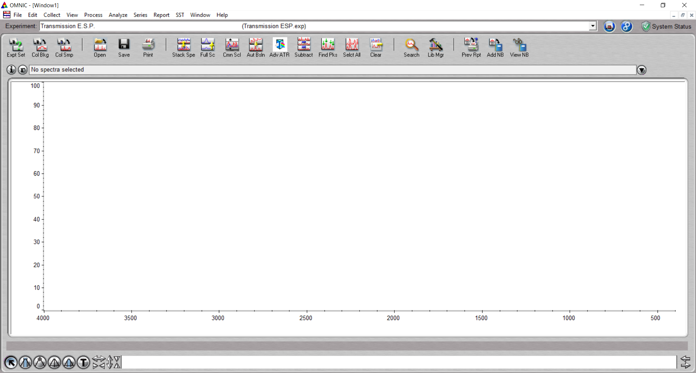

- To start a new experiment it is usually best to start with a fresh experiment window to open one click Window>new window and assign a name
- Then click the Expt Set icon on the left of the tool bar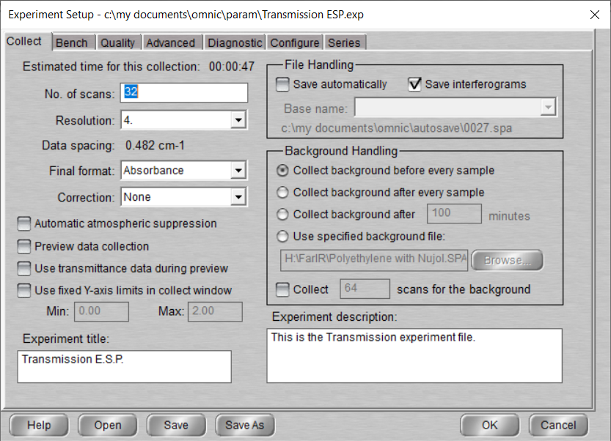
- Use the Collect tab to set the following
  - Set the desired number of scan (you can change this later)
  - Set the desired resolution
  - To change the Y axis from Transmission to Absorbance
  - You can also apply correction (this is better done post data collection)
  - You an use the file handling box to Autosave the data as you go along it will save the file to the shown path and auto number the files to a set base name
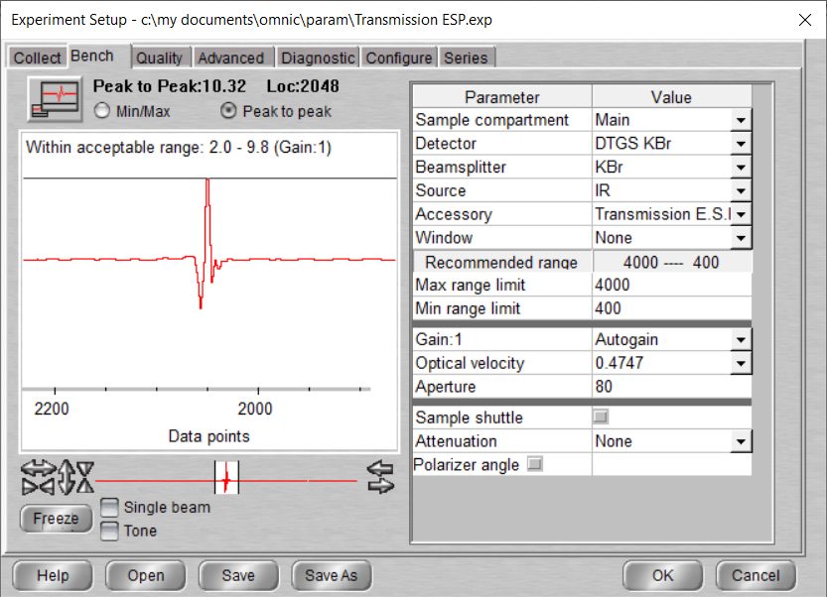
  - Select the desired Backgrounding method. Before every sample is the default. (see notes on other options)
- Use Bench Tab to set the spectra range
  - Use the drop down menu to select the desired Source, Beamsplitter and detector. See notes section for the available combinations.
  - If the desired part is not shown please contact RTP staff to have it activates.
  - Once you have selected the configuration the optimal range is shown in the Recommend range widow you can over ride this using the limits boxes. (Please Be aware that it is better to select an improved configuration than extend the range manually. See notes section for the available)
  - You can Set the gain to optimise the interferogram shown on the left (it should have a peak to peak value of between 10 and 6)
  - Set the aperture size. If the selected aperture is too large for the requested resolution the software will correct it. It wont increase the aperture if you lower the resolution.
- Press OK to close the window

Making a measurement (method assumes Backgrounding before Sample)

- To take a back ground you must first select the appropriate aperature from the sample slides (located on the shelf above the spectrometer)
- To load you sample slide
  - Then open the sample compartment lid
  - Slide the sample Slide into the sample holder
  - Use the reflect laser line to ensure the aperture is central and at the right height
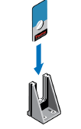
  - If required adjust the sample height using the thumb screw
- Close sample compartment
- the experiment setup click the Col Smp icon on the tool bar
- Add in you sample Title (file name)

If you have selected “collect background after x minutes”
- In he experiment setup click the Col bkg icon on the tool bar
- Confirm you are ready to background when prompted
- Background will collect
- When completed you will be given options to increase the number of scan follow the onscreen prompts if required
- Once happy you will be asked if you want to add the sample to your window (you do not need to)
- Once the back ground has been collected Place the Sample in the compartment
  - Open the sample compartment lid
  - Remove the Sample slide with Aperture
  - Close sample compartment lid
  - Affix sample over aperture (blutack/tape)
  - Open sample compartment lid
  - Replace sample and sample slide in the sample holder
  - Close Sample compartment lid

- Once Sample collection is complete you will be given the option to
  - Take more scans
  - Oncehappy Click Yes to add the spectra to yoru workspace window
Go to viewing and saving
If you have selected “collect background before every sample”
- the experiment setup click the Col Smp icon on the tool bar
- Add in you sample Title (file name)
- Confirm you are ready to background when prompted
- Background will collect
- Once completed you will be promted to place sample in the spectrometer
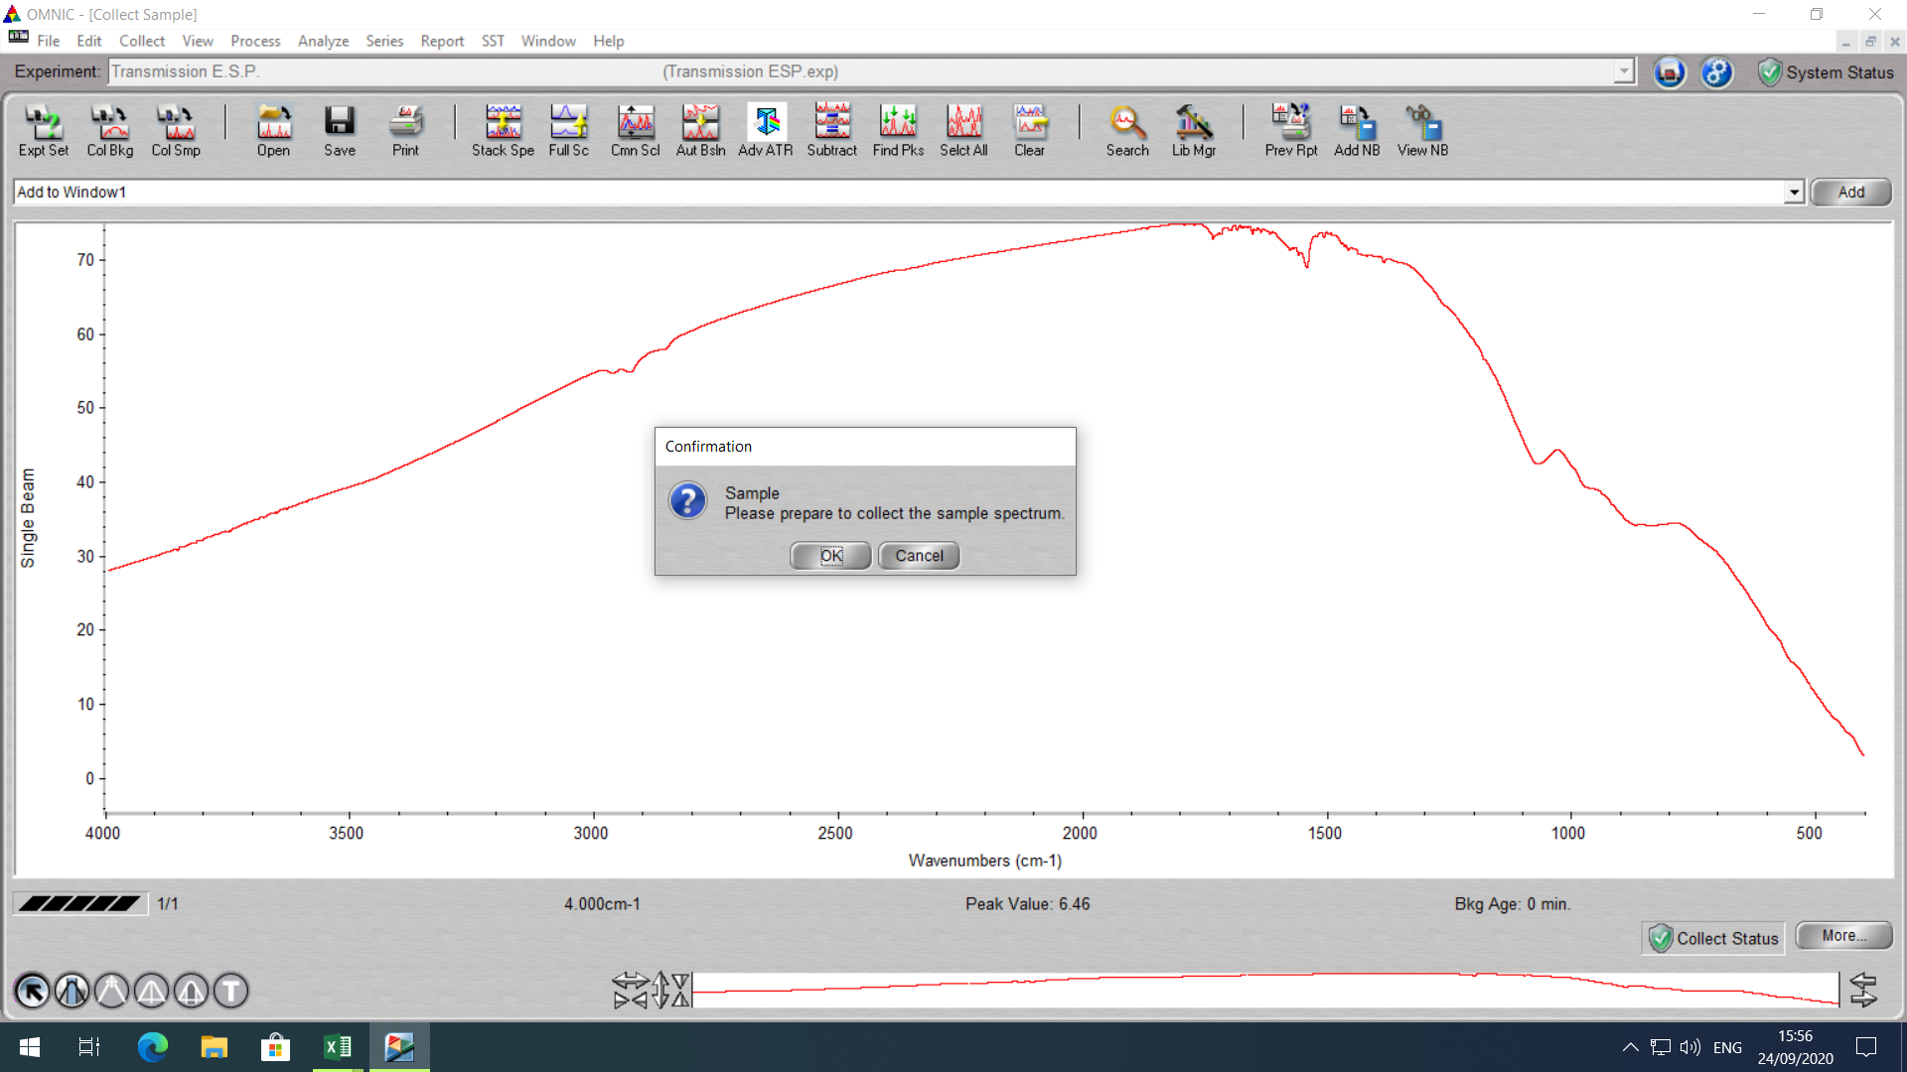
- Placing a sample
  - Open the sample compartment lid
  - Remove the Sample slide with Aperture
  - Close sample compartment lid
  - Affix sample over aperture (blutack/tape)
  - Open sample compartment lid
  - Replace sample and sample slide in the sample holder
  - Close Sample compartment lid
- Click OK and Sample collection will begin
- Once Sample collection is complete you will be given the option to
  - Take more scans
  - Oncehappy Click Yes to add the spectra to yoru workspace window
Go to viewing and saving

Viewing and Saving
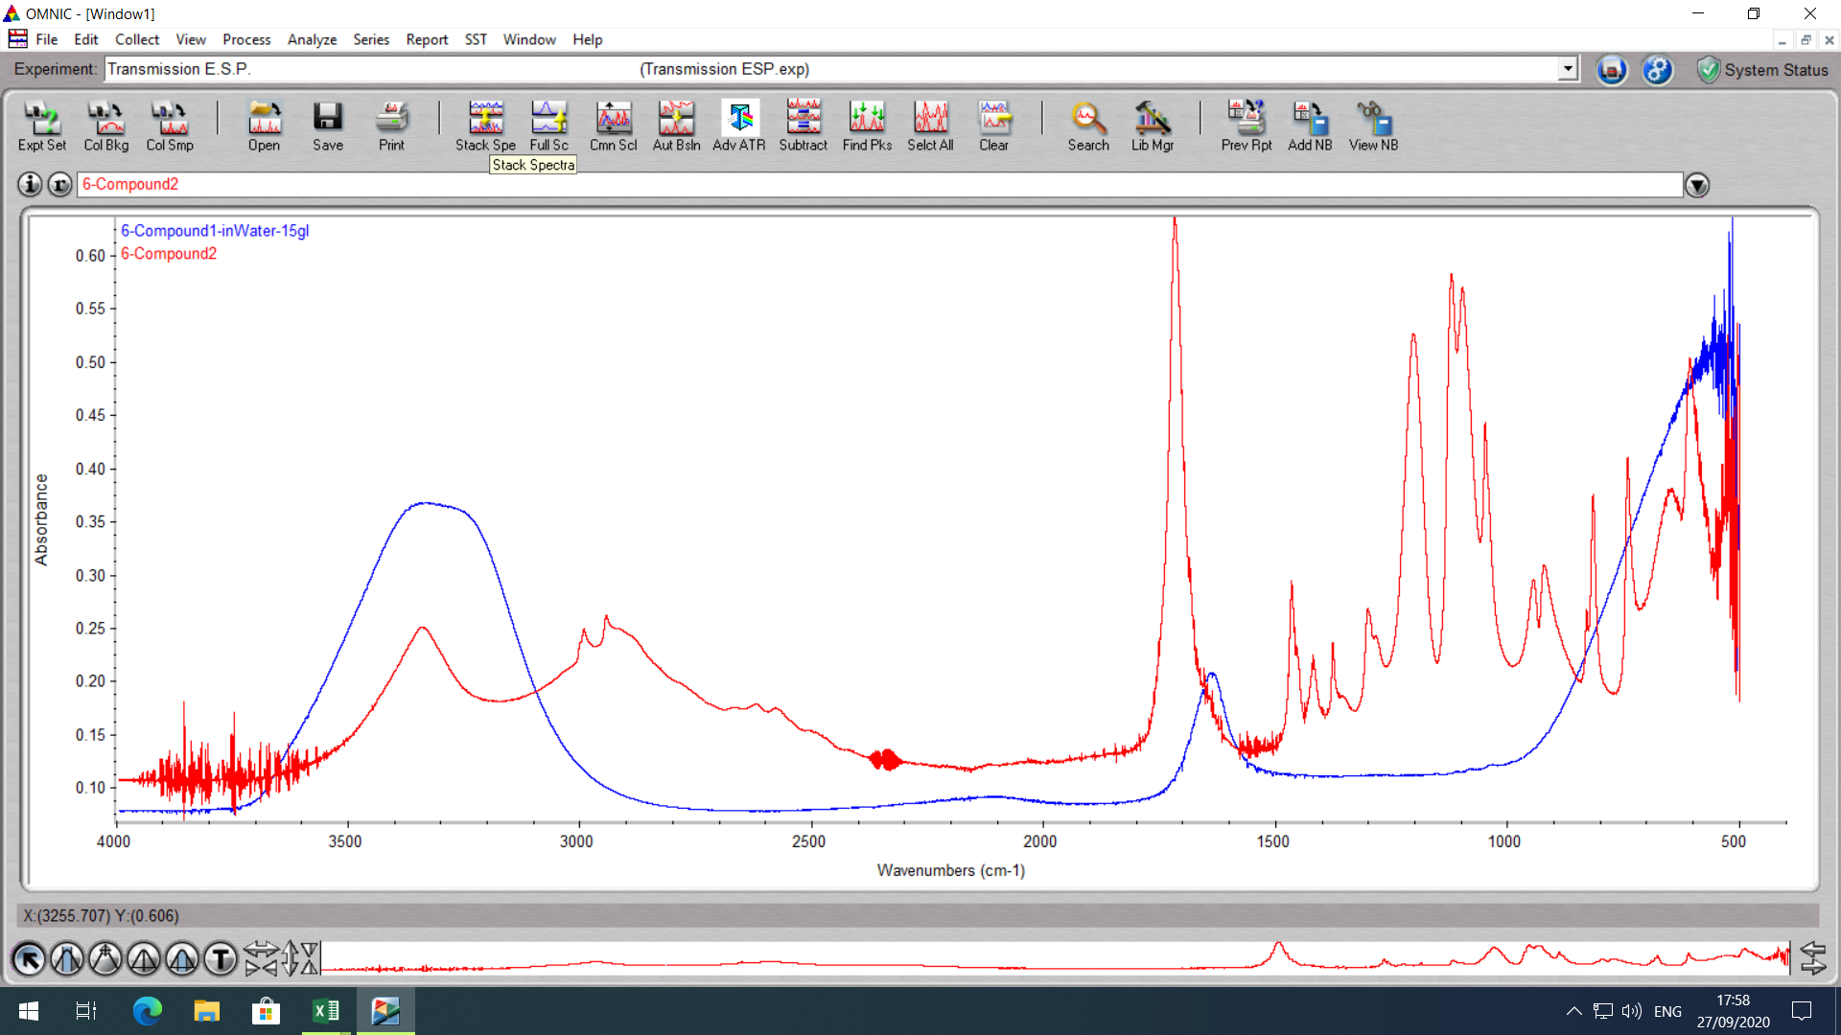
- Your data will all be displayed in you experiment window but you can use the stack spectrum icon in the tool bar to stack the spectrum
- you can select a spectrum by clickin on the data (selected spectrum will be red)
- you can use the process menu to perform transformation or correction to you data
- To Savel and go to file>Save then assign a name and location and save
- The defuauly file is a .SPA but you can select CSV etc as well.
- You can save all you data by pressing control w to select all your data then following the same procedure as for one file
- You can also save all your data as a group which will allow you to open it all again in Omnic (or Omnic Anywhere).
  - Control W to select all
  - File>save as group
  - Assign title.
Please visit the link below for details on Omnic Anywhere for cloud best processing

https://www.thermofisher.com/uk/en/home/industrial/spectroscopy-elemental-isotope-analysis/molecular-spectroscopy/fourier-transform-infrared-ftir-spectroscopy/cloud-enabled-ftir-spectroscopy.html

Close down.

After you have finished please close you experiment window and leave the spectrometer in a tidy state.

Notes

Possible Configuration options

 | Range | Comments
Sources
IR source | 20-9600 cm⁻¹ | Ever-Glo MIR Default
White Light Source | 2000 – 27000 cm⁻¹ | Quartz Halogen
Beam Splitters
Solid state | 20 – 700 cm⁻¹
KBR | 350 – 7400 cm⁻¹ | MIR Default
CaF2 | 1200 – 4500 cm⁻¹
Quartz | 2800 – 27000 cm⁻¹
Detectors
Teflon DGTS | 200 – 6400 cm⁻¹
KBR DGTS | 350 – 12500 cm⁻¹ | MIR Default
MCT | 600 – 11700 cm⁻¹ | N2 cooled
InGaAS | 3800 – 12000 cm⁻¹
Si | 8600 – 21000 cm⁻¹

