Lambda 1050/950
Written by: | Dr B G Breeze | 05/05/20
Amended by:

IMPORTANT
Spectrometers must only be operated by authorized personal, who have had a full induction into working in the Spectroscopy labs and completed local training. A list of trained personal can be found in the webgroup px-OpticalAbsortion-users.

Before beginning any experiment do a quick visual inspection of the spectrometer to confirm it looks in good working order and no previous experiment is left in place. If you have any issues, please contact a member of RTP staff.

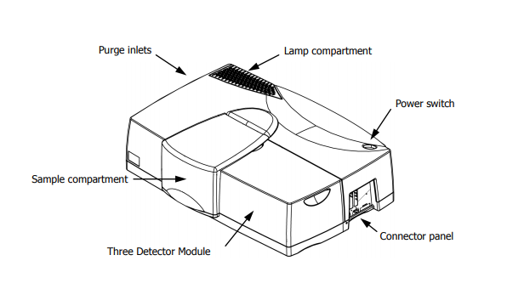

Turning on the spectrometer
- First off lift the sample compartment cover and check that no samples are in place and the both the sample and reference paths are free from obstructions.
- To turn it on use the green switch on the back right of the spectrometer. (The spectrometer should be off when you arrive, if it is on leave it on)
- The spectrometer will make around 2 minutes to go through its start-up routine during this time you will hear the motors whirling and the light source should now appear to be glowing on in the back left of the spectrometer.
- Once the spectrometer has become quite again you will need to boot the UV Winlab software Icon on the bottom left of the screen.
- When prompted login as an “analyst”
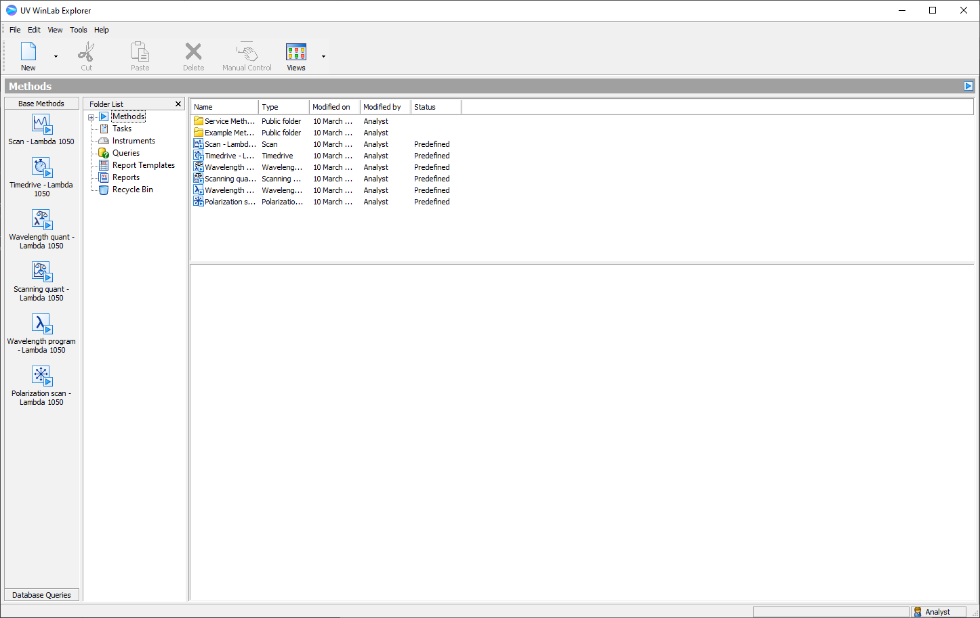
- In the explorer window you need to select a method for experiment. You can do this in two ways. You can select a base method from the right hand column (normally scan lambda 1050) or by selecting an existing method from those displayed.
- This will open a new window called the workspace where data will be collected.
Setting up an experiment.
- To set the experiment parameters your need to select the Data collection icon on the left hand menu
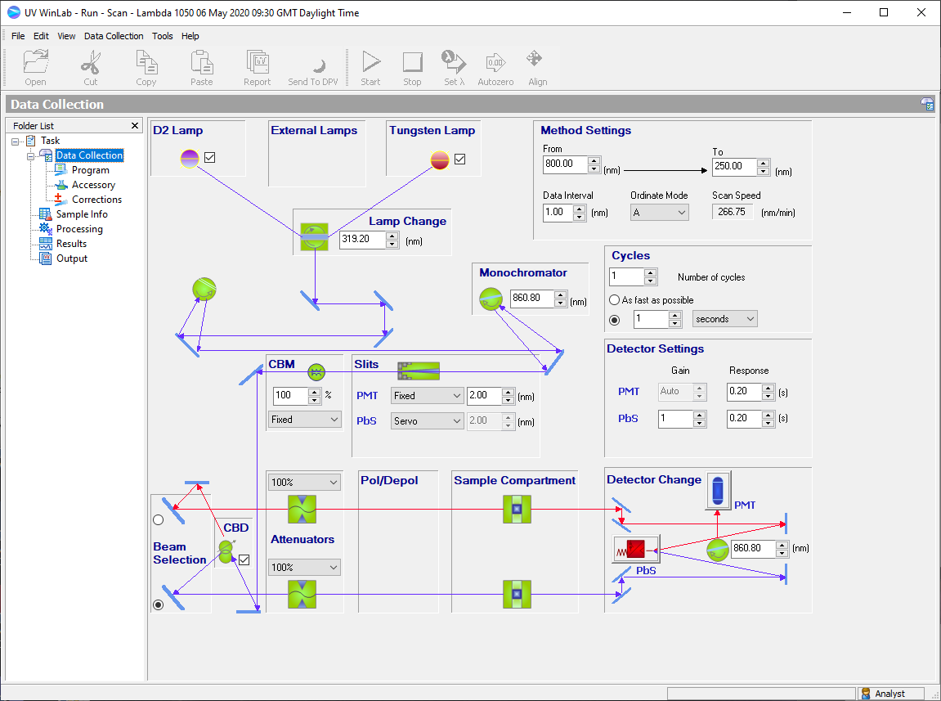
- Possible parameters
  - Spectral range can be set in from and to boxes the mothod settings area. Note the spectrometer must start at the longest wavelength
  - Data Interval Use the box to select the size of spectral steps to be taken.(should be less than the slit width)
  - ordinate mode can be set to either Transmission (%T) Absorption (A) depending on preference. (it can be transformed later)
  - Lamps Select with lamps you wish to using the tick boxes. (the tungsten lamp covers visible and IR range, and D2 lamp the UV)
  - Lamp change position can be altered with the lamp change box to say. Its default setting is 319.2 nm. However, if this is a region of particular interest it can be moved within the range 300–350 nm to avoid any artefacts.
  - The spectrometer uses a second monochromator for the IR region and you can alter when this happens with the monochromator box to avoid artefacts. Be aware that Values below 700 nm or greater than 900 nm may damage your
  - slits have two main modes of operation Fixed and Servo that can be selected in the drop down box. If using Fixed you can set the desired slit width on the box to the right of the operation mode. (See notes for details)
  - CBM the common beam mask is used to alter the height of the light beam.
  - Beam Selection make sure the path which will hold your sample is highlighted and light beam blue- (lower path is front path in spectrometer)
  - Detector change by default the spectrometer will change between detectors at the same time as the monochromator change and this is recommended.
  - Detector setting. You can set the gain and response time for each detector in the boxes. (See notes for details)
- Once the parameters have been set we need to run a back ground. Confirm that the correct sample holders are in place. (see 12/13) If you are using a solvent blank you may wish to add (See step XX) it now or it can be ran as a sample later often best approach for Solid samples.
- In the corrections menu make sure 100 % T /0A baseline is selected and that always at start of task. Confirm that validation period is suitable for your experiment.
- Collect the back ground by using the Autozero icon
- When prompted to confirm the sample compartment is empty when press OK. (assuming it is apart from any reference solvent)
Sample Loading
  - Liquid sample
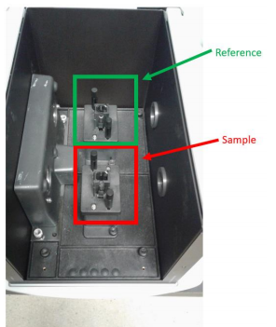
    - place you sample in a clean 1 cm path length cuvette (size 12.5 mm x 12.5 mm x 45 mm)
    - If you are using a solvent reference place this into a second cuvette of the same design.
    - Left the lid to the sample compartment.
    - Make sure that the cuvette holders are in place and are securely screwed to the base plate.
    - Place sample and reference in the appropriate paths.
    - Close lid carefully. The spectrometer is an optical bench
  - solid samples
    - Mount your sample on a thin microscope slide or on aperture sample holder
    - Left the lid to the sample compartment
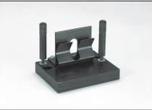
    - Remove the reference arm sample holder if not being used by unscrewing the silver screws at the base and lifting gout.
    - Remove the sample path cuvette holder unscrewing the silver screws at the base and lifting
    - Add in the solid sample holder to the sample path and screw down till
    - Mount sample in the solid sample holder
    - Close lid carefully. The spectrometer is an optical bench slamming/dropping the lid will effect alignment and performance
- In the sample info tad add in the desired number of samples
- Use Sample ID to set the desired File names. do not copy and paste Sample IDs this can cause major errors in data.
- add any description required in the description columns
Data collection

- to start the experiment press run.
- You will be prompted to place you sample in the sample path do so if you have not already and click ok.
- The spectrum will be collected
- When the spectrum is finished you will be prompted to add the next sample. Do so as before or click cancel.
- you can review the data in the graphs tab in the sample info.
- To save the data the best method is to go to file>save spectra and follow the onscreen instruction to save the files in .spc format
- You can also export you data by going to file>export. This can be used to export all the spectra and the Sample table info as csv files which can be easily opened elsewhere.
Close down

- If you wish to save this method for future experiments, you can using File>save method. Your method will now appear in the methods in the UVwinlab explorer window.
- After you have saved you data closed down the workplace window
- Close the Explorer window
- Turn off the spectrometer.

Notes

Advice on slits

The slits are used to control energy throughput. Set a wide slit width to increase the energy throughput and the signal-to-noise ratio; This decreases the resolution and the photometric accuracy and can cause band broadening. Set a narrower slit width to increase the resolution and the photometric accuracy.
If Fixed is selected, enter the slit width in the adjacent field. For the PMT detector the minimum slit width is 0.05 nm and the maximum is 5.00 nm for other detectors the range is between 0.2 nm and 20.0 nm. It is recommended that Set a slit width that is between one-fifth and one-tenth of the bandwidth of the spectral feature of interest.

If Servo is selected the system will monitor the reference beam energy and adjust the slits to avoid over saturation of the detectors. In practice for highly absorbing samples this means the spectrometer will open the slits up very wide. It is not recommended in when looking at dark samples for sample with Sharp features.

Advice on detector settings

A gain must be set on the detector to produce a useable spectrum. If the gain is too low, no spectrum will be observed. If the gain is too high, the detector will saturate and the spectrum will be truncated. For the PMT use auto and the spectrometer will be able to find a suitable gain. For the other detectors setting the gain is a matter of 'trial and error' as the correct gain will depend on other factors such as slit width, sample size and opacity.
Response times define the signal averaging time the longer the time the better signal to noise ratio will be but the longer the scan will take. Generally, a longer response time is required on the InGaAs than the PMT for the same SNR.

Advice on Corrections

The 100% T baseline should always be taken. This corrects for the spectrometer response and differences in the sample and reference path. which can be large. The 0 %T baseline block the beam and measure the detector offset at and noise. It is very useful for low transmittance samples.
If Do not invalidate baselines with respect to instrument settings is selected and you may change any instrument settings after collecting corrections, the correction will still be used by the spectrometer. The exception to this is if you increase the range of the experiment when a new background s taken. Use this option with caution as change parameters such as slit widths can alter the spectrometer back and invalidate your background. If in any doubt take a new back ground.

