Peak fitting with Renishaw Wire
Written by: | Dr B G Breeze | 16/04/20
Amended by:

Notes
Fitting was performed with Renishaw WiRE 3.4 but is in principle the same for WiRE 4.
I used Origin 2019 in the later sections but the features are also present in previous versions.
Data courtesy of Jia Lu.

Fitting

- Load you data into a new window in WiRE, using file>opep in new window and selecting the data you wish to fit. This file can be a .wxd .wdf or .txt file
- Select analysis>curve fit to open the curve fitting tool box
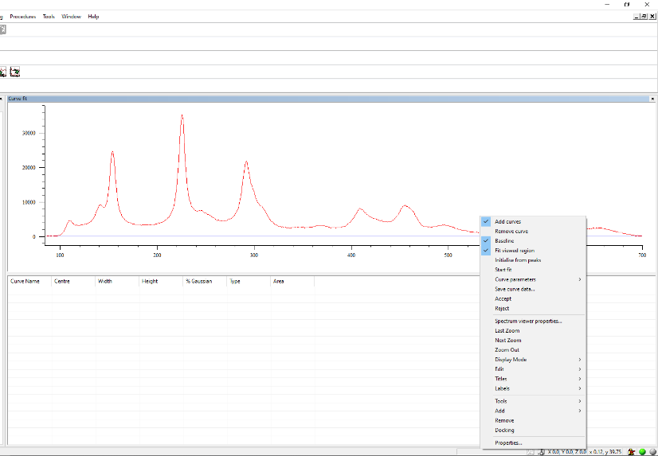
- By right clicking on the data you can open up the options menu, select add curve.
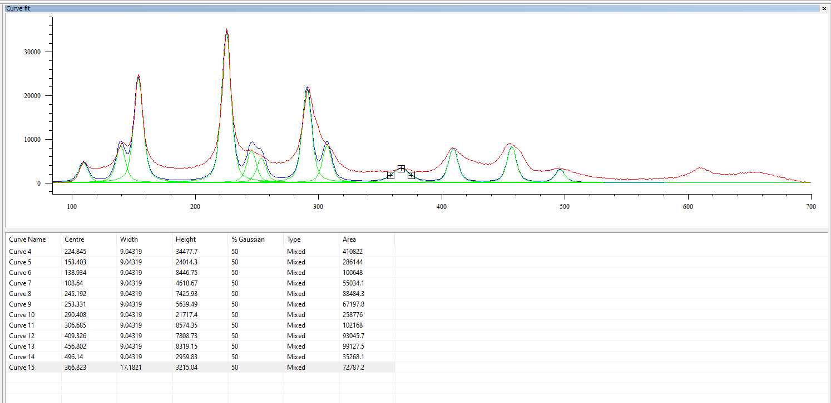
- Left click on the data where the curve you wish to fit is. You can add multiple curves in this manner, if required. You can also use the crossed to optimize the position and width of peaks.
- Once you have added the desired peaks you can right click on the data to add in in a linear baseline or remove any unwanted peaks. You may also select to only fit the region visible on screen, this can be optimized d by using the zoom options.
- Once you are happy with the initially parameters you can perform the fit by right click and selection “start fit”.
- If you have many peaks or a difficult background you may need to optimize you fitting parameter. To do this right click and select Properties
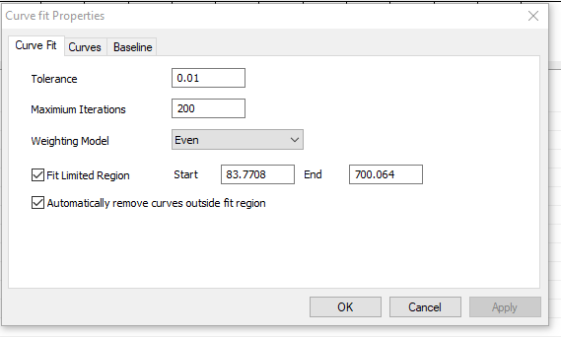
- This first tab (curve fit) will allow you to select to only fit of a defined region and alter the tolerances and number of iterations the software will perform whilst fitting.
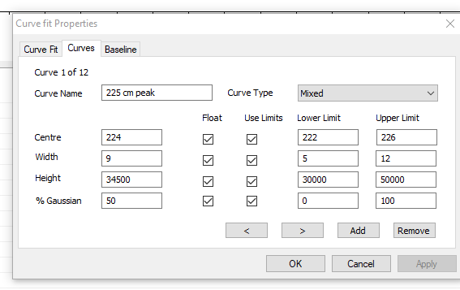
- The next tab (Curves) allows you to fine tune the starting parameter and add in constrains. Remember to click apply when you make changes
  - By default, the software will use a Mixed Gaussian/Lorentzian line shape which you can change to be a pure Gaussian of Lorentzian using the Curve type box, I recommend mixed.
  - Adding constraint will stop the software moving peaks to fit a different part of the data and will also speed up fitting by reducing the parameter space for the software. Be careful to over constraint he system though as this will result in poor fitting.
  - You can also name your peaks to help you keep track of the.
  - You can move between peaks by using the < and > at the bottom of the screen.
  - To add or remove peaks use the add and remove buttons.
- The final tab (baseline) allows you to add a baseline to the data of the form y=ax³+bx²+cx+d. you can preload the variable a b c and d but it is often best to let the software find them.
- Once you are happy with the setting click Apply then OK.
- The fit by right click and selection “start fit”.
- The fitted data will be displayed at the top and a table below.
- If you wish to save the results you have a number of options:
  - To save the table of results:
    - Right click on the table and select “copy results”
    - Paste the table into excel/word to save
  - To save the actual curves for replotting
    - Right click on the data and select “Save curve data…”
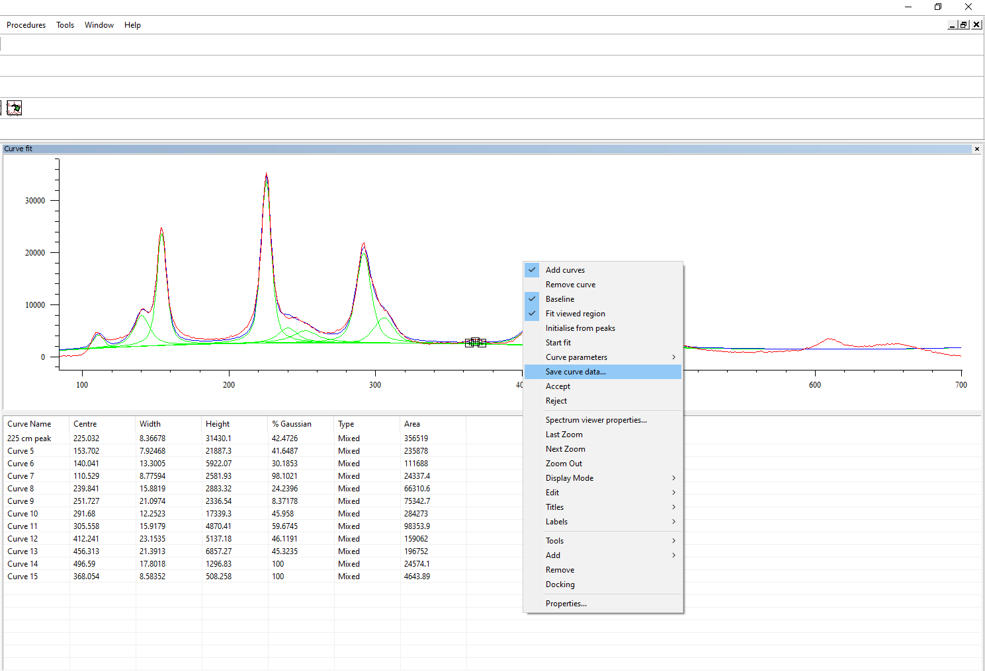
    - Save the file as a .txt file.

- If you wish to use the same parameters to fit data at a later date you can save the in ital. parameters by right clicking and selecting “curve Parameters > save”
- Once you are finised right click and select accept to save the fitted curves into you .wxd file.

Opening Saved Curves in Origin

The save curve data .txt file will contain 3 columns which contain all the fitted curves one after another, and will be in the form:

Curve number | Raman Shift | Fit
0 | 100 | Data
0 | 101 | Data
…. | …. | Data …. Data
0 | 3000 | Data
1 | 100 | Data
1 | 101 | Data
… | …. | Data …. Data
1 | 3000 | Data
2 | 100 | Data
… | …. | Data …. Data

Curve 0 is the sum of all fitted curves and then Curve number 1 is the first fitted curve, curve 2 the second etc. the last curve will be the baseline if one was applied. Once this is loaded into origin you will need to split it up into individual curves before plotting, this can be done using the split columns tools.

- Load the data into origin using the import single ASCII Tool (Data>import from file >Single Ascii)
- Ensure that columns A and B are set to as X and C is set as Y
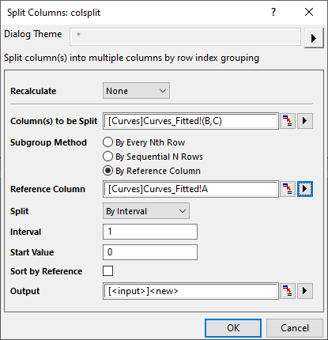
- You should now have three columns of data as described above. To split the data, go to Worksheet>Split Columns>open Dialogue.
- Set recalculate to none
- In the Columns to be split select the columns to be split this is best achieved using the arrow on the right and then Select from worksheet and selecting columns B & C
- Set subgroup method to by reference column
- Set the reference column to the Column A by using the arrow
- Set Split to interval
- Set interval to 1 and start value to 0
- Leave output as <new> unless you have a worksheet already setup for the data
- Press ok
- You should get a new sheet with the fitted curves in
