Renishaw Raman Microscope X-Y mapping
Written by: | Dr B G Breeze | 23/03/20
Amended by:

IMPORTANT
This procedure is a guide for authorized personnel, who have had a full training session with the guardian of the spectrometer, a list of trained personnel can be found in webgroup blah

The lasers used in the Raman spectrometers are powerful enough to cause serious eye injury. Since in some cases the light is invisible, this can happen without your realizing it. Never over-ride interlocks, adjust or modify the systems in anyway. Always follow best practice, If use properly the systems are class 1: safe under all conditions of normal use.

Mapping

Before creating a map make sure that the sample is flat on the sample Stage. There are two reason for this. Firstly, you want to be sure that the sample will not crash into the objective during the measurement and secondly, changes in focus will affect the intensity of the Raman Signal. The stage does allow for very small tilts to level a sample but if you are working with powders or non-flat samples XY maps may not be possible. If in doubt Consult the spectrometer guardian before attempting anything

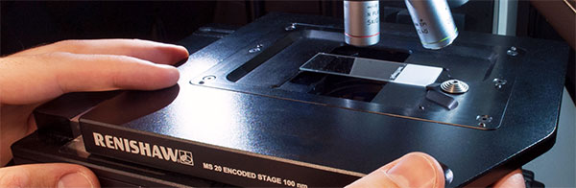
- To level a sample, you must slightly loosen the main screws with a hex key (a). The screws are mad of soft metal so be very careful not to strip the head.
(b)
(a)
- Put you sample on the stage and focus with the X5 objective.
- Move the stage to the to left corner of your expected map area and use the set origin button (looks like a cogwheel) to set the origin position to this spot.
- If needed refocus.
- Carefully move the stage to the top right point of the map whilst observing the sample on the eyepieces. (If the sample becomes very out of focus stop and move onto the next step.)
- once in position adjust the
- Sample into focus using the grub screws on the stage (b). be very carefully whilst doing this not lean on the stage or to raise to high this.
- Once the sample is in focus return to the origin. If the sample is still in focused move to step 9 is not repeat 4-7
- Repeat steps 4-7 but moving to the bottom Left position then bottom right
- Finally, carefully gently retighten the main screws.

Mapping

- To take a map you must first acquire an image of the area you wish to map. Before continuing make sure the correct objective is selected in the sample review pane.
- Make sure that the live video viewer has the desired brightness and sharpness by using the field stop, aperture and white light power in the sample review pane.

  - Small areas (less than one live image vie
    - A single area of the live image viewer can be taken using Live Video > Snap > Single
    - Right click on the data to save this as a jpg if required
  - Large area (more than one live image viewer)
    - Move the stage to the top left of the area to be mapped
    - To create a montage select Live Video > Snap > montage
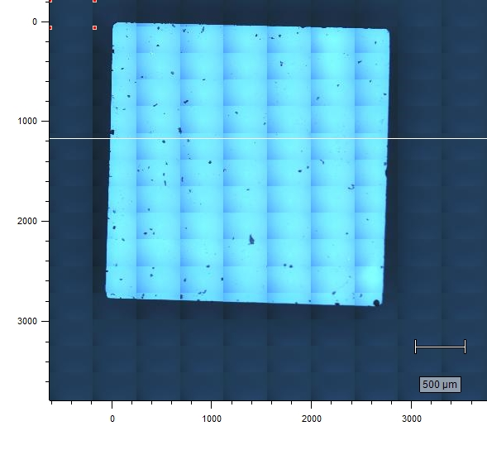
    - Set the designed size of the map in X and Y fields of view (the image below is a 10 X 15 montage of a sample using the X20 objective)
    - It is possible for very large areas to take the montage at a lower magnification and then change objective for the Raman map to optimize the spot size and light collection.

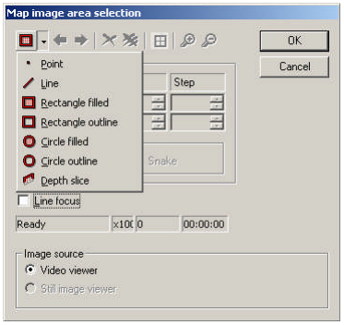
- to create a new map go to measurement > new > map image acquisition
Number of spectra
To be collected

- In the new window first select still image viewer (greyed out in screen grab)
- Using the drop down menu select the style of map
    - Point (multiple selected points on the samples)
    - Line (measurements spaced equally in a line)
    - Rectangle filled (A grid of measurements)
    - Rectangle outline (measurements equally spaced on the perimeter of a rectangle)
    - Circle Filled (A grid of measurements inside a circle)
    - Circle outline (measurements equally spaced on the circumference of a Circle)
    - Depth slice (see spate work notes)
- Draw a rough approximation of the required map on the image taken in step 3 it can be edited later
- Edit the map into the desired configuration using the X or Y first / last / step windows. There will be a calculated number of points displayed in the widow (arrow on image) (first = start point last = end point Step = size of step between points all measurements in µm)
- Press ok
- The Spectral Acquisition Setup window appears allowing you to set up exactly as for a static measurement. With the additional of a additional Area set up scan which will allow final tweaks of the map area and display an estimate of the map time in HH:mm:ss (this is reasonable for static scans and terrible for extended, aslo be aware is your scan lasts longer than 24 hours days are nto displayed, ie. A 25½ hour map would show as 1:00:00)
- It is strongly advised set you set a path to save the map before running and save to the local drive. The map will save after the collection of data at each point and saving to mapped or USB drives will increase the map time vastly.
- Press Apply
- Start scan using run icon, scans can be aborted using the red square icon.

Processing

