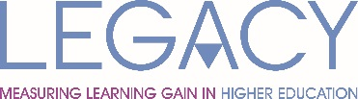 | 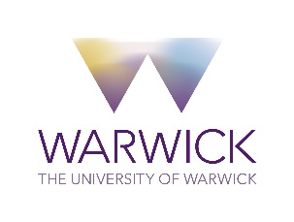
LEGACY Project Workshop: The TEF, Learning Gain,
Student Profiling & Employability

Feedback Questionnaire
Please place mark your response with an ‘x’ in the relevant box or respond to the questions to make improvements for a future event.
 | Strongly Agree | Agree | Disagree | Strongly Disagree
Overall, I was satisfied with this event

The Workshop met my expectations

The content was relevant to me/my job

In regards to the workshop subject matter (The TEF, Learning Gain, Global Education Profiler and Student Employability) please identify up to 3 things that you were able to ‘learn’ from the event?

I benefited the most from?

I benefited the least from?

Next time I’d like to hear about…

Do you have any other comments and/or questions?

Please return this form to Sunil Maher, LEGACY Project Manager, s.maher.1@warwick.ac.uk

