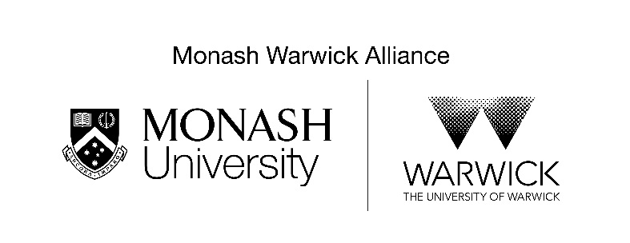
Alliance Joint PhD
Joint supervision statement
Applicant and supervisor details
Applicant name
Application submitted through Monash or Warwick | Monash | Warwick
Academic unit/department
Faculty
Proposed main supervisor
Other members of supervisory team (if applicable)
Details of proposed project
Title of student’s proposed project:
Brief description of project:
Does collaboration already exist between the academic units?
If yes, briefly describe the extent of the collaboration and how this project supports the collaboration?
If no, what collaborations are planned and what is the timeframe for undertaking these activities?
Briefly describe the supervisory experience of each of the main supervisors. | Monash:  Warwick:
What value is added by providing this student with a joint supervisory experience as opposed to them pursuing a single degree at either university?
Students in the Monash-Warwick Joint PhD are required to spend a minimum of 12 months at each university. If this applicant is not successful in gaining mobility support from other sources, what resources would be available for the student to draw upon at each of Monash and Warwick? | Monash:  Warwick:
Please outline support for any costs associated with the research project in each of the academic units? | Monash:  Warwick:
Signatures of main supervisors | Monash: | Warwick:
Authorisation of academic unit/faculty | Monash:  Name:  Signature | Warwick:  Name:  Signature

