RESERVED WHEN COMPLETED

DEPARTMENT iNCIDENT MANAGEMENT PLAN

Estates Office

DIMP

Contents
1.0 | About this Plan | Page No
1.1 | Document Control
1.2 | Plan Purpose
1.3 | Plan Remit
1.4 | Plan Owner
1.5 | Plan Distribution
1.6 | Plan Storage
1.7 | Plan Review Date
1.8 | Plan Exercise/Testing
1.9 | Links to Other Plans
2.0 | Plan Activation
2.1 | Circumstances
2.2 | Responsibility for Activation
2.3 | Availability for Response
2.4 | Process for Activation
3.0 | Incident Management
3.1 | Purpose of the Incident Management Phase
3.2 | Actions to Protect the Safety of Staff, Visitors and members of the Public
3.3 | Actions to Support Business Continuity
3.4 | Actions to Support Recovery and Resumption
3.5 | Communication Actions
3.6 | Communicating with staff
4.0 | Business Continuity
4.1 | Purpose of the Contingency Phase
4.2 | Priority Activities
4.3 | Non Priority Activities
5.0 | Annexes
5.1 | University Incident Impact Categories
5.2 | Institutional Priority Activities
5.3 | Incident Management and Business Continuity Glossary
 | [This is extra space for you to add any other appendices you may want e.g. staff contact lists/communication cascades, maps, grab bag details, equipment maintenance schedules etc]

About this Plan
The University is committed to Major Incident Planning and Business Continuity to ensure the safety of its members and the effective running of its priority activities. This DIMP is set within a framework of policy and University plans and is aligned to the University’s risk management processes.

This Department Incident Plan for Estates Office forms part of a suite of plans covering the range of business continuity management activities:

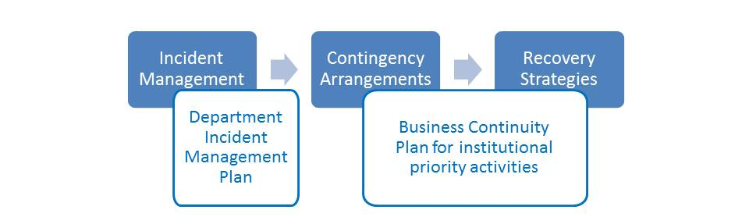

Document Control
Whenever the contents of the plan are revised or amended, it is important to make a note of these changes in order to establish a clear audit trail. Updated DIMPs should be sent to the Institutional Governance Team (businesscontinuity@warwick.ac.uk) who hold the central University record of departmental plans for reference and support the University’s Major Incident arrangements.
- Useful links: Emergency Planning

Date | Revision/Amendment Details & Reason | Author
06/06/2014 | New template - First Draft | D.Stiles
02/09/2014 | New template – Second Draft | D.Stiles
23/09/2014 | New template – Third Draft | D.Stiles
24/10/2014 | New template – Fourth Draft | D.Stiles
10/11/2014 | New template – Fifth Draft | D.Stiles
27/11/2014 | Final Approved | D.Stiles
09/09/2015 | Updated | D.Stiles
11/09/2015 | Updated | D.Stiles
03/12/2015 | Updated | D.Stiles
17/12/2015 | Updated. Removed Estates contacts. Item 3.6. details held with Security. | D.Stiles
18/03/16 | Updated | D.Stiles
26/05/16 | Updated with Project Managers contact details | D.Stiles
22/07/16 | Updated with adding and removal of Estates contact details | D.Stiles
27/09/16 | Updated Operations Directors contact details | D.Stiles
14/10/16 | Updated Warwick Accommodation details and Suppliers information | D.Stiles
21/11/16 | Removed Capital Project Directors contact details | D.Stiles
19/12/16 | Add Arden Construction contact details | D.Stiles
02/02/17 | Removed Head of Facilities contact details | D.Stiles
30/03/17 | Add Capital Programme Director | D.Stiles
19/04/17 | Removed Operations Directors contacts details | D.Stiles
09/08/17 | Removed Site Manager Wellesbourne and Senior Administrator details, added Asbestos removers contacts and updated CHP details. | D.Stiles
12/12/17 | Removed Project Manager and added in Site Manager for Wellesbourne Campus | D.Stiles
18/12/17 | Add contact details. G.Hine and R.Boxall. | D.Stiles
08/02/18 | Add contact details C.Lewis and G.McBride | D.Stiles
23/02/18 | Removed Head of Maintenance contact details | D.Stiles
07/06/18 | Add Contact details Head of Maintenance, Office Manager and Operations Manager  Campus Cleaning | D.Stiles
05/10/18 | Add contact details for Electrical Supervisor (Wellesbourne) and Service desk contact details. | D.Stiles
12/11/18 | Updated contact details as supplied by G. Evans | D.Stiles
15/11/18 | Updated Severn Trent and Water Plus contact details | D.Stiles
10/12/18 | Updated Severn Trent and Water Plus contact details | D.Stiles
23/01/19 | Added Fire, Water, Asbestos and additional Accommodation staff contacts add Waste oil emergency information, insurance contacts and remove Bob Gamble details | D.Stiles
18/04/19 | Removed Gareth Evans and John Bentick | D.Stiles
23/07/19 | Removed Mark Henry, Asbestos Manager | D.Stiles
25/09/ 19 | Add contact for new members of staff and remove contact details for R.Boxhall and M.Soule | D.Stiles
16/12/19 | Remove contact details Suzanne England and new staff and update Severn Trent details | D.Stiles

Plan Purpose

Incidents come in various forms and at any time. To focus your plan, concentrate on the potential impact of any incident rather than the cause in the first instance. For example, consider the impact on your priority activities if you lost access to facilities or resources, did not have key staff available etc.
You may also find it useful to think through any operational risks identified in your departmental risk assessment which if they materialised, would significantly disrupt priority activities.

To provide a flexible response so that the Estates Office can:

Respond to a disruptive incident (incident management)

Identify priority activities in the context of institutional impact criteria
- Provide initial contingency for the delivery of priority activities/departments during an incident (business continuity) (including the provision of relevant information to central service departments and the University Major Incident Team and communicating with department staff, students and other stakeholders).

Plan Remit
This section requires you to explicitly state the remit of the DIMP.

For example:

“The following functions are covered by this Plan:
- The provision of teaching to students
- Externally funded research activities”

AND…
“The following sites are covered by this Plan:
- Floors 2 & 3 Ramphal Building, Library Road ”

The following activities/ functions are covered by this Plan:

The section provides 24 hour emergency standby in support of the entire University.

The following sites are covered by this Plan:

- Main Campus
- Science Park - Argent Court
- Science Park - Institute House
- Science Park - Schmitt Building
- Science park – Milburn House
- Westwood
- Gibbet Hill
- Wellesbourne Site
- Off Campus Housing
- Beehive, Westwood Business Park

The following activities/ functions are NOT covered by this Plan:

The following sites are NOT covered by this Plan:
Other Science Park buildings

Plan Owner
It is important to assign responsibility for the maintenance, exercise and review of this plan and to put a schedule in place to do this. The Head of Department is accountable for the development and implementation of the DIMP (to be listed as Plan Owner below) but may wish to delegate responsibility for its development and maintenance to a named member/members of the department who will liaise with the Institutional Governance Team and central services as necessary (to be listed as Plan Co-ordinator).

Director of Estates is this Plan’s owner and accountable for ensuring that it is maintained, exercised and updated in accordance with internal requirements for incident management and business continuity.

The Head of Compliance and Assurance is this Plan’s Co-ordinator and responsible for ensuring that it is maintained, exercised and updated in accordance with internal requirements for incident management and business continuity.

Plan Distribution
The plan can often contain sensitive data e.g. out-of-hours contact information for staff, it is therefore important to keep the document secure, as per the Data Protection Act and to keep a record of who has received the plan. It may also be of benefit to brief appropriate staff about maintaining the security of the document, i.e. restricting access and identifying safe storage solutions.

This Plan is distributed as follows:

NAME | ROLE
James Breckon | Director of Estates with overall responsibility
Kevin Edwards | Chief Finance Officer, Estates
David Hammond | Capital Programme Director
Steve Twynholm | Operations Director
Parvez Islam | Director of Transport & Future Mobility
Paul Shead | Head of Maintenance
Alan Piper | Site External Services Engineer
Duncan Stiles | Head of Compliance and Assurance
Mark Evans | Health & Safety (Construction) Adviser
Laura Harris | Estates Site Manager (Wellesbourne Campus)
Peter Hawksworth | Electrical Supervisor (Wellesbourne Campus)
Joel Cardinal | Head of Energy and Sustainability
Marc Smith | Property & Assets Information Manager
Angie Dumper | Office Administration Manager
Alan Warwood | Head of Facilities
Wendy Roberts | Director of Student and Staff Accommodation
Matthew Scott | Accommodation Manager and Senior Warden
Serena Johal | Operations Manager  Campus Cleaning - Non residences
Jane Wilson | Operations Manager  Campus Cleaning - Residences & TCC’s
Tina Briggs | Staff and Family Housing
Gareth McConnell | Student Reception Manager
Alison Easingwood | Assistant Customer Services Manager
David Shaw | Maintenance Manager, Electrical Services
Michael Keenan | Electrical Services Officer
Dave Aston | Maintenance Manager, Building Fabric
Craig Roberts | Maintenance Manager, Mechanical Services
Peter Smith | Energy Centre Manager
Sioned Cash | Operations Planning Manager
Graham Hine | Transport & Logistics Manager
George McBride | Programme Manager
Charlotte Lewis | Head of Strategic Programmes and Governance
Simon Watson | Fire Adviser
Andy Clews | Water Hygiene Manager
Tim Woodman-Clark | Senior Operations Manager, Residences and Campus Cleaning
Cathy Cattel | Senior Property Manager

A copy of the DIMP should also be provided to the Institutional Governance Team via businesscontinuity@warwick.ac.uk for reference in the case of a University major incident.

Plan Storage
It is good practice to have the document saved/stored in multiple locations as a contingency arrangement i.e. a hard copy of the plan in a ‘grab bag’, online or saved on a memory stick, so that if you do encounter IT system failure, you have a back-up copy of the plan available.

Electronic copies of this Plan are stored:

On the Estates Services M Drive

M:\EO\EO_Estates_Incident_Plan

  - Plan Review Date
A decision needs to be made around the frequency of review of the plan(s) e.g. monthly/quarterly maintenance of the plan to check phone numbers etc are still up-to-date and then the University requires a full review of arrangements on an annual basis.

Departments are required to review DIMPs on at least an annual basis and to provide any updates due to change in the department’s site, scope of plan or key personnel to the Institutional Governance Team (businesscontinuity@warwick.ac.uk)

This Plan will be updated as required or formally reviewed May 2020

Plan Exercise/Testing
All plans MUST be tested or exercised to ensure they are valid and that incident responses are rehearsed in a ‘safe’ environment, without the pressure of a ‘real life’ incident. This ensures that plans will actually work in an incident, but staff will also feel more prepared and comfortable in their business continuity roles. Following an exercise it is useful to generate an action plan which may include recommendations for how the plan can be improved and suggestions for improving the resilience of the team/service/department.

You may find it helpful to base your tests/exercises around potential issues identified in your departmental risk register and/or potential institutional operational risks. The Institutional Governance Team will provide further information on this.
- See Emergency Planning website for ways in which the Team can help you in developing and testing your DIMP and other University scenario exercises and training opportunities

This Plan was tested/exercised on 14 January 2019 and the recommended amendments made.

The next planned date of test/exercise of this plan is TBC Links to Other Plans
There may be other plans in place that will support your response to a business disruption or larger scale emergency. For example a specific Health & Safety plan to deal with specific hazards/activities for your department , an evacuation plan etc. This section has been included to briefly explain the purpose and contents of such plans and where/how they can be accessed.

This plan is associated with:

- The University Major Incident Plan dated 2 July 2018. A copy is located within the Estates M drive. M:\EO\EO_Estates_Incident_Plan
- Environmental Spill Response and Emergency Planning guidance by DIEM Ltd
http://www2.warwick.ac.uk/about/environment/warwick/ems/ep-05-v01-_environmental_emergency_plan.doc
- Managing Communicable Diseases Plan dated 25 May 2017

2.0 Plan Activation
In order to ensure that the plan is used appropriately and under the correct circumstances, there is a clear framework to help guide you through the decision making process. Included are some examples of the types of situation that may lead to plan activation and who has responsibility for plan activation (usually a Head of Department or Plan Co-ordinator within a department). The diagram in section 2.4 shows circumstances where the plan would be activated and the different phases of your response to an incident over time.

2.1 Circumstances

This Plan will be activated in response to an incident causing significant disruption to normal department delivery/business, particularly the delivery of key/priority activities. Examples of circumstances triggering activation of this Plan include:

Critical Function | Threats | Consequences | Maximum Tolerable Down-time  (at peak time)
Heating | Loss of services | District heating systems or local boilers | Minimal
Sewage pumping | Loss of services | Potential disaster | None
Storm water | Loss of services | Flooding engineering block and other areas. | none
Security/access systems | Loss of property or threat to personnel safety
Electrical supply | Loss of services | Loss of protection systems | 4 hours
Service desk | Inability to re-act | Possible loss or part loss of University’s ability to function. Possible relocation of resident students | 1 hour
Out of Hours | As above | As above | 1 hour
Ability to maintain campus infrastructure | As above | As above | 3 hours
Ability to maintain building stock | As above | As above | 3 hours
Environmental contamination to air, water and land | Temporary loss of services | Potential disaster

2.2 Responsibility for Activation
The members of a Departmental Incident Management Team (DIMT) are responsible for managing the department’s response to an incident including deployment of local people and resources. The DIMT will escalate major incidents to the University Major Incident Team (via businesscontinuity@warwick.ac.uk), liaise with central services in the management phase and take direction from the Major Incident Team around prioritisation of response in the case of a University Major Incident.

N.B. Some departments already have established Local Incident Response Teams (LIRT) – you can use these sections to detail the individuals involved in these – just change DIMT to LIRT!

- See the University Emergency Planning Policy for information on the University’s incident management structures and details of the individual teams involved.

A lead member of the nominated Department Incident Management Team for Estates Services will normally activate and or stand down this Plan:

Name | Role | Office | Out of Office | Mobile
James Breckon | Director of Estates with overall responsibility | 024765 24244 |  | 07823 524620
Kevin Edwards | Chief Finance Officer, Estates | 024765 73353 |  | 07876 877887
David Hammond | Capital Programme Director | 024765 23438 |  | 07825 834754
Steve Twynholm | Operations Director |  |  | 078240 86933
Parvez Islam | Director of Transport & Future Mobility | 024765 28314 |  | 07385 029195
Paul Shead | Head of Maintenance | 024765 74905 |  | 07824 086926
Alan Warwood | Head of Facilities | 024765 24408 |  | 07880 175369
Duncan Stiles | Head of Compliance and Assurance | 024761 50462 |  | 07785 433164
Laura Harris | Estates Site Manager (Wellesbourne Campus) | 024765 74966 |  | 07341 072 385
Joel Cardinal | Head of Energy and Sustainability | 024761 50973 |  | 07824 541061
Wendy Roberts | Director of Student and Staff Accommodation | 024765 23148 |  | 07876 217823
Matthew Scott | Accommodation Manager and Senior Warden | 024765 22772 |  | 07876218165
Craig Roberts | Maintenance Manager, Mechanical Services |  |  | 07385 029231
Dave Shaw | Maintenance Manager, Electrical Services | 024765 22563 |  | 07392 125548
Serena Johal | Operations Manager  Campus Cleaning - Non residences | 024765 24648 |  | 07341072378
Jane Wilson | Operations Manager  Campus Cleaning - Residences & TCC’s | 024765 73026 |  | 07876218149
Tina Briggs | Staff and Family Housing | 024765 74536 |  | 07876218031
Gareth McConnell | Student Reception Manager | 024765 22646/ 22280 |  | 07920531139
Pippa Collins | Customer Services Manager | 024765 74777 |  | 07824540920
Sioned Cash | Operations Planning Manager | 024765 28861 |  | 07881267489
Graham Hine | Transport & Logistics Manager | 024761 50532 |  | 07824 540958
Charlotte Lewis | Head of Strategic Programmes and Governance | 024761 51787 |  | 07384 231368
George McBride | Programme Manager | 024765 28350 |  | 0774 002 3728
Peter Hawksworth | Electrical Supervisor | 024765 74987 |  | 07817 263451
Andy Clews | Water Hygiene Manager | 024765 74504 |  | 07876 218127
Simon Watson | Fire Adviser | 024765 28266 |  | 07876 218170
Tim Woodman-Clark | Senior Operations Manager, Residences and Campus Cleaning | 02476 525725 |  | 07876 876964
Cathy Cattel | Senior Property Manager | 024765 24562 |  | 07876218030

In the event of a University major incident, the University Major Incident Team (MIT) will be established and the HoD or other senior representative of the department named in this DIMP may be required to join the MIT and/or make regular impact assessment and plan implementation reports to the MIT.

2.3 Availability for Response
Members of the Department Incident Management Team for Estates Services will normally be called together to support the departmental response to an incident:

Name | Role | Office Ext | Out of Office | Mobile
Paul Shead | Head of Maintenance | 024765 74905 |  | 07824 086926.
Charlotte Lewis | Head of Strategic Programmes and Governance | 024761 51787 |  | 07384 231368
Steve Twynholm | Operations Director |  |  | 078240 86933
Parvez Islam | Director of Transport & Future Mobility | 024765 28314 |  | 07385 029195
George McBride | Programme Manager | 024765 28350 |  | 0774002 3728
24/7/365 On call staff | Duty Electrician  Duty Mechanical support | Duty Electrician – 07876217878  Duty Mechanical – 07876217879  BST 81 – 07824540777  BST 81 - 07824540774 |  | Via Gatehouse (Security)  02476  522083 or 02476 522222
Alan Piper | Site External Services Engineer | 024765 24688 |  | Via Gatehouse
Duncan Stiles | Head of Compliance and Assurance | 02476150462 |  | 07785 433164
Richard Gough | Commercial Manager | 024765 73733 |  | 07341 072409
Daniel Gibbons | Planning & Development –  Senior Project Manager/Team Leader | 024761 51631 |  | 07823 362115
Gez Hunter | Planning & Development -  Design Team Manager | 024765 28274 |  | 07469 020704
Colin Howson | Planning & Development –  Senior Project Manager | 024765 28277 |  | 07876 218180
Laura Harris | Estates Site Manager (Wellesbourne Campus) | 024765 74966 |  | 07341 072 385
Graham Steer | Planning & Development –  Senior Project Manager/Team Leader | 024761 51012 |  | 07341072374
Alasdair MacIntosh | Planning & Development –  Senior Project Manager/Team Leader | 024765 28114 |  | 07341 072408
Alastair Dixon | Planning & Development –  Senior Project Manager | 024765 24209
Alistair Lawry | Planning & Development –  Infrastructure Manager | 024765 24674 |  | 07876 217865
Alan Warwood | Head of Facilities | 024765 24408 |  | 07880 175369
Wendy Roberts | Director of Student and Staff Accommodation | 024765 23148 |  | 07876 217823
Jim Mylott | Senior Project Manager | 024761 51844 |  | 07920599442
Craig Roberts | Maintenance Manager, Mechanical Services |  |  | 07385 029231
Dave Shaw | Maintenance Manager, Electrical Services | 024765 22563 |  | 07392 125548
Graham Hine | Transport & Logistics Manager | 024761 50532 |  | 07824 540958
Angie Dumper | Office Manager | 024765 28273 |  | 07890 948390
George McBride | Programme Manager | 024765 28350 |  | 0774 002 3728
Peter Hawksworth | Electrical Supervisor | 024765 74987 |  | 07817 263451
Andy Clews | Water Hygiene Manager | 024765 74504 |  | 07876 218127
Simon Watson | Fire Adviser | 024765 28266 |  | 07876 218170
Tim Woodman-Clark | Senior Operations Manager, Residences and Campus Cleaning | 024765 25725 |  | 07876 876964
Cathy Cattel | Senior Property Manager | 024765 24562 |  | 07876218030
Sandra White | Maintenance Manager (Contracted Out Services | 024765 28679 |  | 07385 029203

2.4 Process for Activation
The process for activation is set out in the diagram below:
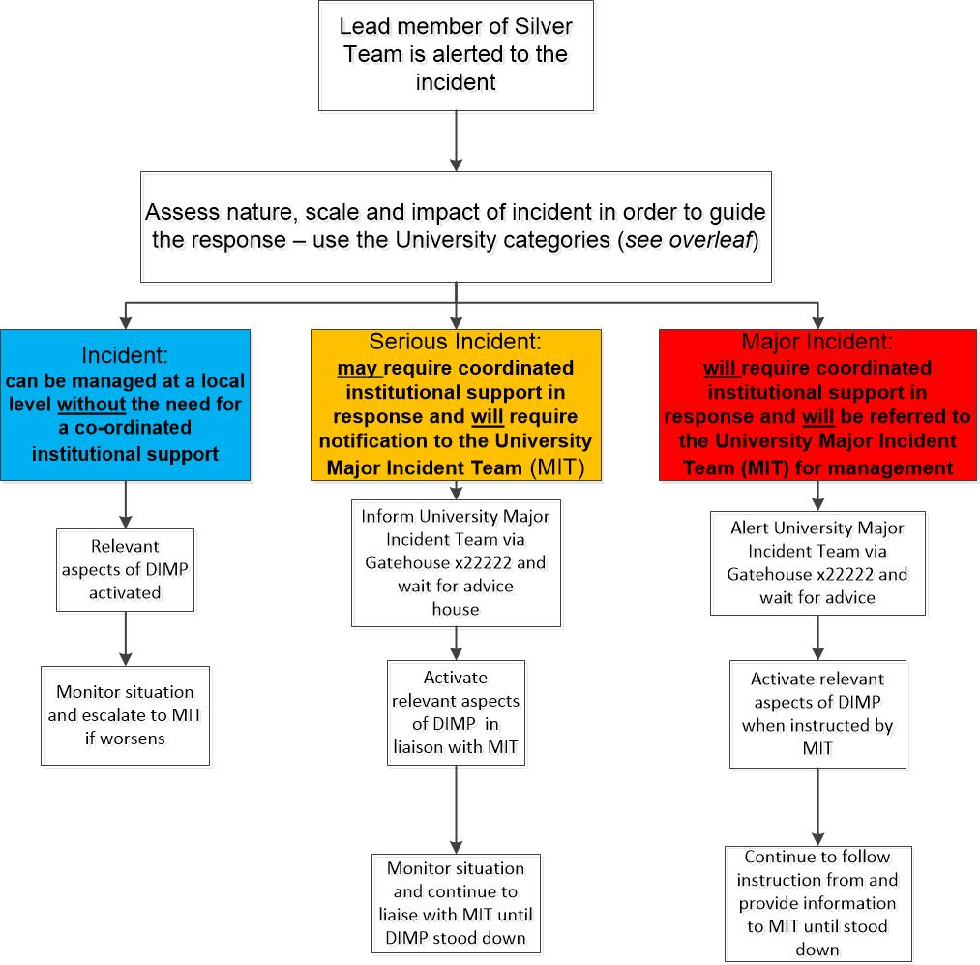
3.0 Incident Management
The ‘Incident Management’ phase of your response to a business disruption is often the most crucial; actions taken during this phase of your response can impact on your ability to recover successfully and with minimum disruption. This is the first stage of your response, where your number one priority is to protect human welfare. If circumstances allow, you might also be involved in retrieving vital equipment or information, as described in this section of the plan. Throughout the phase you will be engaged in urgent communication with the key stakeholders (contact details should therefore be included and maintained for validity). Please note that the incident management actions listed in this Section have been provided as a guide only, we recommend that they should be adapted for use in your own department to ensure procedures are accurate and fit-for-purpose.

3.1 Purpose of the Incident Management Phase
- Protect the safety of staff, students, visitors and the wider community
- Protect vital assets (physical and non-physical) e.g. equipment, data, reputation etc
- Ensure necessary communication takes place e.g. with other departments incl central services, staff, students and other stakeholders
- Support the Contingency phase

3.2 Actions to protect the safety and welfare of staff, students, visitors and the public
The following actions will be taken to protect the immediate safety of staff, visitors and the public:

 | ACTION | FUTHER INFO/DETAILS
1 | Evacuate the building if necessary | Use normal evacuation procedures for the building and evacuate under the instruction of the University Security Services Team and/or the emergency services
2 | Assist in ensuring all individuals have been evacuated from the building and are present. Consider safety of all staff, students, contactors and visitors as a priority | As part of the staff induction process notification of assembly points will be notified.  DIMT Lead is responsible for completing this action
3 | Ensure all staff report to the Assembly Point. | The Assembly point for the Estates department is:  Argent Court Fire Assembly Point – Schmitt Building Car park  The Fire Assembly Point for the Electricians Workshop, Stores and BST Office is Car Park 11, which is at the front of the Boiler House.  The Boiler House Fire Assembly Point is Car Park 10.  At Wellesbourne for Estates staff the Fire Assembly point is The Crescent.  The Portacabins Fire Assembly Point is the ‘Rear Car Park’.  If the Assembly Point is not appropriate, contact Security Gatehouse or Security Services at the scene to agree an alternative.  DIMT Lead is responsible for completing this action  Note: Fire Coordinators and Fire Wardens to support this process.
4 | Call Security Gatehouse | TEL: 02476 5 22222  - Confirm nature of the incident  - Location of the incident  - Whether emergency services are required  - Whether incident needs escalation to the MIT
5 | Consider whether the involvement of other teams, departments or organisations are required to support the management of the incident | Out of hours contacts for the below teams is via the Security Gatehouse 02476 5 22222  Depending on the incident the following may be approached in office hours to assist with incident management:  - HR (02476 150859 or 50858)  - Health and Safety (024761 50022 / 07876217888 or 024765 75873 / 07824541196)  - Legal (024 765 75906)  - Occupational Health (024761 50082 / 07824541191)  - Estates (in hours 024765 22567)  - Space Management & Timetabling (in hours 02476 522634)  - IT Helpdesk (In hours 02476 573737).  - For live major contracts the 24 hour emergency contact details will be held with Security at the main Gatehouse.
6 | Ensure log of incident is started and maintained throughout the incident | DIMT Lead to assign a loggist.  Use a decision and action log to do this.  The log template can be found [include location i.e. as an appendix to the plan or location on network – templates can be obtained from the Institutional Governance Team businessccontinuity@warwick.ac.uk ]
7 | Communicate with other response teams and stakeholders | DIMT Lead to assign:  - Liaison with Security Services and other response teams on the ground  - Communications Lead to begin actions under Section 3.5 as required by the nature of the incident
8 | Record names and details of any individuals who may have been injured or distressed in the incident | DIMT Lead is responsible for ensuring the loggist captures this
9 | Forward details of any injuries or fatalities in the incident to HR (depending on scale of incident) and agree action that will be taken | The HR contact to forward this information to Michelle Scally, HR Adviser, Campus & Commercial Services Group  DIMT Lead is responsible for completing this action BUT may assign an individual to this task
10 | Assess impact of the incident to agree response / next steps  - Use Institutional Impact Criteria in section 5.1 | DIMT Lead is responsible for completing this action in liaison with other DIMT members or key individuals
11 | Log details of all items lost by staff, visitors etc as a result of the incident | DIMT Lead to assign an individual to this task

3.3 Actions to Support Immediate Contingency Arrangements

 | ACTION | FUTHER INFO/DETAILS
 | Recover vital assets/equipment to enable delivery of priority activities | The essential equipment/resources/ information that need to be recovered where possible are: [insert details as relevant]
 | Assess the key priorities for the remainder of the working day and take relevant action | Consider sending staff home, to recovery site etc
 | Inform staff what is required of them  - Use Section 3.6 | Staff would either be sent home or support the recovery operation and remain on site.
 | Publicise the interim arrangements for delivery of priority activities | Ensure all stakeholders are kept informed of contingency arrangements as appropriate.  Estates would publish access to services via the Estates website.

3.4 Actions to Support Recovery
 | ACTION | FUTHER INFO/DETAILS
 | Check whether it is safe to reoccupy evacuated space | Reoccupy evacuated space ONLY when declared safe by Security.  DIMT Lead is responsible for checking this with relevant teams on the scene (Security Services, Estates, Emergency Services).  EXAMPLE list of requirements for reoccupation:  - Power and water  - Safety and security of facilities  - Structural soundness  - Cause identified and no risk of re-occurrence  - Incident resolved/under control  - Fire or other alarms reset
 | Take any salvage/asset recovery actions that are appropriate | If safe to do so, attempt to remove any key equipment, furniture, records etc. that are at risk of damage.  If already damaged or it is not practical to remove them, leave them in situ but detail what has been damaged.  Contact University Insurance Services as soon as practicable:  (024761)50817/ (024765)24222  And follow up with an email at earliest convenience
 | Continue to log all expenditure incurred as a result of the incident | Log expenditure on SAP with clear reference that this was incurred as a result of an incident  In working hours log on the Estates Helpdesk, so no cost code would be necessary. If it were out of hours and reported by security, it would go to the BSTs on shift, which would raise this on the Helpdesk remotely.

3.5 Communication Actions
In the event of an incident and this plan being activated, the following people should be contacted. Nature of contact will depend on the incident type and time it has occurred.

The DIMT Lead is responsible for assigning an individual(s) to complete the actions.
As well as recording with whom you need to communicate, you will need to think through how best to communicate with these groups.
This will depend on a number of factors including but not limited to:
- Time of day
- Nature and expected duration of incident
- Immediacy of message (i.e. need for them to know immediately/real time to take action)
- Number of people in each group (i.e.is individual calling realistic? You may also want to consider using a call tree to cascade phone message more quickly – template available from Institutional Governance Team)
- Access to a phone/computer/email to access contact details or send messages

Use the section below to record your plans – tailor it to suit your departmental arrangements.

ALWAYS CONTACTED

 | Name | Role | Contact Details | Likely message
 | James Breckon | Director of Estates | 07823 524620 | - Incident is taking place  - Action being taken  - Impact on the department  - Request to escalate or support if impact is Category 1 or 2
 |  | DIMT Lead(s)(if different to Head)

CONTACTED DEPENDING ON INCIDENT IMPACT
 | Name | Role | Contact Details and Methods | Likely message
 | Ben Pithouse | Major Incident Team Action Manager | 024761 50949  07469 020 716 | - Incident is taking place  - Action being taken  - Impact on the department  - Decisions referred to MIT (as required)
 | Internal Comms Team | Communications Office | 024765 24668  Internalcomms@warwick.ac.uk | - Incident is taking place  - Action being taken  - Impact on the department  - Indication of any press interest  - Areas they can support department e.g. updating web site/intranet etc
- 0 | Staff | N/A | See Section 3.6 | - Incident is taking place  - Action being taken  - Impact on the department  - Where they need to report to/work from
 | Students |  | Consider appropriate methods for communicating with students | - Incident is taking place  - Action being taken  - Impact on the department  - Expected duration of the disruption
 | HV & LV Electrical Off Campus and supply to the Campus | Western Power Distribution | Emergency control room and to be used only in an emergency  0845 601 4843  or alternative number.  0800 056 8090 | - Incident is taking place  - Action being taken  - Impact on the department  - Expected duration of the disruption
 | HV - University Estates maintenance and repair | HV Power | 07775 496 416 & 07501 369 418 | - Incident is taking place  - Action being taken  - Impact on the department  - Expected duration of the disruption
 | Generator maintenance and Generator Hire | WBPS | 0115 944 4422 | - Incident is taking place  - Action being taken  - Impact on the department  - Expected duration of the disruption
 | Generator hire | Aggreko | 08458 24765 | - Incident is taking place  - Action being taken  - Impact on the department  - Expected duration of the disruption
 | UPS repairs | UPS | 08007 313 269 | - Incident is taking place  - Action being taken  - Impact on the department  - Expected duration of the disruption
 | Gas Off Campus and supply to Campus | CADENT | 0800 111 999 | - Incident is taking place  - Action being taken  - Impact on the department  - Expected duration of the disruption  - Where they need to report to/work from
 | Water Supplier | Severn Trent | Emergency Number  0800 783 4444  Leah Fry  Head of Customer Strategy and Experience  Customer Delivery  E-mail: leah.fry@severntrent.co.uk  Tel: 07721 747314  Address: 2 St Johns St, Coventry CV1 2LZ, UK  Phone: +44 345 750 0500 | - Incident is taking place  - Action being taken  - Impact on the department  - Expected duration of the disruption  - Where they need to report to/work from.  Note:  Water Plus is a water retailer and have no emergency response actions. The university should however inform them of an incident as this may impact billing and Water plus are able to leverage Severn Trent on our behalf if necessary.  Water Plus (Water Retailer)  Carole Manning  Key Account Manager  07703 718199  carole.manning@water-plus.co.uk
 | BMS – On Call  (Honeywell BMS, FS90 Security Systems) | Honeywell (HBS) | Via Gatehouse | - Incident is taking place  - Action being taken  - Impact on the department  - Expected duration of the disruption
 | BMS – On Call  (Schneider BMS) | Kendra Energy Solutions | Via Gatehouse | - Incident is taking place  - Action being taken  - Impact on the department  - Expected duration of the disruption
 | Fire Alarms & Security Alarm Systems (non FS90) | Trinity Fire & Security | Via Gatehouse | - Incident is taking place  - Action being taken  - Impact on the department  - Expected duration of the disruption
 | Drain clearance (Drains Are Us) | Shaun Clifford | 01926-853111 | - Incident is taking place  - Action being taken  - Impact on the department  - Expected duration of the disruption
 | Gritting and snow clearing | Wayne Bailey, Grounds Supervisor.  At Wellesbourne gritting is carried out by staff on site where practically possible. | 07876 217898 | - The University also have a contract with Coventry City Council for them to grit University Rd and Library Rd. This will be done on every occasion that the City Council grit the main roads by the same team who grit Gibbett Hill Rd. whenever frost is forecast.
 | Tree emergencies | Beechwood Trees | Simon Rotherham 07976 358219 or Daniel Rotherham 07875 507136 | - Incident is taking place  - Action being taken  - Impact on the department  - Expected duration of the disruption
 | Gas Contractor  (Smell of gas) | PRT | Pete Tilsley 02476 407399 or 07831 498292 | - Incident is taking place  - Action being taken  - Impact on the department  - Expected duration of the disruption  - Ways they can support
 | CHP 1 Contractor (Main Energy Centre and East Site Energy Centre) | Veolia CHP | Veolia CHP Help Desk is 01403272270 | - Incident is taking place  - Action being taken  - Impact on the department  - Expected duration of the disruption  - Ways they can support
 | CHP 2 Contractor (Cryfield Energy Centre) | EDINA UK | EDINA Help desk is:  Southern 07557853570  Northern 07920863401 | - Incident is taking place  - Action being taken  - Impact on the department  - Expected duration of the disruption  - Ways they can support
 | Asbestos Removals | Asbestos Abatement Services | In hours 01922 644712  out hours 07767 221837 | - Incident is taking place  - Action being taken  - Impact on the department  - Expected duration of the disruption  Ways they can support
 | Asbestos Removals | Rhodar | In hours  Out of Hours 0843 320 5127 | - Incident is taking place  - Action being taken  - Impact on the department  - Expected duration of the disruption  - Ways they can support
 | Asbestos Analytical monitoring | Environmental Essentials | In hours 0845 4569953  out hours 01782 663552 | - Incident is taking place  - Action being taken  - Impact on the department  - Expected duration of the disruption  Ways they can support
 | Environmental Management | DIEM Ltd | 07737194686  David Inman | - Incident is taking place  - Action being taken  - Impact on the department  - Expected duration of the disruption  - Ways they can support
 | Plant and Tool Hire | Clements Plant and Tool Hire Ltd  209 Torrington Avenue  Coventry  CV4 9AP | Tel: 024 76 420380  Fax: 024 76 474878  Email: sales@clementsplant.co.uk  24 hours | - Incident is taking place  - Action being taken  - Impact on the department  - Expected duration of the disruption  Ways they can support
 | Specialist cleaning of bodily fluids, sewerage and chemicals. | Rentokil Specialist Hygiene | Contact details via the Security Gatehouse  24 hours | - Incident is taking place  - Action being taken  - Impact on the department  - Expected duration of the disruption  - Ways they can support
 | Environmental Agency | Environmental Agency | General Enquires- 08708 506 506 | - Incident is taking place  - Action being taken  - Impact on the department  - Expected duration of the disruption  - Ways they can support
 | Environmental Agency | Environmental Agency | Incident hotline- 0800 80 70 60 | - Incident is taking place  - Action being taken  - Impact on the department  - Expected duration of the disruption  - Ways they can support
 | Environmental Agency | Environmental Agency | Flood line - 0845 988 1188 | - Incident is taking place  - Action being taken  - Impact on the department  - Expected duration of the disruption  - Ways they can support
 | National Grid | National Grid potential hazard on or near an overhead electricity | 0800 40 40 90 | - Incident is taking place  - Action being taken  - Impact on the department  - Expected duration of the disruption  - Ways they can support
 | Oil Salvage Ltd (Boiler House) | Waste Oil | 0151 9334 084 (Mani office no) out of hours calls will be directed to the emergency contact no. | - Incident is taking place  - Action being taken  - Impact on the department  - Expected duration of the disruption  - Ways they can support
 | Safety Kleen (UK) Ltd (re Cryfield Energy Centre) | Waste Oil | Trevor Jordan, Waste Branch Manager Mobile 0795 7341 555 (24hrs) | - Incident is taking place  - Action being taken  - Impact on the department  - Expected duration of the disruption  - Ways they can support

  - Communicating with Staff
It is highly likely that staff will need to be informed about a business disruption and actions being taken to ensure the continuity of the Department. The DIMT may also have to contact staff out of hours to advise them of any alterations to working conditions e.g. relocation of some activities to alternative locations or methods of working. Where possible and agreed with individuals, staff members contact details in and out of usual working hours should be recorded for this purpose.

Estates Staff - Internal and Mobile Telephone List
NB - A (P) after a mobile number indicates that this is a personal number and should not be given out

Contacts:

Estates Service Desk (02476) 575100
Email: Estates.Servicedesk@warwick.ac.uk

In Hours +44 (0) 2476 575005
Out of hours: +44 (0)24 765 22083
[For building repairs e.g. heating, lighting, power]

For Wellesbourne
In Hours contact +44 (0) 2476 575100

IT Services (02476) 5 73737
[For connectivity to the Internet]

AV Services (02476) 5 22463
[For operation of the Audio Visual equipment]

Central Room Bookings 22787 (Rob McLean)
Bookings from 9:00 a.m. only if required earlier
go through in house Porter of building via David Smith]

Campus Services (02476) 5 234567
[For catering requirements]

Cleaning Services (02476) 522554
[For spillages]

Porters [David Smith] (02476) 5 22776
porters@warwick.ac.uk
[For setting up and altering the conference meeting rooms]

Beehive Building (Simon Loveridge, Building and Facilities Manager): Contact University Security out of hours

Security | Building and Personal security, Parking, Card Access, CCTV, Events | Emergencies-  02476 522222  General Enquiries-  02476 522083 | Card Office – cardoffice@warwick.ac.uk  Car Parking – carparking@warwick.ac.uk  CCTV Management-  Cctv.management@warwick.ac.uk  Security Events –  Security.events@warwick.ac.uk  Team Managers –  campussecuritymanagers@warwick.ac.uk
IT |  | 02476 573737 | ithelpdesk@warwick.ac.uk
Health and Safety |  |  | healthsafetyhelpdesk@warwick.ac.uk
Insurance |  |  | Richard Campbell-Kelly  07570 601392  R.Campbell-Kelly@warwick.ac.uk

Committee Room Catering
Warwick Food and Drink 23789

Unitemps 28118

Trinity Taxis 02476 999 999

Honeywell
Andrew Wilson 07974 452 289

Kendra Energy Solutions
Scott Bethell 07740 740 245
David Clayton 07714 594 551

Trinity Fire & Security
Colin Edwards, Contracts Manager
Mobile: 07973615081
Main Office: 01926 485080
Colin Edwards <Colin.Edwards@trinitypro.co.uk>

Arden Construction (Off Campus Housing) 07879648767

Security (02476) 5 22083
[Out of Standard working hours]

Emergencies 22222
[In the event of an emergency contact Security]

Wellesbourne Tenants list refer to document

Link to tenant list at Wellesbourne M:\EO\EO_Wellesbourne\Tenants\Contact Database.xlsx

Webmail is accessible via https://webmail.warwick.ac.uk

Contact details change, it is therefore important to ensure a process is in place to ensure details recorded in this plan are kept up-to-date.
4.0 Business Continuity

4.1 Purpose of the Business Continuity Phase

The purpose of the business continuity phase of response is to ensure that priority activities are resumed as quickly as possible and/or continue to be delivered during the disruption.

4.2 Priority Activities

In addition to or in support of the University’s institutional priority activities (see Section 5.2), Estates Services has identified the following activities as priorities:

 | Brief Description of Priority Activities | Critical times of the year | Tolerable period of disruption
 | Estates Service desk | Monday to Wednesday 7:30 until 17:00  Thursday and Friday 7:30 to 16:00 | Same day (With urgent or high priority calls diverted to security gate house).
 | Electrical services | 24 /7 / 365. Peaks when students arrive and leave. Prep for events. Construction projects and refurb projects | 1/2 day
 | Grounds maintenance | Institutional obligation  Winter gritting, snow clearance. Degree Congregation days, Open Days | Gritting and snow clearance required immediately. Grounds maintenance for high level events 1 day. Litter clearance 3 days in term time
 | Mechanical services | Quiet during the summer as heating issues are less. But then the chiller issues increase. Seasonal changes or where there is a shut down or bringing online of plant. In the summer heating maintenance and in the winter chiller maintenance | 1/2 day
 | Building fabric services | Open days and graduation ceremonies and the summer (busy period!) | 1/2 day
 | Accommodation Services | End and beginning of term, open days, | 1/2 day
 | Cleaning | Business pattern similar over whole year but priority periods at start of term and for graduation and open days. Cleaning carried out in two main timeframes 6am - 10am and 5.30pm - 8.30pm | 1/2 day for high risk areas
 | Foul Water Pumps (Bluebell) | 24/7 peaks of high water usage in the morning. | 1/2 day
 | Pumping Stations | 24/7 peaks of high water usage in the morning. | 2 hours

4.3 Non-Priority Activities

A number of activities are not classed as priorities and consideration will be given to:
- Not recovering these activities until priority activities have been resumed
- Suspending these activities and diverting their resources to support the priorities

The non-priority activities for Estates Department are:

 | Brief Description of Non-Priority Activities | Critical times of the year | Tolerable period of disruption
 | Post and Portering | 24/7/365 | 1 day
 | Waste | Business pattern similar over whole year but priority periods at start of term and end of term. Main waste collection service carried out between 6am and 2pm, and a reduced service between 2pm and 4pm (priority collections for bulky items) | 1/2 day
 | Transport |  | 1 day
 | Interior design furniture and equipment | June to October | 1 week

4.4 Short Term Recovery Solutions

These recovery strategies have been developed as part of the business continuity planning to provide solutions for each of the activities associated with your department in the event of an incident or disruption. The solutions outlined below are for the short term recovery (1/2 day to 3 days) as the longer term solutions are documented within your departmental impact assessment workbook and are likely to be coordinated by the Business Continuity Steering Group and Major Incident Team.

Activity | Loss of people | Loss of environment | Loss of IT | Loss of equipment | Loss of key stakeholders
Electrical services | Prioritise and respond to the risks  Use Wellesbourne electricians | Relocate to the Fitters Shop (Science B block) | Email - use radios / phones  Quantarc - paper manual system  Opera  Shared drives - O&M stored throughout the Uni / archive | testing equipment – request from contractors if not, make safe and evacuate.  tools - borrow from contractors or other departments | Estates service desk - use security  Security - phone individuals (leverage relationships)  Admin (finance and procurement) - ring supplier direct
Mechanical services | Prioritise and respond to the risks  Use trades staff from Accommodation Services | Relocate to the BST Workshop/Fitters Shop (Science B block) | Email - use radios / phones  Quantarc - paper manual system  Opera  Shared drives - O&M stored throughout the Uni / archive | testing equipment - request from contractors if not, make safe and evacuate.  tools - borrow from contractors or other departments | Estates service desk - use security  Security - phone individuals (leverage relationships)  Admin (finance and procurement) - ring supplier direct
Building fabric services | Prioritise and respond to the risks  Use trades staff from Accommodation Services | Relocate to the Electrical Workshop or Fitters Shop (Science B block) | Email - use radios / phones  Quantarc - paper manual system  Opera  Shared drives - O&M stored throughout the Uni / archive | testing equipment – request from contractors if not, make safe and evacuate.  tools - borrow from contractors or other departments | Estates service desk - use security  Security - phone individuals (leverage relationships)  Admin (finance and procurement) - ring supplier direct
Accommodation services | Prioritise and respond to the risks  Use other trade staff from the "Estates Maintenance" core team | Relocate to Estates workshops | Email - use radios / phones  Quantarc - paper manual system  Opera  Shared drives - O&M stored throughout the Uni / archive | testing equipment - request from contractors if not, make safe and evacuate.  tools - borrow from contractors or other departments | Estates service desk - use security  Security - phone individuals (leverage relationships)  Admin (finance and procurement) - ring supplier direct
Cleaning | Share the workload between existing team. Prioritise workloads by risk as necessary. | Cleaning operation is carried out across the campus. Cleaning cupboards are available in all areas and can be used to service alternative areas if required. Keys can be relocated to alternative collection points. Alternative office areas can be used. | Telephones / mobile phones can be used in place of e mail. H drives and EO Cleaning may be accessed via the University intranet page using laptop. Local paper based forms can be used until IT applications are resumed. Cleaning related information is located in each cleaning cupboard. | Equipment can be moved from other locations of our business across the campus. Equipment may be borrowed from other cleaning operations on the campus. Additional equipment can be supplied at short notice from our supplier. Machinery could be hired in. | The operation could continue as long as we have access to buildings, a power supply and water. We would have sufficient supplies to cover this period of time.
Waste | Other team members including Manager and Supervisor to step in and fill in the gap. Utilise services of staff within cleaning services who may have carried out this task previously or have interest in carrying out the task (if new to task training will be administered). Get an advert out through Unitemps for an immediate start (Unitemp staff will be trained). | Working environments for actual task/operation is across campus collecting waste items from temporary hold areas out with University buildings (Waste Assistants). | E mail - Phone contacts directly to communicate H Drives & EO_Waste & Recyclates - can be accessed via the University intranet page (insite) using laptop | Vehicles - Hire suitable replacement vehicle from Northgate Fire extinguisher - borrow from other team member/sections of Estates First aid kit - Notify staff of where to get access to one should the need arise in the interim. Access to fuel (Westwood ) - Get fuel from Tesco Garage. Manual Handling Equipment/PPE/Cleaning kit (brushes, shovel, waste bag etc.) - go to Estates stores/speak to other sections of Estates. Mobile phones, computer/laptop - Report and access items from other parts of the University.  Access to spill kits. | Service desk - use security; Coventry City Council (Waste Contractor) - approach Warwick District Council/Warwickshire County Council or other local waste contractors (e.g. Tom White) Other waste contractors - Ask Coventry City Council to take over waste collections in the interim; Systematic Servicing LTD - source alternative compactor maintenance contractor
Grounds maintenance | Prioritise tasks to ensure public health, safety are addressed first. Litter clearance a priority. | Working environment is campus exterior, no action. Loss of working base, relocate to Westwood sports facility or Cryfield Grounds Depot or vice versa. | Email - use radios / phones  Quantarc - paper manual system  Opera | Hand tools stocks are held in house or purchase from local supplier. Large scale specialist equipment hire in or use specialist contractor. Access to fuel - use local public fuel station.  Access to spill kits. | Service desk - disseminate Grounds contact number on in-site  Security - use existing contact relationships by phone or radio  Admin (finance and procurement) - ring supplier direct
Wellesbourne Campus Services | Prioritise and respond to the risks  Use Coventry Campus Estates Staff | Relocate to other buildings within the Wellsbourne Site | Email - use intercom / phones | Equipment - borrow from contractors if not, make safe and evacuate.  tools. | Main Campus Estates Management.

Some departments may have specific facilities or locations that are complex, therefore if required, a facility specific section has been developed and can be inserted into this plan where necessary.

A smaller template of the plan has also been developed to act as a “wallet card” for the Departmental Incident Management Team to have access to pertinent information on them at all times.
4.5 Requirements and actions

This section outlines the requirements and actions that need to be taken over the course of an incident, providing a timeline to recovery. Whilst every incident presents its own challenges, the actions outlined below are designed to remind responders of the high level actions which will be common across many incidents.

A standalone communications matrix has been developed for those departments who have a wide range of stakeholders they would have to inform and liaise with in the event of an incident or disruption.

Use this checklists to document the actions that may need to be carried out regardless of the incident, for example communicate with stakeholders, these should be as detailed as you require for your departmental activities.

First 4 hours

Assess resource requirements (taken from the Departmental Impact Workbook): you may want to include the breakdown of resources within the check list for ease of reference  People and skills  Equipment  IT applications  Stakeholders  Access to Contractors and Suppliers  Any third part tenants | □
Assess departmental priorities | □
Complete departmental situation report and submit to businesscontinuity@warwick.ac.uk | □
Communicate with stakeholders and update department web site | □
Deploy resources | □
 | □
 | □

Within 1 day

Assess resource requirements (taken from the Departmental Impact Workbook): you may want to include the breakdown of resources within the check list for ease of reference  People and skills  Equipment  IT applications  Stakeholders | □
Communicate with stakeholders | □
Deploy, Staff Contractors and Suppliers | □
Set up cost centre | □
Set up record keeping process | □

Within 2-3 days

Assess resource requirements (taken from the Departmental Impact Workbook): you may want to include the breakdown of resources within the check list for ease of reference  People and skills  Equipment  IT applications  Stakeholders | □
Communicate with stakeholders | □
 | □
 | □
 | □

By the end of the week

Assess resource requirements (taken from the Departmental Impact Workbook): you may want to include the breakdown of resources within the check list for ease of reference  People and skills  Equipment  IT applications  Stakeholders | □
Communicate with stakeholders | □
 | □
 | □
 | □
 | □

Longer than a week

Assess resource requirements (taken from the Departmental Impact Workbook): you may want to include the breakdown of resources within the check list for ease of reference  People and skills  Equipment  IT applications  Stakeholders | □
Communicate with stakeholders | □
 | □
 | □
 | □

5.0 Annexes
5.1 University Incident Impact Categories
Category | Impact Criteria (impact can be in one or more areas) | Further Detail (including examples) | Response
Major Incident | Primary Driver - Requires immediate response  Health, safety and wellbeing – severe threat to life, welfare, or fulfilment of obligation to the University community.  Service – operational issues affecting a majority of local activities for over a month.  Reputational - severe impact on institutional or departmental reputation: direct quantifiable impact on market standing / position; extensive national or international adverse media coverage; severe stakeholder / customer dissatisfaction.  Non Compliance (regulation or legislation) – very serious legal or statutory breach resulting in censure, fines, other penalties and intervention from the relevant body. Major / fundamental breaches may result in suspension of autonomy. | Including senior level decision making  For example:  - Severe injury requiring ambulance response  - Loss of life  - Confirmed fire spread beyond room of origin  - Powercut set to last longer than 3 hours in hours of darkness or in failing light conditions (when emergency lighting backup will fail in large building)  Results in markedly below-quality service experienced either by:  - the majority of staff/students  - acutely by key stakeholder group(s).  - Market standing / position entails: impact on league tables; research rankings; National Student Survey.  - Stakeholder / customer dissatisfaction may be exemplified by: complaints relating to a single issue, threat of litigation, or the rejection of the institution by a particular market or group.  - Extensive media coverage may result in the University being unable to maintain income or continue as a going concern.  The University must:  - report incidents / near misses to external regulatory bodies and/or  - record / investigate internally. | A Major Incident will require an immediate and centrally co-ordinated response.  The Major Incident Team (MIT) will manage the response and work in partnership with the DIMT Lead(s).  Head(s) of affected Department(s) and Department Incident Management Team(s) may be required to attend MIT.  The University Major Incident Plan will be followed.
Category | Impact Criteria (impact can be in one or more areas) | Further Detail (including examples) | Response
Serious Incident | Health, safety and wellbeing - Substantial threat to life, welfare, or fulfilment of obligation to the University community.  Service – operational issues affecting a majority of local activities for over a week  Reputational - Some impact on market position / standing; extended adverse local media coverage / moderately adverse national coverage; considerable stakeholder / customer dissatisfaction.  Non Compliance (with regulation or legislation) – significant breaches resulting in limited censure, fine or other penalty but no regulatory intervention. | For example:  - serious injury requiring ambulance response  - confirmed fire contained within room or area of origin  - power cut lasting more than 3 hours in daylight or expected to go into worsening light conditions or hours of darkness  Results in below-quality service:  - experienced by a significant minority  - having an unacceptable negative impact on other stakeholder group(s).  - Some indeterminate impact on market position and standing might be expected.  - Media coverage would negatively portray the University.  The University may be obliged to:  - report incidents / near misses to external regulatory bodies and/or  - record and investigate incidents internally | The response will be managed primarily by the Department Incident Management Team(s), with the oversight of the Duty MIT Lead.  Duty MIT Lead or Action Manager will instruct Head(s) of the affected Department(s) or their nominee(s) of their ownership and requirement to monitor the incident and report potential escalation triggers to the Duty MIT Lead or Action Manager.

Category | Impact Criteria (impact can be in one or more areas) | Further Detail (including examples) | Response
Incident | Health, safety and wellbeing - Some threat to welfare or fulfilment of obligation to the University community.  Service – minor local operational issues on a daily-weekly basis.  Reputational - Short term adverse media coverage at local level; some stakeholder or customer dissatisfaction  Non Compliance (with regulation or legislation) - minor breaches, managed locally through communication with external bodies and short- term solutions. May result in some adverse communication from the relevant body. | For example:  - injury  - fire alarm activation  Results in a below-quality service:  - experienced by a minority of staff and/or students  - concerning negative impact on other stakeholder group(s).  Media coverage could leave a negative impression of the University.  Breach of regulation or legislation.  The University may be obliged to:  - report incidents or near misses to external regulatory bodies and/or  - record and investigate incidents internally. | The Head(s) of Department(s) will manage the response as a business as usual problem, possibly using Department Incident Management Plan (DIMP) or contingency plans.

INITIAL DRAFT SUBJECT TO FUTHER CONSULTATION

5.2 Institutional Priority Activities

These are the institutional priorities for business continuity planning and incident response.

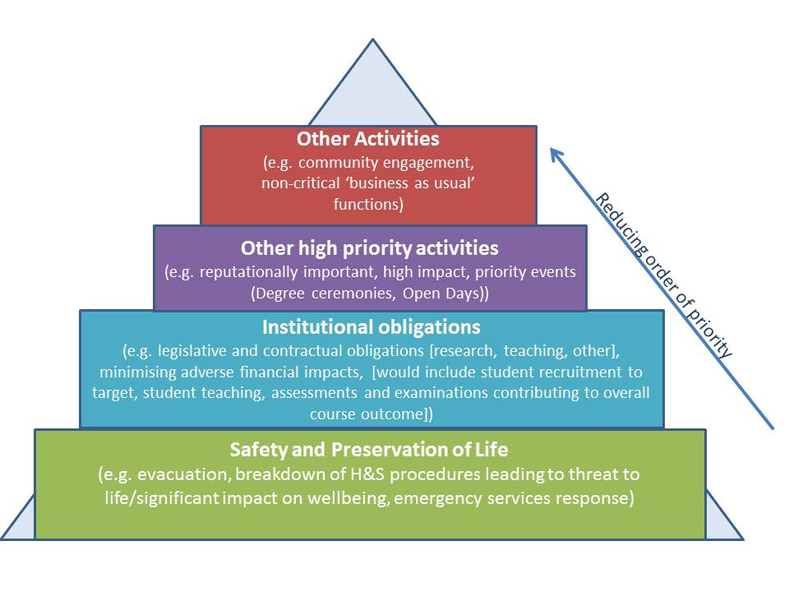

All levels of the University will be involved in the planning and response to incidents impacting on these priorities.

This is not a linear process – response to aspects in different priority layers could happen simultaneously

The activities within each layer may vary in the overall level of priority depending on the time of year/phase in a cycle. For example, online student enrolment becomes a priority activity August-October when we are processing the main intake for the next academic year.

5.3 Incident Management and Business Continuity Glossary
Term | Abbr. | Definition
Business Continuity | BC | The capability of the University to plan for and respond to incidents and disruptions to priority activities in order to continue to operate at a tolerable level.  There are three phases to Business Continuity:  - Incident Management  - Contingency  - Recovery
Business Continuity Plan | BCP | A documented set of procedures and information developed and maintained in readiness for use in an incident to enable the department to continue its activities at a tolerable level.  A Business Continuity Plan includes strategies for contingency and recovery.
Contingency |  | Plans, solutions, resources etc. to allow a priority activity to continue to operate at a tolerable level during a period of disruption.
Department Incident Management Plan | DIMP | The DIMP deals with the local management of the initial aftermath of an incident.  This includes details of the Department Incident Management Team, instructions on assessing the situation to enable decisions to be made, direction on escalation points to the University Major Incident Team should the incident have the potential to cause disruption or impact at University or strategic level and information to manage communication to local stakeholders.
Departmental Incident Management Team | DIMT | The DIMT in each department that would respond in an incident or emergency, and should lead the writing and testing of the Department Incident Management Plan.  Departmental teams may need to work together to provide resilience and additional capacity to manage incidents in a particular area of campus or campus-wide.
Disruption |  | An event that interrupts normal activities whether anticipated (e.g. strike action, severe weather) or unanticipated (e.g. power outage, technology failure, terrorist attack)
Impact |  | The evaluated consequence of a particular incident or plan of action i.e. what is the impact on your activities if you don’t have access to your office? What is the impact if you can’t carry out activity X for a day/week/fortnight?
Incident |  | An event which has the capacity to lead to loss of or a disruption to the University’s activities or poses a serious threat to safety and welfare - which if not managed could lead to an emergency situation.  See University Incident Impact Categories in Annex 5.1 for more detail.
Incident Management |  | The process to respond to and manage an incident
Term | Abbr. | Definition
Major Incident Plan | MIP | The MIP deals with the initial aftermath of an incident on a University or strategic level. This includes managing communications, media relations, assessing the situation to enable decisions to be made and monitoring the response of teams ‘on the ground’ e.g. Security Services, Estates, Departmental Incident Response Teams).
Major Incident Team | MIT | The MIT are responsible for managing the Silver (tactical) response to an incident on a University or strategic level in line with the MIP.  The MIT will co-ordinate the response of the operational, ‘on the ground’ teams and escalate strategic decisions to Senior Management as required.
Priority Activity |  | An activity (e.g. a process or service) which must be continued to deliver the University’s core aims or to meet agreed external obligations.
Recovery |  | The process of resuming disrupted priority activities to either pre-incident levels or to an agreed new level of operation.  This is a permanent solution and differs from the interim contingency arrangements put in place to continue activities at a tolerable (but below optimal) level in a period of disruption.
Threat |  | A potential cause of an unwanted incident, which may result in harm to individuals, the University, facilities, the environment or the community
Tolerable (period or state) |  | The level of service or resource beyond which, or period of time after which, the University’s core aims will be significantly damaged if a particular priority activity cannot be resumed.  Tolerable levels of service or resource are by definition below optimal but allow for continuity of priority activities during the period of disruption.

University Major Incident Planning Policy:www.warwick.ac.uk/gov/emerg-planning/
In an incident, this column can be used to tick actions that have been completed
See 5.2 of this Plan for details of institutional priority activities
In an incident, this column can be used to tick actions that have been completed
In an incident, this column can be used to tick actions that have been completed

