Estates Health, Safety and Environment Suppliers Forum
24 November 2017

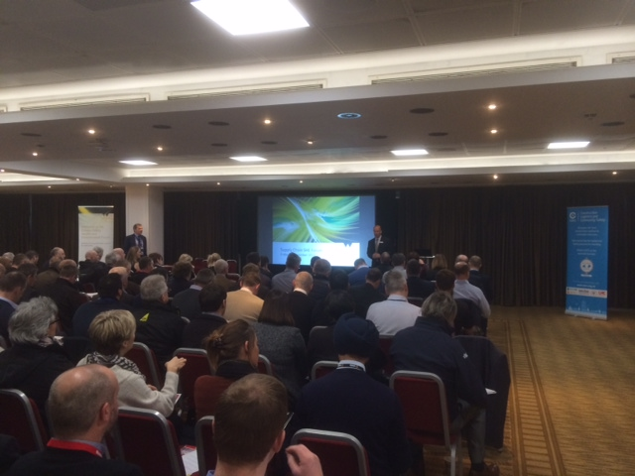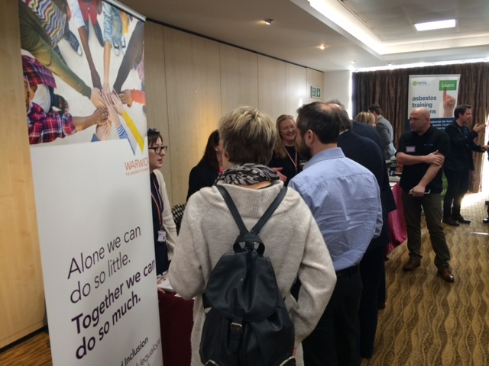

Thanks to over 120 people who attended our third supply chain Health Safety and Environment Forum at the University on 24 November. The feedback from the event was very positive and encouraging.

Led by James Breckon our Director of Estates and John Phillips Director of Health & Safety, set out Warwick’s vision for health, safety, environmental best practice and equality, diversity and inclusion. The event was to establish stronger connections with our supply chain partners and build on the relationships formed at our previous forums so that we can work together and improve our collective performance in Safety, Health & the Environment.

We were delighted that our annual event was supported by representatives from the health and safety, equality, diversity and inclusion, estates procurement, sustainability teams, water and asbestos specialists.

We shared the vision of our extensive capital build programme, so that our supply chain can understand the volume of work that may be required.

Louise Taggart, Workplace Safety Speaker presented on a personal tragedy that led to her attentions becoming focused on the field of health and safety. She told about her Brother Michael’s tragic story in which caused his death at an early age from an electric shock. Her primary aim in doing was to prevent others from losing their life or their loved one to a preventable workplace incident. Louise’s presentation certainly triggered positive emotion amongst the audience which will hopefully become focused on safety initiatives.

Derek Rees, Project Director of Construction Logistics and Community Safety (CLOCS) presented on the planning requirements for effective Construction Logistics Plans with an emphasis on the duty of care on all construction clients, principal contractors and designers and others to ensure facilities are designed, constructed and maintained in a way to protect the safety of all others - including Vulnerable Road Users at risk of collision with HGV’s servicing sites. Alarmingly ten times as many persons are killed or seriously injured by vehicles servicing construction sites than are harmed within construction sites.

💬 Feedback from our delegates:

Hello Mark

Thank you again for inviting me to your contractor’s forum to hear Louise speak. It is the first time I have seen her presentation live and I found it a roller coaster of emotion and hard hitting facts. It had a strong impact on the people sitting around me too. It was interesting to hear that they don’t go to many Supplier Forums, and see Warwick as taking the lead in this area.

