OPeRA Chemical Structure Search

The Structure Search interface is used for performing structure and keyword searches to find available structures and also the related hosted catalogues.
There are 4 structure search types to choose from:
substructure, superstructure, similar, and exact.
Search fields-Product Name, CAS number, molecular formula, and molecular weight can be used by themselves or in combination with other fields and/or a structure drawing.
Structure Drawing Using the on screen tools to specify any properties of the structure.
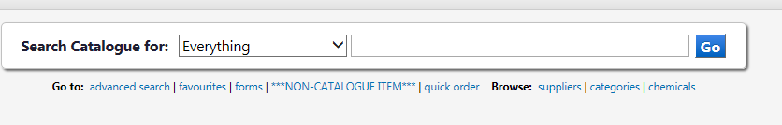
To launch the “Chemical structure search” first select “Chemicals”

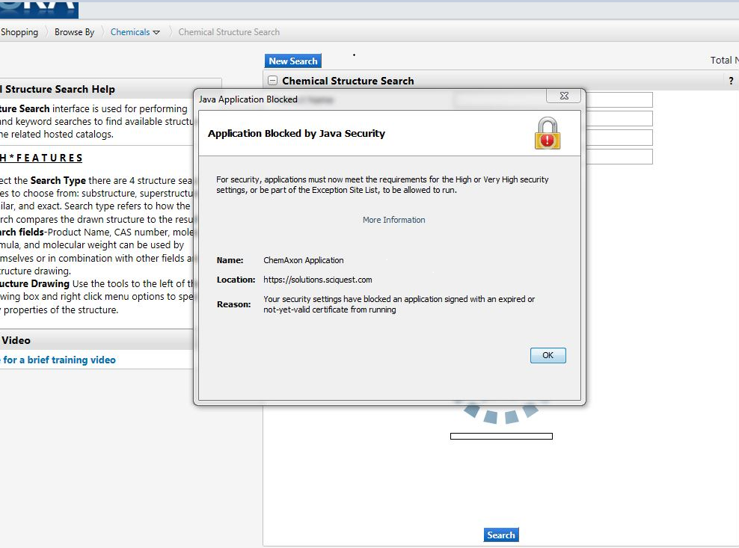
The first time you try to access this you may receive an “Application Blocked” message, this is because IT services have blocked Java as standard however the steps which follow will allow you to add the SciQuest webpage as a trusted site and enable you to use the search tool.

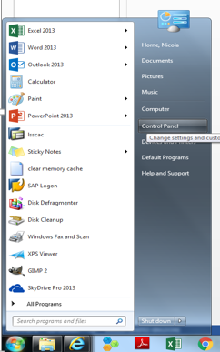
Step 1
Select “Start” followed by:
“Control Panel”

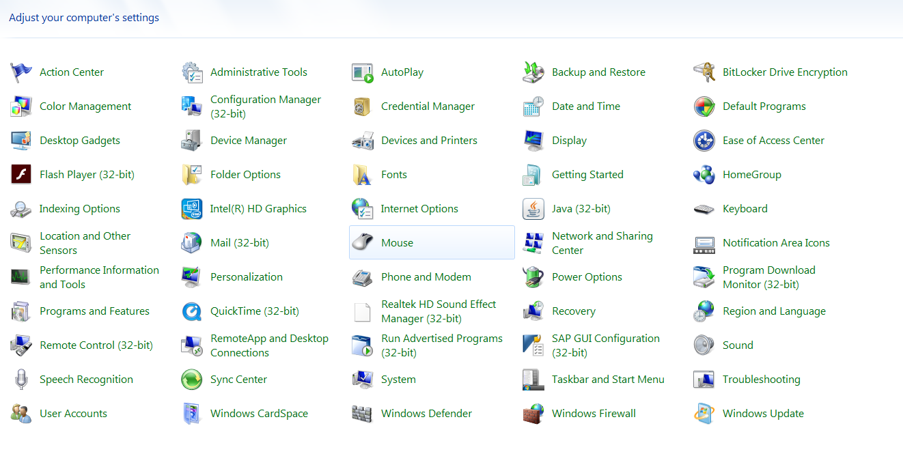
Select Java (32-bit)
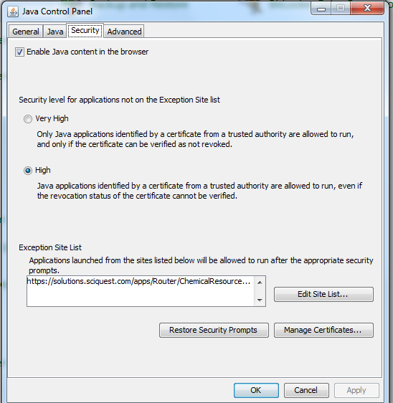
Select the “Security” tab
Security Level will be “High”

“Edit Site List”

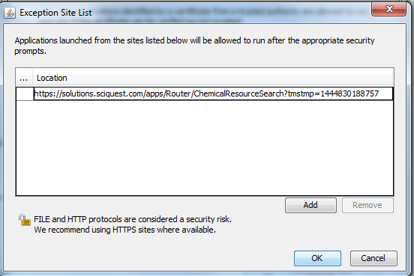
Enter the SciQuest web address (which can be copied from the website direct or entered manually) https://solutions.sciquest.com/apps/Router/ChemicalResourceSearch?tmstmp=1445242861497
Select “Add”

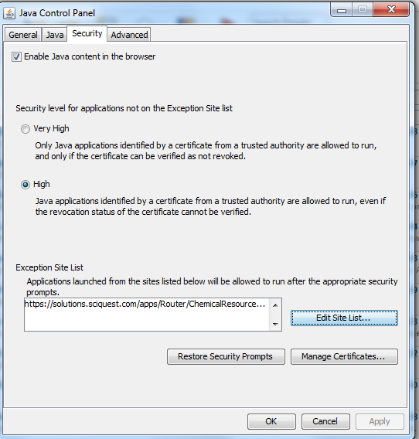
Select “Apply”
Followed by
“OK”
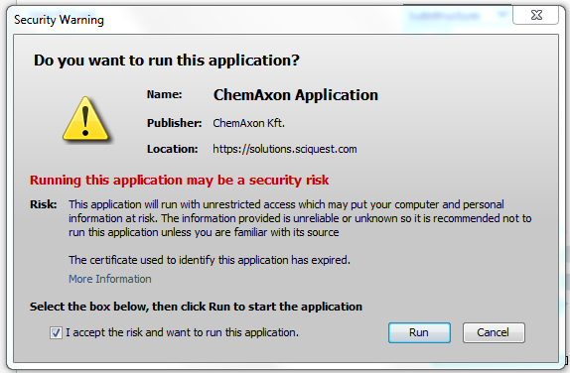
Each time you launch “Chemical Search” you will see a “Security Warning” Box,
Click the “I accept the risk and want to run this application” box
Then select:
“Run”
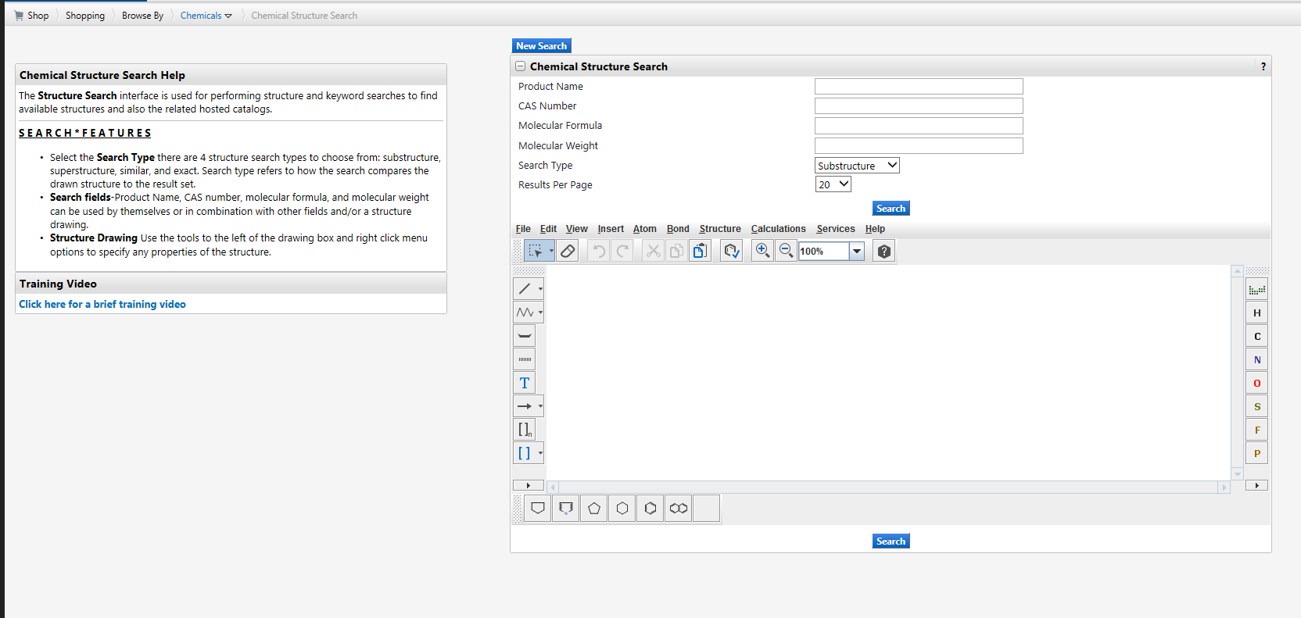
You can now use the search feature

