How To – Create a booking

Step 1: Select a date & time at the top of page

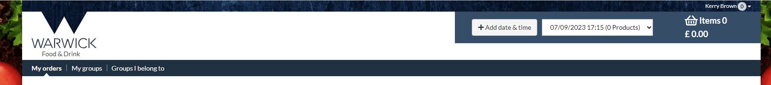

Step 2: On left side of screen select the required category & then add the product & amount needed, these items will be added to your basket

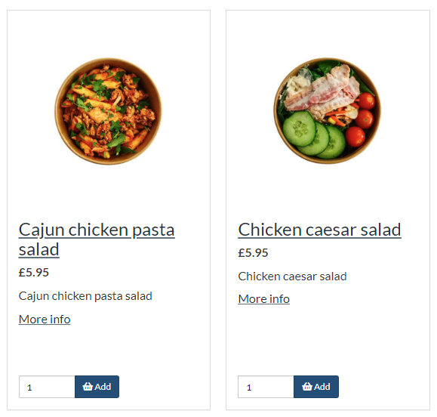
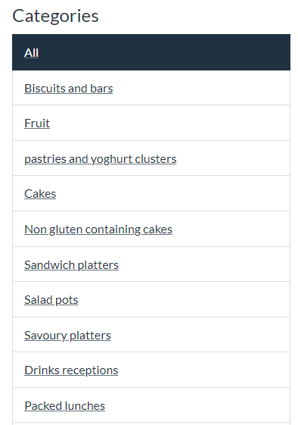

Step 3: Click on basket to view items ordered, if this is correct proceed to checkout

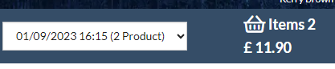

Step 4: Complete Checkout – Delivery form with all required fields – click continue at the bottom of page

Step 5: Checkout – Summary page, review details and tick ‘I have read and agree to terms & conditions’
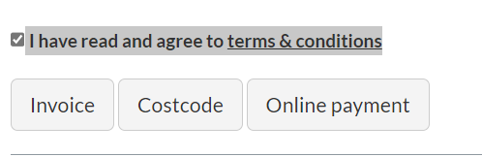

Step 6: Select payment method eg. cost code, enter your cost code and click place order, repeat with alternative payment methods
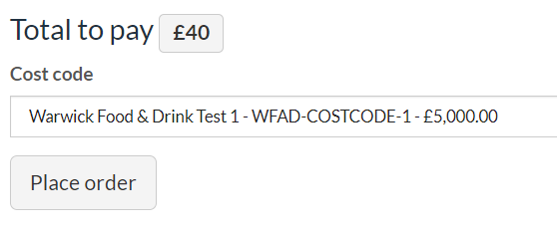

Step 7: Confirmation received with reference number

