
Committee Membership SharePoint Site
Secretariat Quick Reference Guide
To Access the Committee Membership SharePoint Site

To access via Office 365
- Go to your Warwick webmail account at: webmail.warwick.ac.uk
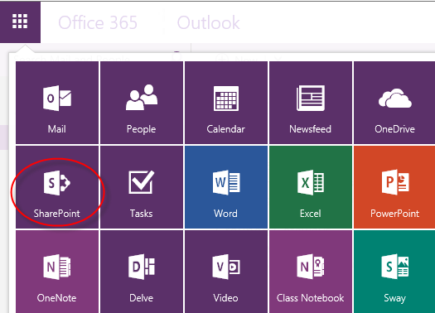
- Click on the app launcher, located at the top left of the window, and select SharePoint
- Type Committee Membership in to the search box located at the top left of the screen

- Once the site has loaded, click the Follow link to add the site to your list of followed sites.

- Alternatively you can bookmark the following url to gain direct access to the Committee Membership site:
https://livewarwickac.sharepoint.com/sites/committee-memberships

- Click the Secretariat button
- Click the required icon to access the Secretariat Main Menu.
- To return to this menu click the Secretariat link at the top of the screen.
To Submit a New Committee Nomination:

- From the Main Menu select Nominations
- Click the New Item link
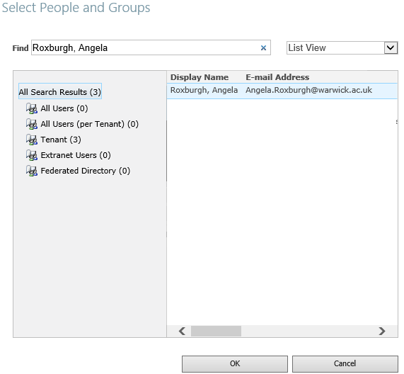
- Once the form has loaded complete all of the fields that are shaded or have a red star in them. The PeoplePicker fields, Nominee fields, can only be used to enter information regarding University members.
If you are entering a nomination for an external candidate, leave the Nominee field blank and manualy complete the shaded fields below it.
- If nominating a representative on another committee you should complete the Send confirmation receipt to field with the secretary responsible for that committee so that they are aware of the nomination.
- To populate the people picker field:
  - Click the address book icon to the right of the field
  - Search for the Nominee using the following format Surname, Forename
  - Ensure that the field has validated the entry before continuing to complete the form (name will appear underlined).
  - Click Update Details to auto complete the rest of the form – you will need to manually enter the correct title i.e Professor/Dr/Ms etc
- Start and End Date. If the Nominee is to commence their tenure at the start of the term, tick the relevant Term commencement box. Start and end dates will be automatically completed based on a 3 year term. Nominee start and end dates can be manually adjusted if necessary
- Click Save and Close to submit the form. If you wish to create additional items, Click Save and New
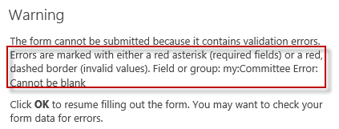
- If you receive a warning message, as displayed on the right, you have failed to complete a mandatory field(s). Click OK and complete all fields that contain * or are outlined in red.
You will be unable to submit the form until you complete the missing information.
- Additional nominations can be entered using the Save and New button.
- An email receipt will be sent to you for each submitted Nomination.
- Your completed nomination(s) will appear in the Nominations list for a short period until it is processed by the Senate team Clerical Officer.

Frequently Asked Questions

What browser should I use?
We recommend that you use a recent version of Internet Explorer to complete SharePoint forms. Other browsers may not fully support forms in SharePoint.

After saving my form I have received a critical error
As with all browsers, forms will time out when left inactive. Complete your and submit it immediately to avoid loss of data. You can save the form and edit it later if necessary.

Can I edit an item once it has been submitted?

Yes, you can edit items for as long as they appears in the relevant list. Once the item has been removed from the library, you should contact the Clerical Officer in the Senate team (senate@warwick.ac.uk or ext: 51699).

Can I delete a submission?
Nominations and requests to Request to Amend the Constitution can be deleted while they are still visible in the library.

Who should I contact if I have a problem submitting a form?

All requests for assistance should be registered via the Clerical Officer in the Senate team (senate@warwick.ac.uk or ext: 51699).

Can I turn off the confirmation emails?
No, the emails are auto generated and cannot be turned off for specific individuals. We suggest that you create a rule in Outlook to filter the emails in to a specified folder.

To create a rule to automatically move mail to a specified folder
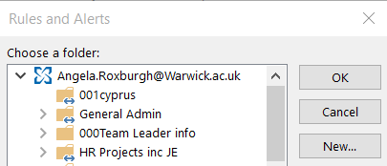
- Right click on the confirmation email and select rules
- Select the option to Always move messages
- Click the New
- Enter a Name for the folder
- Click OK and OK again to close the Choose a folder window
- Repeat the rule for each type of confirmation email i.e. Nominations and Requests to change the Constitution. You can store both confirmation email types in the same folder. Just select the folder from the list of available folders in your mailbox.
- All new mail will be filtered into the specified folder.
- Further rules can be made to automatically delete emails. Please contact the helpdesk if you would like further instructions.

