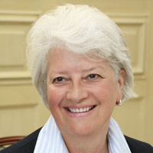
Philippa Foster Back CBE

Director, Institute of Business Ethics
Philippa began her career in Corporate Treasury and Finance, prior to her appointment as Director of the Institute of Business Ethics in 2001.
In this role, she runs the IBE delivering with the team UK and international advisory work, research and publications, training, and events, all with the purpose of raising awareness and sharing of best practice in business ethics, in line with the IBE’s charitable aims. She speaks widely on business ethics issues, encouraging high standards of business behaviour based on ethical values.
In 2008 she was a member of the Woolf Committee looking at business practices at BAE Systems. She currently sits on the Stakeholder Panel Group of the Financial Reporting Council and is a member of the BEIS/FRC Coalition group looking at Corporate Governance in Large Unlisted Companies.
Her external appointments include the Chartered Institute of Securities and Investment; RAND Europe; Barrier Biotech Ltd. Philippa is also Chairman of the UK Antarctic Place-names Committee and the South Georgia Heritage Trust.
In 2006 she was awarded the OBE for services to the Ministry of Defence in her capacity as NED and Chair of the Defence Audit Committee. She won the M&S/BITC Sieff Award in 2008. In January 2014 she was awarded the CBE for services to UK Antarctic Heritage.

