Charles Fefferman – Short bio

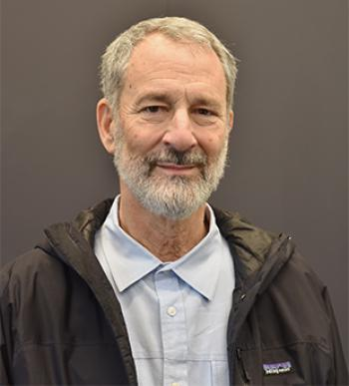
Charlie Fefferman is the Herbert E. Jones, Jr. ’43 University Professor of Mathematics at Princeton University, where he teaches calculus and undergraduate and graduate courses in analysis.
Professor Fefferman earned his Ph.D. at Princeton University in 1969. After a year at Princeton, he was hired as an assistant professor at the University of Chicago, and then promoted to professor after one year, the youngest full professor at any college in the United States. In 1974 he returned to Princeton as the youngest full professor in the University’s history.
Professor Fefferman is a Fellow of the American Mathematical Society, the American Academy of Arts and Sciences, the National Academy of Sciences, the American Philosophical Society, and is an honorary member of the London Mathematical Society.
He was the first recipient of the Alan T. Waterman Award, and received the Fields Medal in 1978. He has also been awarded the Salem Prize, the Bergman Prize, the Bocher Memorial Prize, and shared the Wolf Prize with Richard Schoen in 2017.
Professor Fefferman’s service to the mathematical community has been extensive. He is recognized as both an exceptional researcher and an excellent teacher. He has served on the editorial boards of many mathematical journals, and has written a number of foundational articles on analysis.

