Douglas Terrier, Acting Chief Technologist
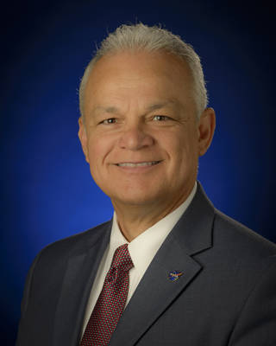
Dr. Douglas Terrier serves as acting chief technologist and is the senior leader of the office. In this role, Terrier is the agency's principal advisor and advocate on NASA technology policy and programs, helping plot the strategic direction of the agency's space technology program.
Terrier is responsible for the operation, management and programs within the Office of the Chief Technologist. The Office of the Chief Technologist serves as the NASA Administrator’s principal advisor and advocate on matters concerning agency-wide technology policy. Terrier directs the work of the strategic integration and innovation teams, coordinating and tracking technology investments across the agency, working to infuse technologies into future NASA missions and facilitating agency technology governance. He also is responsible for coordination and integration of research and development planning, policies and programs with other NASA Directorates and Offices, NASA centers and other government agencies, industry and academia. In addition, Terrier conducts advocacy activities with technology partners in industry, the educational community, the public, customers, and stakeholders.
Prior to his current position, Terrier worked at NASA’s Johnson Space Center, Houston, as the center’s chief technologist, serving as the principal advisor to the Center Director for technology, and the Center point of contact for the Agency Chief Technologist and the Space Technology Mission Directorate. He is responsible for guiding JSC’s technology investment strategy and integrating and managing the comprehensive technology portfolio.
Terrier also served as the deputy director of NASA Johnson’s Strategic Opportunity and Partnership Development (SOPD) Office. SOPD is responsible for guiding JSC future business including: strategic planning; new business pursuit; technology investment and commercialization; and partnership development. SOPD coordinates all external competitive pursuits and collaborative efforts on behalf of the Center technical Directorates.
Terrier’s previous assignment was Associate Director of Engineering where he led teams responsible for design and development of spacecraft for NASA’s human space exploration program. He also managed the multi-center Crew Exploration Vehicle Aero-science Project developing the critical aerodynamic and aero-thermal environment design database for the Orion spacecraft.
Prior to joining JSC, Terrier served in the Enterprise Readiness Division in the Office of Program Analysis and Evaluation at NASA HQ where he led efforts to align field Center institutions with the Vision for Space Exploration. He joined NASA in 2003 at the Langley Research Center in the Office of Business Development where he was responsible for growing and realigning the Center’s strategic business profile.
Terrier worked in the commercial aerospace sector for a total of 23 years with Lockheed Martin, General Dynamics and General Electric Aircraft Engines. He was responsible for International Business Development for Lockheed Martin in the Asia/Pacific region, supporting major successful campaigns including the Australian Joint Strike Fighter campaign worth $12B and the Singapore F-16 Peace Carvin Program worth $4B. Terrier managed Lockheed Martin’s Executive Strategy Team in their successful bid for the DoD’s Joint Strike Fighter program worth $500B.
As an engineering project manager for the Lockheed Martin, Terrier led several highly successful Department of Defense development projects on flight programs including: The F-35 Joint Strike Fighter international variants and block upgrade program; F-22 Raptor fighter program; A-12 Lightning program; National Aerospace Plane; and several classified programs.
Terrier earned a Ph.D. in aerospace engineering and a MS in Mechanical Engineering from the University of Texas. He also completed the Carnegie Mellon Graduate School of Industrial Management program with the Lockheed Martin Institute for Leadership Excellence. Terrier holds patents for his work in aerospace propulsion and has published numerous technical papers. He has earned the Lockheed Martin “Outstanding Technical Achievement” award on four occasions, several NASA “Superior Technical Accomplishment” awards, and the NASA Leadership medal.
Terrier is the proud father of two daughters and a son. In his spare time, he is an avid soccer player and an aircraft owner and pilot.

