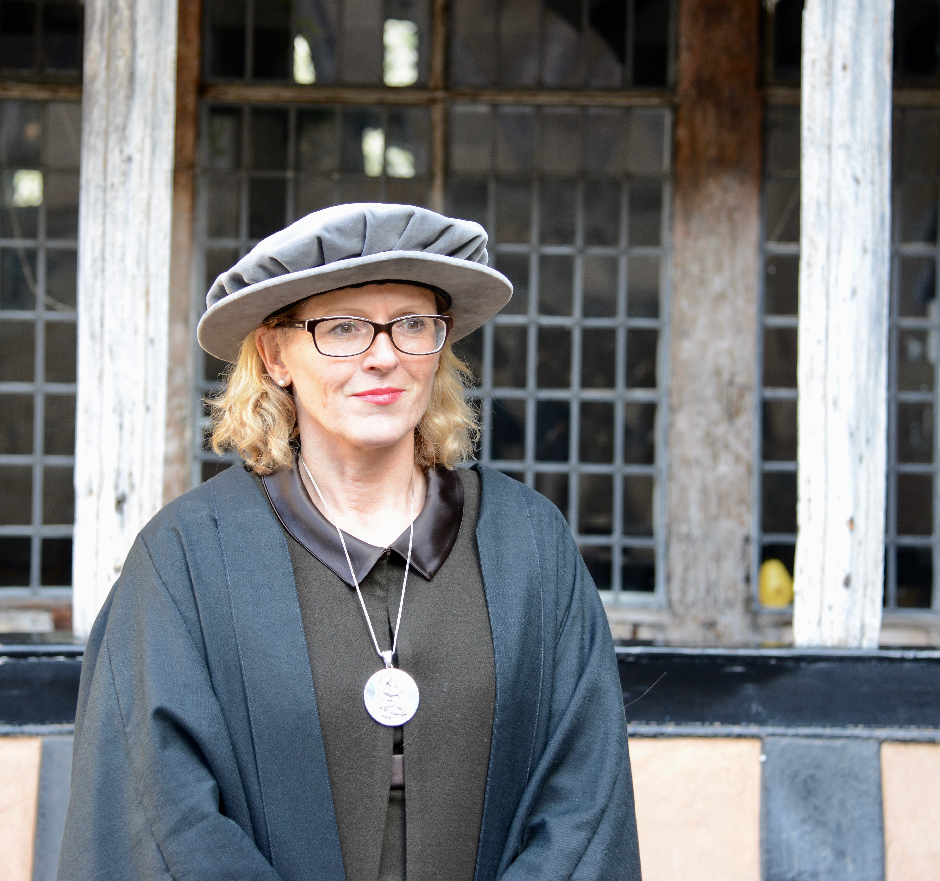
Biography for Heidi L Meyer,
Master Lord Leycester Hospital, Warwick

Heidi Meyer has held the position as the 33rd Master of the Lord Leycester Hospital Warwick since November 2016 and is the first female master to be appointed in 450 years.

Before she took up this position she lived overseas for thirty five years working primarily for the US government and NATO in security and defence policy and operations – spending five years of that in Afghanistan at the height of the conflict.

In her last position before coming to Warwickshire, she worked for NATO as the Senior Political Advisor to the Commander of the Land Forces of NATO in Izmir, Turkey invovled in issues such as the migrant crisis, the Ukraine crisis, the Turkish coup, the rise of ISIS and the Syrian war.

Between 2000 and 2013, she worked as a policy official for the US Government – either with the US Department of Defence or the US Department of State - working primarily on Afghan strategic policy and civilian security issues in Mons, Washington DC and Kabul. She has also worked in Italy for NATO in civil military affairs during the Kosovo crisis.

Prior to working for the US government, Heidi Meyer was Associate Director of Admissions, Dartmouth College, New Hampshire;
a schoolteacher at the International School in Naples Italy;
set up and ran a charity delivering emergency aid to forty countries;
and held a Commission in Her Majesty’s Army to the rank of Captain.

In 1994 she earned a Master of Science degree in International Relations from the School of Foreign Service, Georgetown University, Washington DC, and a Bachelor of Science degree in Communications from Cameron University, Oklahoma.
She was born in Newbury, Berkshire, United Kingdom, is married to Ed Woods and has two children Ben and Alex.

