Risk & Resilience Team
Risk Management
Briefing

Risk and Risk Management
Risk:

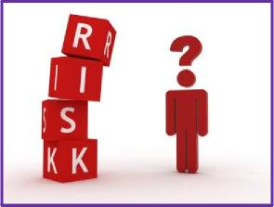 | “The effect of uncertainty on our objectives”  At a dept/team level the objectives at risk will be your departmental objectives.  At an institutional level, these will be the University’s strategic objectives.  Risk Management:  A coordinated set of activities and methods employed to control the risks that can impact our ability to achieve objectives. The management process is cyclical and involves the following steps...

Steps in Risk Management

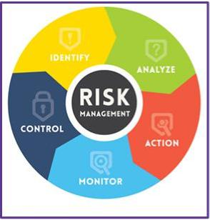 | - Risk Identification – Recognise & describe it – a process used to find, recognise, and describe the risks that could impact our objectives.  - Risk Analysis – Score it – a process used to determine the ‘Likelihood’ of the risk happening and the potential ‘impact’ if it did. The resulting ‘Risk Score’ is a calculation of Likelihood x Impact.  - Risk Evaluation – Is it acceptable? – a process used to examine the magnitude and whether the risk is acceptable against the Risk Appetite/Tolerance of the Dept or University.  - Risk Treatment – Mitigation – a process by which ‘controls’ (mitigation measures) are put in place to help lower the risk score.

1. Risk Identification

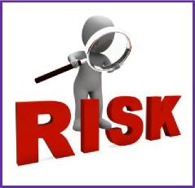
Internal Sources | External Sources
Governance | Legal/Regulatory
University Structure | Severe Weather
Culture | Political Change
Finance | Sector Changes
Staff & Students | Global Economy
Health & Safety | Epidemic/Pandemic
Information Security & GDPR | Competitors

Examples only; not an exhaustive list

2a. Risk Analysis – Likelihood Score
Likelihood | Score |  | Description
Extremely likely | 5 |  | Something that will be occurring in the next few weeks or is very likely to occur during the current business ! operational planning cycle. Over 75% chance of risk occurring.
Probable | 4 |  | Something that is likely to occur during the next business ! operational planning cycle.  Between 50% and 74% chance of risk occurring.
Possible | 3 |  | Something that could happen at some point over the current strategic planning cycle.  Between 25% and 49% chance of risk occurring.
Unlikely | 2 |  | Something that is unlikely to occur based on current intelligence.  Between 10% and 24% chance of risk occurring.
Highly unlikely | 1 |  | Something that is highly unlikely to occur based on current intelligence.  Less than 10% chance of risk occurring.

2b. Risk Analysis – Impact Score (zoom in for detail)
 |  |  | IMPACT CATEGORY
Impact | Score |  | Delivery/Performance (D) | Finance (F) | Reputation (R) | Health & Safety (H) | Legal (L) | People & Wellbeing (P) | Environment (E)
Very High | 5 |  | - Multiple Depts unable to continue service  delivery  - Resolution required at Executive level  - Prolonged disruption to operations  - Major decreases across a broad range of KPIs  - Failure to deliver one or more strategic goals | - Major impact on finances available to affected business area (£millions) | - Sustained (for a number of days within 1 week) adverse  international / national media coverage  - Cancellation of events, withrawal of donations,  cancellation of conferences  - Significant reduction in confidence and trust from  existing and/or prospective students and large increase in  actual and threatened student drop-outs  - Widespread and prolonged reduction in public  confidence  - Criticism at Government level  - Major unjustified impact on human rights or diversity | - Fatal incidents  - Health effects - affecting more than one person or chronic medical disability due to, for example, exposure to a probable carcinogen  - Property damage - the loss of one or more buildings | - Prosecution of University - Successful, substantial claims/fines against the University outside the limits of our insurance  - Knowingly failing to comply with legislation  - Failure to meet Government requirements | - Loss of a number of members of the Executive Team - Redundancies affecting >100 people  - Major drop in staff morale  - Major reduction in student numbers (>20%) - Huge increase in staff accessing EAP, very high levels of stress related sick leave across a number of areas, wellbeing reports made to Managers in several Depts/areas  - Significant increase in student drop-outs/non-continuation rates, high increase in students accessing wellbeing support | - Major and widespread contamination of  groundwater and/or soil  - Significant and prolonged air pollution  - Extremely damaging impacts on Biodivesity  and protected species  - Large quantities of non-recyclable waste  materials produced
High | 4 |  | - One Dept unable to continue service delivery  - Resolution required at Executive level  - Medium to Long term University-wide disruption  to operations  - Serious decrease in performance across several  KPIs  - Failure to deliver on a priority strategic goal | - Serious impact on finances available to affected business area (£100,000s) | - Persistent (frequent/regular news coverage) adverse national media coverage  - Threats of Event cancellation and donation withdrawal - Significant reduction in confidence and trust from existing and/or prospective students and significant threat of student drop-outs  - Temporary reduction in public confidence  - Criticism at Local Government level or intervention by the UK Research & Innovation and/or Office for Students office  - Serious unjustified impact on human rights or diversity | - Injury - permanent disability or other reportable injury/disease, for example, amputations or major fractures. Severely life shortening diseases.  - Health effects - affecting one person, toxic by inhalation/contact with skin or swallowed. Damage to eyes, respiratory system, skin sensitisation, effects on fertility, prolonged exposure risks, limited evidence of carcinogenic effects.  - Property damage; major. Extremely flammable and explosive substances. - Lost time; > 3 months | - Potentially successful claims/fines against the University outside the limits of our insurance  - Failure to comply with  legislation  - Failure to deliver on stated Government priority | - Loss of one member of the Executive Team  - Redundancies affecting between 60-99 people  - Serious drop in staff morale  - Serious reduction in student numbers (10-15%)  - Significant increase in staff accessing EAP, high levels  of stress related sick leave across several areas,  wellbeing reports made to Managers in more than one  Dept  - Increase in student drop-outs/non-continuation rates  and increase in students accessing wellbeing support | - Significant but limited (in terms of area) contamination of groundwater and/or soil - Moderate and prolonged air pollution - Damaging impacts on Biodivesity and protected species  - Large quantities of non-recyclable waste materials produced
Medium | 3 |  | -Multiple teams within a Dept unable to continue  service delivery  - Resolution required at Faculty/Group level  - Short to Medium term disruption to  Faculty/Group activity  - Significant decrease in specific KPIs  - Adverse effect on objectives | - Significant impact on finances available to affected business area (£10,000s) | - Sustained adverse local media coverage  - Poor public sentiment  - Moderate reduction in confidence and trust from  existing student community and moderate threat of  student drop-outs/non-continuation rates  - Limited and temporary reduction in public confidence  - Short term customer dissatisfaction  - Internal or external audit criticism  - Significant unjustified impact on human rights or  diversity | - Injury; loss of consciousness, lacerations, concussion, serious sprains, minor fractures, deafness, asthma, burns or injury resulting in absence from work.  - Health effects; acute health effects, e.g. harmful if inhaled/contact with skin/ or swallowed, dermatitis, ill-health leading to minor but permanent disability.  - Property damage; serious but confined to a work-room or area. Oxidising, flammable and highly flammable substances.  - Lost time; > 4 days – 3 months | - Significant claims/fines against the University, within our insurance cover  - Failure to deliver on multiple other Government policies | - Loss of a number of senior managers  - Redundancies affecting between 30-59 people - Significant drop in staff morale  - Significant reduction in student numbers (5-10%) - Slight increase in staff accessing EAP, small increase in stress related sick leave in a concentrated area of the University, wellbeing reports to Managers in one Dept - Very small increase in student drop-outs/non-continuation rates and some increase in students accessing wellbeing support | - Moderate contamination of groundwater and/or soil  - Moderate-Minimal air pollution  - Limited (in terms of area affected) but significant damaging impacts on Biodivesity - Moderate quantities of non-recyclable waste materials produced
Low | 2 |  | - One team unable to continue service delivery  - Resolution required at Department level  - Short term disruption to Departmental service  delivery  - Minor decrease in specific KPIs  - Failure to achieve an internally agreed objective | - Minor impact on finances available to affected business area (£1000s) | - Isolated adverse media coverage  - Minor damage to reputation - perception, feedback  surveys, SM activity  - Very limited and temporary reduction in public  confidence  - Reduction in confidence and trust from existing  student community and minor threat of student drop-  outs/non-continuation rates  - Internal criticism  - Minor unjustified impact on human rights or diversity | - Injury - Wisespread bruising, minor cuts,  light abrasions  - Health effects - mild irritation of skin or  eyes, headaches, ill-health leading to  temporary discomfort  - Property damage; minor  - Lost time; < 3 days | - Minor claims, complaints within our insurance cover - Failure to deliver on one Government policy | - Redundancies affecting between 10-29 people - Minor drop in satff morale  - Minor reduction in student numbers (1-5%) - Slight increase in staff accessing EAP, small increase in short term stress related sick leave in one Dept, possible wellbeing reports to Managers in one Dept - A small increase in students accessing wellbeing support | - Minimal contamination of groundwater and/or soil  - Minimal air pollution  - Limited (in terms of area affected) and moderately damaging impacts on Biodivesity - Moderate-minimal quantities of non-recyclable waste materials produced
Very Low | 1 |  | - Negligible impact on service delivery  - Resolution required at team management level - Minor reduction to department service delivery - Negligible decrease in specific KPIs  - Partial failure to achieve an internally agreed objective | - Negligible impact on finances available to affected business area (£100s) | - Negligible adverse media coverage  - Minimal damage to reputation  - Minor and temporary reduction in public confidence  - Temporary and minor reduction in confidence and trust  from existing student community  - Low level internal criticism  - Negligible unjustified impact on human rights or  diversity | - Very minor injuries; minimal cuts & bruises  - Property damage; minimal  - Lost time; < 1 day | - Negligible claims or complaints - Failure to deliver on aspects of Government policy | - Neglible drop in staff morale  - Redundancies affecting between <10 people  - Neglible reduction in student numbers (<1%)  - Minor increase in short term stress related sick leave  in one Dept (only) and some minor concerns about staff  wellbeing flagged to Managers in one Dept  - Minor increase in students accessing wellbeing  support | - Trace contamination of groundwater and/or soil  - Trace air pollution  - Limited (in terms of area affected) and minimal undesireable impacts on Biodivesity - Small quantity of non-recyclable waste materials produced

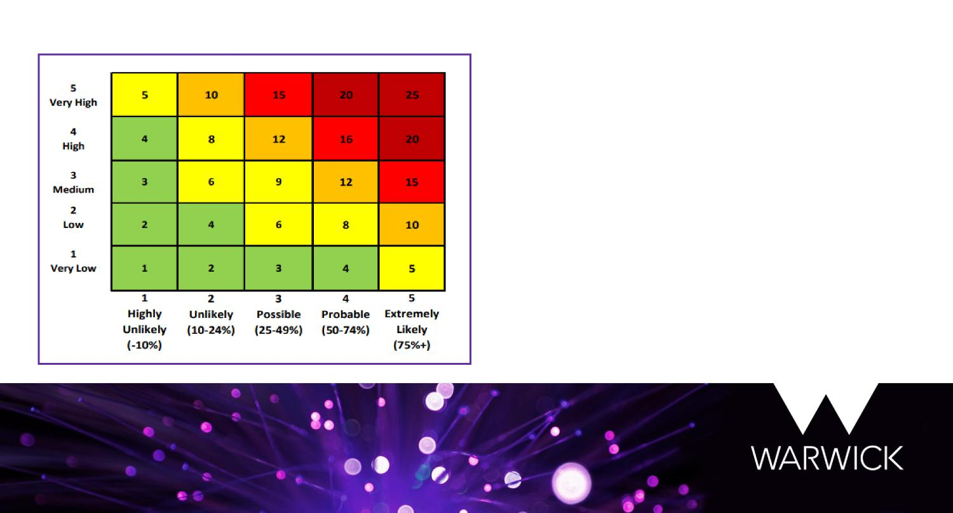
2c. Risk Analysis – Overall Risk Score
The Impact score multiplied by the Likelihood score, gives an overall ‘Risk Score’.
The matrix shows how this Risk Score is then categorized into Very Low, Low, Medium, High and Very High.
Doing this helps us see which risks are most significant and require the most attention and management.
The University’s Strategic Risk Advisory Board (SRAB) focuses on risks that are 16+ after mitigation and have strong links to our Strategic objectives.

3. Risk Evaluation
Risk Threshold

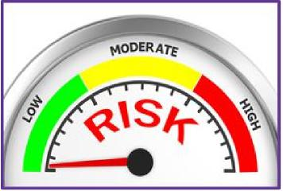 | Risk Threshold is a level beyond which an organisation will need to address the risk. It is a quantified limit and for the University this has been set at 16+. If a risk has a Current Score greater than 16 it will not be tolerated; it will need to be treated with an appropriate risk treatment option.  Risk Appetite  Risk Appetite is the amount of risk that the University is prepared to pursue in order to meet its strategic objectives. Risk Appetite can range from ‘Risk Averse’ (low) through to ‘Risk Tolerant’ (high).

3a. Risks that score under 16 – Stays Local

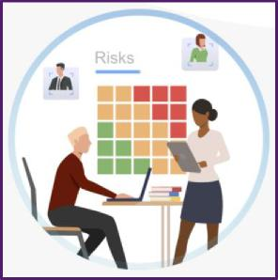 | - Risks that have a Current Score of less than 16 do not need to be flagged up to SRAB.  - The risk can stay on the dept/faculty Risk Register and does not warrant inclusion on the institution’s Strategic Risk Register  - These risks can be dealt with at a local level. The Risk Treatment, as mentioned earlier, will depend on the risk. Most risks will be ‘treated’ but some will be ‘transferred’ and some occasionally ‘tolerated’. Risks only need to be ‘terminated’ if they present significant impacts, which is highly unlikely for risks below 16.

3b. Risks that score over 16 - Go to SRAB

- Risks identified which are aligned to the strategic objectives and have a Current Score of 16+, which is our institutional ‘Risk Threshold’ score.
- Use the ‘Risk on a Page – Escalation’ or ROP-E to detail the concerns about the risk and request mitigation support. This can be found on the Risk Management webpage.
- SRAB will review the ROP-E. If they deem it appropriate they will escalate the risk to UEB for inclusion on the Strategic Risk Register.

3c. Exception – Thematic Risks...

- It is likely that there will be a number of thematic risks across departmental Risk Registers
- For current risk scores that are not 16+ but are thematic and present significant challenges, the Risk & Resilience Team will work with faculties or depts (or the overseeing committee) to determine whether the risk still warrants being reviewed at SRAB

4. Risk Treatment Treatment option will always depend on the nature of the risk and
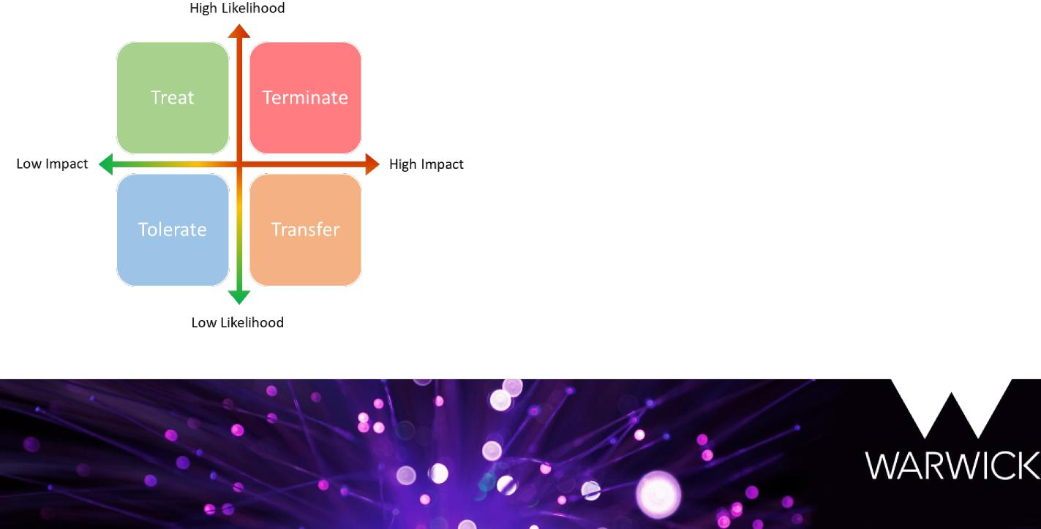
how it aligns to Risk Appetite.

Treat– Most commonly used treatment option. Usually best for high likelihood but low impact risks.
Transfer– Usually best for high impact but low likelihood risks. The act of transferring the risks to another party. Insurance policies and outsourcing are prime examples.
Tolerate– Only appropriate to use when the risk is low likelihood and low impact and deemed acceptable against our Risk Appetite.
Terminate – If a risk is very high likelihood and very high impact we may look to eliminate it all together where possible. However, this is rarely possible in practice, and ‘Treat’ is often a more realistic option.

Any Questions?

Feel free to get in touch with the Risk & Resilience Team to find out more:
Resource Account: risk.management@warwick.ac.uk
Risk & Resilience Manager: Chris Griffin –
Christopher.Griffin@warwick.ac.uk
Risk & Resilience Officer: Kim Jebson-Hambly –
Kimberly.Jebson-Hambly@warwick.ac.uk

