Activity / Use | Cleaning down of metalworking machinery after use |  |  | University Hazard Classification |  | MEDIUM
Substances used in activity | J22 Multi-Citrus Cleaner |  |  | UN No: 1760  Transport Cat: 8
Handling Requirements e.g. fume cupboard, MSC, glove type etc. | Undiluted fluid should be handled whilst wearing safety spectacles, nitrile protective gloves and a fastened lab coat. Avoid formation of mists. Wear protective gloves when transferring diluted products from machines to waste containers.
Laboratory Info | Appropriate to the department (state lab number and containment level where appropriate)
Additional Information | This substance is a highly alkaline solution (pH 13) consisting of a mixture of chemicals. It is intended to be diluted 1:25 with water when used for the cleaning down of machinery. It may not be used by persons under 18 years of age as it is a professional product.
Hazard Statements  H314 | 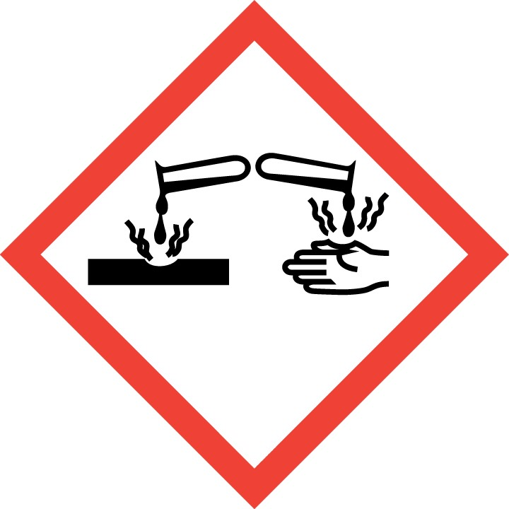  Causes severe skin burns and eye damage
Handling Precautions |   Wear impervious chemical resistant gloves to EN 374 -nitrile gloves |   Wear close fitting eye protection (EN 166) |   Wear a fastened lab coat
Storage & Transport | Do not store with strong acids, oxidizing agents or metals.
Spillage and Waste Disposal | Spills:-  - Use Personal Protective Equipment listed above.  - Absorb spillage using inert absorbent material or cloths. For large spills use alkaline-resistant absorbent granules or sand.  Waste: -  Waste liquid should be transferred to a labelled container. Solid waste arising from clean up of spillages should be put in plastic bags or containers and labelled clearly. All waste should be disposed as hazardous waste in accordance with departmental procedures.
First Aid   | EYES: Immediately rinse with water for 15 minutes while holding the eyelids wide open. Get  immediate medical advice/attention.
 | SKIN: Wash with plenty of soap and water. Take off immediately all contaminated clothing and wash it before reuse.
 | INHALATION: Remove person to fresh air. Seek medical attention if symptoms persist
 | INGESTION: Do not induce vomiting. Rinse mouth. Drink plenty of water. Seek medical attention.

