Substance | Alkalis (water-soluble bases) |  | UN No:1813 / 1823/2672  Transport Cat: 8 |  | University Hazard Classification |  | MEDIUM
Activity | Chemical reactions, cleaning
Handling Requirements e.g. fume cupboard, MSC, glove type etc. | - Ammonium hydroxide should be handled in a fume cupboard (LEV) due to ammonia vapour.  - When carrying out the risk assessment for the use of the material, ensure consideration is given to the concentration and volume being used.  - Wear protective nitrile gloves (EN374) and eyewear (EN166) when handling solids and solutions.  - When preparing solutions of sodium or potassium hydroxide from pellets or granules, the reaction is highly exothermic and care should be taken to add solids slowly to excess of water. Keep mixing container cool, i.e. ice jacket.  - Ammonia is a lachrymator (i.e. will cause your eyes to water). Open containers of ammonium hydroxide slowly in a fume cupboard and allow any excess pressure to release.
Laboratory Info | Appropriate to the department (Lab number and containment level where appropriate)
Additional Information | - Sodium hydroxide Short Term Exposure Limit (STEL): 2 mg/m³  - Potassium hydroxide STEL: 2 mg/m³  - Ammonium hydroxide 8hr TWA 18 mg/m³; STEL 25 mg/m³ (both as ammonia vapour).  Exposure limits must not be exceeded.
Hazard Statements  H290  H302  H314  H335  H413 | 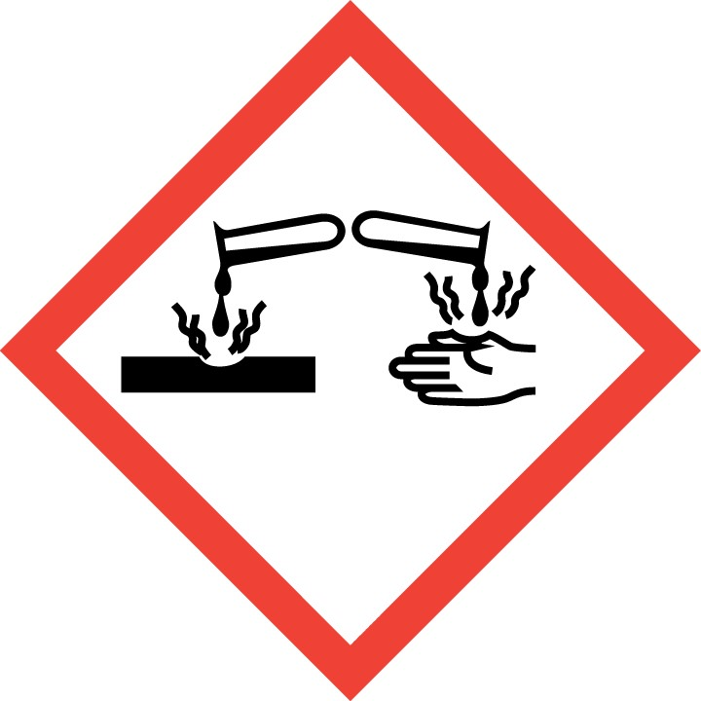  May be corrosive to metals | 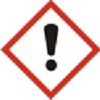  Causes severe skin burns and eye damage.  May cause respiratory irritation |  | 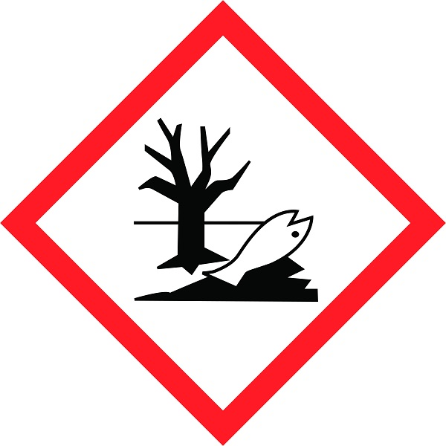  Very toxic to aquatic life
Handling Precautions  P260  P280  P301 + P312 + P330  P303 + P361 + P353  P304 + P340 + P310  P305 + P351 + P338 |   Wear appropriate chemical resistant safety gloves (EN 374) |   Wear close fitting eye protection (EN 166) |  |   Wear protective clothing e.g. fastened lab coat
Storage & Transport | - Do not store with strong acids, organic halogen compounds e.g. trichloroethylene which can cause violent reactions, flammable liquids and oxidisers.  - Store tightly-closed containers in cool, dry, well ventilated place.  - Containers which are opened must be carefully resealed and kept upright to prevent leakage (liquids) or water ingress (solids).  - Containers of ammonium hydroxide may develop pressure. Cool before opening. Handle and open container with care.  - Transport between laboratories in an appropriate secondary container.
Spillage and Waste Disposal | Spillage  Ensure the appropriate SDS is consulted for the actual material being handled and ensure suitable arrangements exist to deal with all foreseeable spillage situations. Give due consideration to the concentrations and volumes involved.  Spillage inside an LEV:  - For a spill of liquid, dilute with excess water and flush to drain. Continue to run water for several minutes to clear waste lines.  - For spill of solid – granules / pellets - scoop, transfer to plastic bag or container, label and dispose as hazardous waste. Rinse down surface of LEV with water.  - For spill of powder, dilute with excess water and flush to drain.  Spillage outside an LEV:  - For spill of liquid, evacuate personnel to a safe area and trained users don respiratory protection with chemical absorbing filters (for example 3M - ABEK1P3). Following manufacturers guidelines, absorb spill with inert material, Spill-X-C or Vytac Alkali Neutralising powder is recommended as this both neutralises and absorbs alkaline solutions. Transfer to plastic bags or containers, label and dispose of as hazardous waste.  - For spills of solid materials (e.g. sodium and potassium hydroxides), evacuate personnel to a safe area and trained users don respiratory protection with chemical absorbing filters (for example 3M - ABEK1P3). Avoid dust formation (do not use a brush) and ensure adequate ventilation. Scoop material, transfer to plastic bag or container, label and dispose as hazardous waste. Rinse the area with water.  Waste: Dispose of hazardous waste in line with written departmental procedures.

First Aid   | EYES: Rinse thoroughly with plenty of water for at least 15 minutes and seek medical attention.
 | SKIN: Take off contaminated clothing and shoes immediately. Wash off with soap and plenty of water. Seek medical attention.
 | INHALATION: If breathed in, move person into fresh air. If not breathing, give artificial respiration. Seek medical attention.
 | INGESTION: Do NOT induce vomiting. Never give anything by mouth to an unconscious person. Rinse mouth with water. Seek medical attention.

