Substance | Acrylamide, Bis-acrylamide  (liquid only) |  | UN No: ADR/RID 2074  Transport Cat: 6.1 |  | University Hazard Classification |  | High
Activity | Dispensing and preparation of gels for electrophoresis, chromatography
Handling Requirements e.g. fume cupboard, MSC, glove type etc. | Do not autoclave acrylamide.  - Liquid solutions or precast polyacrylamide gels should be used where possible and powdered acrylamide should be avoided (see separate SIN for powder).  - Wear nitrile gloves (EN374) when handling. Breakthrough times must be strictly adhered to.  - A fume cupboard (LEV) must be used when handling liquid solutions.  - Always follow manufacturer’s instructions.  - Operators must be trained to carry out task.
Laboratory Info | Appropriate to the department (lab number and containment level where appropriate)
Additional Information | - Acrylamide Workplace exposure limit (WEL): 0.3mg.m⁻³.  - Pregnant workers should refrain from working with this material.  - Carbon oxides, nitrogen oxides (NOx) can be formed during a fire.  Exposure limits must not be exceeded.
Hazard Statements  H301  H312  H302 + H332  H315  H317  H319  H340  H350  H361f  H372 | 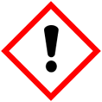  Harmful in contact with skin or if inhaled.  Causes skin irritation.  Causes serious eye irritation.  May cause an allergic skin reaction. | 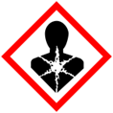  May cause genetic defects.  May cause cancer.  Causes damage to organs through prolonged or repeated exposure e.g. peripheral nervous system. |  | 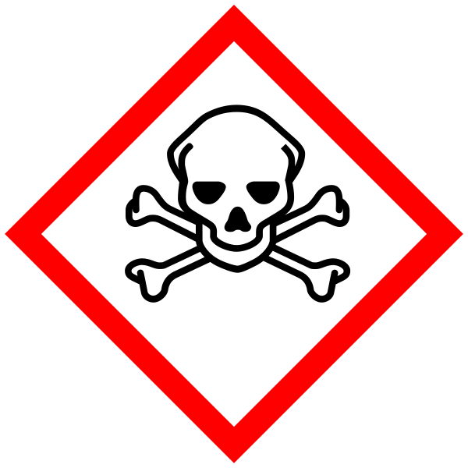  Toxic if swallowed, inhaled or through the skin  Reproductive toxicity -Suspected of damaging fertility.
Handling Precautions  P201, P260, P264, P280, P301+P310+P330, P308+P313 |   Wear safety goggles, when risk of splash into eye (EN166). |   Wear nitrile gloves (EN374) |  |   Wear protective clothing e.g. fastened lab coat.
Storage & Transport | - Do not store with acids, oxidising agents, iron and iron salts, copper, brass, free radical initiators  - Store in cool, dry, well-ventilated chemical cabinet.  - Light sensitive – keep in secondary container  - Store under inert gas  - Stable under recommended storage conditions
Spillage and Waste Disposal | Spill inside an LEV  - Ensure fume cupboard is working  - Use absorbent to contain liquid – DO NOT wash to drain  - Transfer into plastic bags or containers, label and dispose of as hazardous waste in line with departmental arrangements.  Spillage outside an LEV  - Evacuate personnel to a safe area and trained users don respiratory protection with chemical absorbing filters (for example 3M - ABEK1P3).  - Prevent further leakage or spillage if safe to do so.  - Do not let product enter drains. Discharge into the environment must be avoided.  - Following manufacturers guidelines, absorb spill with inert material. Transfer to plastic bags or containers, label and dispose of as hazardous waste.  Waste: Dispose of hazardous waste in line with written departmental procedures.
First Aid   | EYES: Rinse immediately with plenty of clean running water for at least 15 minutes. Seek medical advice.
 | SKIN: Wash well with soap and water. Seek medical advice.
 | INHALATION: Remove to fresh air. If not breathing give artificial respiration. Immediately seek medical advice.
 | INGESTION: Immediately call the emergency services and seek medical attention.

