Substance | DIESEL |  | UN No: 1202  Class Code: F1  Transport Cat: 3 |  | University Hazard Classification |  | High
Activity | Dispensing into tractors, agricultural vehicles and generators etc.
Handling Requirements e.g. fume hood, MSC, glove type etc. | - Diesel dispensing must only be carried out in well-ventilated areas or outdoors as it can release vapours that can readily form flammable mixtures.  - Smoking is strictly prohibited.  - Wash skin thoroughly after handling.
Laboratory Info | Use only outdoors or in well-ventilated areas
Additional Information | - Only trained individuals must dispense diesel fuel.  - A responsible person must be nominated for ordering and organising deliveries.  - A strict log of dispensed quantities of diesel MUST be maintained at all times.  - Diesel store is locked at all times.  - Workers handling diesel may be at risk of dermatitis and skin drying. They should regularly check their skin condition to ensure no noticeable changes have occurred  - Any change in health status you think may be related to using these products must be reported to your supervisor/line manager immediately and an Occupational Health referral made.
Hazard Statements  H226  H304  H315  H332  H351  H373  H411 | 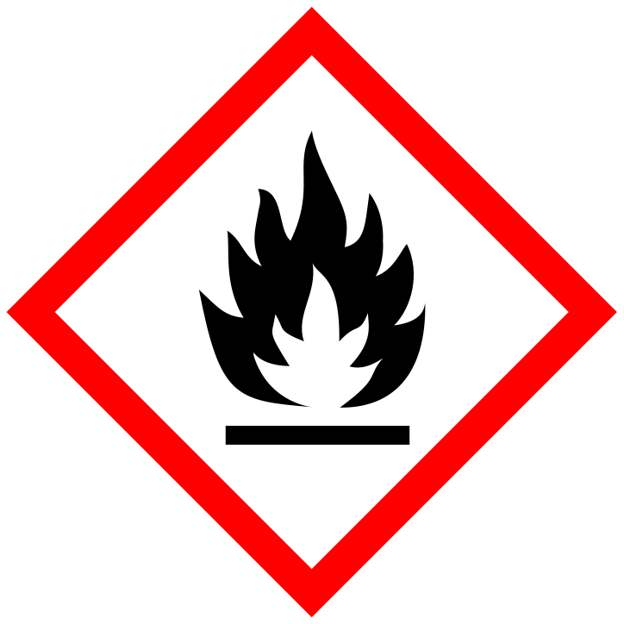  Flammable liquid and vapour  Keep away from hot surfaces, heat, sparks, open flames and other ignition sources | Causes skin irritation.  Harmful if inhaled. |  |   May be fatal if swallowed and enters airways.  Suspected of causing cancer.  May cause damage to organs through prolonged or repeated exposure (bone marrow, liver, and thymus). |  | Toxic to aquatic life with long lasting effects
Handling Precautions  P210  P260  P273  P280  P301 + P310  P331 |   Chemical resistance gloves to EN 374 – must cover wrist |   Wear long-sleeved protective overalls.  Contaminated clothing should be changed and not worn again until thoroughly washed. |  |   Wear goggles (EN166) where there is a risk of splashing. |  | Insert appropriate safety symbols
Storage & Transport | - Storage is in an enclosed tank within the Boiler House and dispensed via an approved metered nozzle housed on an exterior wall of the building in a secluded cupboard with a key entry system.  - Red diesel (gas oil) is dispensed directly into the tractor / agricultural vehicle tanks by approved operators in Horticultural Services team. This occurs in an open air environment and therefore maximum ventilation available.  - Use explosion-proof electrical, ventilating and lighting equipment.  - Use non-sparking tools  - Take action to prevent static discharge
Spillage and Waste Disposal | Minor spillages on sealed ground:  - Eliminate all sources of ignition in immediate area. Use an absorbent spill kit available and follow local procedures.  - Place all waste in black plastic bin liners and carefully transfer to contaminated waste bin for approved supplier to dispose of appropriately.  Land Spill:  - Eliminate all ignition sources (no smoking, flares, sparks or flames in immediate area).  - Stop leak if you can do so without risk.  - All equipment used when handling the product must be grounded.  - Do not touch or walk through spilled material.  - Protect entry into waterways, drains, basements or confined areas using spill control booms.  - Absorb the spillage with absorbent material and non-sparking tools and transfer into waste containers.  - Water spray may reduce vapour, but may not prevent ignition in enclosed spaces.  Notification: In the event of a major spill or accidental release, notify the H&S team immediately who will contact the relevant authorities in accordance with all applicable regulations.
First Aid   | EYES: Use one bottle of Diphoterine® per eye as per manufacturer’s instructions. If Diphoterine® is not available flush thoroughly with clean water for at least 10 minutes. Seek medical attention.
 | SKIN: If skin surface is damaged apply a clean dressing and seek medical attention. If skin surface ins not damaged, wash affected areas thoroughly with soap and water. If irritation or redness develops seek medical attention
 | INHALATION: If respiratory symptoms or other symptoms of exposure develop, move victim away from source of exposure and into fresh air in a position comfortable for breathing. If symptoms persist, seek immediate medical attention. If victim is not breathing, clear airway and immediately begin artificial respiration. Seek immediate medical attention..
 | INGESTION: Seek immediate medical attention. Do not induce vomiting. If ingested, material may be aspirated into the lungs and cause chemical pneumonitis. Treat appropriately.

