Substance | Inorganic acids, moderate dilution (not nitric or hydrofluoric) |  | UN No: 1789 / 1830/ 1805/1873/1787/ 1788  Transport Cat: 8 |  | University Hazard Classification |  | MEDIUM
Activity | Laboratory use in reactions and cleaning operations, further dilution and handling prepared solutions
Handling Requirements e.g. fume cupboard, MSC, glove type etc. | - In laboratories, handle/dispense in a fume cupboard (LEV).  - Wear chemical resistant gloves (EN374) suitable for the material being handled and adhere to glove breakthrough times  - Wear tight fitting safety goggles (EN166)  - Extreme caution must be taken when diluting with water to add the acid slowly to an excess of water, as the reaction is highly and aggressively exothermic  - When carrying out the risk assessment for the use of the material, ensure consideration is given to the concentration and volume being used.  - Follow local rules at all times.
Laboratory Info | Appropriate to the department (state lab number and containment level where appropriate)
Additional Information | - See index for applicable acid dilution ranges  - Exposure limits must not be exceeded  - Sulfuric acid (CAS 7664-93-9), 8hr TWA 0.05 mg-m³.  - Phosphoric acid (CAS 7664-38-2), 8hr TWA 1mg-m³ / STEL: 2 mg-m³  - Hydrochloric acid (CAS7647-01-0) 8hr TWA 2 mg-m³/ STEL: 9mg-m³  - Hydrobromic acid (CAS10035-10-6), STEL; 3ppm/10mg-m³  - During a fire, hazardous decomposition products can be produced e.g. sulphur oxides, phosphorous oxides, chlorine, hydrogen chloride, Borane/boron oxides, hydrogen iodide, hydrogen bromide gas  - Container explosion may occur under fire conditions
Hazard Statements  H271  H290  H302  H314  H315  H318  H319  H335  H373  H360FD (Boric acid only) | 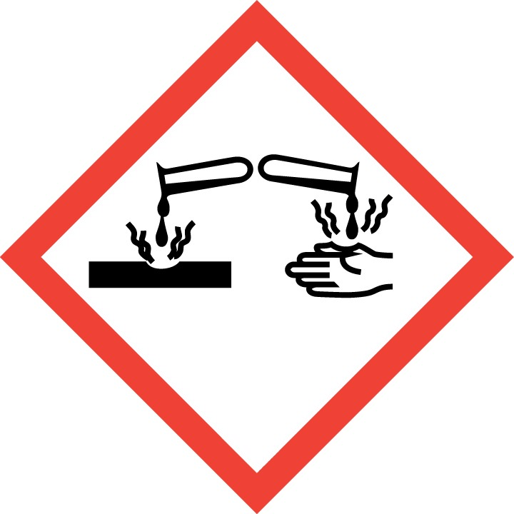  May be corrosive to metals  Causes severe skin burns and eye damage | 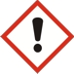  May cause respiratory irritation  Causes skin irritation  Causes serious eye irritation and damage  Harmful if swallowed |  | 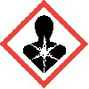  May cause damage to organs (Thyroid) through prolonged or repeated exposure.  May damage fertility.  (Boric acid)  May damage the unborn child (Boric acid) |  | 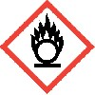  May cause fire or explosion; strong oxidiser.
Handling Precautions  P201  P210  P260  P261  P271  P280  P301+P330+P331  P303 + P361 + P353  P304 + P340 + P310  P305 + P351 + P338+ P310  P308 + P313  P403 + P233 |   Tightly fitting safety goggles to EN 166 |   Impervious chemical resistant gloves to  EN 374 |  |   Protective clothing e.g. fastened lab coat
Storage & Transport | - Keep container tightly closed in a dry, cool and well-ventilated place (chemical cupboard).  - Containers which are opened must be carefully resealed and kept upright to prevent leakage.  - Abide by the containers’ expiry date  - Some materials may be light and air sensitive  - Consult the specific material’s SDS for incompatible chemical storage. Examples below:  - DO NOT store with strong bases, strong acids, amines, alcohols, halides, organic materials, carbides, fulminates, nitrates, picrates, cyanides, chlorates, alkali halides, zinc salts, permanganates, hydrogen peroxide, azides, perchlorates, nitromethane, phosphorous, strong reducing agents, metals, water, organic materials, alcohol, magnesium, potassium, perchloric acid, strong oxidizing agents, ammonia, ozone, fluorine  - Reacts violently with; cyclopentadiene, cyclopentanone oxime, nitroaryl amines, hexalithium disilicide, phosphorous (III) oxide, powdered metals, strong bases and strong oxidising agents, amines, alcohols  - Transport between laboratories in an appropriate secondary container e.g. Winchester carrier.
Spillage and Waste Disposal | Spillage inside an LEV:  - For a spill of liquid, dilute with excess water and flush to drain. Continue to run water for several minutes to clear waste lines/drain.  - For spill of solid, sweep to pile, transfer to plastic bag or container, label and dispose as hazardous waste. Rinse down surface of LEV with water.  Spillage outside an LEV:  - For spill of liquid, evacuate personnel to a safe area  - Trained users don respiratory protection with chemical absorbing filters (Type ABEK (EN14387) to deal with spill.  - Following manufacturers guidelines, absorb spill with inert material, Spill-X-A or Vytac Acid Neutralising powder is recommended as this both neutralises and absorbs acidic solutions. Transfer to containers, label and dispose of as hazardous waste.  Waste: Dispose of hazardous waste in line with written departmental procedures.
First Aid   | EYES: Rinse thoroughly with plenty of water for at least 15 minutes and consult a physician
 | SKIN: Take off contaminated clothing and shoes immediately. Wash off with soap and plenty of water. Consult a physician
 | INHALATION: If breathed in, move person into fresh air. If not breathing, give artificial respiration. Consult a physician.
 | INGESTION: Do NOT induce vomiting. Never give anything by mouth to an unconscious person. Rinse mouth with water. Consult a physician

