Substance | BASTA®(Kaspar contains Ammonium Glufosinate) |  | UN No: 2902  Transport Cat: 3 |  |  | University Hazard Classification |  |  | HIGH
Activity | Used for the selection of transgenic plants carrying resistance to BASTA
Handling Requirements e.g. fume cupboard, MSC, glove type etc. | - Dispensing and spraying plants must be carried out in a fume cupboard (LEV).  - Diluted solutions used for soil drenching or rock wool treatment can be used outside of a fume cupboard wearing the PPE stated below. Documented local departmental SOPs must be followed at all times  - Wear chemical resistant nitrile gloves (EN374) and tightly fitted safety spectacles (EN166) at all times when using this product. Breakthrough times must be strictly adhered to.  - Avoid formation of dust and aerosols.  - Do not heat
Laboratory Info | Appropriate to the department include room number and containment level
Additional Information | - New and expectant mothers must not use this product as it is suspected of damaging the unborn child.  - May damage fertility.  - Refer user to Occupational Health if there are any changes in health status which you think is related to the use of this product.  - Carbon oxides, nitrogen oxides (NOx), sulphur oxides, oxides of phosphorous, ammonia can be produced during a fire.  - If the product contaminates rivers, lakes or drains contact the Health and Safety Team
Hazard Statements  H302  H312  H332  H319  H360F  H361d  H373 | 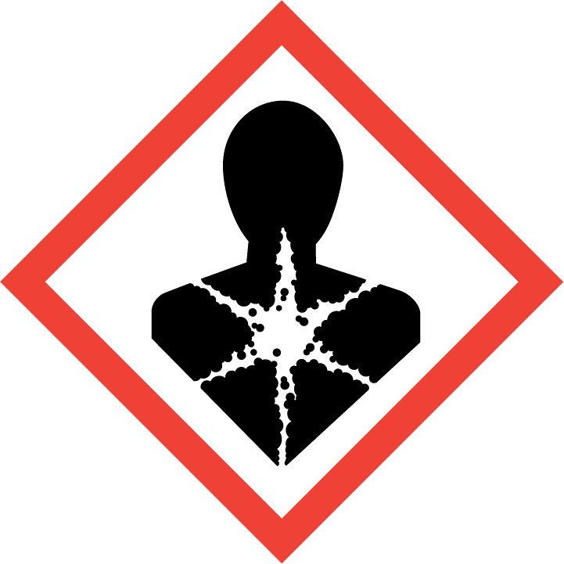  May case damage to organs (nervous system) through prolonged or repeated exposure  Suspected of damaging the unborn child  May damage fertility | 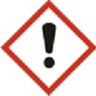  Harmful if swallowed  Harmful if inhaled  Harmful if in contact with skin  Causes serious eye irritation |  | 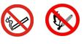  Do not smoke.  Do not use near naked flame or other heat source.
Handling Precautions  P201, P202, P260, P264, P270, P271, P280, P302+P352+P312, P304+P340+P312, P308 + P313, P363, P405, P501 |   Wear nitrile gloves (EN374) |   Use tightly fitted safety glasses (EN 166) |  |  |   Wear protective clothing e.g. fastened lab coat. |  |  |   Do not breathe dust/ fume/ gas/ mist/ vapours/ spray  Where risk assessment shows air-purifying respirators are appropriate e.g. spill use a full-face respirator ABEK (EN 14387) respirator cartridges as a backup to engineering controls
Storage & Transport | - Store in a locked chemical cupboard and limit access to trained users only  - Store in the original container, tightly closed in a cool, dry and well-ventilated place.  - Protect from freezing.  - Keep away from direct sunlight.  - Do not store with strong oxidising agents, acids, bases, alkali metals.  - Do not reuse the container for any other purpose.
Spillage and Waste Disposal | Spillage:  Outside a fume cupboard (LEV)  - Evacuate personnel to safe areas.  - Ensure adequate ventilation/air changes.  - Trained users wear respiratory protective equipment (RPE) with the appropriate filters and the personal protective equipment stated above.  - Prevent further leakage or spillage if safe to do so.  - Soak up with inert absorbent material and discard waste as per departmental procedures.  - Clean contaminated floors and equipment thoroughly observing environmental regulations.  - Arrange for waste to be kept in suitable closed containers before disposal.  Waste: Product must not enter the drainage system. All waste must be treated as hazardous and disposed of in line with departmental procedures.
First Aid   | EYES: Flush eyes with water as a precaution for at least 15 minutes. Remove contact lenses if safe to do so. Seek medical attention if irritation develops and persists.
 | SKIN: Remove contaminated clothing, shoes immediately. Wash off with soap and plenty of water. Seek medical attention.
 | INHALATION: If breathed in, move person into fresh air. If not breathing, give artificial respiration. Seek immediate medical attention.
 | INGESTION: Never give anything by mouth to an unconscious person. Rinse mouth with water. Seek immediate medical attention.

