Standard Operating Procedure
Department XXX

SOP code
Title | Use of calibrated anemometer for recording air flow measurements in microbiological safety cabinets and fume cupboards
Author(s) | Mary Bagnall
Reviewer(s) | Ian Graham, Rebecca Allen
Approver | Departmental approver
Date issued | July 2021
Version number | V1.0
No. of pages

- Purpose

  - To define a procedure for using a rotating vane anemometer to take and record air flow measurements in microbiological safety cabinets (MSC) and fume cupboards (ducted and recirculating) (all local exhaust ventilation (LEV) systems). This SOP is in line with the University’s LEV and MSC Codes of Practice.

Scope

  - This SOP describes how to undertake airflow tests using a rotating vane anemometer in:
    - Class I and Class II MSCs.
    - a fume cupboard.

Responsibility

  - Laboratory workers and Technical Support staff who have been trained in how to use a rotating vane anemometer and how to interpret the results.
  - The department must ensure that the vane anemometer in use is calibrated by a UKAS-accredited organisation at least annually.

Frequency

  - Monthly.

- Anemometer Guidance Videos
  - Videos have been developed which demonstrate the use of an anemometer for MSCs (Class I and Class II) and a fume cupboard to complement this SOP. These can be found on the Health and Safety Services LEV page.

Class I MSC

  - Check the anemometer has been calibrated in the last year. Do not use if the anemometer is past its calibration renewal date.
  - Switch the MSC on and leave running for at least 5 minutes
  - Ensure that you hold the anemometer away from your body to prevent disruption of airflows.
  - Position the anemometer in the plane of the front aperture, ensuring that the arrow on the anemometer housing is pointing into the MSC. Hold for 30 seconds at each of the five positions shown in Figure 1, i.e., the geometric centre of the aperture, and each of the four corners of the opening (with the centre of the anemometer 50-55 mm from the side and top or bottom edge of the aperture).

Figure 1: Anemometer positions for recording airflows, Class I MSC
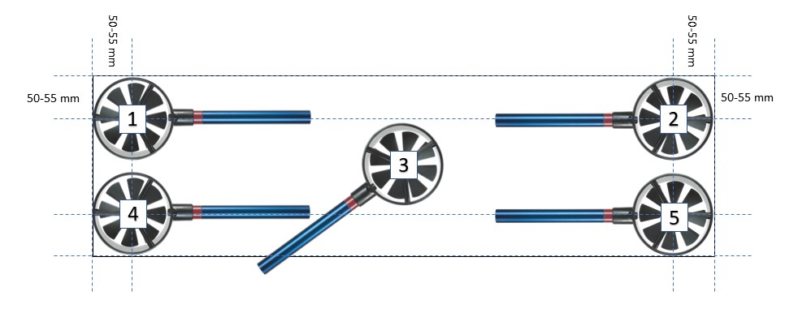

  - Record measurements in the Monthly Anemometer Readings Log.
  - Record “Fail” if:
    - any value is less than 0.7 m/s or above 1.0 m/s
    - an individual measurement differs from the mean by more than 20%.
  - If an MSC falls outside of tolerance (“Fail” has been recorded) immediately:
    - display “out of use” signage (refer to Appendix A)
    - complete the issues log (found within the logbook)
    - report findings to your Department contact e.g., Supervisor / Laboratory Manager / Technical Services team.
    - ensure that an approved contractor has been engaged to confirm the MSC is safe to use. NB: Workers must not use the MSC until it has been confirmed it is offering the users protection.

- Procedure – Class II MSC

  - Check the anemometer has been calibrated in the last year. Do not use if the anemometer is past its calibration renewal date.
  - Switch the MSC on and leave running for at least 5 minutes.
  - Draw an imaginary horizontal line across the middle of the front aperture and take readings at the left, centre and right along this line. Refer to Figure 2.
  - Ensure that you hold the anemometer away from your body to prevent disruption of airflows.
  - Position the anemometer in the plane of the front aperture, ensuring that the arrow on the anemometer housing is pointing into the MSC. Maintain the position for at least 30 seconds and record the measurement. Repeat for all three positions.

Figure 2: Anemometer positions for recording airflows, Class II MSC
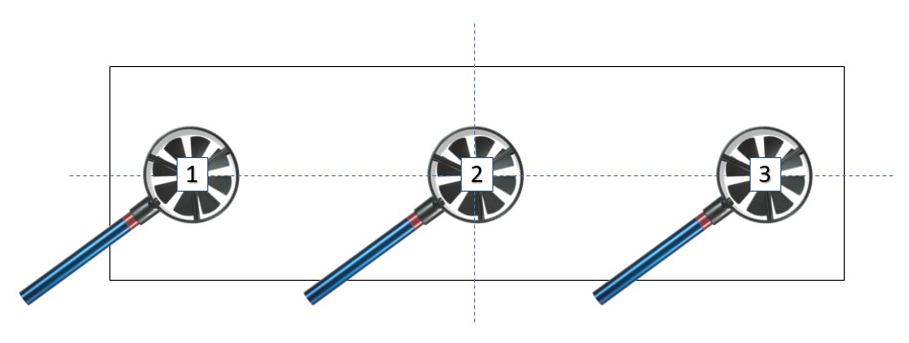

  - Record measurements in the Monthly Inflow Readings Log.
  - Record ‘Fail’ if:
    - any inflow value is less than 0.4 m/s
    - if any value varies from the average of all three readings by more than 20%.
  - If an MSC falls outside of tolerance (“Fail” has been recorded) immediately:
    - display “out of use” signage (refer to Appendix A)
    - complete the issues log (found within the logbook)
    - report findings to your Department contact e.g., Supervisor / Laboratory Manager / Technical Services team
    - ensure that an approved contractor has been engaged to confirm the MSC is safe to use. NB: Workers must not use the MSC until it has been confirmed it is offering the users protection.

- Procedure – Fume cupboard- ducted and recirculating

  - Check the anemometer has been calibrated in the last year. Do not use if the anemometer is past its calibration renewal date.
  - Switch the fume cupboard on, move the sash to a height of 500mm (or its indicated maximum height for safe operation, if less, e.g., the physical stop or before the sash height alarm sounds) and leave running for at least 5 minutes.
  - Draw three equally spaced imaginary horizontal lines and three equally spaced vertical lines across the face of the aperture, with the outer of each being 100mm from the edge of the fume cupboard. Take a reading with the anemometer where each of these lines intersects. Refer to Figure 3. Note that if the fume cupboard has a fixed sash of considerably less than 500mm (as is often the case with recirculating units), it may be appropriate to reduce the number of positions to two rows of three (i.e., six readings).
  - Ensure that you hold the anemometer away from your body to prevent disruption of airflows.
  - Hold the anemometer vertically, ensuring the arrow on the anemometer housing is pointing into the fume cupboard. Maintain the position for 30 seconds and measure the airflow at each of the positions.

Figure 3: Anemometer positions for recording airflows, fume cupboard
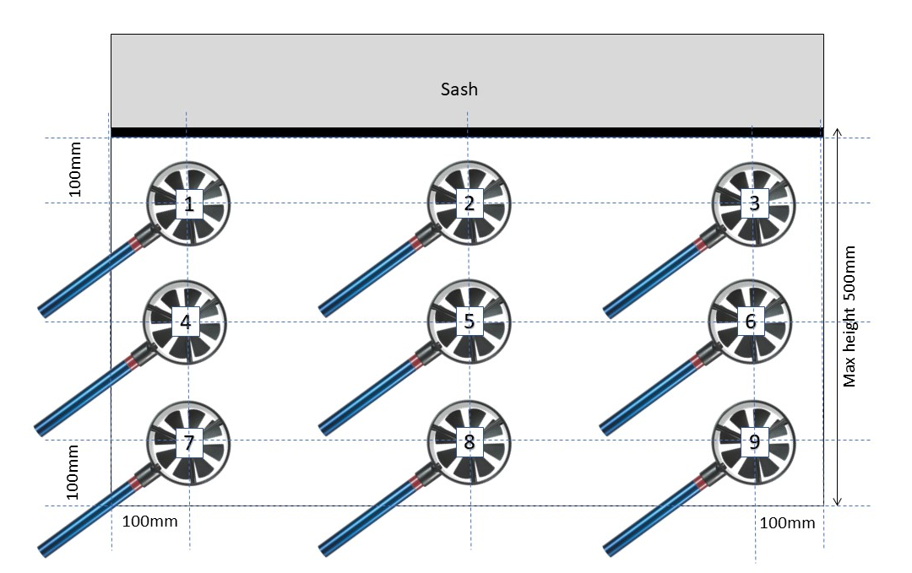

  - Record measurements in the Monthly Anemometer Readings Log
  - Record “Fail” if:
    - any value is less than 0.4 m/s. (Low flow cupboards 0.3 m/s)
    - if the variation is above 20%, or
    - when the average is above 0.7 m/s
    - NB: Specific information about the required face velocity for your fume cupboard may also be available in the commissioning documentation supplied with the system
  - If a fume cupboard falls outside of tolerance (“Fail” has been recorded) immediately:
    - display “out of use” signage (refer to Appendix A)
    - complete the issues log (found within the logbook)
    - report findings to your Department contact e.g., Supervisor / Laboratory Manager / Technical Services team
    - ensure that an approved contractor has been engaged to confirm the fume cupboard is safe to use. NB: Workers must not use the fume cupboard until it has been confirmed it is offering the users protection.

6. History, or change control

Version Number | Reviewed by | Date | Comments
V1.0 | Mary Bagnall, Ian Graham |  | New version

Appendix A: LEV Out of Use Sign




Department Contact

Contact Number

Date

