Standard Operating Procedure
[Department]

SOP code
Title | Use of Concept Air Trace Mark 2 handheld battery smoke wand as an indicator of fume cupboard and capture hood air flow efficiency
Author(s) | Heidi Thompson, Mary Bagnall
Reviewer(s) | Steven Leemoon, Ian Graham
Approver | Department Approver
Date issued
Version number | 1.0
No. of pages | 9

- Purpose

  - To define a procedure for testing the air flow within a fume cupboard and a capture hood (all local exhaust ventilation systems) using a Concept Air Trace Mark 2, handheld battery smoke machine (therein called a smoke wand). This SOP is in line with the University’s LEV Code of Practice

  - The use of a smoke wand is a qualitative test to perform a visual check on the air flow efficiency in a fume cupboard or capture hood. NB: If a fume cupboard requires a quantitative test, please refer to SOP entitled: Use of calibrated anemometer for recording air flow measurements in microbiological safety cabinets and fume cupboards

- Scope

  - This SOP describes how to undertake an airflow test using a Concept Air Trace Mark 2, handheld battery smoke machine (smoke wand) in a:
- Fume cupboard
- Capture hood

- Responsibility

Laboratory Workers and Technical Services staff who have been trained in how to use a Concept Air Trace Mark 2, handheld battery smoke machine (smoke wand) and how to interpret the results

- Frequency

At least monthly, in line with University Code of Practice for LEV

- Equipment

  - The Concept Air Trace Mark 2 case contains the following:
- Smoke generator
- Smoke fluid (Oil)
- Portable battery
- Mains adaptor
- 2x wands (single jet and multiple jet)
- Instructions

  - Departments can purchase replacement smoke fluid from: www.concept-smoke.co.uk using product code: s/fluid-AT-0.5

  - Smoke wand requires approximately six hours to fully charge on first use or when fully depleted. It is recommended that the smoke wand is charged pre-use.

- Smoke wand guidance videos

Short videos have been developed which demonstrate how to set up the smoke wand and, the use of a smoke wand for fume cupboards and capture hoods which complement this SOP. These can be found here

- Procedure

  - Setting up the machine (refer to appendix A)

    - Check the oil level in the smoke generator using the indicator level window. The reservoir should be at least half full. If the generator requires oil unscrew the reservoir cap and fill with the oil provided in the case. NB: Do not overtighten the lid when screwing it back on as this may cause the reservoir to crack

    - Install the battery by holding it with the writing face up and the silver terminal pointing towards the smoke generator. Push the battery into the smoke generator until you hear a click, and the metal tab drops down

    - Select either the single jet or the multiple jet wand and attach it by pushing it into place ensuring the air holes remain visible

    - A green light will be displayed to show the smoke wand is ready to use

    - To generate smoke, hold down the button on top of the generator. When the button is released, the smoke will stop. NB: If you need to change the smoke setting from low to high or from momentary to latching use the switches on the side of the smoke generator and slide them left or right depending on the preferred setting (arrows on the side of the generator will show settings). *Remember smoke can set off the fire alarm system therefore only generate smoke when your LEV system is running or when there is no smoke detection present

  - Fume Cupboard

    - Check the fume cupboard has passed its statutory compliance test by checking for “pass” on the statutory compliance sticker

    - Turn on the light and switch on the fume cupboard

    - Open the sash and set it to the safe working height (indicated on the side of the fume cupboard)

    - Allow the airflow to stabilise for at least 5 minutes

    - Check that the airflow of the LEV is in the ‘safe’ or ‘green’ on the airflow gauge

    - Face the smoke wand into the fume cupboard and press the smoke generator button. Gradually move the smoke wand along the entire aperture of the fume cupboard checking that the smoke is being drawn into the LEV system

    - Face the smoke wand into the fume cupboard and press the smoke generator button. Gradually move the smoke wand underneath the under-seal vent (“shelf” which protrudes the fume cupboard) checking that the smoke is being drawn into the LEV system

    - To pass – the smoke should be successfully drawn into the fume cupboard and away from the operator (see section 7.4 for failures)

    - Record the “pass/fail” result in the department’s record system

  - Capture Hood

    - Check the statutory compliance sticker displayed on the capture hood for the safe distance it should be used at. NB: the distance is usually displayed in mm

    - Angle the capture hood so that the smoke will be drawn away from the operator (e.g., an angle of 45°) and set it to the safe distance displayed on the statutory compliance sticker

    - Turn on the LEV system and allow the airflow to stabilise for at least 5 minutes

    - Place the smoke wand in the position the user conducts the work and press the button on the smoke wand to generate the smoke
    - To pass – the smoke should be successfully drawn into the capture hood and away from the operator (see section 7.4 for failures)

    - Record the “pass/fail” result in the department’s record system

  - Failures

    - If at any point the air flow fails to be drawn into the capture hood/fume cupboard this results in a failure and the LEV system should not be used. Turn off the system, display an out of use notice with contact details completed (refer to Appendix B) and follow your department’s escalation process e.g., inform your Supervisor/Line Manager/Department contact (e.g., Technical Support team) and the users in the space
  - Disassembly and storage of the smoke wand (refer to appendix A)

    - Remove the wand by pulling it gently to release. Store in the assigned holder in the case

    - To remove the battery, hold the smoke generator at a backwards angle and lift the metal tab, the battery will release. NB: take care not to drop the battery. Place the battery in the assigned holder in the case

    - Place the smoke generator in the assigned holder in the case ensuring the lid to the oil chamber is not loose

    - Ensure that the lid to the oil and the lid to the smoke generator are in the same orientation before closing the case

    - Stand the case vertically when storing to prevent oil leaks

- NOTE: It may be appropriate to undertake smoke wand testing of the LEV while it contains the equipment that is in normal or everyday use. This can provide useful guidelines for what is or is not acceptable in terms of positioning of equipment and consumables
- History, or change control

Version Number | Reviewed by | Date | Comments
1.0 | H. Thompson, M. Bagnall | 18/10/2022 | New version

Appendix A: Smoke Wand

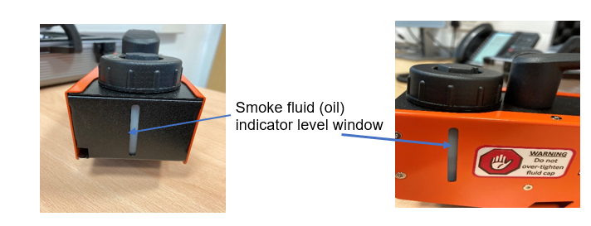
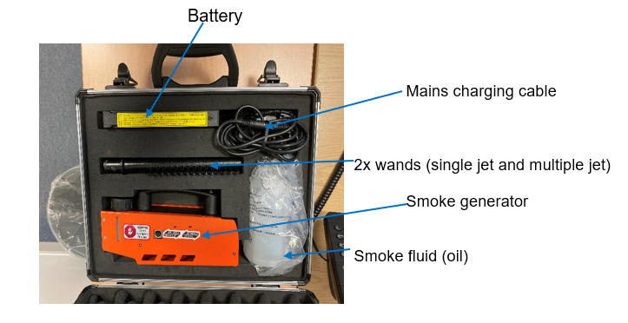

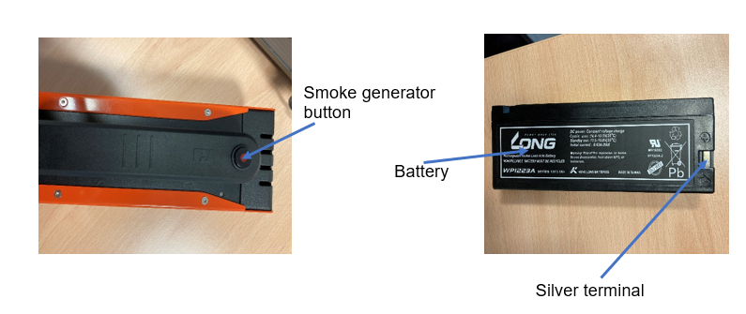

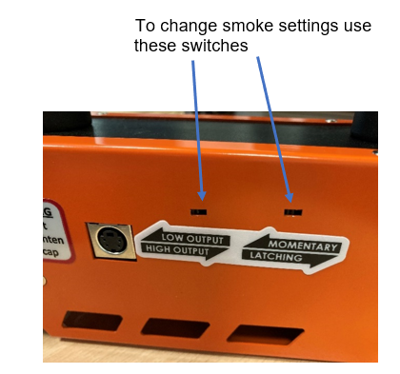

Appendix A: LEV Out of Use Sign



DO NOT USE

Department Contact:

Contact Number:

LEV Asset Number:

Date:

