Standard Operating Procedure

Title | Lone working procedures for ‘X’ activity.  NB: where there is a lone working risk identified related to a work activity, state what the work activity is and remove this note e.g., Lone working procedures for activities within research laboratories in SLS and WMS.
Author(s) | M Bagnall,
Reviewer(s) | G Hakes
Date issued | 25/03/20
Next Review Due | February 2031
Version number | V3.0
No. of pages | 5

- Purpose

  - This document defines the lone working procedures all staff and students must comply with whilst conducting [state what the work activity is] work activity.
- Scope

  - For the purposes of this SOP, lone working is defined as any activity where the worker is at increased risk of harm, due to the reduced ability to respond to emergencies (e.g. fire, first aid, spills). This may arise from work outside normal operating hours or from work in a remote location.
  - This SOP applies to lone work conducted as part of the work activity stated above. It does not cover other risks related to activity; these are covered by the work group’s own procedural risk assessments and SOPs.
  - The SOP applies to all authorised activities across Gibbet Hill Campus, Central Campus, Westwood Campus, Stratford Innovation Campus and at Clinical Sciences Research Laboratory (CSRL) (University Hospital Coventry and Warwickshire). [NB: remove non-applicable sites]
  - This SOP includes work activities scheduled and notified to the Head of Department (or their equivalent) to be undertaken during periods of low occupancy (e.g. Christmas & Easter shutdowns).

- Responsibility

  - Line Manager/Supervisor

    - Ensure there is a buddy-system in place for their work activities, and the buddy is aware of their responsibilities.
    - Ensure that their staff/students are adequately trained to conduct the task by themselves.
    - Ensure any incident, accident and near-miss is reported via the University’s reporting system.
    - Ensure their staff/students understand the emergency procedures associated with lone working e.g., fire, first aid, spills, response to alarms etc. NB: Community Safety are not trained to deal with hazardous spills, respond to gas alarms and or any other department-specific emergency. Departments must have processes in place to deal with their foreseeable emergencies in and out of normal work hours, and the Line Manager/Supervisor is responsible for ensuring their staff/students understand these.
    - Advise their staff/students to download the Safezone app to supplement the buddy-system.
    - Advise their staff/students, who are acting as a buddy, to put the Community Safety emergency contact information (02476 522222) in their mobile devices.

  - Buddy - Is nominated by or is the line manager/supervisor for the period that an individual is working alone. NB: The buddy must be University of Warwick member of staff or postgraduate student and not a friend or family member. They must:

    - Be expected to be fully aware of the movements, activities being conducted and location of the lone worker.
    - Hold all contact details for the lone worker and supervisor/line manager (if different to themselves).
    - Be available to perform these duties for the period of lone work.
    - Contact the lone worker as per these procedures.
    - Attempt to contact the lone worker if they do not hear from them as expected.
    - Raise the alarm with Community Safety (02476 522222) if they cannot be contacted.
    - Inform their line manager/supervisor if they cannot fulfil their buddy responsibilities e.g., sickness or other absence.

  - Individuals/Lone Workers

    - Must be contactable.
    - Must take reasonable care of themselves.
    - Must report incidents, accident and near-misses via the University reporting system.
    - Must inform their buddy of their movements as per these procedures.
    - Must comply with these procedures, work group risk assessments, SOPs, lab rules, emergency procedures and University policies for health and safety at work.
    - It is advised that all individuals/lone workers download the Safezone app. to their mobile device and familiarise themselves with its use.

- Frequency

Short periods of lone working to be undertaken under exceptional circumstances.

- Procedure

  - Lone Working Procedures

Prior to Arrival | Lone worker must:  - Inform buddy of their approximate arrival/leaving times and work activities being conducted.  - If the lone worker is on site for more than 1 hour agree a timetable of “check-in” contact with your buddy.

On Arrival | Lone worker must:  - Phone/text/message buddy when arrived on site.  - Reiterate anticipated leaving time.  - Sign in the departmental ‘out of hours book’/’register’ where applicable.  - Check in and set a timer for ‘check-in’ via Safezone app where group process has stipulated its use.  - During the visit check-in as per agreed contact prior to arrival.  Buddy must:  - Acknowledge lone worker’s arrival on site e.g. return text/message.  - Contact the lone worker if the lone worker fails to comply with agreed check-in arrangements.  - If the lone worker cannot be contacted follow the emergency procedures (Section 5.2)

Before Leaving | Lone worker must:  - Check all work has been made safe (e.g. all chemicals/biological agents are stored away correctly, etc.)  - All equipment has been switched off, especially anything which can cause a fire (e.g. hot blocks, heating mantles, etc.)  - All lights have been turned off and doors closed.

Post Visit | Lone worker must:  - Phone/text/message buddy when they have finished their visit to site.  - Sign out in the departmental ‘out of hours book’/’register’ where applicable.  - ‘Check out’ of the Safezone app where their group process as stipulated its use.  Buddy must:  - Acknowledge lone worker has left site (e.g. return text/message).  - Remind lone worker to check out of Safezone app where their group process as stipulated its use.  - If the lone worker cannot be contacted follow the emergency procedures (Section 5.2).

  - Emergency Procedures

    - Failure to contact - If the lone worker cannot be contacted the buddy must:
    - Immediately contact:
      - Gibbet Hill//Central Campus/Wellesbourne - University Community Safety on 02476 522222
      - CSRL – Hospital Security on 02476 962222
    - Inform Community Safety or Hospital Security of the lone worker’s location, what work activities they were involved with, and any hazards Community Safety should know about.
    - Contact the lone worker’s line manager/supervisor if this is different to the designated buddy.

    - Fire – If the fire alarm sounds whilst lone working the individual must:
    - Make their work safe.
    - Leave via the nearest fire exit without sweeping the building.
    - Go to their assembly point.
    - Contact University Community Safety on 02476 522222 or Hospital Security on 02476 962222 and wait until they arrive.
    - On arrival, inform the responders if there is a confirmed fire.

    - First Aid – First aid cover in departments may be reduced if working out of hours/during periods of low occupancy. If a first aider is required, the individual should contact University Community Safety on 02476 522222 (internal x22222) or Hospital Security at CSRL on 02476 962222 (internal x2222). If individuals are on University of Warwick campuses and have downloaded the Safezone app they can call a first aider via the ‘First Aid’ green button (Figure1).

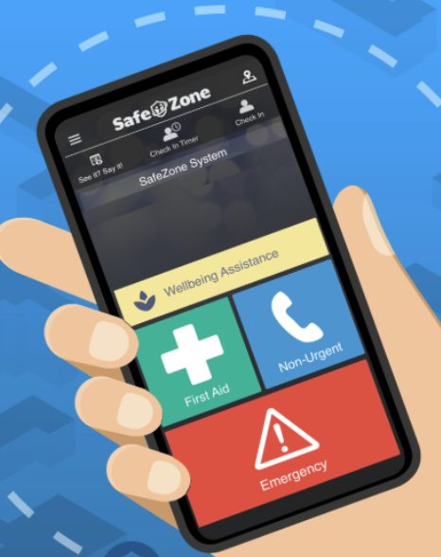

Figure 1.

    - Spills – All spills should be dealt with as determined by your department’s local procedures. If you do not know how to deal with a significant spill, please do not put yourself at risk. If in doubt, leave the room immediately, display warning signage and contact your line manager/supervisor for further advice.

NB: Community Safety are not trained to deal with department-specific spills.

    - Other departmental-specific emergencies – Departments should have local procedures in place for specific emergencies which staff and students who are lone working must understand and follow.

- History, or Change Control

Version | Date | Reviewer/s | Comments/Changes made
V1.0 | 25.03.20 | I Graham,  R Allen,  J Brannon | New version.
V2.0 | 05.02.21 | M Bagnall,  I Graham | Expanded the scope of the document to include CSRL and added emergency contact details for Hospital Security. The document should be read in full. Reviewed by M Bagnall and I Graham
V3.0 | 11.02.26 | M Bagnall,  G Hakes | Added clarification to the document where extra information should be added. Removed all references to Covid, altered Wellesbourne Campus to the Stratford Innovation Campus and changed Campus Security to Community Safety. Added information about Safezone app. Altered history of the document table and updated university branding. The document should be read in full.

