Guide on Use of Fire Extinguishers
This information will enable staff to operate fire extinguishers that are found on campus.
Do not put your personal safety at risk. Only use a fire extinguisher in an emergency to aid escape from a fire or to extinguish a ‘small’ fire.
- Ensure that the alarm has been raised
- Select the correct extinguisher for the type of fire in accordance with the following table:
Types of fire extinguisher used on University Premises:
Water | CO₂ | Powder | Foam
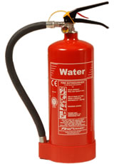 | 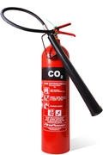 | 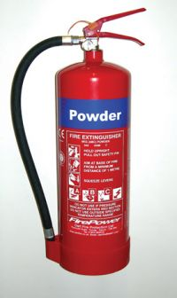 | 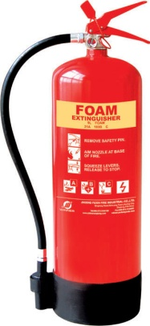
USE on:
Wood, paper, textiles and solid material fires | Flammable Liquid and Electrical fires | Flammable Liquid,  Flammable Gases, Electrical and Wood, paper, textiles fires | Flammable liquid, wood, paper, textiles and solid material fires
DO NOT USE on:
Flammable Liquid, Electrical or Metal fires | Metal fires | Metal fires | Electrical or Metal fires

- Use the extinguisher:
- PULL the safety pin out, to free the lever on top of the extinguisher
- AIM the fire extinguisher nozzle or hose at the base of the fire, standing around 2.5 metres back from the fire
- SQUEEZE the handle to release the fire-fighting agent
- SWEEP the nozzle or hose across the base of the fire (not the flames) until it is fully extinguished; with foam and powder, lay a blanket of foam or powder over the burning area
Warning:- Do not touch the horn of the CO₂ extinguisher as your hand could freeze to it.

- Evacuate and report to the Security Response Team

Fire Blankets may be used to extinguish cooking pan fires:
- Pull the blanket out of its case
- Check that the fire is smaller than the blanket
- Hold it well up in front of you by the top corners and keep your hands tucked in behind the blanket
- Place it over the fire to smother it and leave it there
- Don’t take it off for half an hour, in order to let the material cool down.

