Tuesday 3rd April Theme: Crafts and Creativity

9s and over
A huge welcome and ‘getting to know each other’ games! (AM)
Teambuilding task- with limited resources the children will need to protect their egg from breaking once thrown from a height! (AM)
Lunch
Outdoor marble run. (PM)
In the afternoon the children will be using foam clay to decorate their own sculptures. They will then prepare and design a gift bag to present their artwork in. (PM)

8s and under
A huge welcome and ‘getting to know each other’ games! (AM)
Teambuilding task- with limited resources the children will need to protect their egg from breaking once thrown from a height! (AM)
Lunch
In the afternoon the children will be using foam clay to decorate their own sculptures. They will then prepare and design a gift bag to present their artwork in. (PM)
Build a fairy garden outside. (PM)

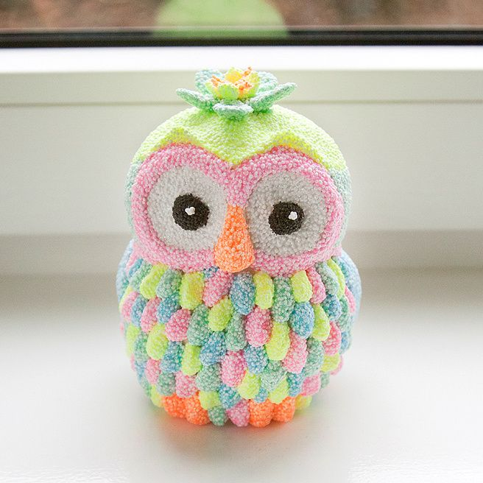

Your child will need:
Children should bring a waterproof jacket and warm clothing for when we venture outside and an old t-shirt or apron.

Wednesday 4th April Theme: Science

8s and under 9s and over
Make your own solar system (AM).
Lunch
The Magic of Colour- advanced
What is colour? When I see red, do you see red? What does your dog see? Join us as we use biology, chemistry and physics to explore how we make colour, how scientists use it and how what we see isn't always what's really there (PM).

The Magic of Colour
What is colour? When I see red, do you see red? What does your dog see? Join us as we use biology, chemistry and physics to explore how we make colour, how scientists use it and how what we see isn't always what's really there (AM).
Lunch
How old is that tree?/ Make a birds nest/ Insect spotting (PM).
Make lava lamp mixture (PM).

Your child will need:

Children should bring a waterproof jacket and warm clothing for when we venture outside and an old t-shirt or apron.

Thursday 5th April Theme: Adventure

8s and under
Ultm8 Warrior involves both awesome obstacle course challenges and warrior themed games. Obstacles include crawling under army nets, climbing over small and large hurdles, hoop hops and more! The activities include shield defence games, gladiator battling, taking on Thor and will be themed on warrior tribes (AM)!
Lunch
A game of ‘higher or lower’ (PM).
Make your own warrior shield and/or warrior accessories (PM).

Lunch

9s and over
A game of ‘higher or lower’ (AM).
Make your own warrior character (AM).
Lunch
Ultm8 Warrior involves both awesome obstacle course challenges and warrior themed games. Obstacles include crawling under army nets, climbing over small and large hurdles, hoop hops and more! The activities include shield defence games, gladiator battling, taking on Thor and will be themed on warrior tribes (PM).

Your child will need:
We will be outside no matter what the weather! Children should bring a waterproof jacket and warm clothing for when we venture outside and an old t-shirt or apron. A change of clothes is also essential.

Friday 6th April Theme: Photography

8s and under
Build a dragon. (AM)

Lunch
An optical illusion photography workshop with expert Michael Jones! The children will use their own photographic devices to create images with a forced perspective. (PM)
Make your own lantern. (PM)

9s and over
The Holiday Scheme’s Dragon’s Den. (AM)

Lunch
An optical illusion photography workshop with expert Michael Jones! The children will use their own photographic devices to create images with a forced perspective. (PM)
Make your own lantern. (PM)

Your child will need

Children should bring a waterproof jacket and warm clothing for when we venture outside and an old t-shirt or apron. A photographic device is also essential for the workshop.

Monday 9th April Theme: Performing Arts

Gemma, an expert in drama and having fun, will be joining us to create a whole play in just ONE DAY! There are plenty of opportunities for each child to take part in different aspects such as acting, directing, costume design and prop making! At the start of the day, we will begin our journey with a script and by 4.15pm we will have a performance (we hope)! Gemma and the Holiday Scheme staff are looking forward to hearing all of the children’s ideas and we are excited to support their vision for the play. All family members and friends are invited to watch the show!

Your child will need

Children should bring a waterproof jacket and warm clothing for when we venture outside and an old t-shirt or apron.

Tuesday 10th April Theme: Sports

8s and under 9s and over
Multi-sports and games- a fun-filled morning of different challenges for the children to take part in. (AM)

Lunch
Warwick Sport will be leading a session on tennis at the Tennis Centre on campus. The children will be perfecting their technique as well as taking part in a warm-up/cool-down and fun games! (PM)
Make your own tennis racket. (PM)

Warwick Sport will be leading a session on tennis at the Tennis Centre on campus. The children will be working on their skills as well as taking part in a warm-up/cool-down and fun games! (AM)
Lunch
Make your own hockey stick and use it in our penalty shoot-out game! (PM)
Multi-sports and games- a fun-filled afternoon of different challenges for the children to take part in. (PM)

Your child will need:

Children should bring a suitable sports change of clothes (including trainers), an old t-shirt or apron and a waterproof jacket and warm clothing for when we venture outside.

Wednesday 11th April Theme: Literacy

John Harris, a professional story-teller, will be joining us for the whole day! John can be seen on The Oxford University Press website telling Biff, Chip and Kipper stories to camera, and he’s the author of four well-loved books himself. He’s been interviewed and told stories on BBC Radio 4, BBC 6 Music and Planet Rock so we are delighted to welcome him to the Holiday Scheme.

In the morning, both groups (8s and under and 9s and over) will experience an original story-telling performance as John
never tells the same story twice! Each group will also have the opportunity to exercise their imaginations with the Holiday Scheme Team as we will be creating and making unique book characters. In the afternoon, all of the children will be involved in John’s fun and practical workshop which demonstrates how to bring a story to life. We can’t wait!

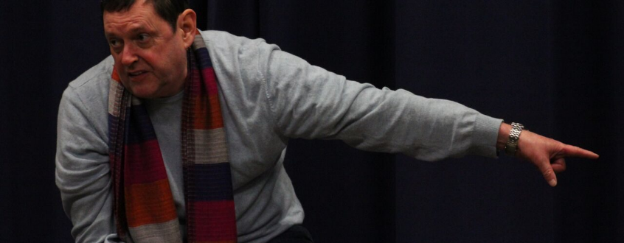
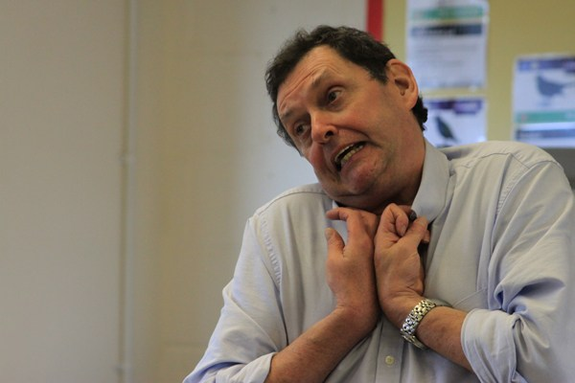

Your child will need:

Children should bring a waterproof jacket and warm clothing for when we venture outside and an old t-shirt or apron.

Thursday 12th April Theme: Community

8s and under 9s and over
St John’s Ambulance will be holding a fun yet educational workshop on First Aid. We will be bandaging teddy bears in the morning as well practising our 999 calls (AM).
Make your own Easter themed piñata (AM).

Lunch
Campus Easter egg hunt and games (PM).
St John’s Ambulance will be holding an interactive short First Aid course which includes four different modules: primary survey, communication and casualty care, choking and the recovery position (AM).
Make your own Easter themed piñata (AM).
Lunch
Campus Easter egg hunt and games (PM).

Your child will need:

Children should bring a waterproof jacket and warm clothing for when we venture outside and an old t-shirt or apron.

Friday 13th April Theme: Prehistoric life

8s and under
Cave building (AM)
Make your own Egyptian Pharaoh headdress (AM)
Lunch
The Dinosaur Dome is a fully digital mobile planetarium that shows 360 degree pictures and feature films. A special guest will provide the younger children with an interactive workshop that explores dinosaurs, rocks and fossils. Not to be missed (PM)!
Outdoor Mummy wrapping (PM)

9s and over
In groups, design and make a recycled Egyptian Mummy (AM).
Lunch
The Dinosaur Dome is a fully digital mobile planetarium that shows 360 degree pictures and feature films. A special guest will provide the older children with a more advanced interactive workshop that explores dinosaurs, rocks and fossils. Not to be missed (PM)!
Outdoor Mummy wrapping (PM)

Your child will need:

Children should bring a waterproof jacket and warm clothing for when we venture outside and an old t-shirt or apron.

