Tuesday 29th May Theme: Crafts and Creativity

9s and over
Outdoor chalk art (AM)
Pancake flipping challenge (AM)

Lunch

Let’s Animate with Gemma. Filmmakers will design and create a model from plasticine, animate, edit and add sound (if we have time); created models can be taken home (PM).

8s and under
Let’s Animate with Gemma. Filmmakers will design and create a model from plasticine, animate, edit and add sound (if we have time); created models can be taken home (AM).

Lunch
Outdoor chalk art (PM)
Design a boat and race with your peers (PM)

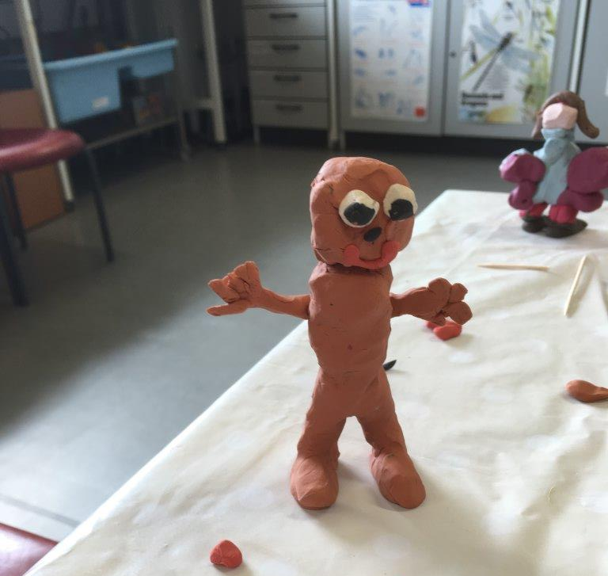

Your child will need:
Children should wear a waterproof jacket and suitable outdoor clothing. An old-t-shirt or apron is also required.

Wednesday 30th May Theme: Performing Arts

In the morning the groups will be working together to design a large back-drop for a play of their choice. The children will also have the opportunity to make props and costumes to support their vision (AM).Lunch.

8s and under (PM)
Ansou will be teaching the children how to play the Djembe drum. After getting to grips with the basics, the group will be working on an ensemble piece.
The children will take part in an outdoor drama workshop. They will practice their facial expressions and body language before moving onto improvisation games.
9s and over (PM)
Time to shine- in groups or individually the children will prepare a performance. Children can dance, sing, act, tell jokes... or do something completely different.
Ansou will be teaching the children how to play the Djembe drum. After getting to grips with the basics, the group will be working on an ensemble piece.



Your child will need:
Children should bring suitable outdoor clothing and a waterproof jacket. An old t-shirt or apron is also required.

Thursday 31st May Theme: Environment

8s and under
Forest School with Jo: the children will build dens, get creative with natural resources, and play in the mud (AM)
Lunch
Recycling games and recycling art (PM)
Welly wanging- A slightly tamer version (PM)

9s and over
Recycling games and recycling art (AM)
Lunch
Forest School with Jo: the children will make a campfire, toast marshmallows after building a secure den which tests their survival skills (PM)
Welly wanging- A slightly tamer version (PM)

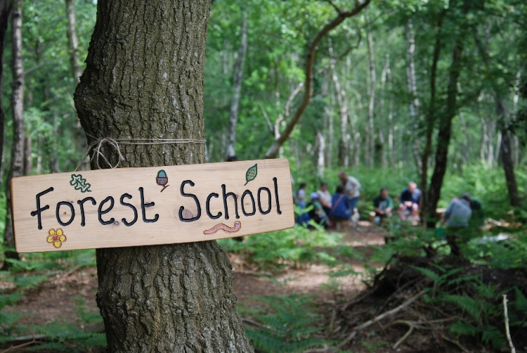

Your child will need:
We will be outside no matter what the weather! Children should wear a waterproof jacket and trousers with a pair of walking boots or wellington boots. Suitable outdoor clothing is a must. Please also pack a change of clothes and an apron or old t-shirt for when we are back in our base room.

Friday 1st June 2018 Theme: Out and About
The children will be visiting Coombe Abbey Park for an action-packed day outdoors. We will be greeted by the education team who will be spending the afternoon with us. During the morning we are going on a trail to explore the woodland, wetland and grassland through interactive exhibitions. After a picnic style lunch, in the beautiful grounds, the children will begin their Art in the Park project. The education team will be leading this activity and we are confident that the children will be bringing something special home. A day not to be missed!
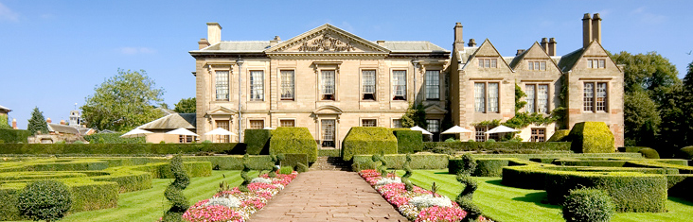

Your child will need:
Children should wear a waterproof jacket and suitable outdoor clothing. Your child will need bottled water as well as a re-fillable water bottle and a rucksack that is easy for them to carry around. Children can bring spending money as there is a gift shop but we recommend no more than £10 per child. Please see the ‘Everything You Need to Know’ document for further details.
Every effort will be made to provide the activity advertised, however we reserve the right to change the timetable at short notice due to circumstances beyond our control.

