Concur – Guide for Approvers

Welcome to Concur, the new staff expenses system.
We’ve put this mini guide together so you have a tailored document to refer back to as you get to grips with the new system. There are also guides available for claimants and Heads of Department/Departmental Administrators.
Looking for FAQs? Access them via our website

Claims to Approve
You should receive an email letting you know you have claims to approve. Please check that this has not gone in to your Junk folder and amend your settings so that future notifications go to your Inbox.

Viewing Receipts
There are a number of ways to view receipts:
- Hover over the receipt icon on an individual line basis (or tab between expense and receipt image).
- Go to Receipts and either “view in current window” or “view in new window”, both of which will allow you to scroll down and view all the receipts on the claim at once.
(Note: beware that if you choose current window you may find you can’t then close it and selecting the double chevron to the right of Receipts may throw you out of Concur)

Exceptions
You need to check all items on a claim, but the “Exceptions Bar” indicates areas which you need to pay particular attention to because the item is outside the University’s policy. Extra justification is needed as to whether the expense should be reimbursed (e.g. Financial Regs or IT Services approval may be needed).
You can see if a claimant has added a comment by hovering over the icon
If an item should not be reimbursed or there is an error on the claim, you are advised to return the whole claim and you will be prompted to add a comment for the claimant.

Viewing Allocations (Cost Code Splits)
There are a number of ways to view allocations:
- Hover over the allocation icon on an individual line basis
- Go to Details/Allocations/Summary – to get an overall total by cost collector
- Go to Print/Report – Allocation – to get an item by item detail (note: if no cost collector is specified, the expense has gone to the default code which is shown in the Employee section at the top of the report)

Allocations within your department
Approvers and delegate checkers can amend cost collectors, but nothing else on a claim.

Allocations outside your department
If a claim includes a cost collector that is not your department, please “Approve and Forward” to someone in the relevant department

Delegate Checkers
Once a delegate checker has checked a claim, they can either return it to the claimant (if there are errors that need amending) or notify the approver. They cannot forward it to anyone else.
If there are two delegate checkers in a department and both need to see a claim, the second person to check the claim will need to mark it as “not reviewed” and then check it.
The approver would need to use Details/Audit Trail to see that the claim had been reviewed by both.

Looking back at claims you have approved
Go to Approvals/Claims/View and select a view option e.g. claims you approved this month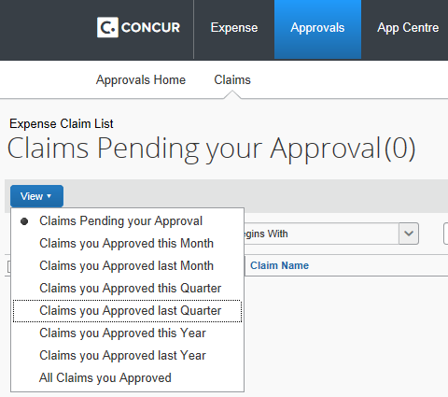

Concur in SAP
Concur documents are type ZD in SAP
If you run a line item report you are advised to select the SAP field “Name” which shows the Business Purpose of a claim and the Offset acct name which shows the name of the claimant or that it was a Corporate Barclaycard expense.
