Concur – Quick Guide

Welcome to Concur, the new staff expenses system.
We’ve put this mini guide together so you have a tailored document to refer back to as you get to grips with the new system. There are also guides available for Concur approvers and Heads of Department/Departmental Administrators.
Looking for FAQs? Access them via our website

Contents
Logging in and Making a Claim (the quick version) 2
Single Sign On (SSO) 2
First Claim 2
Inputting a Claim for Someone Else (Delegation) 2
The More Detailed Guide 3
Getting Started 3
Making a Claim 4
Expense Fields 4
Errors, Warnings and Other Messages 5
Rejected items/Queries 6
Approval Progress 6
Help 6
Tips 6

Logging In and Making a Claim (the quick version)

Single sign-on (SSO)
This is a single sign-on application, so once you have logged into your usual University account, go to www.warwick.ac.uk/concur (save this as a favourite) and you should see your Concur homepage.

First claim
The first time you make a claim, check your profile (top right). Under "Company Information" check your employee ID (this should be the same as your University Card ) and your email address. Under "Expense Settings" you can add your vehicle details or nominate someone to act as a delegate for you (if applicable). Under "Other settings" register your mobile. You only need to look at this in future if you need to make changes.
Start a claim (click on the cross that says ‘Start a claim’ – then enter your expenses, attach your receipts and save.
Either submit the claim now or add expenses throughout the month to your open claim (bottom right) then submit your total claim when you are ready. If you add expenses as you go along, make sure you save.
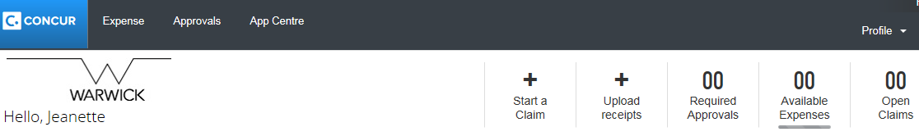

Inputting a Claim for Someone Else (Delegation)
If you are inputting a claim for another member of staff, log in as yourself then select acting as other user.
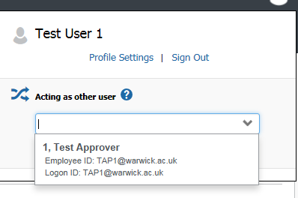 | Start the session and you will see this icon:  
Note: you cannot submit this claim; once you have finished entering all the items you need to click . They will then need to check that you have entered everything correctly and submit the claim themselves.

The More Detailed Guide

Getting Started
There are some fields we’ve set for you and others you can update yourself. Click on your profile (top right) to see what these are: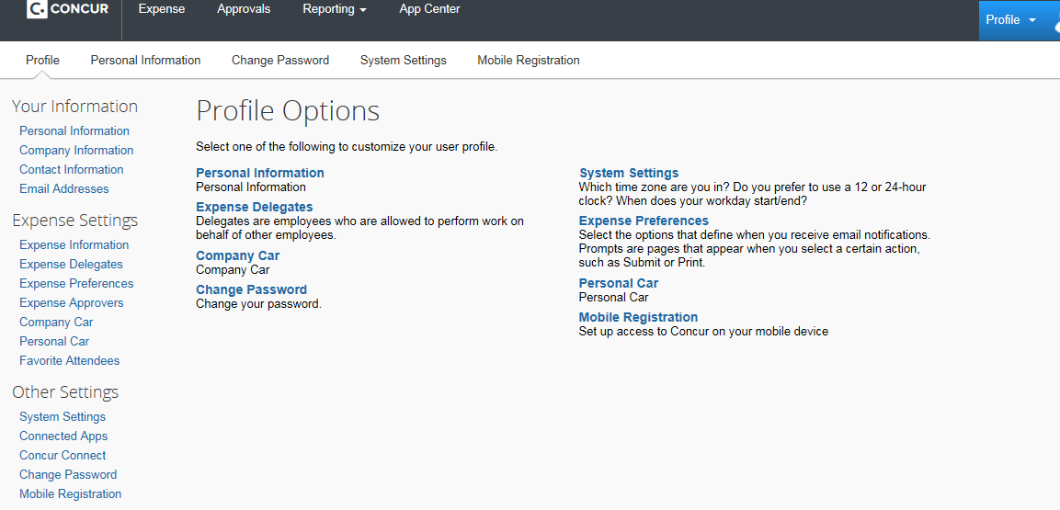
Expense Information – all your expense claims will automatically be assigned to this code (but you can change – “allocate” - the costs when you make your claim, if you need to).
Expense Delegates – you can choose someone (or more than 1 person) to input a claim on your behalf (you will still have to submit the claim). You can also see if someone (or more than 1 person) has selected you to be a delegate for them.
Expense Preferences – you can choose not to receive e-mail notifications (but be aware that if you untick this, you won’t receive e-mails and will need to check on Concur if your claim has been returned for any reason).
Expense Approvers – your claim will automatically be sent to the person shown here.
Company Car and Personal Car – if you need to claim for mileage incurred on University business, you will first need to provide details about your car and confirm you have a valid licence etc.
Mobile Registration – you can download the Concur app and register your mobile device so that you can take photos of your receipts which can then be added to your claim.
Note: you can also complete, submit and approve claims on your mobile, but some functions are not currently available on a mobile device, such as changing a cost code, using Google Maps, returning or forwarding a claim.

Making a Claim
- Click on start a claim
- Complete all boxes with a red vertical line (boxes without a red line are optional). The claim name (report name) is for you to identify the claim. The date defaults to the date you start to make the claim. The business purpose has a maximum of 50 characters and you are recommended to enter the place, date and purpose.
Note: You will see a “comment” box on various screens – please use this if you need to provide additional information that you think might be helpful in understanding your claim
- Choose the type of expense
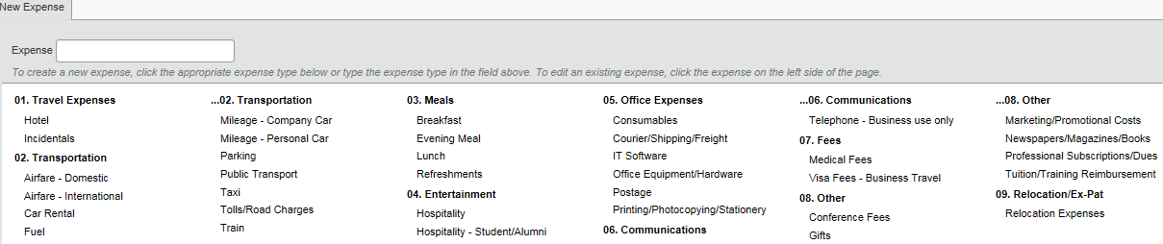

Expense Fields
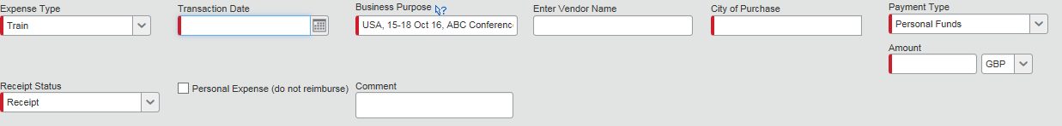
- Select the date you made the transaction
- Business purpose – this automatically carries through from your header but remember to change it if your claim includes various trips
- City of purchase – this automatically changes the currency, so if you have paid for a taxi in Singapore, the currency will change to SGD, for example. If you have made an online purchase, you may need to amend the city to reflect the currency of the receipt rather than where you physically were. After you have used this a few times, Concur will start to remember your most recently used locations.
- Payment type – you don’t need to change this
- Amount – if you have a non-sterling expense the sterling equivalent will be automatically calculated. If this calculation differs from what you were actually charged then you can overwrite the “amount in GBP” (within limits). Please use the “attach receipt” button for attaching both the exchange rate proof and the receipt.
- Receipt status – you need a receipt for all expenses. If for any reason you do not have one, you need to change this to ‘no receipt’ and provide an explanation in the comment box. Ignore the VAT number request - the University isn't currently using this.
- Attach receipts (bottom right of your screen). You will need to have uploaded or scanned your receipts already and saved them on your computer/mobile device.

- Save – this is really important – if you can see the save button, you haven’t yet saved!
- If you have stayed in a hotel, you will also see a button “itemize”; use this to show how many nights you stayed in the hotel and whether any of the charges were for extras on top of the nightly room rate
- Enter the next item, remembering to change the purchase date and business purpose if necessary
- If you need to change the code to which any items are charged, it is quickest to do this after you have entered all your expenses and then going to “details” followed by “allocations”
If you have several items to go to one code, just tick them and they will become a group. Then by entering the appropriate cost collector (you may need to change the company code or cost object type first). Once you have saved a new code you can
- If you see a message that says “Allocations have been saved but there is at least one item that may require your attention” you can ignore it.
- A claim will be an “open claim” and you can choose to keep adding items to it until you press submit. If you have submitted a claim but then realise you need to amend it, you can recall it if it has not yet been approved
- Submit your claim, or sign out and add more items later.

Errors, Warnings and Other Messages
- Means there is something wrong with your claim that must be corrected before it can be submitted. Double click on the item and make the amendment requested
- means there might be something wrong with your claim, read the message and take action if necessary (you might need to double click & enter a comment in the box provided)
- If you have spent on hospitality you need to tell us who this is for by adding a
- means you have attached a receipt, you have not attached a receipt but should have
- means you have changed the code you want this expense to go to
- means you have added a comment
- means this claim is for meals for yourself and/or meals or hospitality for other people

Rejected items/Queries
If your approver has queries regarding your claim, they may send it back. They should have added comments to explain what they are querying. If you need to resubmit the claim, you can also add comments under “details” then “comments”
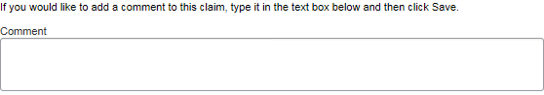

Approval Progress
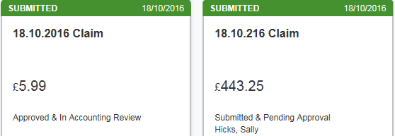
You can see where your claim is in the approval process by going to expense | manage expenses
This claim is with the Expenses HR Team This claim is pending approval from your department

Help
You’ve got a variety of sources that you can go to if you need help with your claim. Click on the “help” icon at the top right of the Concur screen and the training option within this will give you quick links to Concur guides, University of Warwick FAQs, training videos and e-mail/phone details for the Expenses HR Team and your department's Champion.

Tips
- Be patient when searching for items within a claim, such as “city of purchase”– it might take a moment for Concur to respond
- If you are experiencing problems with Concur, check on the training help to see whether there are alerts for problems with the whole system and you just need to try again later
- If you have lots of receipts and need to scan them, you can attach them to one sheet of paper, number them, upload the scanned paper once and use the comments box to reference each number
- If you have made a mistake you can either delete the whole claim (top right of your screen) or delete a single line (on the left of the screen above your detailed expenses)

