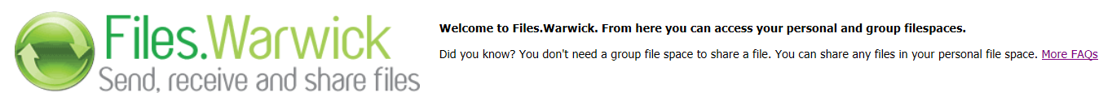
In line with GDPR, all future BWS files/Electronic timesheets must be sent via Files.warwick, which is available from the University Insite page.

The reason for using Files.warwick is because the folders within it have restricted access and are only accessible to designated contacts. As a result, files stored there do not require password protecting.

See below link for further information on how to upload a file:
https://warwick.ac.uk/services/its/servicessupport/web/files/faqs/upload_file

Once a file has been seen by the Payroll Department, it will be removed from its folder for processing.

For spreadsheets with more than 10 entries, the Payroll Department will later replace that file with a document confirming what has been processed. This will be uploaded prior to the payroll being run for the month.

It is the department’s responsibility to review any confirmation documents. If you find any discrepancies between the load confirmation and your own records please advise the payroll office immediately.

Spreadsheets with less than 10 entries will be manually input by the Payroll Department and audited in line with existing procedures.

Please do not create sub-folders within Files.Warwick, as this could delay the retrieval of payments. Access is intended for the uploading of BWS documents only.

Should you require someone else to have access to a folder, for example to cover a holiday or absence, please e-mail payroll@warwick.ac.uk with their name and log-in username.

Please note that BWS files/Electronic timesheets will no longer be accepted by email.

Note to accompany the BWS Load Confirmation

Please find a confirmation file from this load detailing the amounts and individuals who have been paid based on the employee number provided.

Please review the file and if there are no amendments to be made then no further action is required. These payments will be processed as part of the payrun later in the month.

If you need to amend or cancel any of the payments please let me know immediately by completing the ‘BWS amendment sheet’ which was sent to you initially or can be downloaded from the payroll website at http://www2.warwick.ac.uk/services/humanresources/payroll/payrollforms/electronic/

