Viewing your Payslip – A Quick Guide

- Click on the ‘My Profile’ tile on your SuccessFactors homepage and then click on the ‘Payslip’ tab in the ribbon at the top of your screen. Your screen will automatically scroll down to this area…

- Click on the hyperlink relating to the payslip you wish to view…
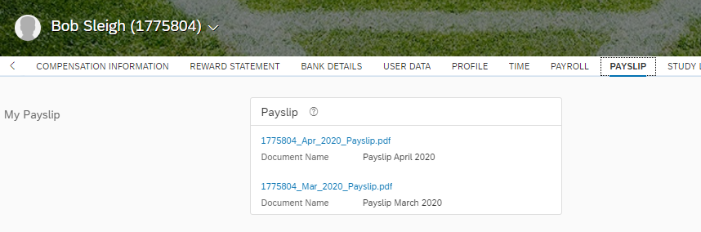

- The payslip will appear as a download on the bottom left of your screen…
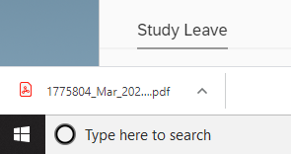

- Click on the arrow to the right of the download and select the appropriate action…

- Your payslip will open on screen.

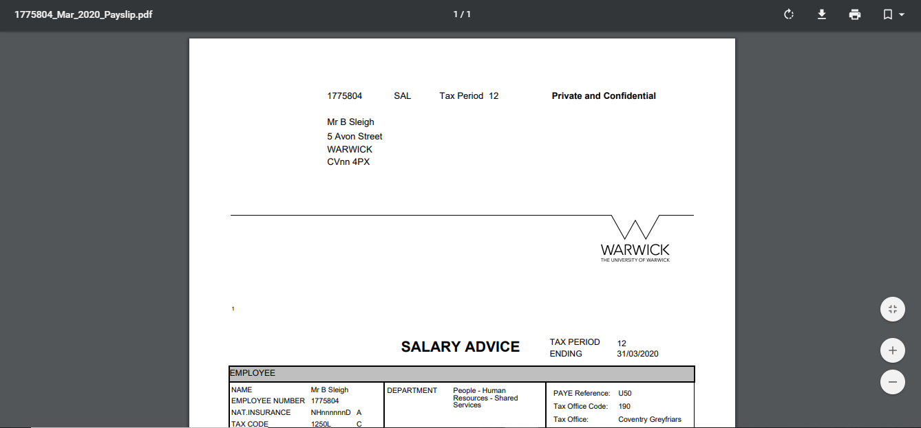

- If you want to print your payslip, you can look at the printer icon at the top right hand corner of the screen.

