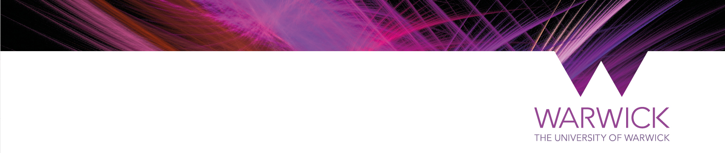
MODERN RECORDS CENTRE ORAL HISTORY PROJECT RECORDING AGREEMENT

Your recorded interview will become part of the collection cared for by the Modern Record Centre, where it will be preserved as a permanent public reference source for use in research, publication, education, lectures, exhibitions, broadcasting and internet access. The purpose of this Agreement is to ensure that your contribution is added to the collections of the Modern Records Centre in strict accordance with your wishes.

This Agreement is made between the Modern Records Centre, University of Warwick, CV4 7AL (“the Archive”) and you (“the Interviewee”, “I”):

Your name: …………………………………………………..

Your address: …………………………………………………..

…………………………………………………..
Your email:
…………………………………………………..

In regard to the recorded interview/s which took place on:

Date: ………………………………………………….

Declaration

I, the Interviewee, confirm that I agreed to take part in the recording and hereby assign to the Modern Records Centre all copyright in my contribution for use in all and any media. I understand that this will not affect my moral right to be identified as the ‘performer’ in accordance with the Copyright, Design and Patents Act 1988.

If you do not wish to assign your copyright to the Modern Records Centre, or you wish to limit public access to all or part of your contribution for a period of years, please state these conditions here:

…………………………………………………………………………………………………………

………………………………………………………………………………………………………….

This Agreement will be governed by and construed in accordance with English law and the jurisdiction of the English courts. Both parties shall, by signing below, indicate acceptance of the Agreement.

By or on behalf of the Interviewee:

Signed: ………………………………………………….

Name in block capitals: …………………………………………………. Date:

By or on behalf of the Modern Records Centre (Archive):

Signed: ………………………………………………….

Name in block capitals: …………………………………………………. Date:

Office use only:
Full name: Acc No: RefNo:

