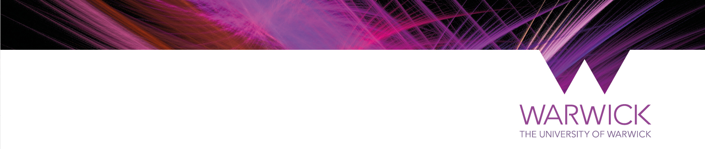
MODERN RECORDS CENTRE (MRC)
ORAL HISTORY PROJECT RECORDING AGREEMENT
ADDITIONAL GUIDANCE

The Oral History Recording Agreement
At the conclusion of your interview, you will be asked to fill in a second form: the Oral History Recording Agreement.

What is this Agreement?
This is a legal agreement which allows you to:
- confirm your previous agreement for the recording to be archived at the Modern Records Centre
- stipulate any special provisions for use of and access to the recording
- specify ownership of copyright and underlying rights in your recording

Recording this information in a short formal document is in the best interests of both the interviewee and the Archive. Before you are asked to sign this Agreement, the oral history interviewer will talk through the document with you, explain each part and answer any questions. The completed Agreement will then be signed by you, or your legally appointed representative. You will be given one copy, and the Archive will retain the other signed copy.

The Oral History Recording Agreement establishes and confirms a legal relationship between you and the Archive. This relationship is also based on trust and a shared understanding of the terms of the agreement. It is therefore very important that you raise any concerns you may have about anything included or omitted from the Agreement before it is signed.

Key elements of the Agreement
The Agreement confirms your willingness for the recording and your personal data to be archived at the Archive. It also allows you to specify how researchers can use your recording – now and in the future. If you wish to restrict access to all or part of your recording, there is space on the Agreement to specify these restrictions.

Catalogue summaries of recordings as well as the actual recordings themselves (where there are no access restrictions) will be made available to readers, either via the Archivist or via the online catalogue. The Archive may be approached by broadcasters (particularly radio journalists) who wish to use excerpts from these recordings. If you have particular concerns, please discuss these with the interviewer or the Archivist:

Your options are:
- If you do not wish to impose any access restrictions, then simply leave this section of the Agreement blank.
- If you do wish to restrict access to the catalogue summary and/or recording – in its entirety or particular parts – please specify in the space provided in the Agreement.

You are required to give an end date to each restriction you specify. In most cases, a maximum closure period of 30 years is appropriate (following British Library best practice).

Copyright
The Agreement contains a statement whereby the interviewee assigns their copyright in the recording to the College. Clarity around copyright is central to the Archive’s ability to provide services that meet the demands of 21st C researchers, such as digital storage and web-based access. Copyright in the words spoken on the recording lasts for 70 years after the year of the speaker’s death, so documenting copyright information at the interview is vitally important.
Usually almost all interviewees assign their copyright to the MRC, as they trust that the Archive will make use of their recording in an ethical and responsible manner and comply with any access restrictions specified. Assignment of copyright does not affect your moral right ie your right to be identified as a contributor and for your contribution to be protected from derogatory treatment which might damage your reputation or the integrity of your contribution.

A small number of interviewees decide to retain their copyright in the recording. This means that no public, published or broadcast use can be made of the recordings without the interviewee’s written consent, although the Archive is permitted to offer access to these recordings onsite for private research and non-commercial use (assuming there are no access restrictions imposed).

We ask interviewees to bear in mind that when they retain copyright, this can cause considerable difficulties for the MRC. The Archive may lose contact with an interviewee (or their relatives or estate), which would prevent the interview being used for published research in the future.

Your options are:
- If you are happy to assign your copyright to the MRC/Archive, leave the Agreement blank and sign.
- If you wish to retain your copyright in the recording, remember to keep the Archive informed of any change of address. Please strike through the relevant sentence on the Agreement. Then choose one of the following options regarding duration of the retention of copyright and write it in the space provided:
- I retain my copyright in the recording until 20XX after which I assign copyright to the MRC.
- I retain my copyright for the duration of my lifetime, after which I assign copyright to the MRC.
- I retain my copyright in the recording. I undertake to keep the Archive updated with the address and contact details of my next of kin and solicitor.

How will the information in the Agreement be used?
The conditions that you have agreed or asked to be met will be included in the catalogue entry made for your interview in the MRC Archive Catalogue. Such information will be of value to researchers wishing to include your interview in their work, while ensuring that any restrictions you have requested are made visible and are upheld.

New data protection legislation (General Data Protection Regulation/GDPR), which came into effect on 25 May 2018, has changed the way in which we inform you about how your personal data is stored and processed, and how you can get access to it. For information about how the Archive will use your personal data, you can review our Privacy Policy at https://warwick.ac.uk/services/library/mrc/using/gdpr/. As a public body, the MRC is also subject to the Freedom of Information Act 2000. This gives members of the public a statutory right of access to information held by a public body. While your personal details will not be released without your consent, other information recorded on the form may be released eg the date the Agreement was signed and the catalogue number assigned to the interview.

Important note: It you have requested an embargo or closure for all or part of your recording, it is not possible for anyone to request access to the closed material under the FOI or Data Protection Acts.

How will I find my recording on the Archive catalogue?
Once your recording is catalogued, you will be able to find the relevant summary catalogue entry by searching the Archive catalogue. A new online catalogue will become available on the internet once the project is complete - in the meantime, catalogues are available by contacting the Archivist. The recording itself will also be uploaded to the catalogue entry for online download, but you have the option to refuse permission for that if you so wish.

How can I listen to oral history material held at the MRC?
Older analogue oral history recordings held at the Archive are not yet converted into digital format, although plans are underway to do this in the near future. Summaries of many of these analogue recordings are available by contacting the Archivist. More recent oral history recordings are held in digital format. These will be made available online via the new Archive catalogue if access is not restricted. In the meantime, these can be accessed on-site via the Archivist. You will need to register as a reader of the Archive and to make an appointment in advance in usual opening hours.

We believe that providing remote web access to interviews will increase the use of this important material by a wide range of users, including researchers, historians, social scientists, journalists, academics and general users.

