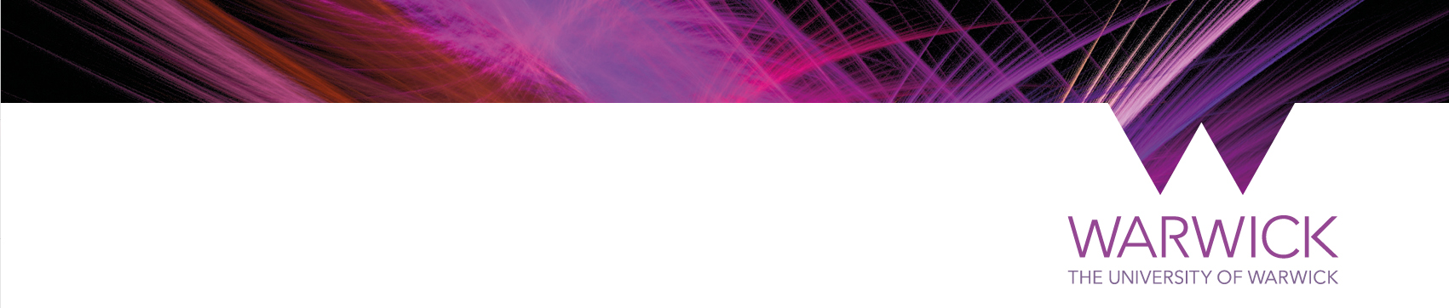
xx MONTH YYYY
Dear

Re: oral history interview, Modern Records Centre

Very many thanks for your participation in the oral history interview.

We will now do the necessary work to put your recording into the archive to join the other interviews which form part of the current Oral History Project.

They will prepare a summary of the recording as well as a catalogue record. Both of these will go into the online archive catalogue.

Thank you also for signing the Recording Agreement, this is much appreciated. This document will be added to the project files for future reference.
OR
I don’t believe that you signed the Recording Agreement which we brought along on the day of the recording. I would appreciate it if you could please return this to me as soon as possible. Without it, we are unable to add your recording to the collection and to use it towards research for the exhibition, nor for any future research access.

I am pleased that you are happy for the recording to be made available without restrictions and that you have assigned the copyright to the Modern Records Centre.
OR
I note from the Recording Agreement that you have opted for some restrictions to be applied to the recording This will be duly noted in any summary or catalogue records.

In due course, your recording will be made available online via our archive catalogue. We will write to you to let you know when this happens. If your recording is selected for sound bites in the exhibition, we will also keep you informed. If in the meantime you would like a digital copy of the recording, let us know and we will send this to you either digitally or on a CD.

Once again, thank you very much for taking part in the project and for helping to add to the permanent archive collection at the Modern Records Centre.

If you have any further queries, please do not hesitate to contact me.

Yours sincerely,

