Using Archives as Evidence

Task 1 – Analysing Images
Photographs of Prison Life
It can feel intimidating when you analyse a historical image or drawing. Unlike written text, you can’t directly quote from it, which can make it seem less straightforward to analyse. However, this can be a good thing because it allows you to form your own opinion.
Look at the photographs below showing prison life in the 20th century:
- What impression do the photographs give of prison life?
- How do the photographs make you feel?
- How accurate do you think the photographs are? What is the role of the photographer?
- What do the photographs not tell you about life in prison?
- Can you think of what other records might exist that would give you more information?
- Do you think images are more or less useful than written sources? Can they give us any information that written sources can’t?
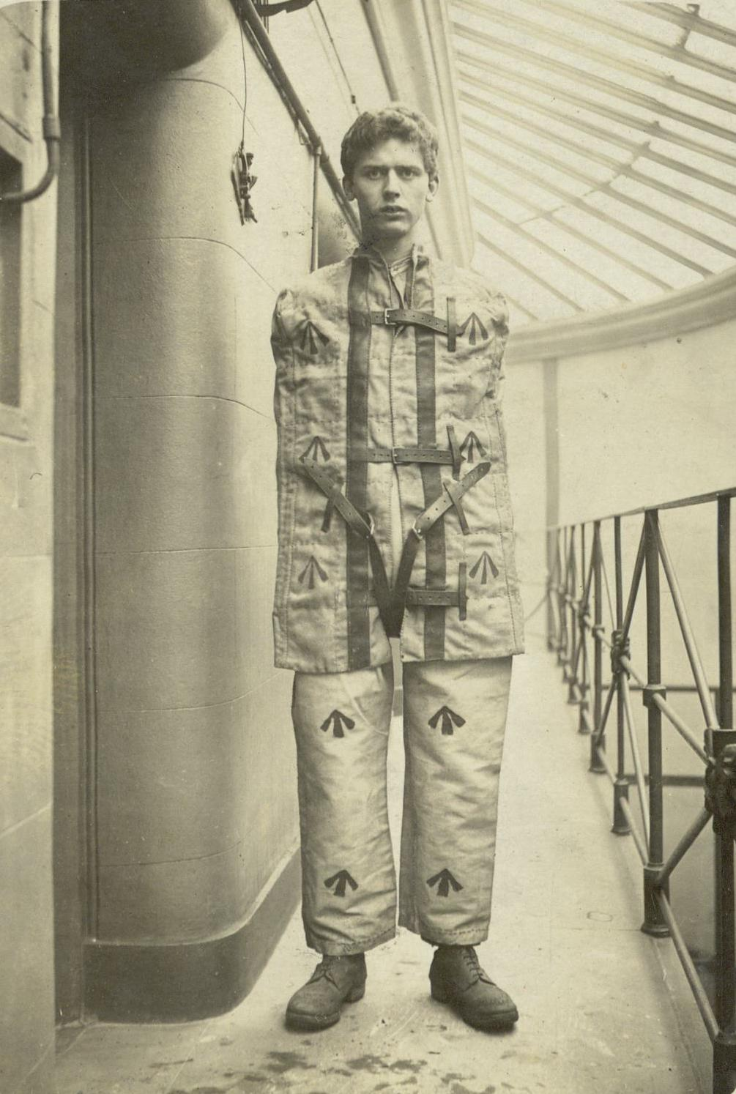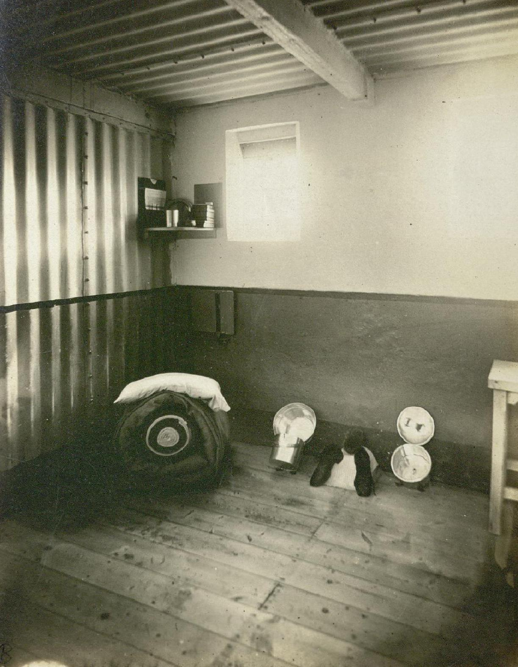
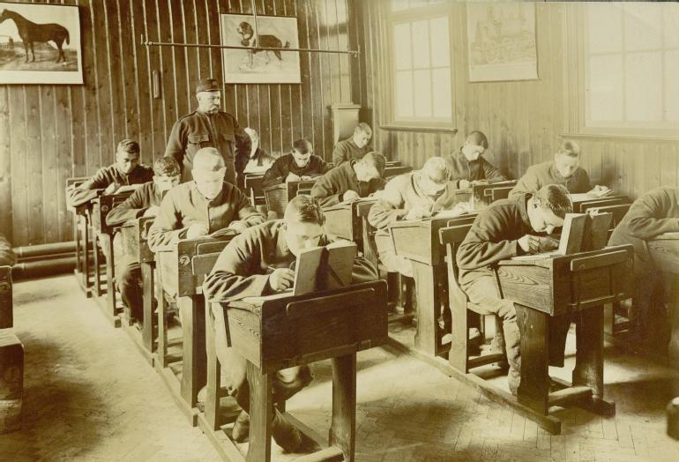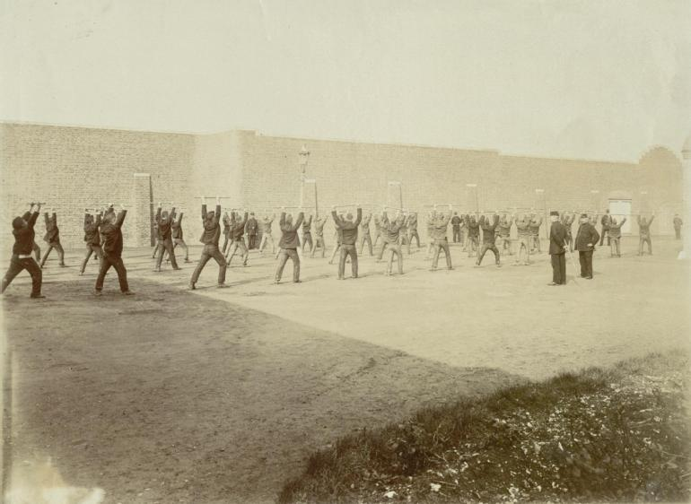
Task 2 – Understanding Context and Bias
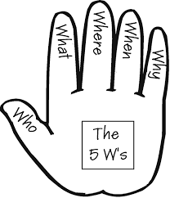
The word ‘bias’ means when someone has a one-sided opinion about something. Although identifying bias is an important tool to have, keep in mind that just because a source is biased, does not mean it is not useful. In fact, ALL sources have a bias, and ALL sources are useful.
To analyse a written source or image, the first step is to consider its context. Context is the extra information we need to understand the source, such as who created the image, who they wanted to see it, and why. A good way of remembering how to analyse context is the 5 W’s – who, what, where, when, and why.
The photographs and sources below are from the archives of the Howard League for Penal Reform. The Howard League was formed in 1866 and still exists today. It aims to improve prison conditions and help offenders when they leave prison. The Howard League was also heavily involved in the campaign which led to the abolition of the death penalty in 1965.
Look at the sources below and discuss the following questions to analyse the context of these sources using the 5 W’s:
WHO: Who created the document?
- Are they an expert?
- Were they creating the document for their job or for personal reasons?
- What bias do they have?
WHAT: What type of document is it?
- Is it a: news article, photograph, poster, report, government document, letter?
- Is it opinion or fact?
- Is it handwritten or printed? Is there a reason it was created this way?
- What information does it give?
WHERE: Where does the document come from?
- Where was the source published or displayed?
- Where was the source made? Was it local to the event?
WHEN: When was the document created?
- When was the document published, displayed or distributed?
- Was it made at the time or a long time after an event?
- What else was going on at the time?
WHY: Why was the document created?
- What was its purpose, for example to persuade, to inform, to make someone laugh or feel angry?
- Who is the intended audience? Was it given to lots of people or was it meant to be private?
- How has the purpose and audience impacted the type of document, its design and the language used?
- How effective do you think the document is? Do you think it would have achieved what it intended?
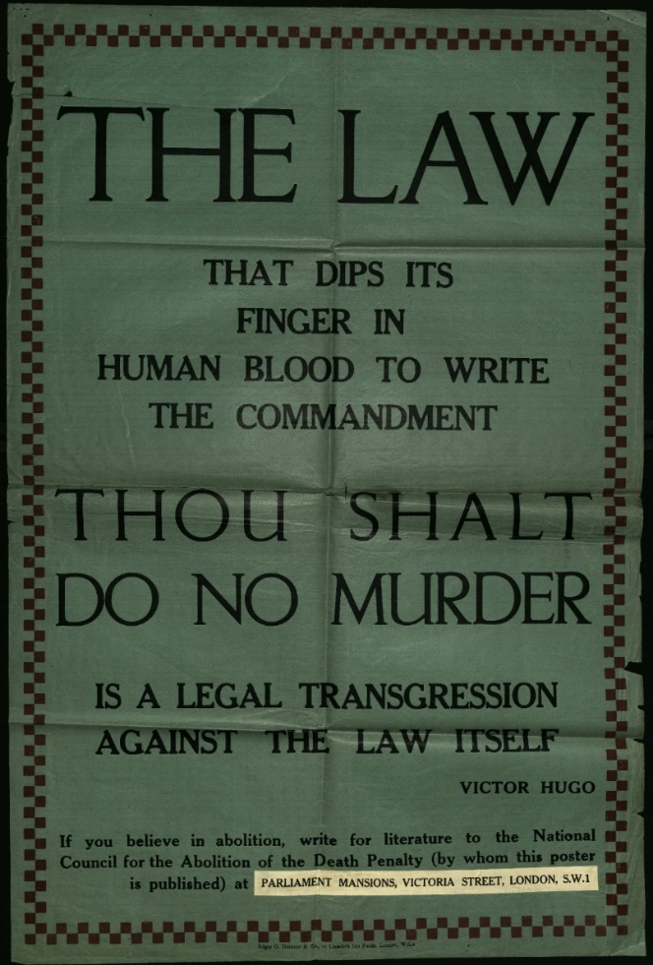
Poster by the National Council for Abolition of the Death Penalty with quote by Victor Hugo, exact date not known, 20th century.

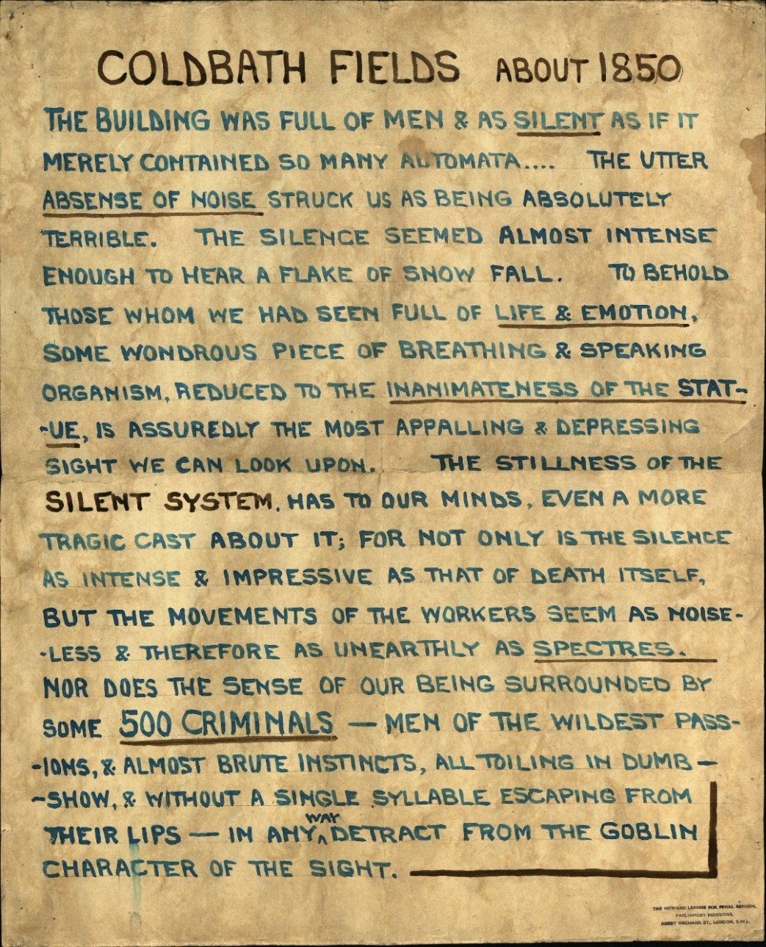
Homemade poster by the Howard League for Penal Reform - comment on the prison at Coldbath Fields, 1850.

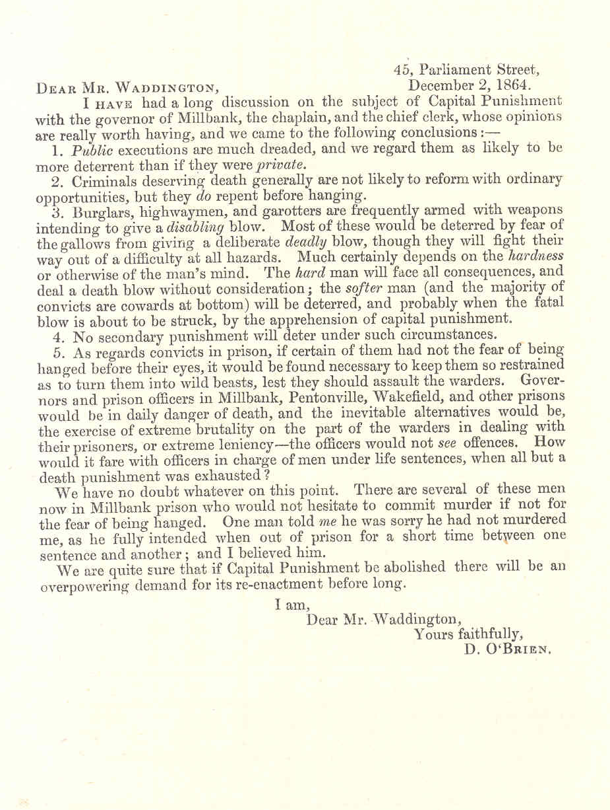
Example of a letter written in response to an enquiry from the Royal Commission on Capital Punishment. It gives the opinions of the Chief Officers of Millbank Prison, London, on the effectiveness of capital punishment, 1864.
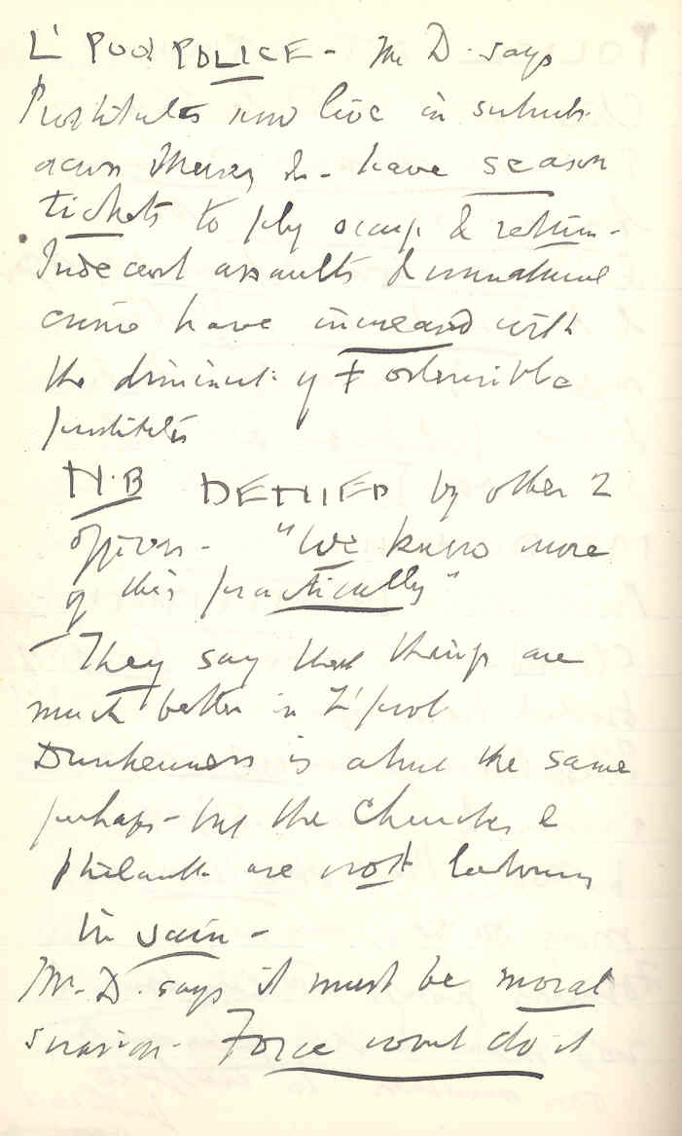
Notes taken by William Tallack, secretary of the Howard League, 1897-8. This extract records his discussions with Liverpool police officers about the issue of prostitution in the city.
Computers are a relatively modern invention and so a lot of primary source material held in archives is handwritten. See how much of the document you can read. Consider the pros and cons of doing archival research compared to getting information from a book or the internet.
Summary:

- Archives are primary sources
- Primary sources are documents created in the past, at the time of an historical event or after
- Images can be harder to interpret than written sources
- We all have a unique perspective and your opinion matters
- There is no right and wrong in history
- Context is the additional information you need to understand a document
- Sometimes you can find context by looking just at the source but often further research is needed
- Remember to use the 5 W’s to analyse the context of a source
- All sources are biased, and all sources are useful
- Analysing a source means discussing its strengths as well as its weaknesses

Further Reading:

For further sources on this topic check out these online exhibitions from the Modern Record Centre:
‘Photographing prison life in the early 20th century’ https://warwick.ac.uk/services/library/mrc/archives_online/digital/prison
‘The Victorian City’
https://warwick.ac.uk/services/library/mrc/archives_online/exhibitions/city/

For more help on analysing sources see:

History Head Start
https://warwick.ac.uk/fac/arts/history/outreach/historyheadstart/

School Resource Packs
https://warwick.ac.uk/services/library/mrc/using/school/

The National Archives
https://www.nationalarchives.gov.uk/education/students/

If you are thinking about going to University:

Opportunities for those 16 and under at the University of Warwick
https://warwick.ac.uk/study/outreach/whatweoffer/pre-16-programmes/

