How to use Concur – Quick Guide

Logging In and Making a Claim

Single sign-on (SSO)
Concur is a single sign-on application; once you have logged into the University’s webpage using your usual University log-in Id enter Concur in the search box, which will take you into your account.

Your profile (your initials in the top right)
There are some fields we’ve set for you and others you can update yourself.
Set fields (for information only)
Personal Information - your employee ID (for staff this should be the same as your University Card), name and your University email.
Expense Information – all your expense claims will automatically be assigned to this code (but you can change (allocate) the costs when you make your claim, if you need to).
Expense Approvers – your claim will automatically be sent to the person shown here.
Updateable fields
Expense Delegates – you can choose someone (or more than 1 person) to input a claim on your behalf (you will still have to submit the claim). You can also see if someone (or more than 1 person) has selected you to be a delegate for them.
Expense Preferences – you can choose not to receive e-mail notifications (but be aware that if you untick this, you won’t receive e-mails and will need to check on Concur if your claim has been returned for any reason).
Company Car and Personal Car – if you need to claim for mileage incurred on University business, you will first need to provide details about your car and confirm you have a valid licence etc. (Students only: please note you will need Social, Domestic & Pleasure Insurance rather than business use but you will still need to confirm this as business insurance)
Mobile Registration – download the Concur app and register your mobile device so you can take photos of your receipts to add to your claim.
Note: you can also complete, submit and approve claims on your mobile, but some functions are not currently available on a mobile device, such as changing a cost code, using Google Maps, returning or forwarding a claim.

Making a Claim
- Start a claim (note: your claim can include many items and many trips. Please do NOT submit several claims for a few items all at once, instead build up a single claim with all your expenses for the month and then submit it. Concur charges the University several pounds for every single claim submitted).
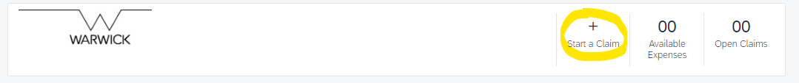
- Complete Header
Complete all boxes with a red asterisk.

Claim name: is for you to identify the claim (e.g. enter your name and month).

Policy and Date: system defaults (no need to change).

Business purpose: Please tell us specifically why you incurred this expense; where you went, why and when. This is a really important field and your claim will be returned if it is not clear why you incurred the expense.
Please do not enter the type of expenditure (train ticket, mileage etc. since we can ascertain that from other fields) nor simply enter “yes”.
There is a maximum of 50 characters (the counter shows how many you have used out of the 50 available), so please truncate where necessary (e.g. shorten Conference to Conf)
This field is uploaded to SAP and provides a quick, at-a-glance record of the reason for the expense.
(If your claim includes various trips, you will need to amend the business purpose for each item claimed, which you can do within the claim).
Note: You will see a “comment” box on various screens – please use this if you need to provide additional information that you think might be helpful in understanding your claim, but this is different to the Business Purpose and does not get uploaded to SAP.

Add Expense
- Choose the type of expense (noting that Concur should in the main be used for travel and subsistence; some type of expenditure is not permitted – see “What may I claim for”)
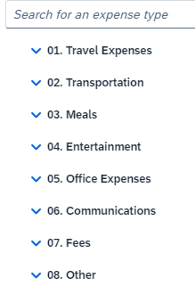
As you create a few claims Concur puts your recently used expense types at the top of your selection screen so you can quickly select the ones you are most likely to use:


Expense Fields
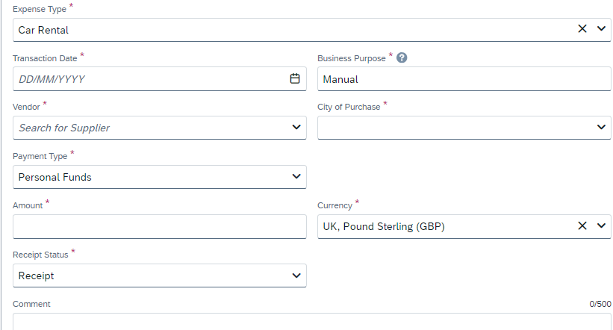

- Select the date you made the transaction
- Business purpose – this automatically carries through from your header but remember to change it if your claim includes various trips
- City of purchase – this automatically changes the currency; for example, if you have paid for a taxi in Singapore, the currency will change to SGD. If you have made an online purchase, you may need to amend the city to reflect the currency of the receipt rather than where you physically were. After you have used this a few times, Concur will start to remember your most recently used locations.
- Payment type – Do not change this
- Amount – if you have a non-sterling expense the sterling equivalent will be automatically calculated. If this calculation differs from what you were actually charged, then you can overwrite the “amount in GBP” (within limits).

Receipts
- Receipt status – you need a full receipt for all expenses. If for any reason you do not have one, you need to change this to ‘no receipt’ and provide an explanation in the comment box. Note: you need a receipt to reclaim any expenditure – losing or not asking for a receipt are not acceptable reasons and we are required by HMRC to keep a log of any claims that are, exceptionally, reimbursed without a receipt. If receipts are persistently not provided, then your claim will be rejected.
(Do not amend Receipt Status to Tax Receipt; doing so will cause your claim to fail processing)
- Add receipt Upload receipts (and any correspondence such as Fin Regs approval) that you have already scanned or saved on your computer/mobile device (format must be png, jpg, jpeg, pdf, tif or tiff). You can upload multiple receipts and the toolbar will show number attached – for example there are 3 receipts on this claim:
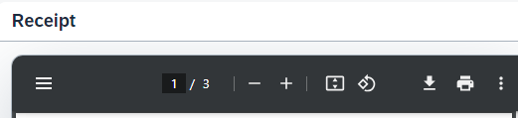
Concur will assume at first that you only want to upload a single receipt so you will need to save after uploading and then go to your claim summary and use the “edit” facility to attach additional items (once you are in the edit facility you can add several items at once)
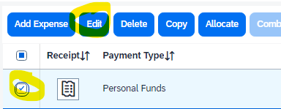

Accommodation
Please do not put anything in the VAT Number field (the University’s tax status means we are not currently using this).
You need to “itemise” your stay to show the cost of the room per night and any other charges that have been added to your bill. Please combine any local tax charges and any itemised breakfast cost to the cost of your room.

Hospitality and Meals for multiple people
If your expense includes the cost of a meal for someone in addition to yourself, you need to tell us who this is via the “Attendees” button.
If the other attendees are all Warwick employees (or if you are a student and the other attendees are also Warwick students) then the expense type should be Meals (breakfast, lunch or evening meal).
If the other attendees include people external to Warwick (or if you are a member of staff and the other attendees include students) then the expense type should be Entertainment (hospitality).
Adding attendees: if your other attendees are Warwick employees it is quite likely they are set up in Concur, so you can search for them by selecting attendee type “Employee”, entering their surname then selecting search and selecting the correct person from the results.

Changing your cost code
Everyone is set up with a default cost code, so you may never need to change this to anything else.
If you do need to change any of your expenses, use the “Allocate” button.
It is quickest to do the allocation once you have entered all your expenses and then going to the overview of your claim and ticking those items for which you want to change the code and then selecting “allocate”.
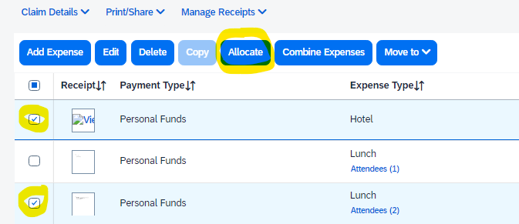
Select either a Percentage or sum to allocate, then scroll down the new allocation tab.
Under Cost Object Type:
You need to know whether the code you want is a cost centre, Internal order or project:
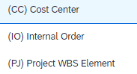
Once you have selected the correct type then go to Cost Object ID and slowly start typing in the start of your code. Concur will filter through the options to show you the valid codes. If you want to select a project, please include the dots in the format e.g. A.AAAA.NNNN.XXX

Alerts
Concur checks your claim before you submit it to see whether it is complete and that you have attached all necessary documentation.
If you have errors on your claim you will see an alert message (which also indicates the number of errors or warnings)

Open the drop down on the alert message to see the errors are and navigate directly to the part of your claim that needs amending:
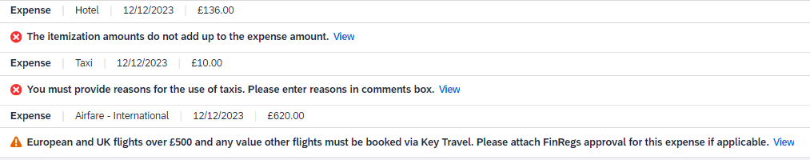

If your claim has an error you will need to correct it before you can submit
If your claim has a warning please read the message and ensure you have complied.

Rejected items/Queries
If the central expenses team or your approver have queries regarding your claim, it will be sent back with comments explaining what is being queried. Please amend the claim as requested, add explanatory “comments” if necessary and remember to save and submit again.

Approval Progress
You can see where your claim is under “Open Claims”/”Manage Expenses”
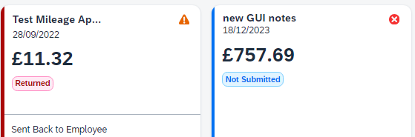

Help
There are a variety of sources you can go to if you need help with your claim. Click on the icon at the top right of the Concur screen and the training option within this will give you quick links to Concur guides, University of Warwick FAQs, training videos and e-mail/phone details for the Expenses HR Team.

