Concur – Delegation
(Note: you need to make any additions to delegation yourself – it is your responsibility who you select and what type of delegation you give them)

To add a delegate
In Concur select:
Profile / Expense Delegates /Add /Search for the person you want to act as a delegate for you, then double click on their name
(You can also see here who your delegates are and who you are a delegate for, if any)

Select what you want that delegate to do
There are 3 types of delegates.
  - Approver Delegate
If you are an approver and want someone else (who must also have approver status) to approve on your behalf tick the boxes as in this example (select the appropriate timescale for you):
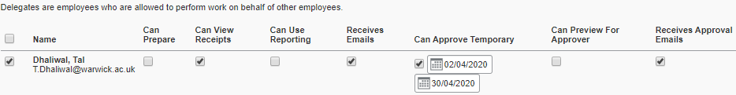
  - Checker Delegate
If you are an approver and want someone to check a claim before it comes to you for final approval, tick the boxes as in this example:
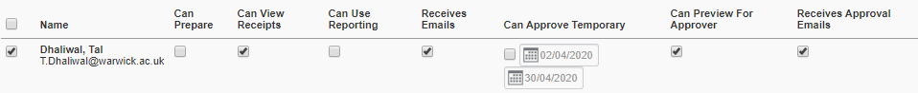
  - Claim preparer delegate
If you want to someone to be able to prepare a claim on your behalf, tick the boxes as in this example (note, the delegate will notify you once the claim has been prepared but you must give it a check to ensure it has been prepared correctly and you must submit the actual claim.
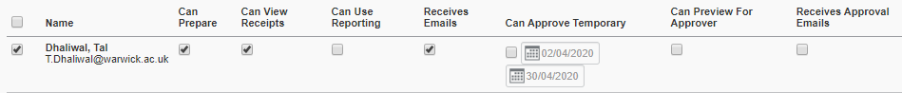
  - Procedure
To act as a delegate, you need to log in to Concur as yourself, then go to “Profile” and select “Act on behalf of another user”. Check that you can see a green box indicating that you are acting on behalf of someone e.g.
 If you do not see a green box then you are acting as yourself and, if you submit a claim, you yourself will be paid in error.

