How to Submit and Approve Paternity Leave in SuccessFactors

This guide walks you through navigating the time-off module and uploading necessary documentation in SuccessFactors to successfully submit a paternity leave request and manage the approval workflow.

- This guide explains how you can request a period of Paternity Leave in SuccessFactors. However, before you do so, you must:
- Check that you meet the eligibility criteria set out in the Paternity Leave policy here.
- If you don’t, you may wish to consider requesting annual leave or unpaid leave instead. Please speak to your People Partner for further advice.
- Complete the Paternity Plan which can be found here.
You will need to record your paternity leave separately for each contract/assignment that you hold with the University within SuccessFactors.

Paternity Leave Submission
- Navigate to SuccessFactors
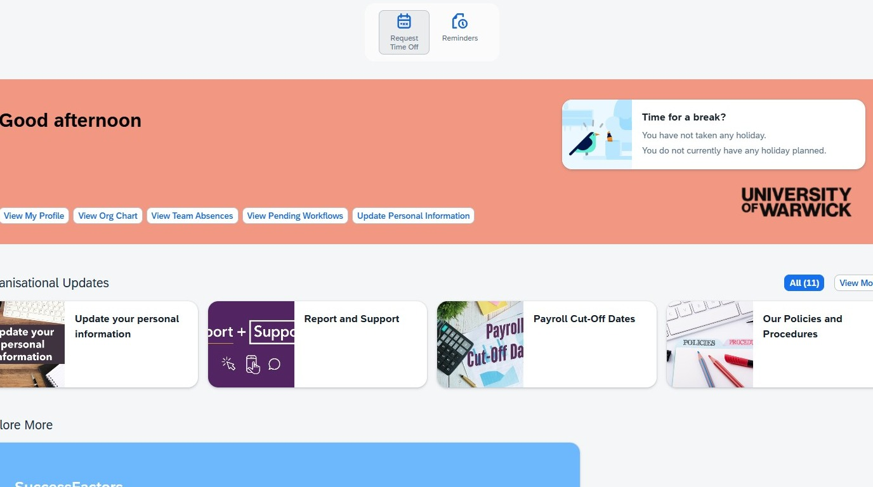
- Click Request Time Off.
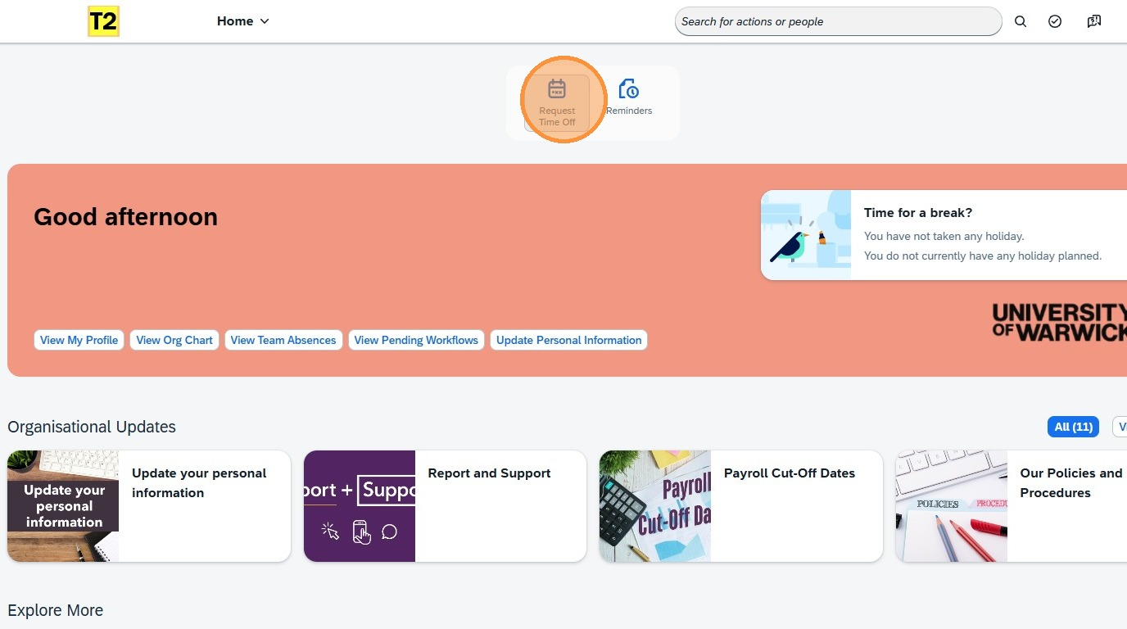
- Select Paternity Leave from the Time Type dropdown.
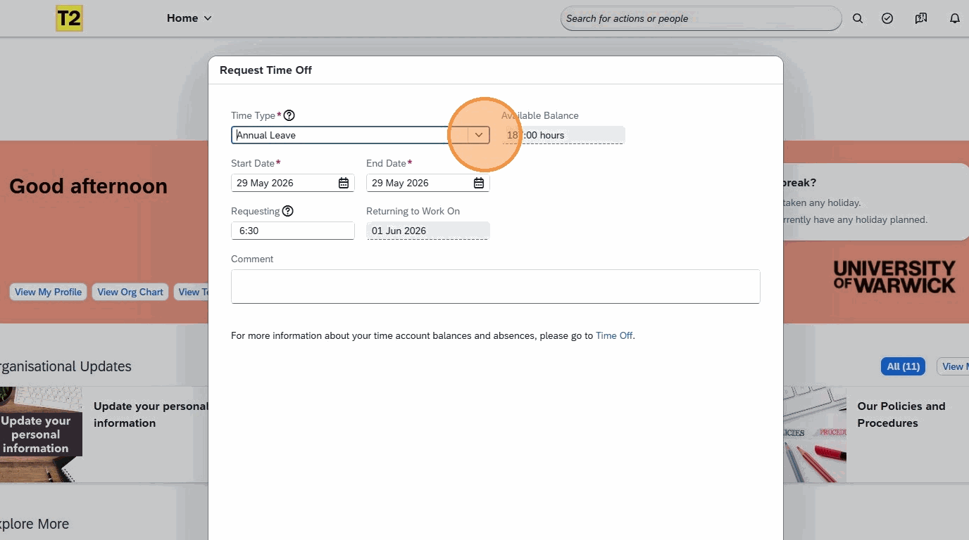
Please note that only 7 or 14 calendar days may be selected for this absence type.
- Select the start date from the calendar.
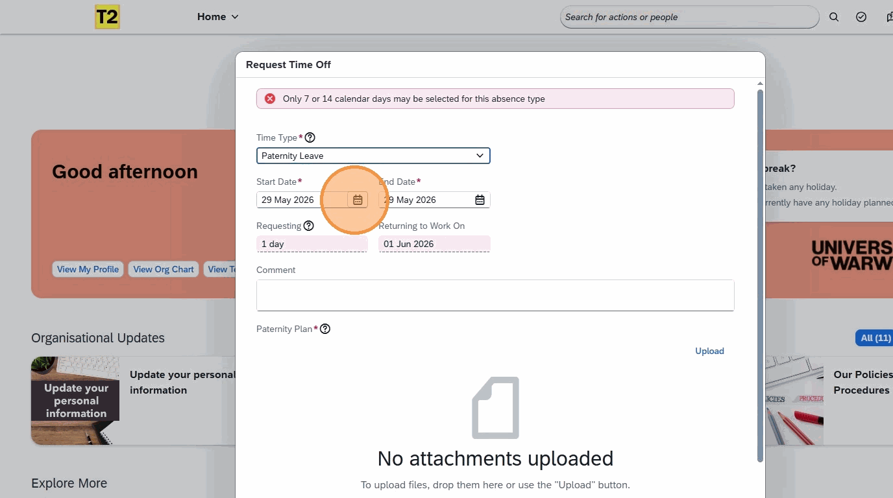
- Select the end date from the calendar.
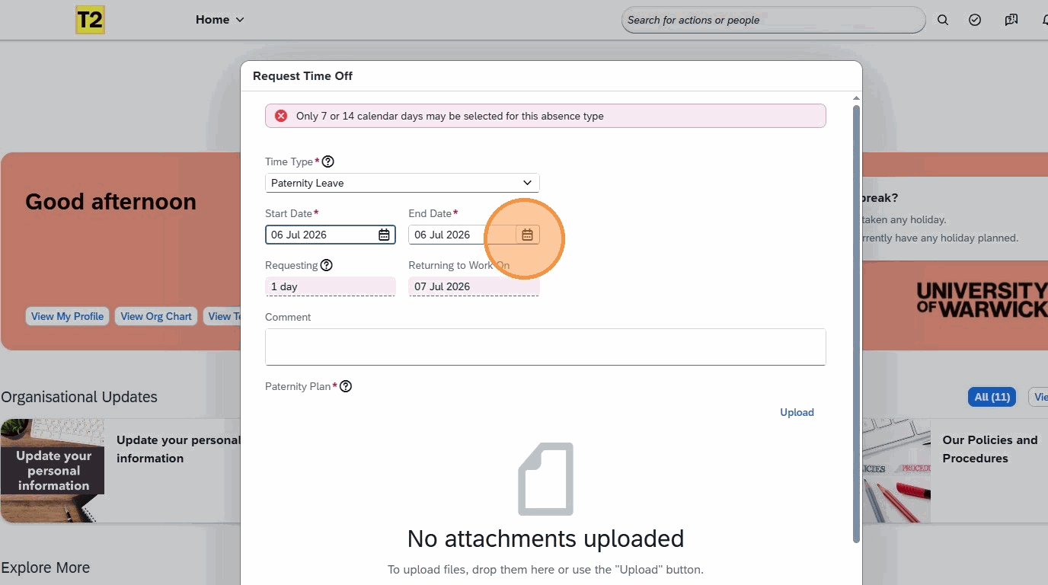
- Type 'Relevant Comments' in the Comment field.
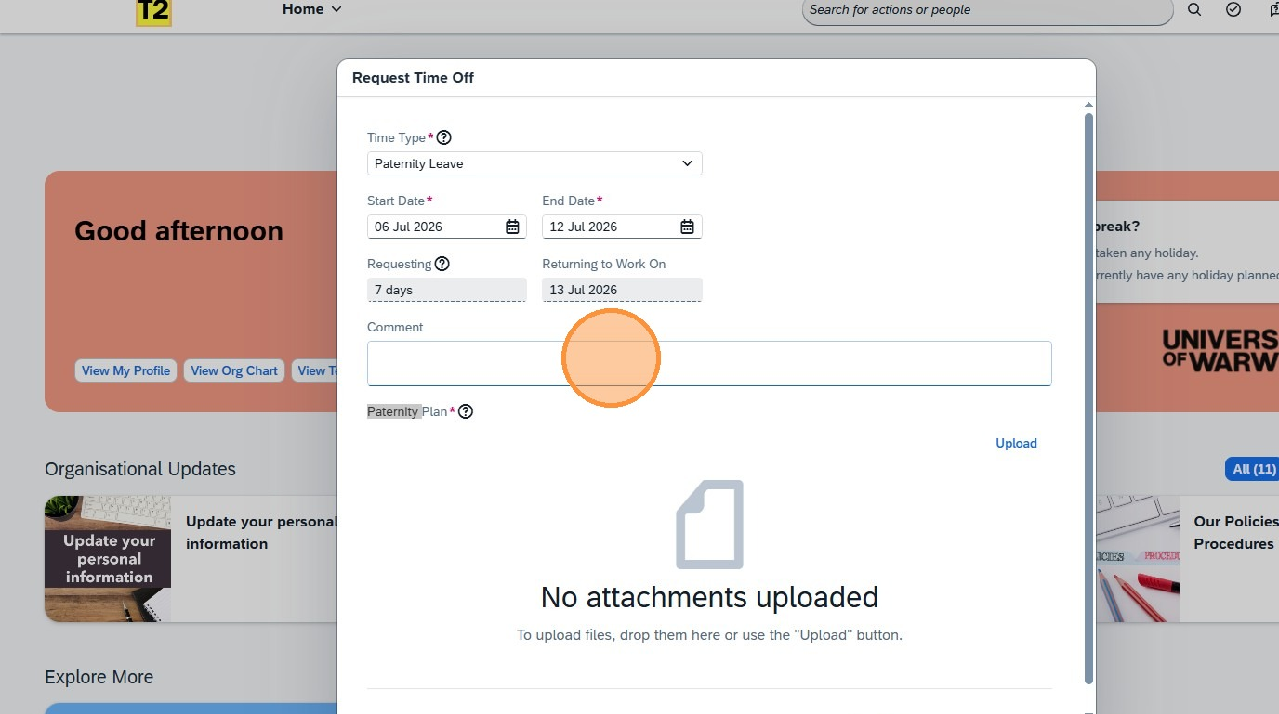
- Click Upload to attach the paternity plan document. The Paternity Plan can be found here.

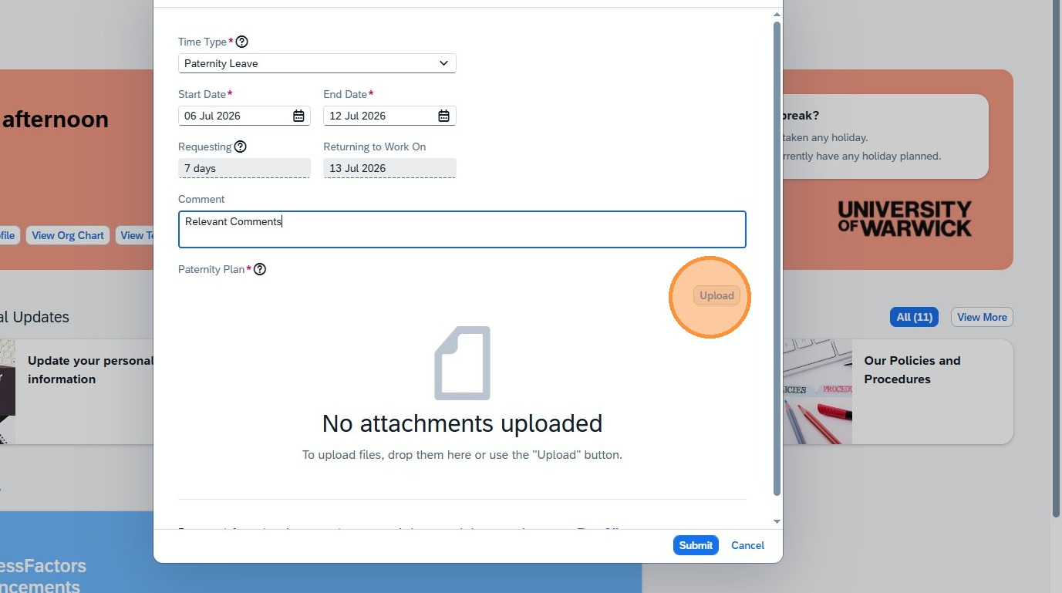
- Click Submit to send the request.
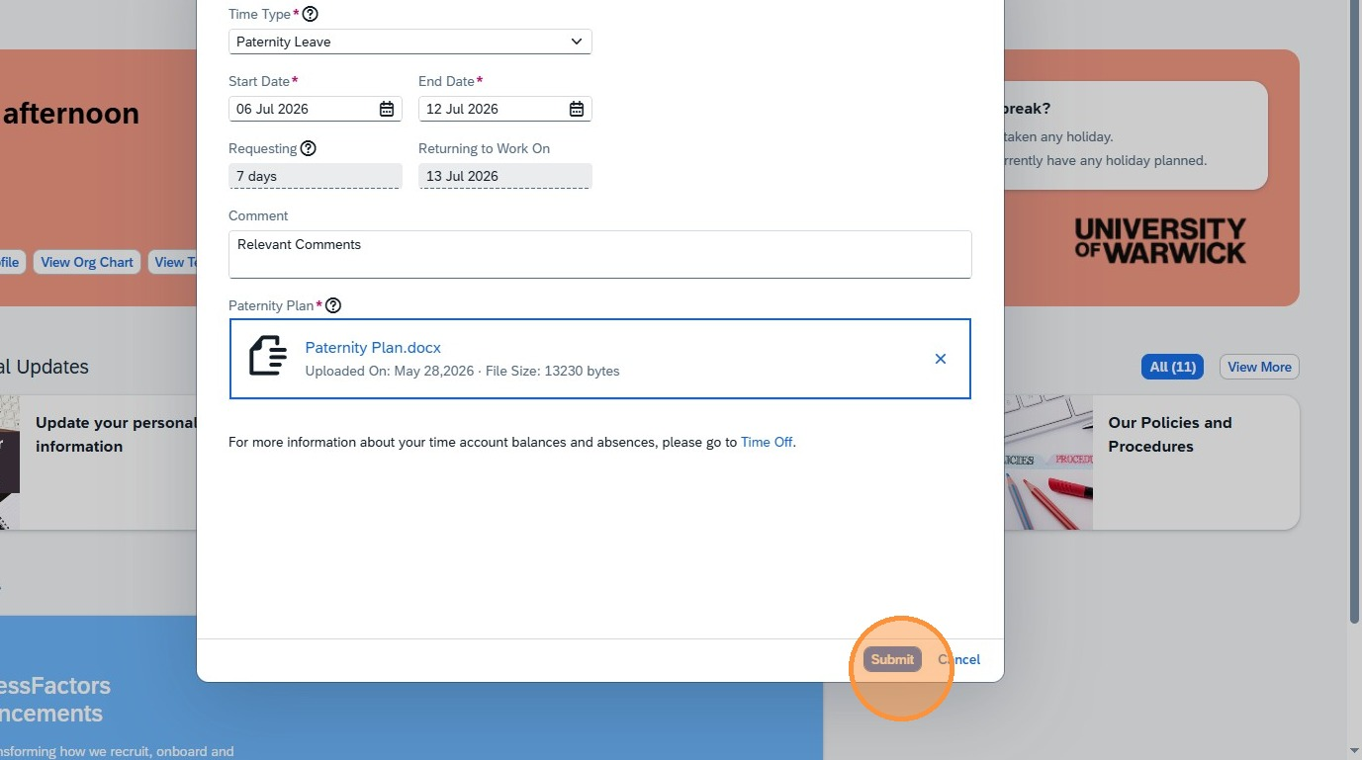
This workflow will now be sent to your Line Manager and then the Payroll Team for approval.

Editing your Leave
- Click "View My Profile"
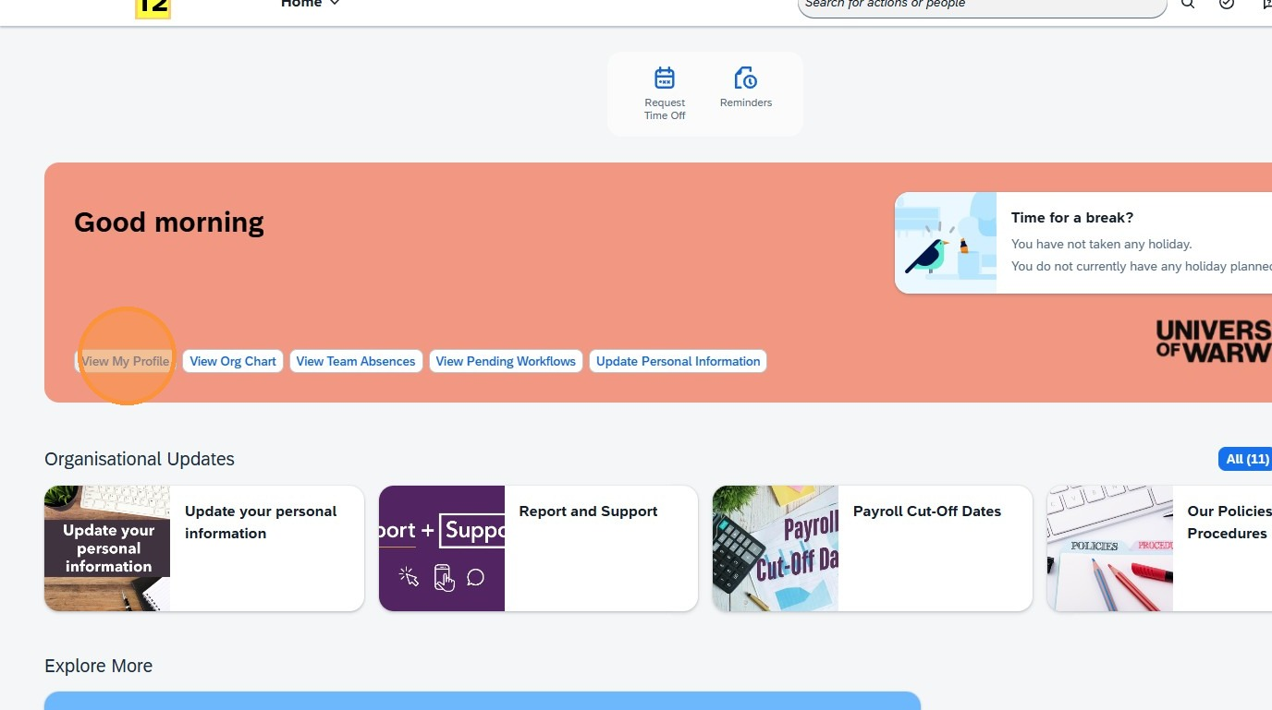
- Select Time.
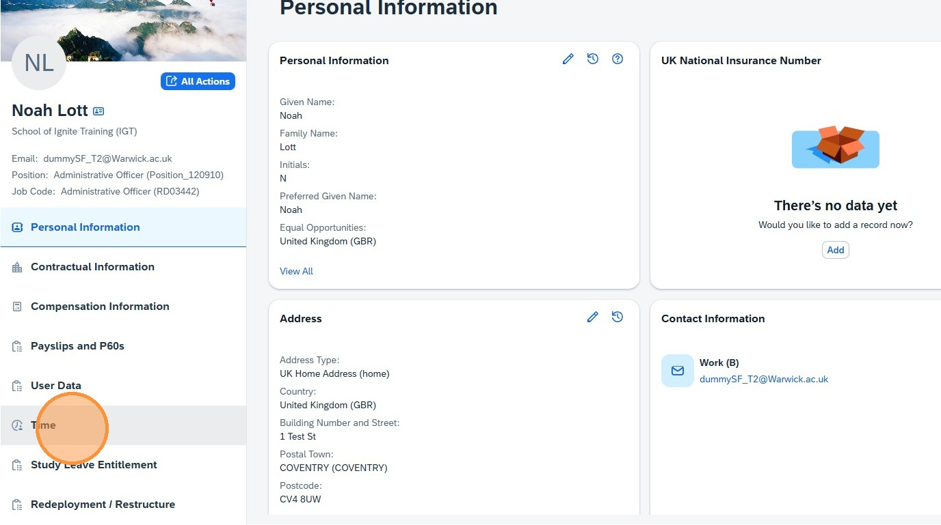
- Click "Go to Time Off"
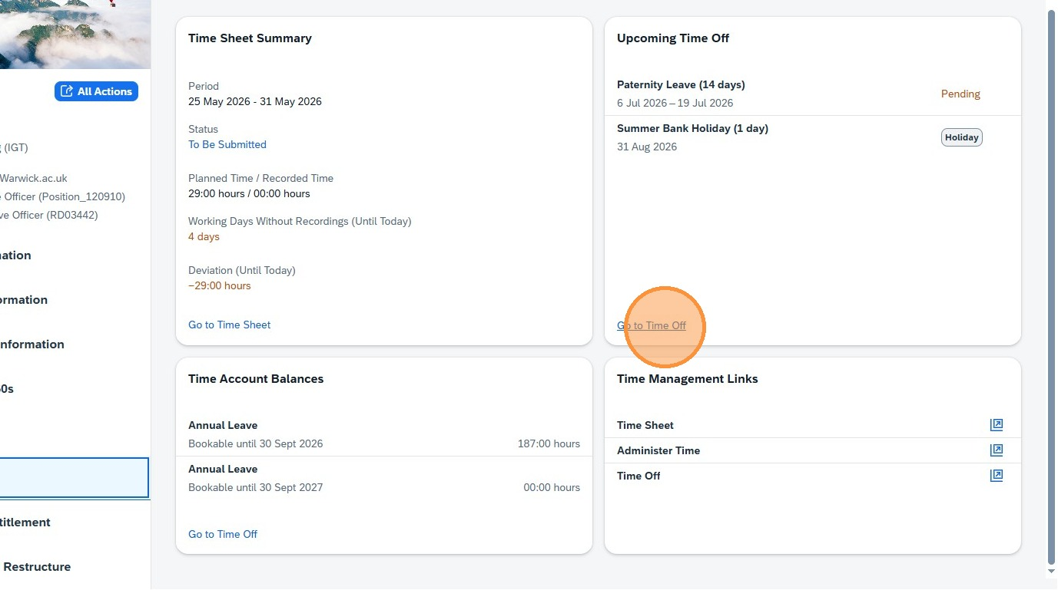
- Select the absence you would like to edit.
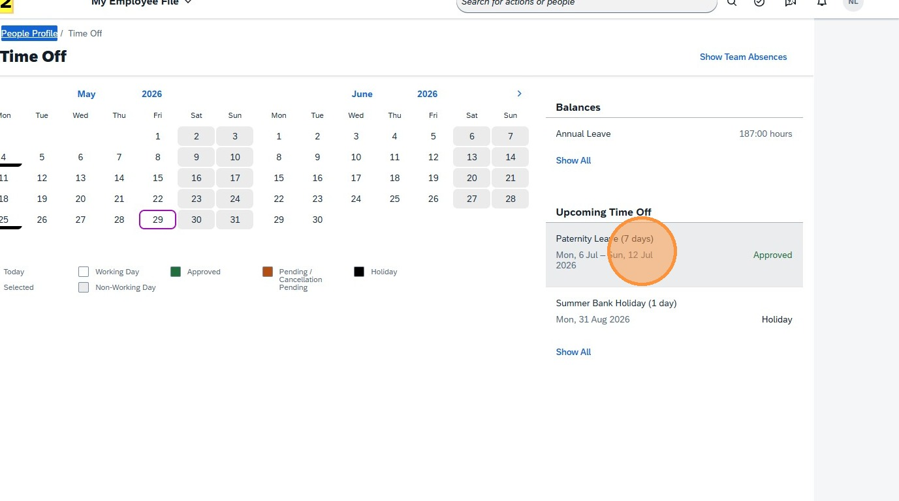
- Click "Edit Absence"
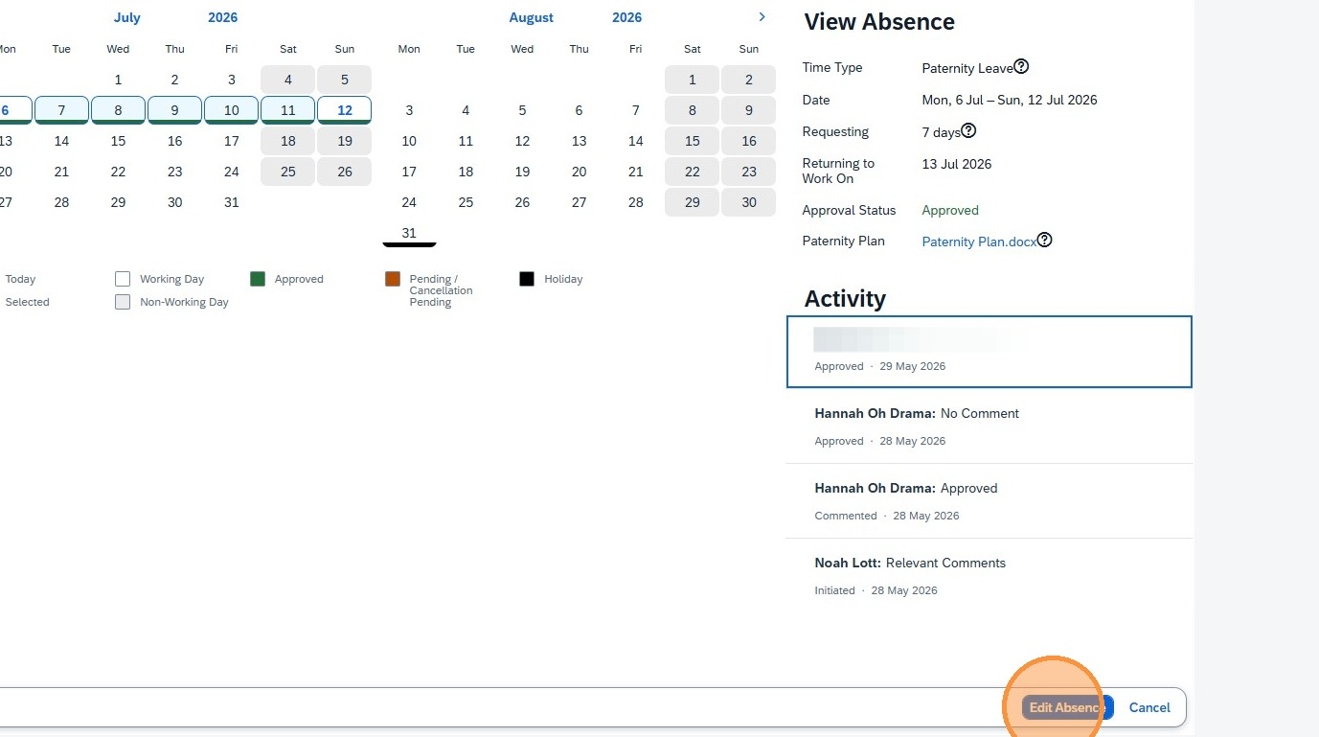
- Use the Calendar to select the new Start or End Date.
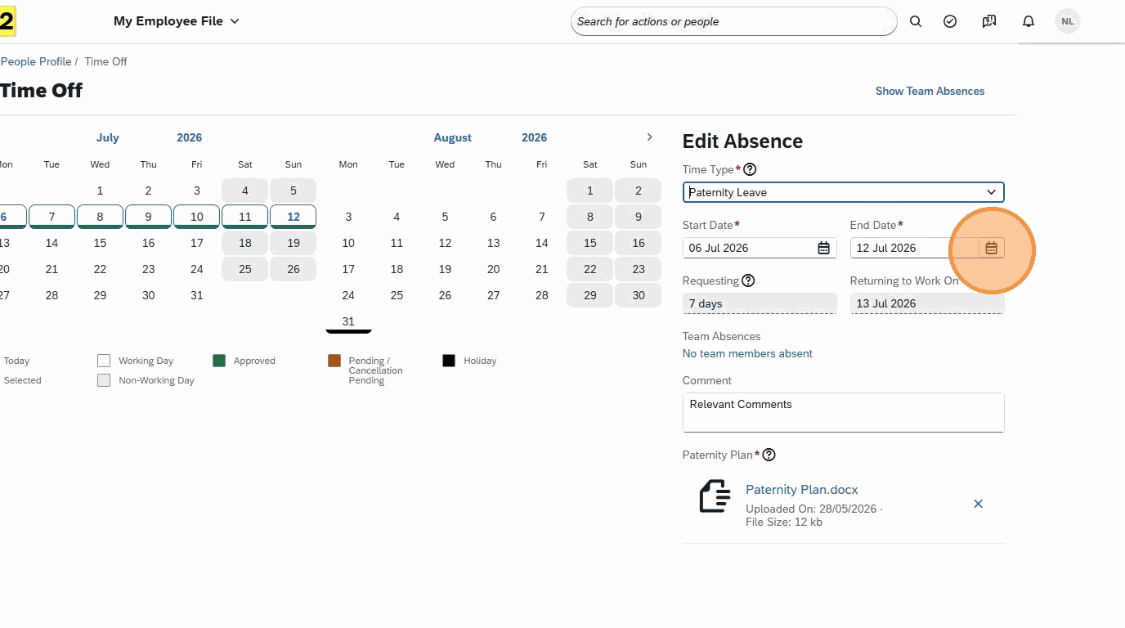
- You can type in any relevant comments in the Comment field.
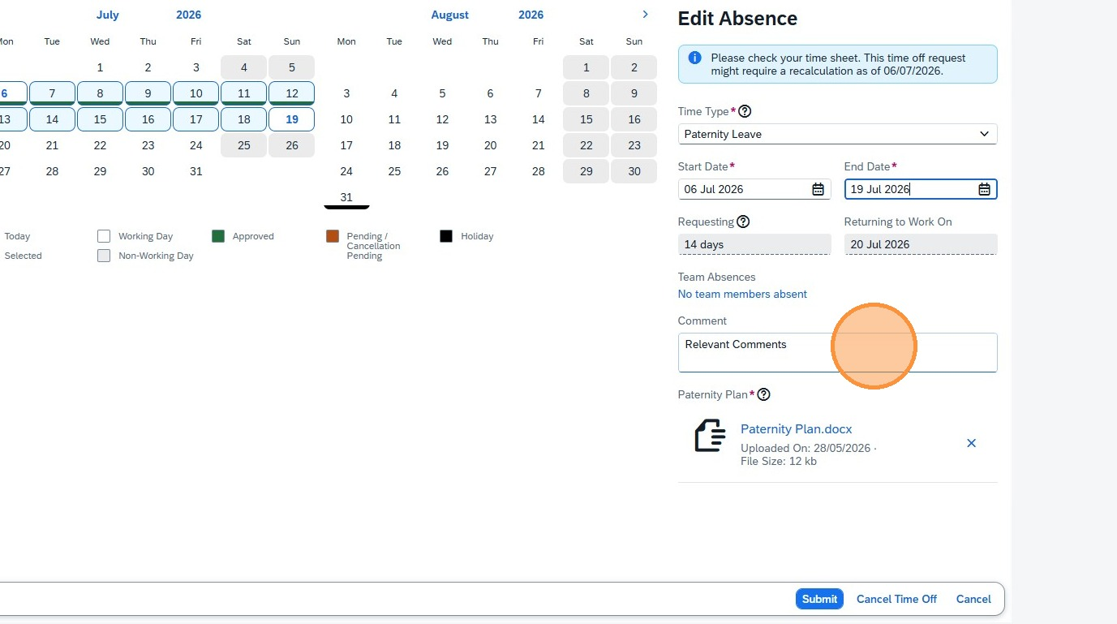
- Click the X to delete the outdated Paternity Plan.
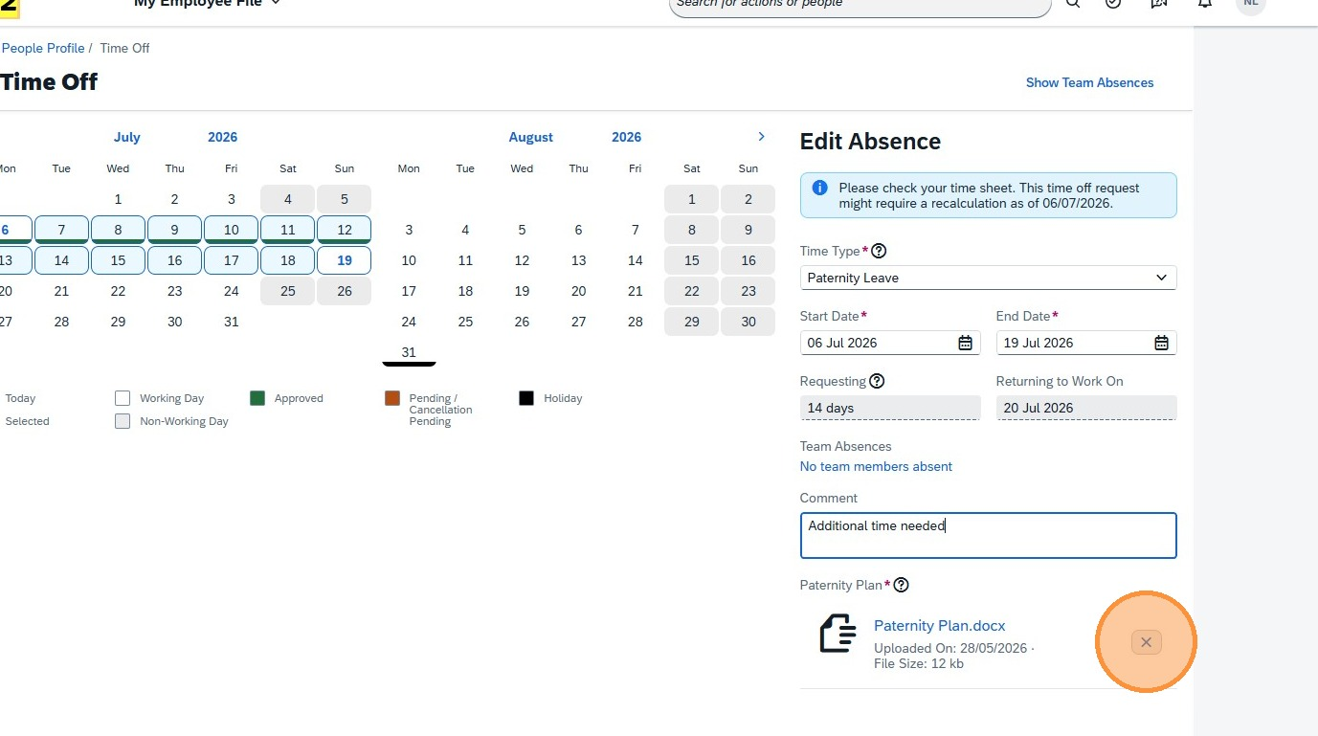
- Click "OK"
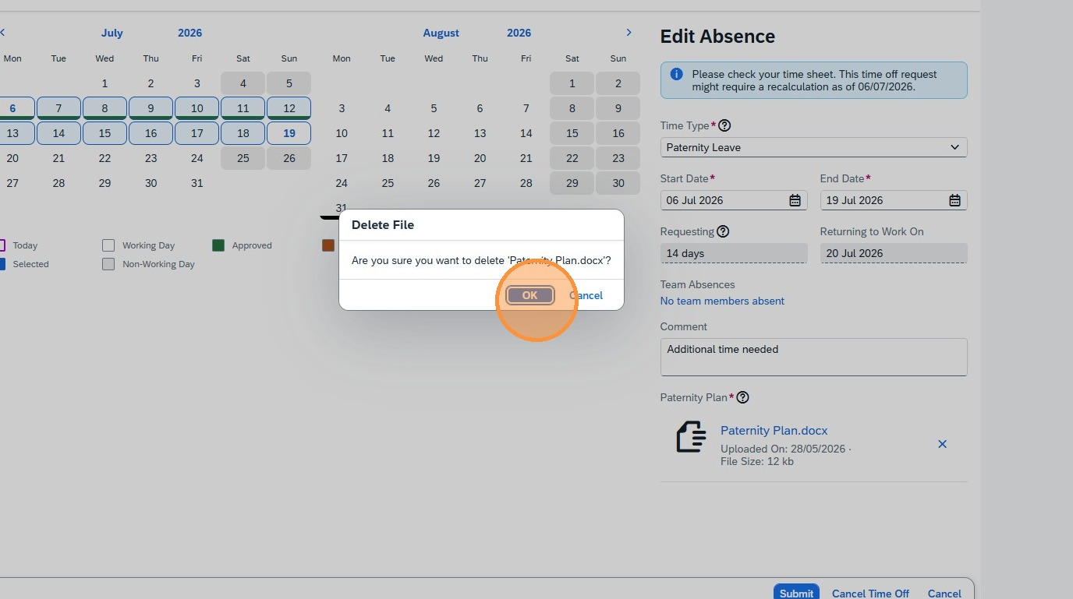
Make the necessary changes to your paternity plan.
- Click "Upload"
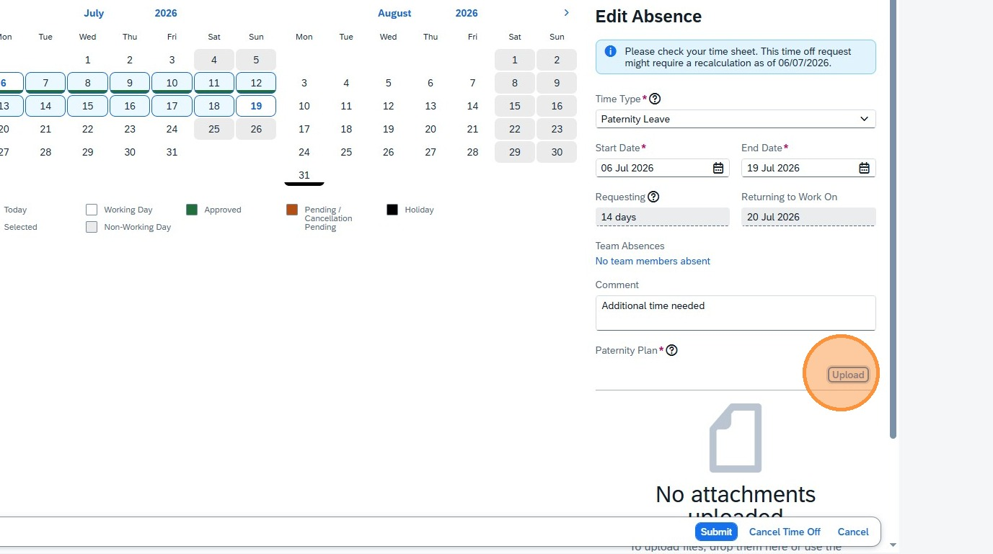
- Click "Submit"
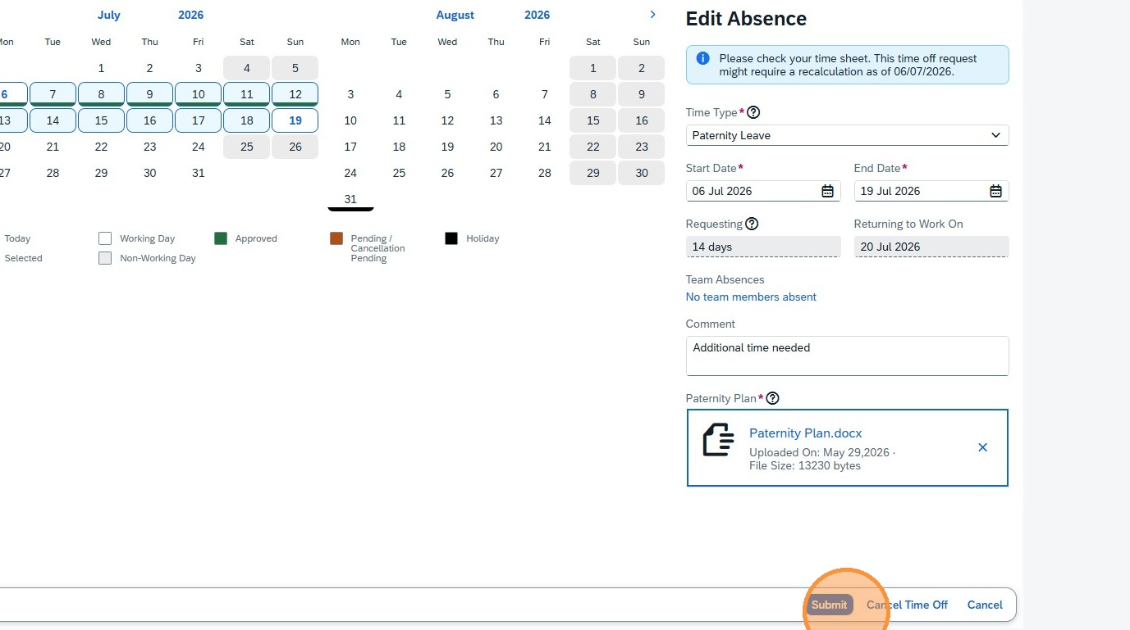
Once you have done this your time off request will have been saved and is awaiting approval by your line manager and the Payroll Team.

Cancelling your Leave
- Click "View My Profile"
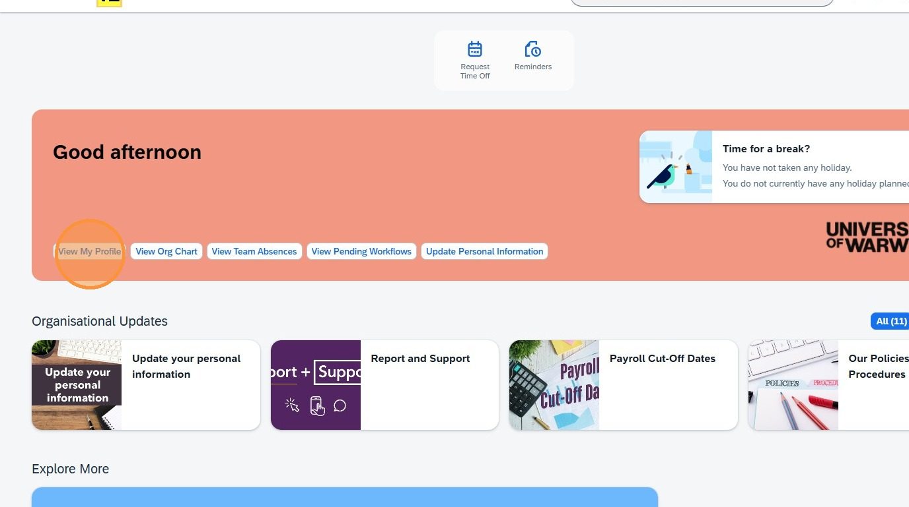
- Select Time.
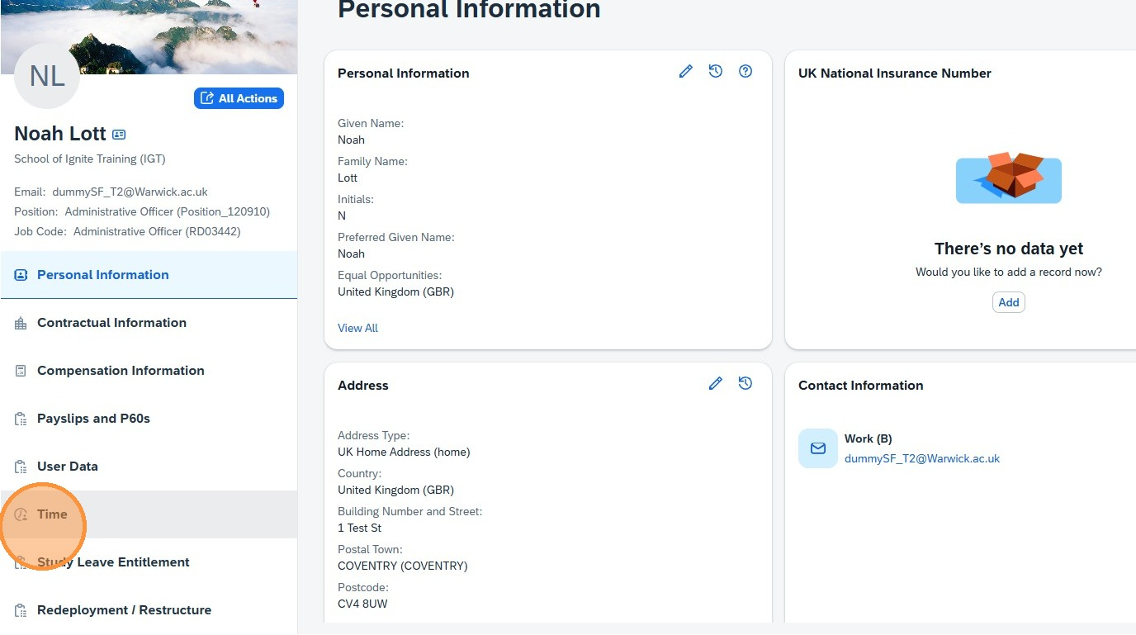
- Click "Go to Time Off"
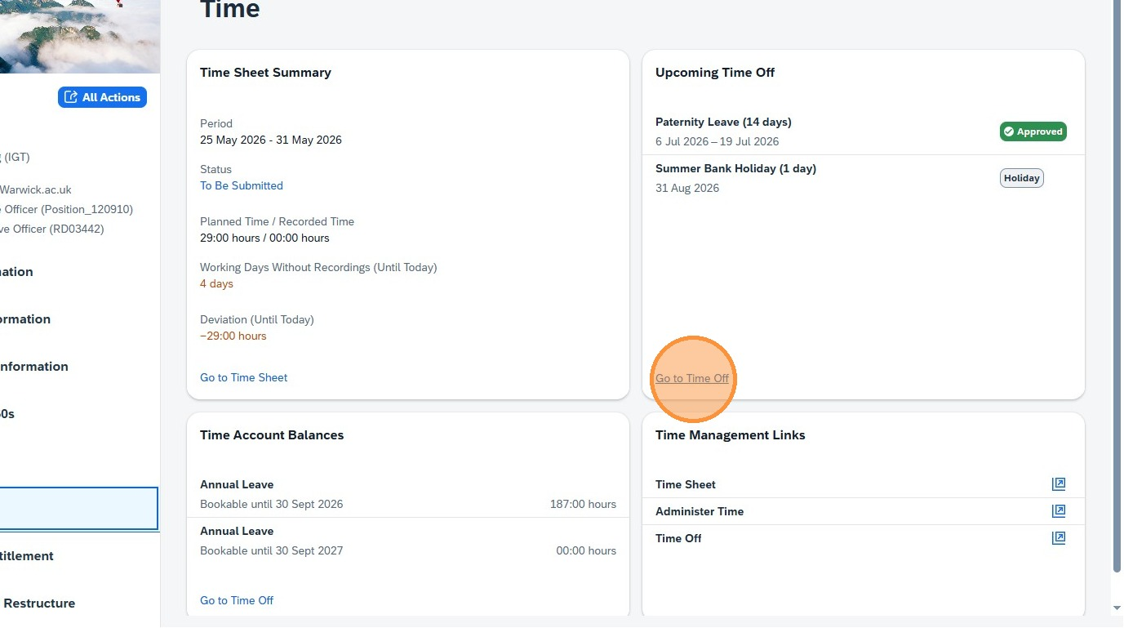
- Select the absence you wish to cancel.
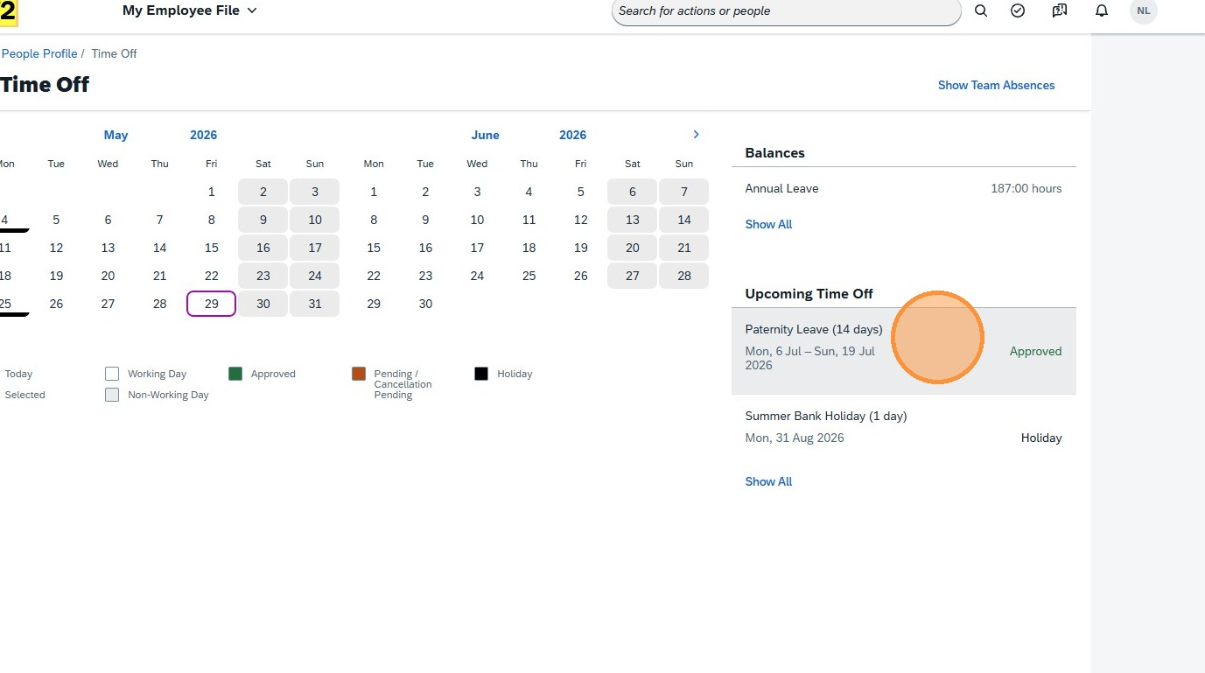
- Click "Edit Absence"
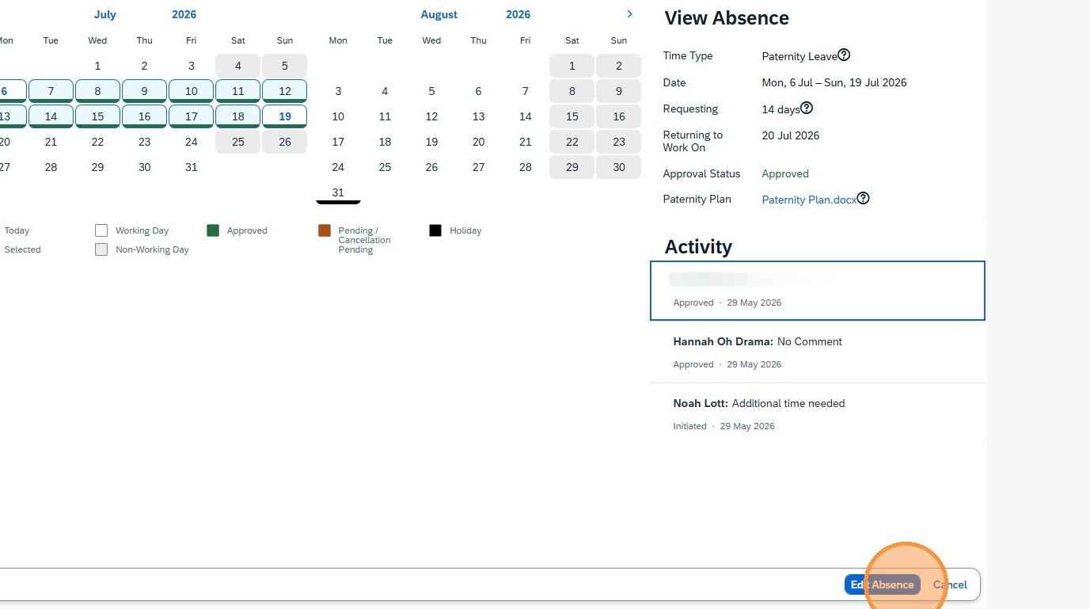
- Click "Cancel Time Off"
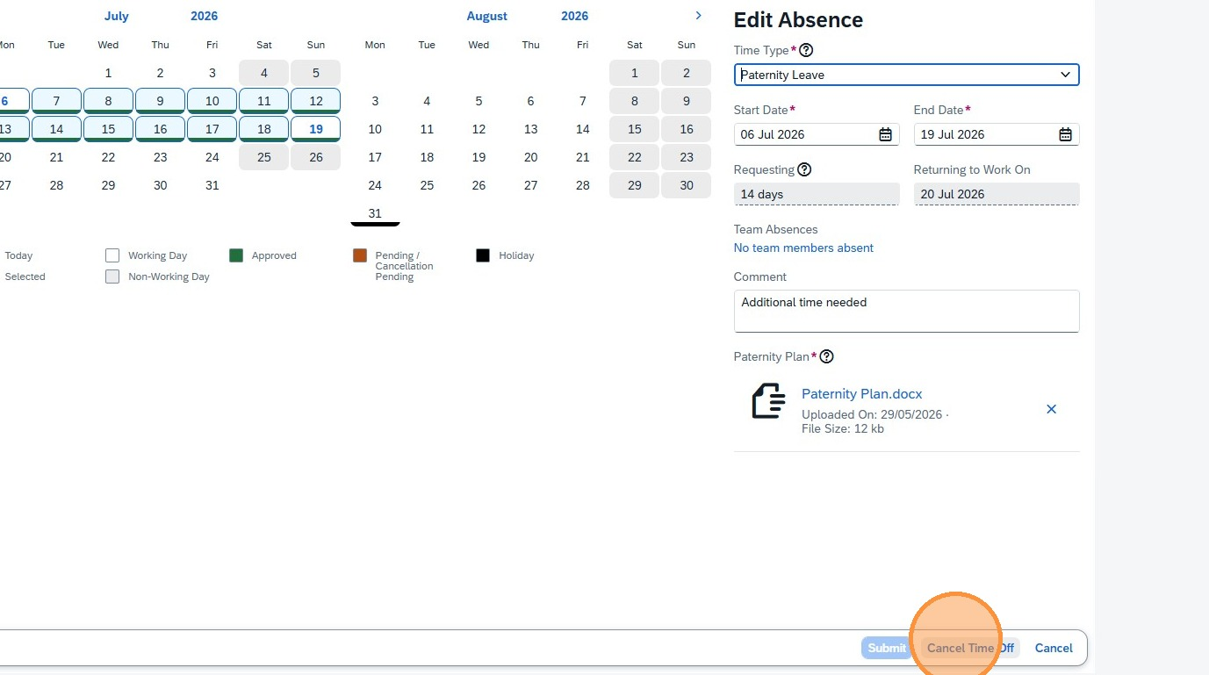
- Click "Yes"
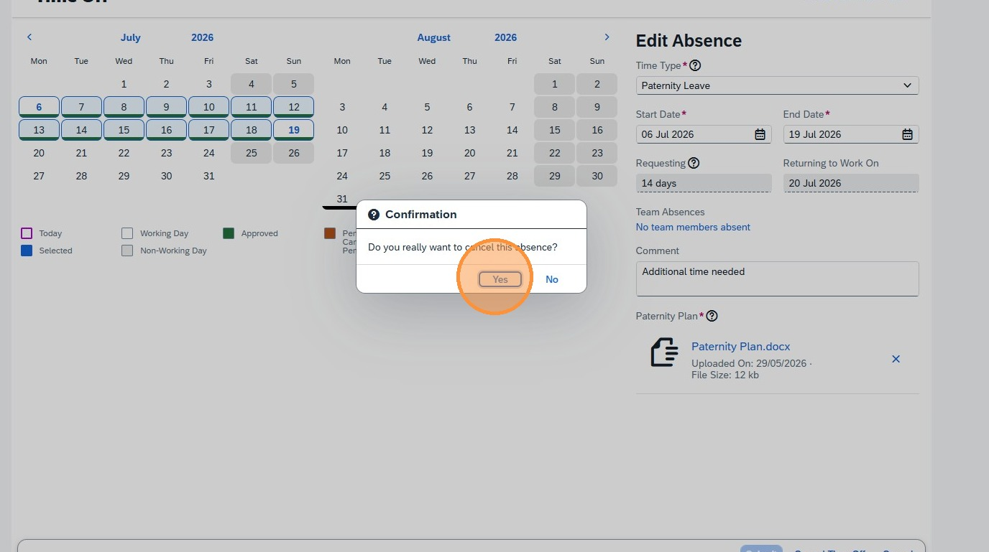
Once you have done this your cancellation request has been submitted and is awaiting approval by your line manager.

Line Manager Approval
- Select the pending Time Off request for the employee from the dashboard. In this example we have used a fictitious employee, Noah Lott.
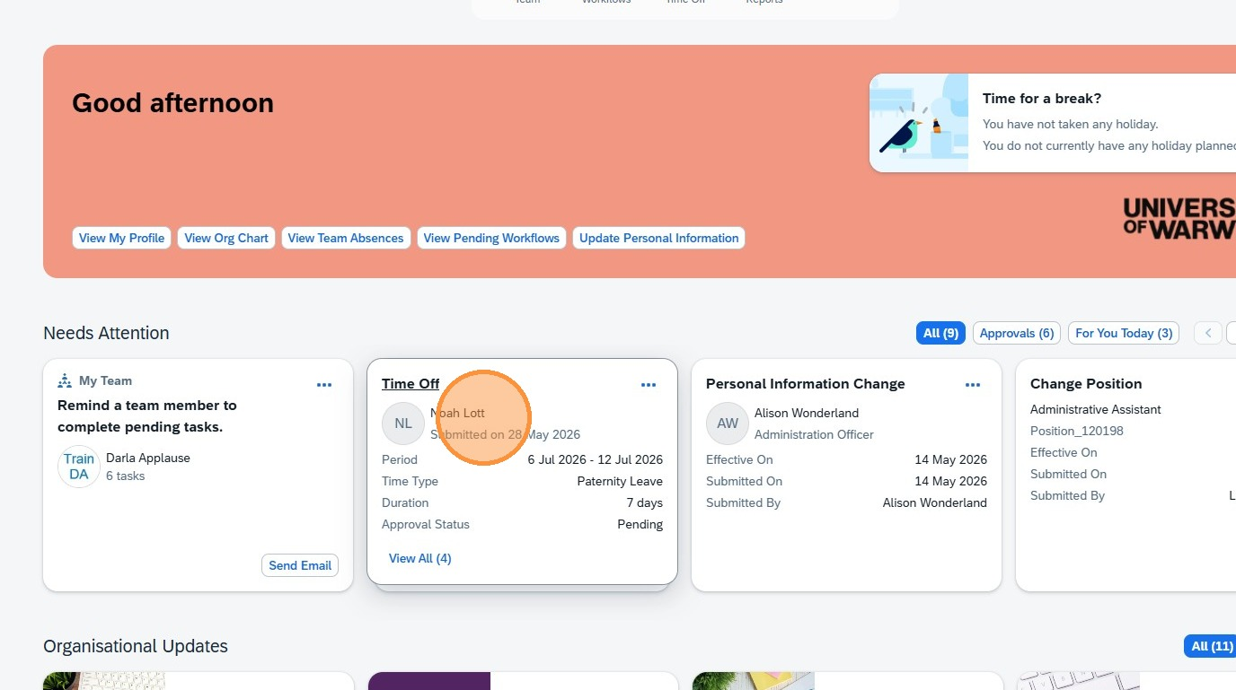
- Click the Paternity Plan.docx link to review the attachment.
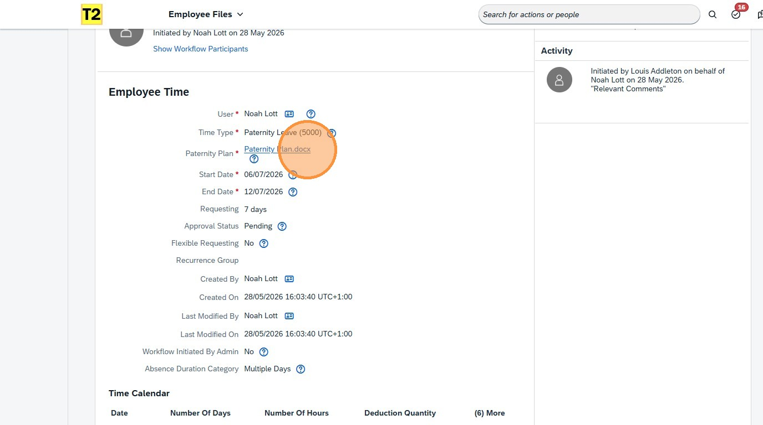
- Type 'Approved' in the approval Comment field.
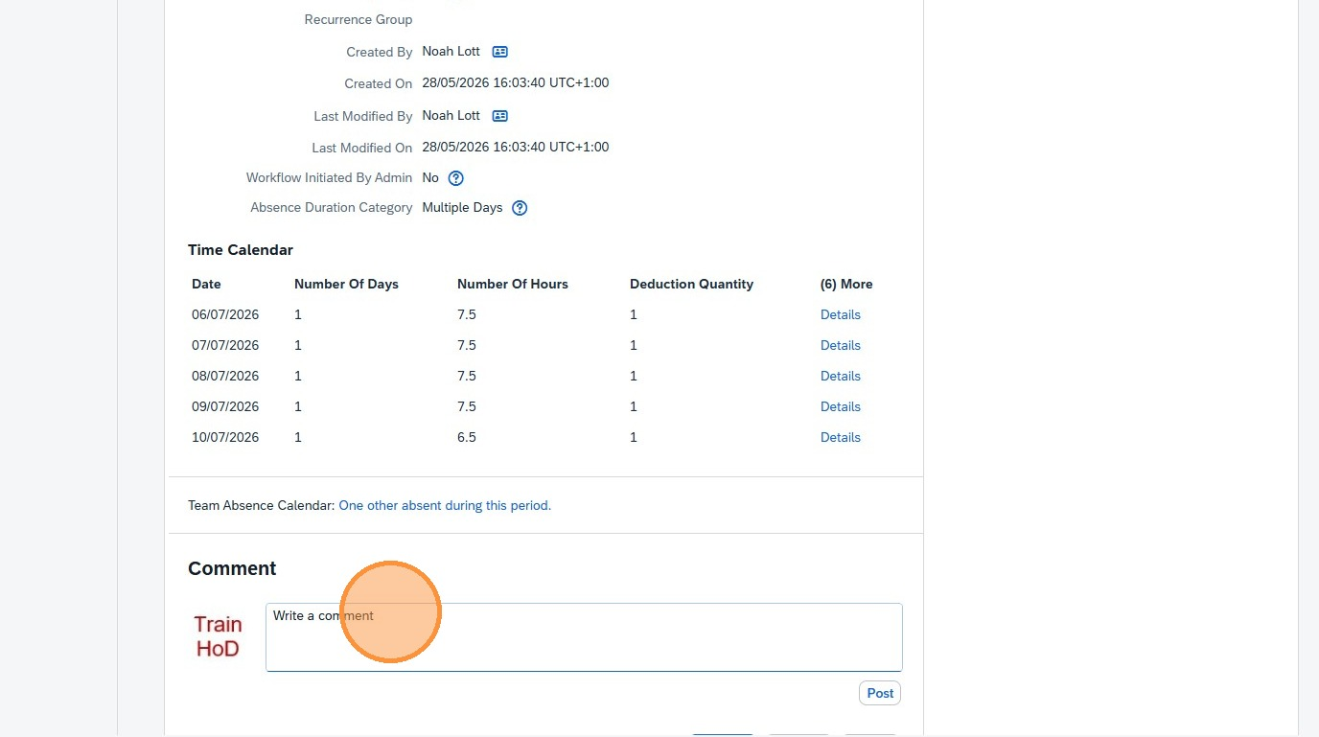
- Click Post to save the comment.
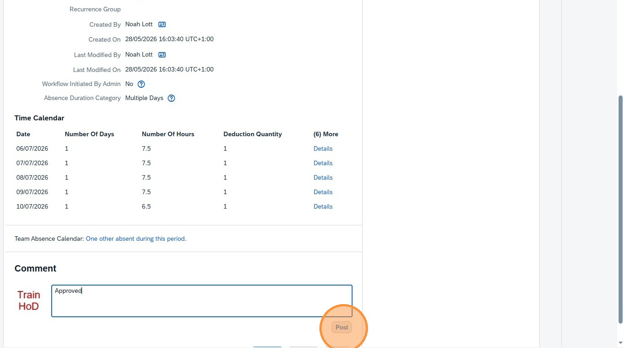
Please note from this screen you can "Delegate" the workflow to somebody else.
You can also "Decline" the workflow. Please speak to your People Partner if you have any concerns in relation to this leave request.
- Click Approve to finalise the request.
