WHAT THE DIFFERENT RESPONSE CODES MEAN

The following section gives you information about the 5 response codes and what they mean in terms of the need for different types of RCUK award holders to make submissions, or not make submissions, during the 2017 exercise

RCUK policies are a little different for our grant and studentship holders. Below we have provided you with two different tables detailing what each response code means for Principal Investigators (PIs)/Fellows, and what they mean for Students:

PIs and Fellows

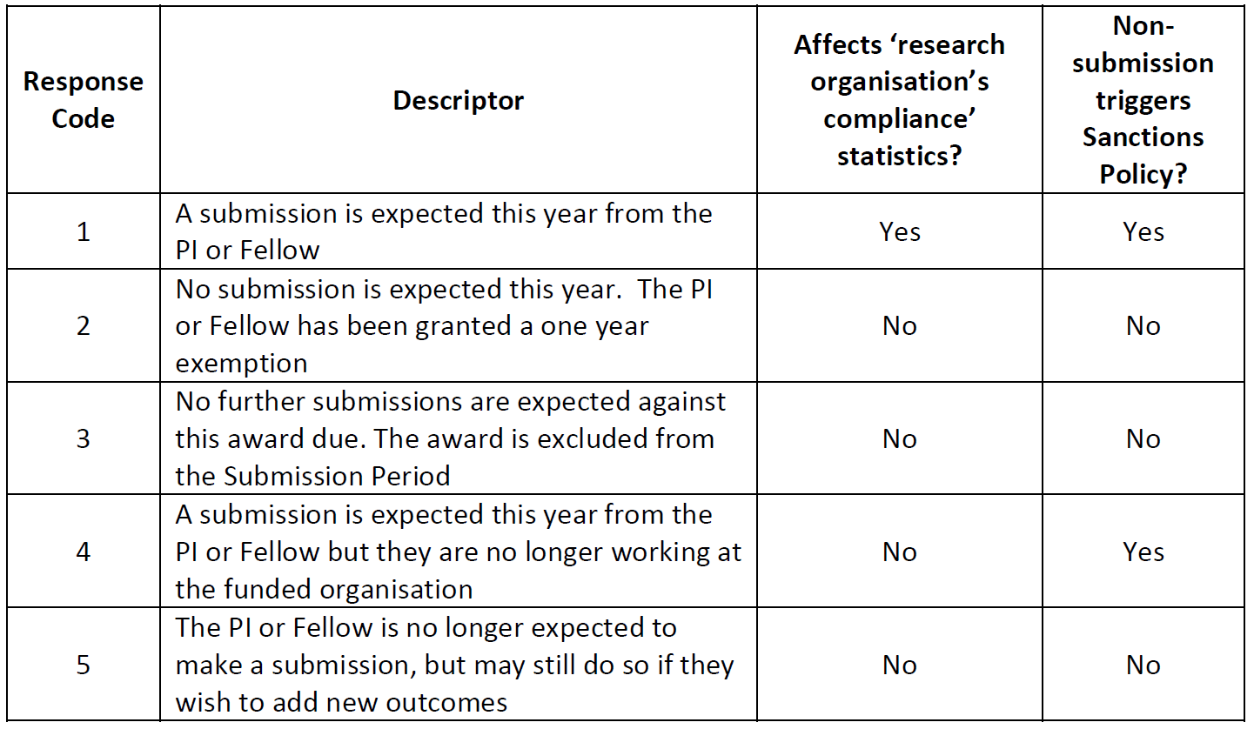

Students
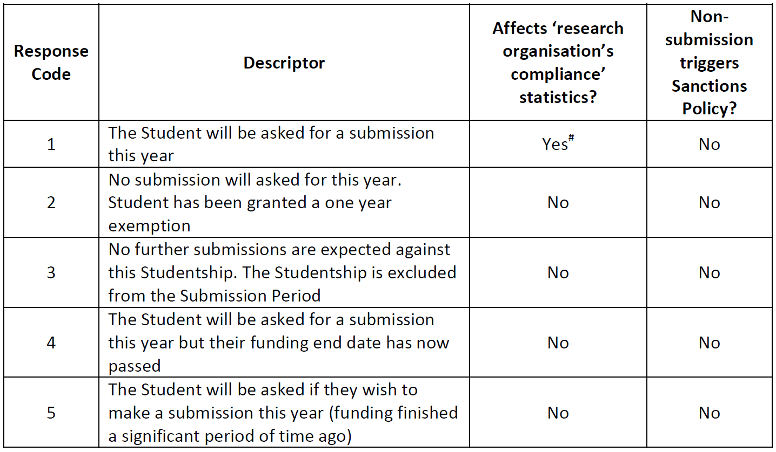

# RCUK understands that some Students may be registered at one research organisation, but will actually be working at a different one. However, for the purposes of compliance statistics a Student will be counted as being at the research organisation where they are registered and not the one where they may actually be working.

CIRCUMSTANCES FOR MAKING A CHANGE TO AN AWARD’S RESPONSE CODE
RCUK recognises that there are a number of circumstances where an institution may feel it is necessary to request for a change in an award’s response code to be made ahead of the next Submission Period. The following tables are designed to help your understand circumstances where RCUK would consider certain changes to be appropriate, but also ones considered inappropriate

Examples of appropriate circumstances




Examples of inappropriate requests

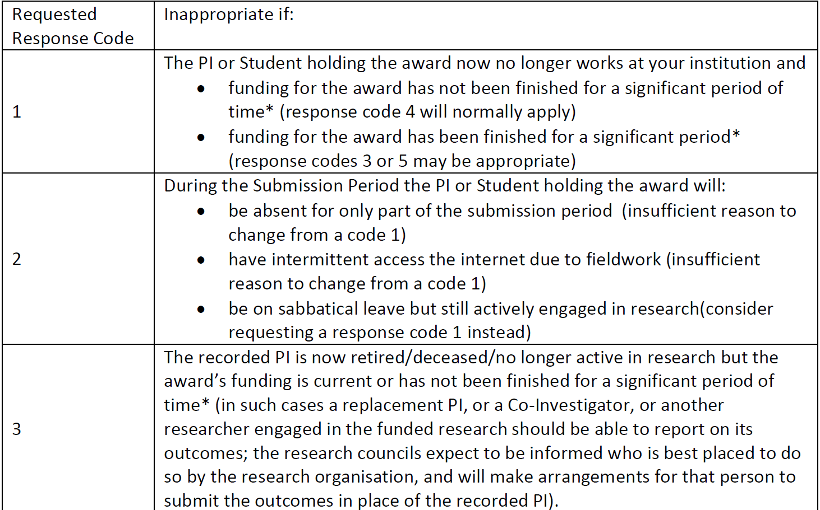


* Definition of ‘a significant period of time’

The Research Councils have agreed the general principle that an award must have ended at least 5 years before a Submission Period to be eligible for response code 3 or 5. Thus:

- Only awards with response codes 3 or 5 are deemed to have been finished for a significant period of time.

- Where a Research Council has assigned a response code of 1, 2 or 4 to an award, this indicates that the Council considers that the award has not been finished for a significant period of time.

There will be exceptions to the general ‘five years’ principle:
- Councils may vary the period to greater, or less than five years, for particular grant schemes or particular awards, where the funding is expected to generate outcomes over significantly longer or shorter periods. When this is done it will be reflected in the response code assigned to the Award(s) by the funding Research Council

- Councils will consider requests to change the reporting requirement (and hence the response code assigned to an award) on a case-by-case basis.

Please see the ‘Response Codes’ webpage on the RCUK site for further details of Council-specific variations to the general principle.

